The report or answer to the question has been prepared under the reality or circumstances of Bangladesh.
- Please Describe the impact of climate change on Old Aged
Bangladesh has been ranked as one of the world’s most disaster-prone countries, with 97.1% of its land area and 97.7% of its population at risk from multiple hazards &. According to the IPCC`s Fifth Assessment Report (AR5) (IPCC, 2013), Bangladesh is at special risk from climate change due to its exposure to sea-level rise and extreme events and the concentrated multidimensional poverty in the country. Consequently, it declines the poverty line and interrupted the achievement of the Millennium Development Goals (MDGs) of the least developed countries, who are highly vulnerable to the climate-induced disasters. As well as the remarkable development gained over the last few decades are being gradually outweighed due to the negative impacts of climate change. In addition, total 26 coastal and mainland districts have experienced climate displacement out of 64 districts of Bangladesh. Moreover, almost 6 million people have been displaced from their home and land due to climate change in Bangladesh. Besides, about 46% people are temporarily displaced and 12% people permanently displaced due to different hazards in four climate hotspots of Bangladesh.

Bangladesh is an overpopulated country in the South Asian region, nearly 8.0% elderly people of the country, among the total country population in Bangladesh (GoB, 2020). It is predicted that it would be 11.9% in 2035 and 17.0% in 2050 (BBS, 2018). However, Climate change is a complex, long-term public health challenge and older people are especially susceptible to certain climate change impacts. The proportion of people aged 60 and over is projected to grow in all regions of the world. Moreover, older people are disproportionately impacted by disaster and climate-related stresses such as cyclone, flood, heat waves and drought. Disasters and climate-related hazards like cyclone, floods heat waves and drought are all projected to increase in the future as a direct or indirect result of climate change. During a disaster, older people are often less able or willing to leave their homes and communities to escape from harm. They can struggle to obtain food, travel long distances or endure periods without shelter. Older people face barriers to realizing their rights to health and housing and their needs are frequently neglected by decision makers. As well as, poverty and exclusion are the greatest threats to the wellbeing of older people due to extreme poverty, which is consequences of climate change induced natural disasters.

Bangladesh has a number of laws, rules, policies, legislations and strategies relating to ‘climate change’, ‘disaster management’ and ‘environment’ as well as rights and dignity, protection and inclusion of elderly people. Different clause of these legislations have been cited or emphasized to ensure safer life and livelihood of the citizens of Bangladesh, especially mentioned women, children, persons with disabilities and elder. Yet, there are no specific legislative practices relevant to climate change and elder people in Bangladesh.

- Please Describe any specific laws, strategies and policies address climate change and old aged person in Bangladesh?
Bangladesh has adopted a number of laws, policies, strategies and institutional frameworks relevant to climate change adaptation, problem and management issues which are-
- The Environment Policy (1992)
- The National Forestry Policy (1994)
- The Bangladesh Environment Conservation Act (1995)
- The National Water Policy (1999)
- The National Land Use Policy (2001)
- The National Rural Development Policy (2001)
- The National Adaptation Programme of Action (2005)
- The National Strategy for Accelerated Poverty Reduction (2005)
- The Coastal Zone Policy (2005)
- The National Food Policy (2006)
- The Coastal Development Strategy (2006)
- The National Housing Policy (2008)
- The Bangladesh Climate Change Strategy and Action Plan (2009)
- The National Urban Sector Policy (2010)
- The Standing Orders on Disaster (2010)
- The Bangladesh Country Investment Plan (2011)
- The Disaster Management Act (2012)
- National Agriculture Policy (2013)
- The National Plan for Disaster Management (2016-2020)
- The Perspective Plan of Bangladesh (2010-2021)
- Bangladesh Sixth Five Year Plan (2010-2021)
- Bangladesh Seventh Five Year Plan (2016-2020)
- Bangladesh Environment, Forestry and Climate Change Country Investment Plan, 2016 (Draft)
- Bangladesh Health-National Adaptation Plan (HNAP), 2018
- Sustainable Development Goals (SDGs) 2015-2030.
As well as, Bangladesh Government recently adopted Standing Order on Disaster (2019) for direction of responsibility of the appropriate management for disaster management of the country. Here, take care of PWDs, women, children and old aged person during the disaster period and post disaster period have been mentioned accordingly to the respective disaster management committees of Bangladesh.

However, different clause of the following laws, rules, policies, legislations and strategies have been emphasizing the social protection and adoption, support, and the rights of the citizens during pre-during and post disaster of Bangladesh, especially mentioned elderly people, women, children and persons with disabilities.

- Cyclone Shelter Construction, Maintenance and Management Policy, 2011
- The Perspective Plan of Bangladesh (2010-2021)
- The Perspective Plan of Bangladesh (2010-2021)
- The Bangladesh Climate Change Strategy and Action Plan (2009)
- Disaster Management Act, 2012
- The National Plan for Disaster Management (2010-2015)
- The National Adaptation Programme of Action, 2005
- Coastal Zone Policy, 2005
- The National Plan for Disaster Management (2010-2015)
- Flood Response Preparedness Plan of Bangladesh, 2014
- National Disaster Management Policy, 2015
- National Social Security Strategy (NSSS) of Bangladesh, 2015
- Standing Orders on Disaster, 2019
- Disaster Management Act, 2012
- Bangladesh Seventh Five Year Plan (2016-2020)
- Bangladesh Environment, Forestry and Climate Change Country Investment Plan, 2016 (Draft)
- Bangladesh Health-National Adaptation Plan (HNAP), 2018

Nevertheless, as per review processes, a very few legislative practices have been scope to inclusion and participation of elderly people in planning and implementation process in Bangladesh, such as
- Bangladesh Seventh Five Year Plan (2016-2020)
- Bangladesh Environment, Forestry and Climate Change Country Investment Plan, 2016 (Draft)
- Standing Orders on Disaster, 2019

3. Summary of relevant data that climate change affected older person in Bangladesh
As per review of literature, there is no specific primary survey or data on climate change and elderly people in Bangladesh yet. However, only population census has enumerated the country elderly people in Bangladesh. However, in pursuance of the vision and mission of YPSA, that incorporated elderly persons issue in its latest strategic plan for ensuring their rights. Followed by the organizational strategic plan YPSA also developed a separate strategic plan to ensure and enhance the life and livelihood, protection and participation of elderly people in Bangladesh. For instance, with the financial support of PKSF (Palli Karma-Sahayak Foundation), YPSA has been implementing ‘Well-being of Elderly’ related projects under the program of Enrich at Syedpur union in Sitakund Upazila of Chattogram Division. YPSA is technically call this program as ‘YPSA-Sitakund Model’. Under this program, YPSA has conducted an empirical research with the ethical approval of the National Research Council, Bangladesh. By this research, YPSA has prepared a source list of the elderly people in Syedpur union of Sitakund Upazila. As well as, this research findings explored that total 1,648 elderly people are living in this union and YPSA follow-up this survey findings from year to year. In addition, YPSA has provided different supportive measures, giving old age allowance, rewarding best father and best children and providing support for funeral process.
Besides, with the financial support of CJRF (Climate Justice Resilience Fund), YPSA has been implementing ‘Addressing the rights and needs of climate forced displaced people in the South-Eastern Coast of Bangladesh’. Under this project, YPSA has conducted a detailed regional field survey on three sub-districts or upazilas namely, Banshkhali, Pekua and Kutubdia Upazilas. The survey findings show that total 34,464 people has permanently displaced from three areas after 1991 cyclone. Among them, 14,106 displaced people living temporarily in their original places yet. Although they are displaced from their original places at least five times. Among 14,106 displaced people, total 578 displaced people (4.1%) are elderly people. Under this project, YPSA has selected the displaced families as a target people by using nine selection criteria for providing the shelter, livelihood and other need based support. Among these selection criteria, one of the criteria is having elderly people in a family to the targeted people of the project. Moreover, YPSA has been implementing another project titled ‘Bangladesh Housing, Land and Property Rights Initiative (HLP)’ for climate displaced people. Under this project, YPSA has successfully relocated nine families under community based planned relocation process. Among them, two families have received houses considering the priority of having elderly people in the family.
Additionally, YPSA has accomplished a project titled “New houses for homeless people in the coastal area” under the financial assistance of Habitat for Humanity International. By this project, YPSA team conducted a detailed area survey to identify homeless climate induced household at Banshkhali upazila in Chattogram District. Through this survey, YPSA has Identified 137 families those who lost their residence due to disaster as an impact of climate change. By this financial support, YPSA has provided ‘Climate Resilience Houses’ to 137 families in this area. Among 137 families, nearly 90 families have selected with elderly people.
Furthermore, YPSA has implemented several projects in ‘Rohingya Refugee Camps’ and built ‘Age-Friendly Center’ for elderly people. In camp areas, YPSA has enlisted total 10,051 Rohingya displaced elderly people and nearly 1000 people in the adjacent host community to provide their health care facilities, one to one counseling and excitement through various recreational events in a selected camp.

4. Please describe the any mechanisms and tools that monitoring the impact of climate change and older person?
The Government of Bangladesh has developed and imposed quite a lot of laws, policies, rules, regulations and strategies about climate change and disaster management in pre-during and post disaster of Bangladesh. These legislatives practices are addressing the social protection and adaptation, support, and the rights of the citizens of Bangladesh and especial emphasis on women, children, elderly and persons with disabilities. However, there are no mechanisms and tools that are in place to measure and monitor the impacts of climate change on the full and effective enjoyment of the human rights of older persons in Bangladesh yet.
Besides, YPSA has not developed a mechanism and tools that monitor the impact of climate change and older person yet. However, YPSA has developed a ‘Strategy of Elderly people’ to ensure their rights, dignity, protection, preservation, participation, prosecution and well-being as well as maintained a mechanism and tools that monitor the set project activities. For instance, ‘YPSA-Sitakund Model’, has been following-up the number of elderly people in every year through door-to-door survey in Syedpur union and provided elderly supportive devices, health care facilities and arranged different amusement events for energize them. As well as, ‘Community based planned Relocation Project’ has been following-up their life and livelihood, dignity, social, economic and cultural inclusion in the relocated areas. Nevertheless, the above-mentioned mechanisms are very limited and periodic.
5. Please identify and share example for good practices and challenges for fulfillment of adverse affect of climate change on aged person
YPSA has been implemented ‘One House One Family at a time’ Program for rehabilitation of climate displaced people in Southeastern coast of Bangladesh under the project of YPSA-HLP and YPSA-CJRF projects. Under YPSA-HLP project, YPSA has been relocated four families in Sitakund Upazila from Sandwip Island in 2016. Among four families, one family has been selected considering the elderly people as a household head. Nowadays, five families have been relocated in the same areas under this project. Among them, two families have been selected considered the elderly people as a household head. Besides, YPSA-CJRF project have been relocating eight families under the specific standard that address the elderly people’s need as well. Moreover, under the financial support of Habitat for Humanity International, YPSA has provided ‘Climate Resilience House’ for 90 families in Banshkhali Upazila of Chattogram District. However, YPSA has been working to ensure the rights, dignity, well-being, healthcare service delivery through ‘YPSA-Sitakund Model’ and humanitarian aspects of Rohingya camps. The following case studies have been prepared on the above projects.
- Case study (‘YPSA-Sitakund Model’)

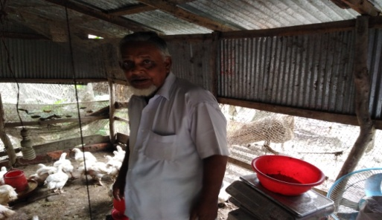
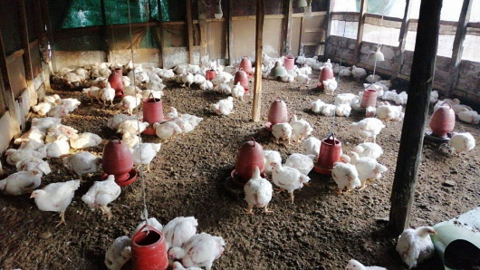
Mr. Harun-Aur-Rashid is a permanent inhabitant in Sitakund Upazila, a disaster prone upazila in Chattogram District. Mr. Rashid was born 1955 in West Syedpur. He is 65 years old. He belongs to a Muslim family and he was living well with his land resources. He had ensured education for his children are higher educated and living in the capital city. After 1991 cyclone, he lost his assets due to recurrent bank erosion. As well as, after the marriage of his children, they separated themselves and living in another city. Consequently, he and his wife was facing multilevel crisis, especially, social, economic and cultural crisis. In this case, their life was becoming worse and they could not meet basic needs, amenities and medical facilities in their daily life. In this situation, YPSA has enlisted such types of household those who are disaster victim, underprivileged and keep untouched with their children. After selecting the target group, YPSA has been implementing different types of humanitarian activities as well as health camp among them. Under the model, YPSA has provided financial support by the support of PKSF. In this circumstance, the target people receiving money and utilize this support with different profitable small business and Mr. Rashid one of them. Nowadays, he has started a small business, namely poultry firm. With the profit of this business, he is now able to meet their daily expenditure, purchase daily food and non-food items. As well as uplift their social status, meet community engagement in their territory and get back his dignity and social status after starting the business, he said.

- Case study (‘Community Based Relocation Model’)

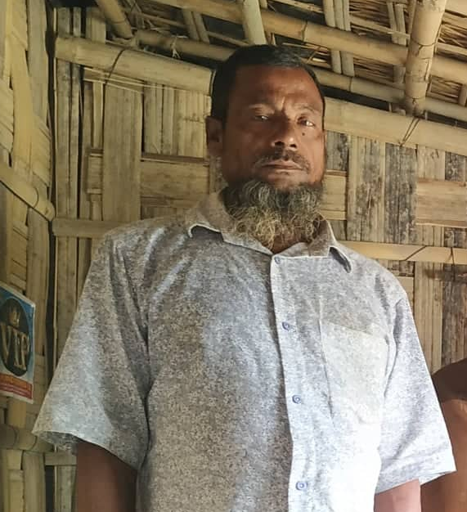
Mr. Mohammad Ishaq is a climate induced disaster victim and living in a temporary settler at Chanua Union in Banshkhali upazila of Chattogram District. Banshkhali upazila is the ‘climate induced disaster hot spot’ located the southeastern coastal belt in Bangladesh. Due to climate change induced disaster, he has lost his paternal property more than four times. He has no land resources and he made a temporary house on other land but due to different disaster event in the coastal area his house becomes a very poor condition. He is a day labor and he becomes unemployed is lean season. Under the financial support of CJRF, YPSA provided him home material support to rebuild his house and living as good condition. As well as, he has been provided small business training and goat rearing training with the financial support to earn money as self-employed. Besides, he has been linkage with different service providing government bodies and inclusion in local level different social and cultural events. These days, Mr. Ishaq is doing a seasonal vegetable business. He has collected vegetable from rural farmers and selling these products on the near villages. He and his family much more happy than before, he said.
- Case study (‘One house one family at a Time’)

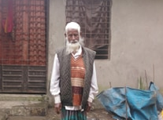
Mr. Abul Kashem as a climate induced disaster victim and temporary settler at Sandwip Island in Chattogram District. Sandwip Island is the ‘climate induced disaster hot spot’ in the coastal Island in Bangladesh. He was working as a farmer and somewhat fisherman in this island area. He has a seven family members and he is the only earning member in his family. He has four sons and one daughter and his wife is a housewife. He was living in ‘Gachua’ union on Sandwip Island with land resources. Unfortunately, he has lost his entire resources in 1991 cyclone and recurrent bank erosion. In this situation, he cannot able to meet his family expenditure and stopped education of children. He was unable to maintain his family expenditure, although he worked other land. Due to adverse effects of climate change, especially bank erosion, sea level change, cyclone and storm surge, a portion of Sandwip Island people were displaced from their original places.

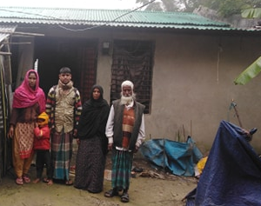
Under the YPSA HLP rights of Climate displaced people, YPSA selected Mr Abul Kashem as an elderly people, who agreed to voluntary relocated in the nearby sub-district. YPSA has relocated nine families in Sitakund Upazila from Sandwip Upazila. Among nine families, two families had considered as elderly family head and Mr. Abul Kashem one of them. Under the project activity, he has been engaged different development activities in relocated area. Like inclusion with Elderly People allowance, livelihood and linkage with different safety net programs.

- Case study (‘New Houses For Homeless People in the Coastal Area’)

Banskhali Upazila is a disaster-prone area, which is located in the southeast region of Bangladesh and one side adjacent to the Bay of Bengal. Nearly eight Unions out of 15 Unions in this Upazila has boarder with sea. The coastal people are losing their land in every year due to hostile behavior of climate change. Most of people are homeless in the unions alongside of sea. These homeless people affected in every cyclone such as Roanu and Mora. Under the financial support of Habitat for Humanity International, YPSA and Upazila administration had jointly conducted a survey. This survey finds out the ultra-poor climate victims household who has lost their home during the disaster events. Subsequently, YPSA has provided house to nearly 137 families who affected by the cyclone Mora in the Baharchara area on the coast of Banshkhali. After getting the new houses, now they are dreaming of a new way. Among them, nearly 80% household was selected those who were 60 and above 60 years old. Among them, Mr. Asahab Uddin was one of them. He is 65 years old. Before rehabilitation, he and his family was living in a plastic made house. Rainwater easily enters the inside of house and house roof dislocates during to gust wind. As well as he has unable to build a new home due to the financial crisis.
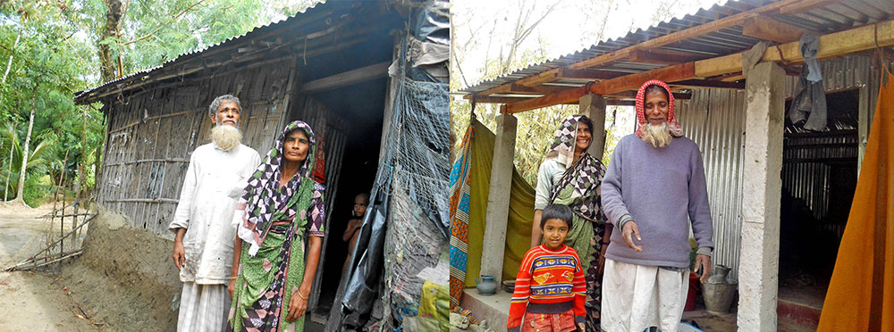
Before | After
He said that his social status, economic inclusion and enjoyment of cultural events have been accelerated after this assistance by YPSA. Because, YPSA has not only provided the ‘disaster resilience house’ but also helped to get assistance from local government representatives.

- Case study (‘Humanitarian Task)

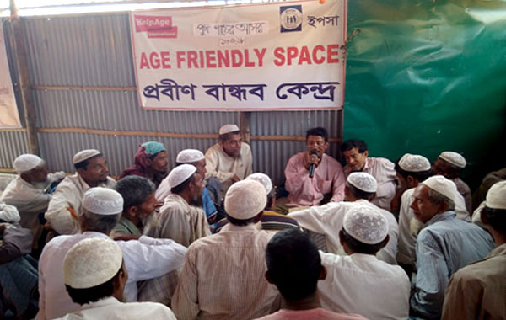
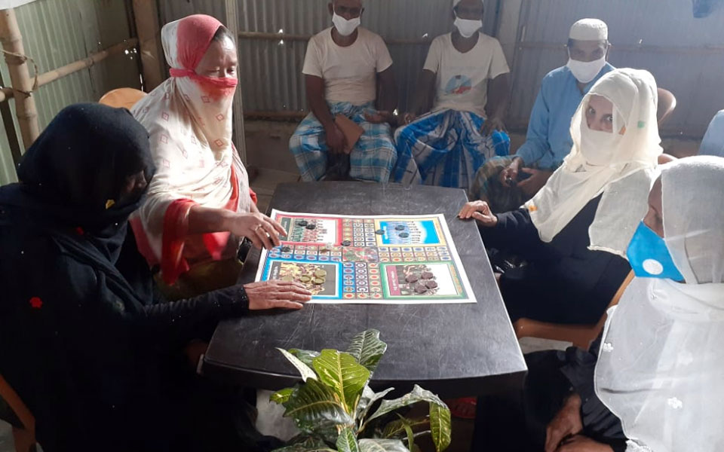
According to the UN Refugee Agency (UNHCR), more than 723,000 Rohingya have fled to Bangladesh since 25 August 2017. On 28 September 2018, at the 73rd United Nations General Assembly, Bangladeshi Prime Minister Sheikh Hasina said there are 1.1 million Rohingya refugees now in Bangladesh. However, the total older Rohingya population in refugee camps are 30064 population cited by UNHCR, Population factsheet, 2019 and 31,500 refugees age 60 or older cited by AMNESTY International, 2019. YPSA has been ensuring different development activities through greater Chattogram since 1985. YPSA has been implementing different Social development activities in Cox’s Bazar since 2008. According to NGO Bureau of Bangladesh (Prime Minister Office), 2020, a total of 2511 (up to August -2020) organizations are working in Rohingya Refugee camp areas in Bangladesh, among them only four organizations are working to Elderly people. Among four, YPSA is a leading organization working on the older people related issues in Rohingya camps. These days, YPSA is also implementing a project named “Integrated Humanitarian Response to the needs of older men and women amongst Forcibly Displaced Myanmar National (FDMN)” making Age Friendly Spaces (AFS) to provide Primary Health, WASH, Protection, Advocacy & Capacity Building, Livelihood and Severe Acute Malnutrition (SAM) Management of Older People under the cooperation and technical support of HelpAge International, Bangladesh (HAIBD), Fund managed by UNOPS and Funded by UK aid. The target group of the project is Older People of Rohingya and Host Community (Aged 50 +) and the purpose of the project is “: Improved access to the lifesaving and life- improving integrated humanitarian services for older men and women and their families amongst the Forcibly Displaced Myanmar National (FDMN)” and Host Community. Under this project, YPSA has covered 10,051 Rohingya displaced people in camp areas and nearly 1000 people in the adjacent host community. Besides, YPSA’s research team has disseminated its activities through social media, seminars and workshops and publications. A manuscript was prepared based main findings entitled “Humanitarian Emergencies of Rohingya older people in Bangladesh: A Qualitative Study on Hopes and Reality” which has been published in Aging International, 2020. As per COVID-19 situation, YPSA has been implemented different sorts of awareness programs and campaigns in the Camp areas. In addition, distributed different COVID-19 related safety measures, for instance, hand sanitizer, mask and hand globs.

6. Good practices that highlight international and multilateral cooperation and approaches
YPSA-Young Power in Social Action is a voluntary, nonprofit and an organization for sustainable development, established in 1985 that registered with the different department of the People’s Republic of Bangladesh. YPSA envisions a society without poverty where everyone’s basic needs and rights are ensured. At present YPSA’s direct program interventions reach in 13 districts of Bangladesh but YPSA has countrywide and regional advocacy and networking program through its Networking & Strategic Linkage unit. Currently YPSA is working with a total number of 14 million (estimated) disadvantaged and vulnerable people. YPSA has been working with disaster risk reduction and emergency management program since 1991 and working with elderly people since 2013. YPSA has a good track record in implementing various projects on climate change, disaster risk reduction and emergency management, education, health rights and emergency responses for Rohingya communities since 2017. Nowadays, YPSA has tried to explore three decades contribution to the development process in Bangladesh, uplift of underprivileged countryside people and sharing lesson learning to wider academia, researcher, expertise and development practitioners. YPSA has prepared a five year ‘Strategy for Elderly People’ for Bangladesh. Under this strategy, YPSA broadly applied or practices 4P approach for well-being of elderly people in the project areas of Bangladesh. This 4P Approach means, Protection, Participation, prevention and prosecution.
Protection: It refers to securing the physical, psychological and emotional safety of older persons with regard to their unique vulnerability to abuse and ill treatment.

Participation: It refers to the need to establish a greater and more active role for older persons in society.

Prevention: It refers to the act or practice of stopping something bad from happening with elderly people.
Prosecution: it refers to the act or process of holding a trial against a person who is accused of a crime to see if that person is guilty.

7. Please provide any additional information for support climate action
We have to scope more to do for well-being of elderly people in Bangladesh. Yet, no legislative strength to elderly people and climate change disasters. So, the time has come to developing uniform or separate legislative strength to elderly people with climate change. As well as, existing laws, rules, policies, strategies should be active and properly practices in our daily life. Besides, ensure their dignity, rights and priority their position at every social, economic and cultural event. Moreover, ensure their inclusion and active participation at every phase in our daily life. In these circumstances, as a development organization or development practitioners, we should enhance advocacy and awareness related events, for instance, knowledge sharing meeting, one to one meeting with relevant state and non-state actors, seminar, leaflet distribution, procession, human chain and relevant day observation.

After meeting with you, we felt the need to include the following items in the recommendation list, such as
- The Age structure of the elderly people should standard age limit all over the world.
- Every nation should develop the Ministerial Body or Ministry of ‘Elderly People’ to manage ‘Elderly People’ related issues properly.
- Government should develop specific laws, rules and policies relating to climate change and rights of elderly people as well as revised existing laws, rules and policies as per priority of climate change and rights of elderly people.
- Government should enumerate total concrete figure of elderly people in the entire country through detailed field survey.
- Government should ensure the rights to participation of Elderly people in social and cultural events.
- Government should ensure the rights to inclusion of Elderly people on Climate Change and Disaster Management related laws, rules and policies.
- Government has bound to consignment to the grave or cementation or Funeral of Elderly People.
- Conceptualization of the Knowledge of elderly people on the subject of the climate change adaptation and mitigation practices, because elderly people is the ‘Knowledge Archive’ in any countries.
- Government should provide the ‘Elderly People Allowance’ to all in the entire country regardless of political party, endorsement of any influential person and institution and rotation of relevant official actors or government. As well as, monitoring the existing condition relating with the Elderly People Allowance’ and distribution process.
- State should arrange and manage the ‘Age-Friendly Space’& ‘Livelihood’ for elderly people those who do not have children, caregiver and relatives.
- State should formalize the dignity full or noble profession for income generating activities of elderly people.
- State should develop elderly people friendly service delivery and communication system of the entire country.

UNICEF. 2011. Bangladesh Country Programme Document 2012-2016. The changing climate, As disaster risks evolve, UNICEF helps build resilience of communities, https://www.unicef.org/bangladesh/en/changing-climate
Maplecroft (2015). Climate Change and Environmental Risk Atlas. Maplecroft
IPCC (2013). Climate change 2014: Impacts, adaptation, and vulnerability. Contribution of Working Group II to the Fifth Assessment Report of the Intergovernmental Panel on Climate Change. Geneva, Switzerland: Intergovernmental Panel on Climate Change.
IPCC (2014). Climate change 2014: Impacts, adaptation, and vulnerability. Contribution of Working Group II to the Fifth Assessment Report of the Intergovernmental Panel on Climate Change. Geneva, Switzerland: Intergovernmental Panel on Climate Change.
Delta Plan, 2017. Bangladesh Delta Plan 2100, Government of the People’s Republic of Bangladesh, Bangladesh Planning Commission, General Economics Division.
Displacement Solutions(2012)Climate Displacement in Bangladesh: The Urgent Need of Housing, Land and Property Rights, 32p.
Comprehensive Disaster Management Programme (CDMP II) (2014)Trend and Impact Analysis of Internal Displacement due to the Impacts of Disaster and Climate Change, Ministry of Disaster Management and Relief, Dhaka.

