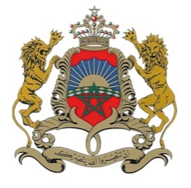

Atelier intersessions sur
le droit à la sécurité sociale
Session I : The human right to social security and the changing world of work
1 Novembre 2021
Madam Chair ;
Distinguished panelists and delegates;
Excellencies, Ladies and Gentlemen;
- First of all, we would like to thank the Chair and the Secretariat for all efforts made to organize this event in the best conditions and we are looking forward to a productive meeting under your guidance. Our congratulations also extend to all panellists for their constructive contributions.
- Allow me to start by saying that social security is a human right. It is a strategic objective decided by states to ensure that their citizens can live in good health and in dignity.
- Universal social protection involves initiating actions and adopting measures aimed at realizing the human right to social security by gradually establishing and maintaining social protection systems adapted to the national context, so that everyone has access to a complete, adequate and durable protection throughout his life, in accordance with the International Labour Organization (ILO) standards.
- Our meeting is fully in line with a new reality that is shaking up – let us say it – our certainties and which plunges us into an unprecedented global turmoil: COVID-19 has put our States in a deep stress test.
- Aware of the magnitude of the upheaval, the Kingdom of Morocco has made every effort to deal with the crisis, including creating a new social dynamic and undertaking many reforms to extend to all Moroccans the scope of universal social coverage, now established as a national priority.
- The immediate opening of an inclusive dialogue with all social partners will precede this reform.
- This major reform will be rolled out gradually over a period of 5 years that has started in January 2021 and will revolve around 3 essential axes:
- The generalization of Compulsory Health Insurance (AMO);
- The granting of family allowances to all households;
- Retirement of the non-covered active population and compensation for loss of employment for the active population.
- We are aware that all these measures will lead to an overhaul of our financial system and our solidarity mechanisms; but it is all with a view to achieve a better governance.
- All of these steps are part of the Kingdom's desire to maintain a balance between economic and social challenges.
Thank you for your attention.

