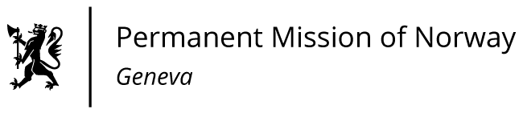

**STATEMENT**

**4th HRC intersessional meeting on human rights and 2030 Agenda**

**Statement delivered by Minister Counsellor Anniken Enersen**

Check against delivery

18 January 2022

**It is clear that the pandemic is reversing global progress towards achieving the sustainable development goals. A pandemic that has hit women and girls especially hard.**

**The impacts of the pandemic on women have been evident in my own country as well. A survey in Norway showed that when schools and kindergartens closed, a greater share of the increased care burden fell on women, and we have seen an increase in gender-based violence. Crises tend to reinforce traditional gender roles.**

**At the same time, we have seen examples of action can be taken to address the current challenges. We have learnt that our response to this crisis must have a gender perspective at its core. It must build on the fact that women and men have different roles, and different access to resources.**

**Democratic countries, where human rights are respected, and where women are able to reach top positions in society, are also the countries that are best equipped to handle crises like COVID-19.**

**One very important aspect is a high level of trust between the general population and the authorities. Transparency and accountability are also important factors for success. In Norway, the Government has held nearly daily press conferences to inform the public and explain the reasons behind the measures we have introduced. We have highlighted the fact that we must all do our part for the common good.**

**Looking forward, we need to look beyond SDG 5 and integrate women’s rights and gender equality across all the SDGs. Systematic mainstreaming of a gender perspective in the implementation and monitoring of the SDGs requires a holistic approach.**

**An approach based on democracy, gender equality and human rights is key to fighting COVID-19 and realising the 2030 Agenda for Sustainable Development. Together, we can build back better, greener and with greater equality – ensuring that no one is left behind.**