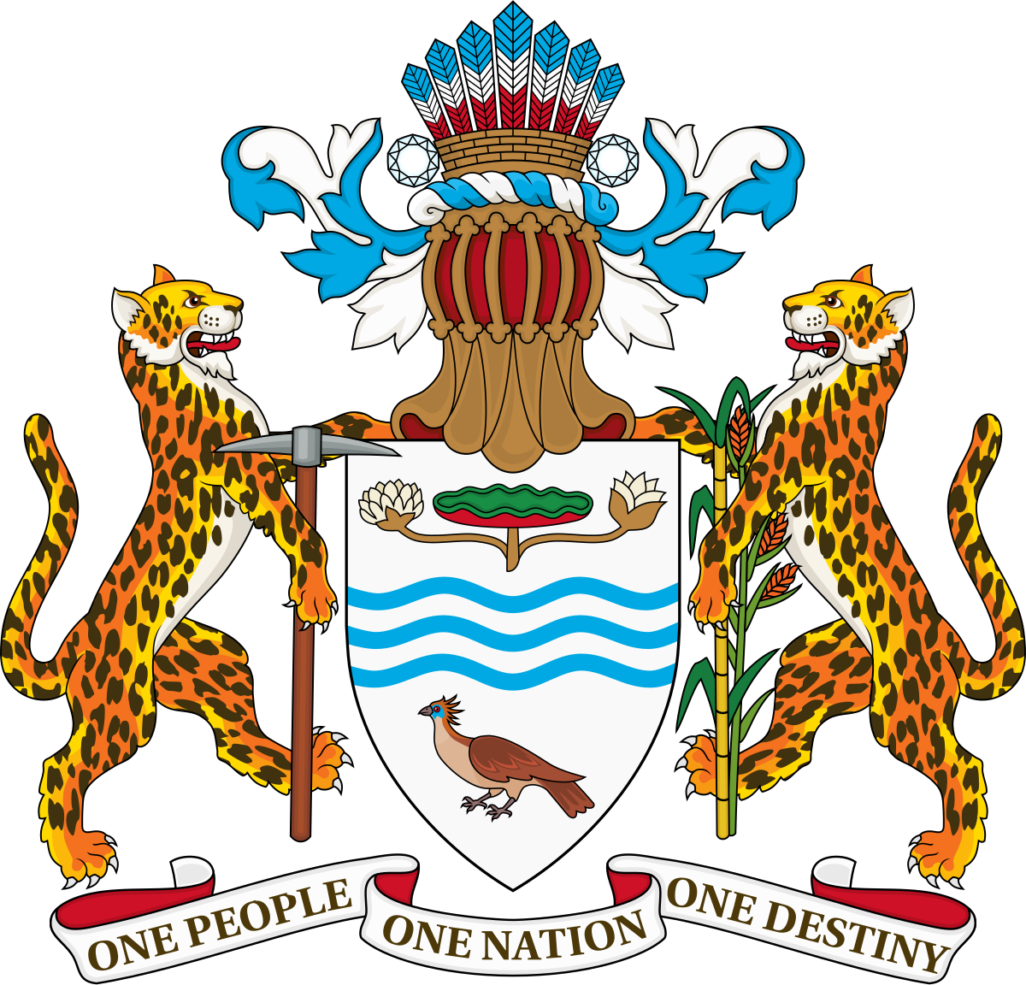  Rights of the child & family reunification  Human Rights Council Res. 45/30 (Follow up No.18) | Government of Guyana  Responses to the questions posed in correspondence TESPRDD/HRESIS/IG/GB/KY  October 31, 2021

- A) How are the human rights of children separated from their families upheld in your country?
The Government of Guyana reports that the separation of children from their families has not been a pervasive issue in the Guyanese context.
The Constitution and laws of Guyana provide clear protections for all children and contain an overarching principle that the state must act in “the best interests of the child.”
Article 38B of the Constitution of Guyana provides that “the best interest of the child shall be the primary consideration in all judicial proceedings and decisions and in all matters concerning children, whether undertaken by public or private social welfare institutions, administrative authorities or legislative bodies.” The deliberate inclusion of this clause in the Constitution is a clear demonstration of Guyana’s commitment to protecting the fundamental rights of all children, including those from vulnerable populations.
Further, the Protection of Children Act (2009) in section 3, titled “General Principles”, states that the act shall be interpreted and administered in accordance with specific principles and that due consideration must be given to these principles by the Court or any other body or entity that is charged with the administration of the provision of the Act. The principle of the best interest of the child is further reiterated in section 3(A) which states “the overriding and paramount consideration in any decision made under this Act shall be the best interests of the child”.
The Protection of Children Act (2009) also goes on to state in section 3(C) that “every child is entitled to be assured of personal safety, health and wellbeing.” This principle is applicable to all children in Guyana and encompasses a series of responsibilities on both state agencies and private institutions which provide services to children and their families.
Section 3(D) of the Protection of Children Act (2009) states that “the family is the basic unit of society responsible for the safety, health and wellbeing of the child”. From a cultural perspective, family in Guyana includes the extended family and is not seen as only being a nuclear family. Further, section 3(F) of the Act clearly states that “kinship ties are integral to a child's self-development and growth and if a child's safety, health and well-being cannot be assured in the context of the family, the extended family shall in the first instance be encouraged to care for the child provided that the Director or the Court, as the case may be, can be assured that the child's safety, health and well-being will not be at risk and that the best interests of the child have been considered.” This clause clearly depicts the state’s commitment to ensuring that children remain in family environments which are conducive to the wellbeing of the child. Even in the absence of parents, or if parents are deemed unfit by the relevant authorities, priority is given to extended family to care for the child. Ultimately, the state maintains the principle of assuring that a child’s safety, health and wellbeing are paramount in any decision-making process including the determination of the most fit caregiver(s).
Where a child is removed from their family, section 17 of the Protection of Children Act (2009) clearly outlines the steps that must be taken to provide quality care for the child. The laws explicitly state the processes which must be untaken in the provision of healthcare, where the child has been removed from the parent and is being cared for by the Director of the Child Care and Protection Agency or an appointed social worker.
Further, the Childcare and Protection Agency Act (2009) establishes an agency under the supervision of the Minister responsible for human services and social security. Notwithstanding any other laws, the Agency has responsibility for the implementation of policies and decisions in relation to the laws of Guyana governing children. The Act explicitly confers onto the agency the responsibilities for childcare and development services, foster homes, voluntary organisations; the status of children; the adoption of children; the protection of children; and the custody, contact, guardianship, and maintenance of children. This agency is fully functional in Guyana and has been since the accession of the Act. The agency works closely with all other government agencies and relevant private and civil society organisations as well as international organisations, such as UNICEF, to ensure that the rights of the child are promoted and protected in all settings.
Thus, there is no gap between the practical implementation of these laws and policies in Guyana. All agencies operate with this law as a governing principle, and the separation of a child from their family is only an absolute last resort if for any reason the health and wellbeing of the child cannot remain in the family setting.

As stated, the Constitution and laws of Guyana are explicit in the provisions set out to preserve the family construct ( including extended family) as a best practice in the interest of children’s development and mental, physical, and emotional wellbeing.

- What are the priorities to strengthen global and national frameworks for the prevention of family separation?

Guyana remains committed to the Convention on the Rights of Children and its optional protocols, the International Convention on the Protection of the Rights of All Migrant Workers and Members of their Families, and, the principle that the every child is deserving of unification with their family.

Guyana has always had an open and liberal immigration policy with nationals and their families from the neighbouring countries of Brazil, Suriname and Venezuela as well as those from India, China, and, countries in Africa, being able to obtain visas and work permits with relative ease and being able to access services equal to Guyanese citizens such as free public education and free health care.

In addition, its legislative instruments support the Free Movement of Skills of CARICOM Nationals in keeping with its treaty obligations as a member country of the Caribbean Community.

Guyana will continue to maintain a liberal policy for those who wish to enter and contribute to the development of the country and do its part in offering humanitarian assistance within its available means.

Globally international agencies need to be more assertive in addressing countries that knowingly separate migrant children from their families in violation of Article 9 and 10 of the Convention on the Rights of the Child.

- A) How can the right to family life be upheld for children in cross border situations, particularly migrant children who are separated from their families (taking into consideration Article 10 of the Convention on the Rights of the Child)?

The Government of Guyana continues to extend humanitarian support to migrants from Venezuela who enter Guyana through various points along the Guyana/Venezuela border. These migrants can be properly documented and registered, even if they initially entered Guyana through an entry point that is not identified as an official port of entry monitored by immigration authorities.

Migrants travelling to Guyana often come with their children and are not separated by authorities in Guyana. Rather, migrants and their children are given equal access to government goods and services that are available to all Guyanese. This includes access to publicly funded and managed education and healthcare services which are free. Migrants from Venezuela, and other migrants, resident in Guyana have benefitted from Covid and Natural disaster relief given by the Government including free Covid vaccinations and treatment. They have been accorded the same benefits as Guyanese within the country’s available resources.

Migrants who move to Guyana without their children are in no way obstructed from contacting their children or other family members. Remittance services which are compliant with the laws of Guyana also provide money-transfer services which enable parents to support their children and families.

Further, parents who migrate to Guyana for any reason are free to return to their place of origin, or, to move to another state if they see fit and can afford to do so by utilizing the proper means. Parents and children are allowed to travel freely and are encouraged and empowered to do so through official ports of entry/departure.

For migrants from other countries who legally enter the country are given extension of stay and who come without their children, they can apply for work permits and bring their children to join them.

B) How can the best interests of children separated from their families in cross-border situations, in particular migrant children, be more effectively upheld without discrimination?
Article 149 of the Constitution of Guyana states that no law shall make any provision which is discriminatory, and that no person should be treated in a discriminatory manner. The constitution goes on to define “discriminatory” as affording different treatment to different persons attributable wholly or mainly to their respective descriptions by race, place of origin, political opinions, colour or creed, whereby persons of one such description are subjected to restrictions to which persons of another such description are accorded privileges.
In this regard, no laws, policies, or practices implemented by the state party enable or promote discrimination of persons based on their place of origin or migration status.
The Government of Guyana also implements projects which are accessible to migrant communities to develop entrepreneurship and stable income generation. Such projects include the Ministry of Human Services and Social Security’s Women’s Innovation and Investment Network (WIIN). These therefore offer an enabling environment for migrant parents in Guyana to generate income and support their children and families.
As it relates to parents accessing employment to generate income to care for children, the Prevention of Discrimination Act (1997) makes it unlawful for any person who is an employer or any person acting on behalf of an employer to discriminate against any other person in relation to recruitment, selection for employment, training apprenticeship or employment. The grounds for non-discrimination as outlined in section 4 of the Act include race, sex, religion, colour, ethnic origin, indigenous population, national extraction, social origin, among others.

- A) What are the main human rights concerns for children living in conflict, children in detention or whose parents are detained, or children allegedly associated with terrorism or terrorist groups regarding their right to be united with their families?

Section 41 of the Protection of Children Act (2009) states that the placement of a child shall be conducted in a manner which is least disruptive to a child. The legislation further states that the state “recognizes the importance of placement with siblings wherever possible, and contact with family or other persons who are significant to the child including godparents or close family and friends.”

If a child must be placed in a setting outside of their immediate family as a result of parents being detained, for example, the Protection of Children Act (2009) in section 41(2) confers responsibility unto the Director of the Child Care and Protection Agency to first consider placing the child with a relative or person with whom the child has a significant relationship. Further, where a child is removed by the Director or social worker from a custodial parent and the non-custodial parent is considered to be suitable to provide care, the child may be placed with the non-custodial parent pending the final determination of applications before the court.
Irrespective of the circumstances which surround the removal of a child from their parent(s), the state party assumes responsibility to ensure that the fundamental rights of the child are protected and that the child is afforded equal and unbiased access to essential services and is in a safe environment. Further, the Act clearly states in section 45 that any child who is removed from any persons caring for them, shall be counselled.
The fundamental rights of the child are always prioritized in all circumstances. Every effort is made to ensure that the safety and wellbeing of children are protected, and that they remain in family settings as far as possible.
Guyana, has many challenges as a small emerging democratic nation, but has not experienced cases of “children allegedly associated with terrorism or terrorist groups regarding their right to be united with their families.”
B) How can the best interests of children separated from the families in these situations be more effectively upheld without discrimination.
The state makes every effort to ensure that the identity of a child in conflict is protected. In cases where parents are parties to any ongoing court matter, the identity of the child is not disclosed as a means of protection.
Further, the Constitution of Guyana in article 38B states “the best interest of the child shall be the primary consideration in all judicial proceedings and decisions and in all matters concerning children, whether undertaken by public or private social welfare institutions, administrative authorities or legislative bodies.” The courts have upheld the Constitution.
- What are the main gaps and strategic priorities to strengthen International cooperation on upholding the rights of children in cross-border situations who are separated from their families.
Only in the last three years has Guyana been experiencing a large influx of migrants from Venezuela, due to the situation in the neighbouring country. The number of migrants from Venezuela entering legally and illegally, registered and unregistered, are estimated to be somewhere between 20,000-40,000 migrants. It should be noted that approximately one-fourth of these migrants are Guyanese or descendants of Guyanese who fled to Venezuela in the 1970s due to the undemocratic regime, extreme poverty, lack of jobs, ethnic discrimination, etc., in Guyana. This latter group mentioned, as Guyanese and their descendants, have constitutional rights that are protected.
This new experience needs to be contextualized as Guyanese fled in large numbers illegally to neighbouring Venezuela, Suriname, Brazil, CARICOM nations and North America between 1970s and 1990s. Guyana’s population significantly declined in this period.
Guyana is emerging yet again from another period where democracy was under threat in the last five years; a period in which 30,000 people lost their jobs (before the COVID-19 pandemic), and where major social programmes, including housing, were neglected. Therefore, the new Government is restoring the economy, rebuilding the social services and providing relief to all of its residents during the pandemic while investing in transformation projects which will improve the quality of life for all of its residents.
The Government has established a National Multi-Agency Coordinating Committee on the influx of Migrants from Venezuela chaired by the Minister of Foreign Affairs and International Cooperation which includes relevant UN agencies and Government entities.
It is critical that international agencies coordinate with the Government to ensure that Guyana’s territorial integrity and security vulnerabilities are not exacerbated with regards to Venezuela’s territorial claims, and the threat of gangs such as the Sindicato.
Through timely sharing of information with Government and less time wasted on duplicating or competing efforts, there will be better use of limited resources and an enhanced ability of Government to respond with greater alacrity to address cases of children separated from their families.

