.
Department of Climate Change, Environment and Health
World Health Organization
Ave Appia 20
CH-1211 Geneva
Switzerland

Further to the request pursuant to Human Rights Council Resolution 47/24 on human rights and climate change, WHO is pleased to submit the following responses for inclusion in the Secretary-General’s report to the Human Rights Council.

1. Please describe the impacts of the adverse effects of climate change on the full and effective enjoyment of the human rights of people in vulnerable situations. Where possible, please share specific examples and stories.
As per article 1 of the United Nations Framework Convention on Climate Change (UNFCCC), health is one of the key adverse effects of climate change. Climate change is adversely impacting human health in different ways. Impacts can be direct, such as those posed by extreme weather events, and indirect, as these are mediated through impacts in some of the key determinants of health (e.g. water, sanitation, air, food, and the overall environment including the living organisms that can transmit infectious pathogens between human or from animals to humans).
Climate change and overall environmental degradation are impeding the enjoyment of not only the right to health but also the right to life to current and future generations.
With regards to mortality, over 7 million people die every year from exposure to air pollution that is also driving climate change. Furthermore, WHO, considering only four health risks (i.e. undernutrition, diarrhoea, vector-borne disease and heat extremes), conservatively estimates that climate change will be causing 250,000 additional deaths per year from 2030 to 2050.
In addition to death, climate change and air pollution are causing an increase in the risk of disease and posing a burden to health systems’ capacity to protect and promote the health of the population they serve.

2. Please describe any specific policy, legislation, practice or strategy that your Government has undertaken, in compliance with applicable international human rights law, to promote an approach to climate change mitigation and adaptation, as well as loss and damage that ensures the full and effective enjoyment of the human rights of people in vulnerable situations. Please also note and identify any relevant mechanisms for ensuring accountability for these commitments including their means of implementation.
At the 26 Conference of the Parties (COP26) to the United Nations Framework Convention on Climate Change (UNFCCC), a formal health programme was included by the UK Government as President of the COP. This health programme included Initiatives on climate resilient and low carbon sustainable health systems. 52 countries across the globe committed to these initiatives in the run-up to COP26 and announced their commitments in Glasgow. WHO is closely working with the UK Government to ensure support is provided to those countries in need while knowledge, capacity and lessons learned are shared among these wide range of countries.
With the implementation of these initiatives, health systems around the world will advance not only in strengthening their climate resilience but will lead by example in reducing the carbon and overall environmental footprint of their operations.
WHO has a full package of technical support on climate change and health, including for the implementation of the country commitments to climate resilient and low carbon sustainable health systems. Information on WHO’s country support package on climate change and health can be accessed here. This support is mainly structured around 5 key functions that, if implemented, will protect and promote health in face of a changing climate:
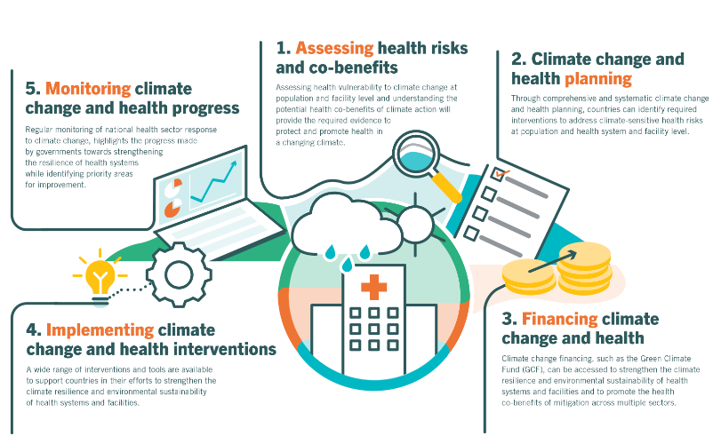

Furthermore, a wide range of air quality guidelines, tools and capacity building activities is available both for ambient air pollution and household air pollution.

3. Please share a summary of any relevant data that captures how the adverse effects of climate change have affected people in vulnerable situations, taking into account multiple and intersecting forms of discrimination (i.e. discrimination based on a combination of multiple grounds, including disability, gender, race, colour, sex, language, religion, nationality and migration status).
While climate change will generally be translated into increased health risks in all regions and countries, those more vulnerable will be greatly impacted. Different vulnerability factors can be observed between countries but also within countries in specific populations.
A key determinant of health is access to health care. Several countries have already weak health systems with low capacity to deal with the increased health burdens caused by climate change. Furthermore, those countries with less capacity to deal with the impacts of climate change in key health determining sectors (e.g. water, sanitation, food and agriculture, energy) will see greater health impacts in their populations.
In addition to access to health care, when assessing health vulnerability of different groups within a country, factors related to geographical exposure (e.g. flood-prone areas), socio-political (e.g. conflict situations) and economic conditions (e.g. lack of formal employment), biological factors and health status, and gender norms and relations should be considered as all of them will influence the exposure pathways and final health outcomes.
WHO has developed methods to assess climate change and health vulnerability and has supported over 45 countries to conduct these assessments. Furthermore, evidence on the health impacts of climate change is included in the WHO/UNFCCC country profiles on health and climate change.

4. Please describe any mechanisms and tools that are in place to measure and monitor the impacts of climate change on the full and effective enjoyment of the human rights of people in vulnerable situations.
From smog hanging over cities to smoke inside the home, air pollution poses a major threat to health across the globe. Almost all of the global population (99%) are exposed to air pollution levels that put them at increased risk for diseases including heart disease, stroke, chronic obstructive pulmonary disease, cancer and pneumonia. WHO monitors the exposure levels and health impacts (i.e. deaths, DALYs) of air pollution at the national, regional and global level from ambient (outdoor) and household air pollution. Such estimates are used for official reporting like the world health statistics, and the Sustainable Development Goals.

The climate change and health vulnerability and adaptation assessments conducted at national level to assess current and future health risks from climate change provide a useful tool to also understand factors driving vulnerability at population level.
5. Please identify and share examples of good practices and challenges in the promotion, protection, and fulfilment of the human rights of people in vulnerable situations in the context of the adverse effects of climate change.
The 2021 global report on climate change and health provides a useful summary of key barriers faced at country level to implementation of national health and climate change plans/strategies. These are summarized below:
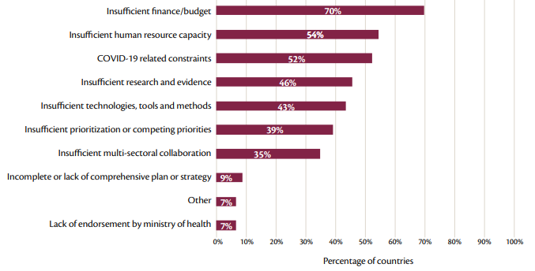

Furthermore, experience gained supporting countries to conduct climate change and health vulnerability and adaptation assessments, indicate that further information on vulnerability factors and exposure pathways should be obtained. This would allow the designing of adaptation options that address the specific vulnerability of populations exposed to the health risks posed by climate change.
As good practices it is important to highlight the involvement of the health sector in the climate change agenda and processes at national level. This has allowed strengthening multi-sectoral collaboration for health and awareness raising of the health implications of climate change among different health determining sectors.

6. Please include examples and good practices that highlight international and multilateral cooperation and approaches that are implemented through close consultation with and active involvement of people in vulnerable situations.
An interesting and successful approach to enforce action by countries for climate and health is litigation. Cases where the population demands the Government for noncompliance with climate change obligations, which goes against their right to health and their right to life have grown in recent years (e.g. Netherlands and Portugal). Furthermore, a case against the UK for dirty air breach resulted in the first time where a death certificate includes air pollution as the cause of death.
At the 46th Session of the Human Rights Council, WHO joined 13 other UN entities in supporting the call for a safe healthy, sustainable environment under the Secretary General’s Call for Action on Human Rights. The subsequent recognition by the Human Rights Council to a clean, healthy and sustainable environment is an important step forward in the protection of health and the environment.

7. Please provide any additional information you believe would be useful to support climate action that promotes the full and effective enjoyment of the human rights of people in vulnerable situations.

New WHO Global Air Quality Guidelines aim to save millions of lives from air pollution
WHO, 2014. Quantitative Risk Assessment of the Effects of Climate Change on selected causes of death, 2030s and 2050s. 9789241507691_eng.pdf (who.int)
Countries commit to climate resilient, low carbon health systems ahead of COP26 (who.int)
Climate change and health: vulnerability and adaptation assessment (who.int)
Assessing Health Vulnerabilities and Adaptation to Climate Change: A Review of International Progress (nih.gov)
Health and Climate Change Country Profiles (who.int)
Air pollution (who.int)
WHO, 2021 WHO Health and Climate Change Global Survey Report, WHO, 2021. 9789240038509-eng (4).pdf
Urgenda Foundation v. State of the Netherlands - Climate Change Litigation (climatecasechart.com)
Portuguese Youth Climate Case v 33 Countries – Portuguese young people versus 33 countries (youth4climatejustice.org)
UK found guilty of dirty air breach by EU court - BBC News
Secretary-General Antonio Guterres. “The Highest Aspiration: A Call to Action for Human Rights”. United Nations, February 2020, New York. At: Secretary-General’s Call to Action for Human Rights (un.org).
A/HRC/RES/48/13 - E - A/HRC/RES/48/13 -Desktop (undocs.org)

