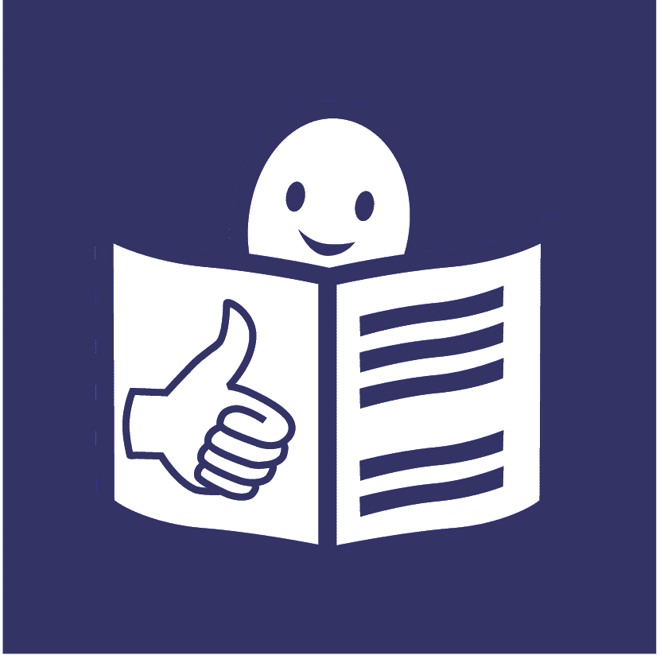United Nations logo **United Nations Human Rights Council**

**United Nations High Commissioner**

**for Human Rights**

**Easy to read**

**Some good ways to make sure that everyone gets the medicines, vaccines and other health things they need**

# A picture containing logo Description automatically generatedAbout this report

We are called the **United Nations** **Office of the High Commissioner for Human Rights**.

Or **OHCHR** for short.

We are part of the **United Nations** (UN).

The United Nations is a group of countries that works together to make the world better and safer.

Our work is about making sure that everyone gets their **human rights**.

Human rights are about what should happen in all our lives.

For example, we all have the right to be safe and treated fairly.

That means everyone in the world should be safe and treated fairly.

This report is about how countries can make sure that everyone gets the medicines, vaccines and other health things they need.

Vaccines can help to stop people getting some illnesses.

People get vaccines from a doctor or nurse.

Other health things might be things like:

* Medical tests to help people find out about their health.

* Machines or equipment to help people to look after their health or to keep safe.
* Things that people might need to move around or to communicate.

Like wheelchairs or hearing aids.

Many people gave us their ideas for this report.

For example, we had a meeting about the ideas in this report on 14 February 2023.

# A cartoon of a child holding his head Description automatically generatedWhat is happening at the moment

Many people in the world are not getting the medicines, vaccines or other health things they need.

For example, many people in richer countries got vaccines for a big illness in the world called Covid-19.

But many people in countries with less money did not.

Many people do not have enough money to buy the health things they need.

Problems like this are often worse for some groups of people, like:

* People who do not have much money.
* Older people.
* People with disabilities.
* People who have a serious illness.
* Women and children.

# What should be happening

Everyone in the world has the right to health.

That means everyone should get the medicines and other things they need to have good health.

There are important laws in the world about that.

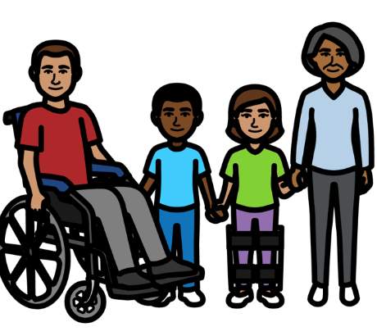

It should be easy for **everyone** to get the medicines, vaccines and other health things they need.

That includes everyone in countries with less money.

Countries and companies often make decisions about medicines and other health things that people need.

They must think about **everyone’s** human rights when they make those decisions.

# Some good ways to make sure that people get the medicines, vaccines and health things they need

Many people should work together to make sure that everyone gets the medicines, vaccines and other health things they need.

The people below should work together:

* Governments who run the country.
* Companies that make medicines.
* Organzations that give people healthcare or support.

They should work together to make the following things happen:

**Getting more medicines and vaccines**

There needs to be more money to make new medicines and vaccines.

For example, some organizations, governments and companies have worked together to get new medicines for people.

That includes medicines and vaccines for Covid-19, malaria, diabetes and cancer.

This has helped to save many lives.

**Making sure that everyone can afford the medicines, vaccines and other health things they need**

Medicines and other health things should not cost too much.

There are some ways to help make that happen.

For example, some companies sell their medicines at a cheaper price to countries with less money.

But the companies can still make money for themselves.

For example, they can sell their medicines to richer countries for more money.

Many people do not have enough money to buy the medicines they need.

Governments should give people extra money for important medicines if they need it.

Or there could be ways for people to get money back for some medicines they buy.

**Making the rules about medicines work better for everyone**

There are some rules about how to make and sell medicines in the world.

But the rules can stop people from getting the medicines they need.

For example, companies can charge more money for new medicines.

This can be too much for many countries and people to afford.

But there are ways to make the rules about medicines work better for everyone.

For example, the rules say that countries can get some medicines or vaccines made at a cheaper price if they need to.

Countries can do this without the company that made the medicines saying yes first.

That means countries could get the same medicine from another company for less money.

Companies that make medicines should not stop this from happening.

Companies that make medicines can also allow other companies to make and sell their medicines.

They could do that for countries with less money.

This has already helped more people to get medicines for illnesses like hepatitis, cancer and Covid-19.

It should also be easier for countries with less money to make their own medicines and health things.

Countries in Africa are already working to make that happen.

And there is a big project to help countries to make their own vaccines for Covid-19.

**Making sure that medicines are safe**

All medicines, vaccines and health things should be good and safe.

Companies should also sell their medicines and vaccines in a fair way.

There are some ways to help make that happen:

For example, countries can now get more information about some new medicines that are made.

That includes how much the medicines cost to make and how well they work.

Companies should also share clear information about new medicines they make.

This can help countries to make good decisions about buying new medicines.

It can also help countries to check that medicines are made in a safe way.

Some countries have laws that stop companies from making and selling medicines in unfair ways.

For example, some laws stop companies from charging too much money for medicines.

Or some laws make sure that lots of companies can make new medicines. Not just a few.

This can help more companies to make new medicines.

And it can help to make new medicines cheaper to buy.

Some countries have also made it easier for people to get new medicines more quickly.

For example, they have found better ways to check new medicines to make sure they are good and safe.

Some people called the World Health Organization can check that some medicines are safe for people in countries with less money.

They can also share information with countries about medicines that are unsafe.

**Helping everyone to get the right medicines when they need them**

Many countries have made a list of medicines and vaccines that are very important for people in the country.

Countries should keep finding out what medicines different people need first.

This will help countries to make sure that important medicines are always there for everyone in the country.

**Helping people to feel OK about taking the right medicines and vaccines**

People need the right information about medicines and vaccines in case they are worried about them.

For example, people may not take a medicine if they think it is unsafe.

Information about medicines should be easy for all groups of people to understand.

That means people might need information in different languages or in different ways.

Different groups of people should also help to make decisions about medicines and vaccines.

All of these things should help everyone to get the medicines, vaccines and other health things they need.

**Pictures by The Picture Communication Symbols ©1981–2016 by Mayer-Johnson LLC a Tobii Dynavox company. All Rights Reserved Worldwide. Thousands of resources available for free at** [**www.boardmakeronline.com**](http://www.boardmakeronline.com/)