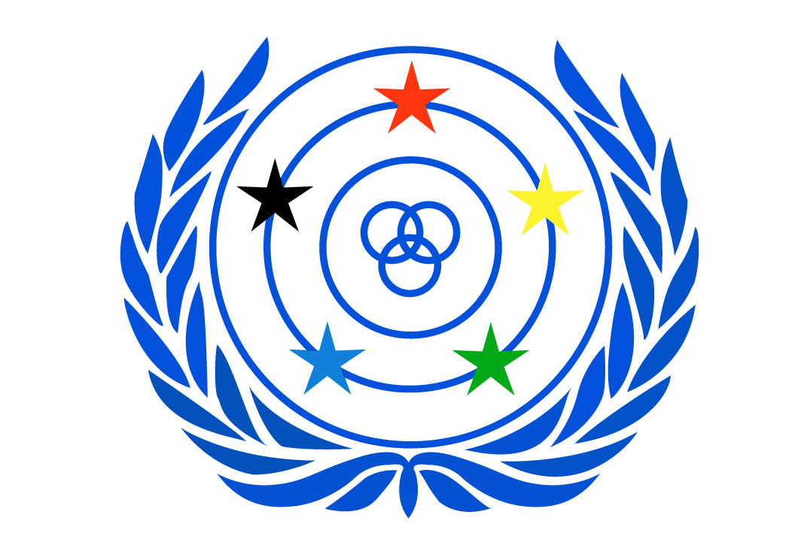

Legal Seat – Helsinki, Finland

WORLD FEDERATION OF THE DEAF
An International Non-Governmental Organisation in official liaison with ECOSOC, UNESCO, ILO,
WHO and the Council of Europe. WFD was established in Rome in 1951.
PO Box 65, 00401 Helsinki, FINLAND
www.wfdeaf.org

President

joseph j. murray
Email: info@wfdeaf.org

Submission of the World Federation of the Deaf on the impact of Covid-19 on the enjoyment of Human Rights

- Introduction
The World Federation of the Deaf (WFD) welcomes the call for submission for the forthcoming thematic reports to the United Nations Human Rights Council or the General Assembly on the impact of the COVID-19 pandemic on the enjoyment of human rights.

The WFD is an international non-governmental organisation representing and promoting approximately 70 million deaf people's human rights worldwide. The WFD is a federation of deaf organisations from 125 nations; its mission is to promote the human rights of deaf people and full, quality and equal access to all spheres of life, including self-determination, sign language, education, employment and community life. WFD has a consultative status in the United Nations and is a founding member of the International Disability Alliance (IDA).

The Covid-19 pandemic is an unprecedented global health crisis affecting billions of people, including more than 70 million deaf people around the world. Persons with disabilities, including deaf people, and other marginalised communities are often at increased risk of serious health complications and being infected by the virus. This risk is increased due to the lack of accessible Covid-19 related information and communication to deaf people in their national sign language.

The global situation of deaf people during this global pandemic is that they are not able to access public health information, healthcare services and emergency response services. In addition, most of the countries around the globe do not provide a quality and professional sign language interpretation in their national sign language(s) for the Covid-19 related communication and information in a consistent manner due to the lack of awareness from the governments, placing deaf communities at further risk of being infected and spreading the virus.

The present submission will present the International Legal and Policy Frameworks obliging States Parties to ensure the provision of the national sign language during the Covid-19 pandemic (II.). Then, it will highlight the specific issues faced by deaf people during the pandemic (III.) before providing some recommendations (IV.).

- International Legal and Policy Framework
This mandate towards sign language access is part of established international human rights law. The Convention on the Rights of Persons with Disabilities (CRPD) includes two specific provisions (Art. 9 and 21) obliging States Parties to the Conventions to take appropriate measures enabling persons with disabilities, including deaf people, to be able to participate fully in all aspects of life and to have access via professional and accredited sign language interpreters. In addition, States Parties must facilitate the use of sign languages in official interactions to ensure equal access to information for deaf people.
From an international policy perspective, the UN Disability Inclusion Strategy highlights that internal and external communication of the UN and its system should be respectful of persons with disabilities. Additionally, this document recognises that accessibility means ensuring that persons with disabilities have equal access to information and communications. Therefore, the provision of information in International Sign is part of the WHO’s obligation to respect the spirit and the objectives of this strategy.
The World Health Organisation (WHO) disability consideration guidelines has recalled State Parties’s’ obligation to ensure that public health information and communication is accessible by including captioning and sign language interpretation for all live and recorded events and communications. This includes national addresses, press briefings, and live social media.
The WFD Charter on Sign Language Rights for All recognises sign languages as the foremost human rights of the deaf people in any situation, including in situation of global health crisis. The Charter also highlights the paramount importance of professional and accredited sign language interpreters and translators and its funding by the State Parties as a means of inclusion and participation in society (Art. 4.3). Finally, this document also highlights the necessity of making health services and health information accessible in the national sign language (Art. 4.4).
The UN Special Rapporteur on the Rights of Persons with Disabilities, Ms Catalina Devandas Aguilar, in her article titled “COVID-19: Who is protecting the people with disabilities?” reminded the necessity of “Public advice campaigns and information from national health authorities must be made available to the public in sign language and accessible means, modes and formats, including accessible digital technology, captioning, relay services, text messages, easy-to-read and plain language. »

- Issues faced by deaf people
The access deprivation faced by deaf people and their communities during the Covid-19 pandemic can be classified in the following categories: access to information and communication (a); access to social services (b); access to education (c) and access to safety for deaf children (d).

- Access to information and communication
Deaf people have clearly identifiable support requirements in this challenging period. These requirements must be provided from the very outset when responding to the pandemic. Most States Parties of the United Nations rightly imposed social distancing measures to reduce the spread of the virus, but they have not been systematically attentive to the specific accessibility requirements of deaf people. Public announcements and information related to the Covid-19 pandemic are not always interpreted and translated into national sign languages.
The WFD and the World Association of Sign Language Interpreters (WASLI) issued a joint statement on access to health services and interpreter occupational health during the Covid-19 pandemic. Televised (whether live or prerecorded) announcements related to the coronavirus outbreak must be interpreted in real time into the national sign language(s) with sign language interpreters being on screen and clearly visible the entire time of the broadcast.
Furthermore, the WFD and the WASLI released a Guidelines on Providing Access to Public Health Information in National Sign Languages during the Coronavirus Pandemic. The key points of this document being that it’s critical that professional sign language interpreters or translators with national-level qualifications are hired in all situation. Also, information in the national sign language should be available through all media channels and on all platforms. Ultimately, an interpreter should be physically present and visible on camera alongside whomever is speaker in making new announcements. This will ensure deaf people can access information through a variety of media outlets as other members of the public do.
To date, over 100 countries have provided national sign language interpretation during public announcements on the Covid-19 pandemic with variable quality. This number hides a lot of disparities. Interpreting is not present on all levels of governments, nor consistently provided for all briefings, or highly dependent on voluntary efforts. Access is the government’s responsibility and this needs to be codified in legislation. The absence of provision to deaf people of quality and accessible information on the Covid-19 in their national sign language put their health at risk, as well as the health and life of their communities.
The WFD conducted consultative meetings on a Regional basis with their Ordinary Members with a total of 90 countries consulted. These meetings highlighted the dire lack of access to emergency services for deaf people through sign language interpretation, either physically or remotely. With rare exceptions, deaf people are not able to access quality healthcare due to the lack of provision of sign language interpretation, through either a physical interpreter or virtual remote interpreting service.

- Access to social services
One additional challenge faced by deaf people in global south countries is food insecurity. Deaf people face a barriers to food distribution services conducted by governments, international organisations, and NGOs access due to the lack of accessibility to these services in the national sign languages. Most of these services are only reachable through phone calls without any alternatives offered such as remote interpretation services, texting or emails. Many deaf people are left out of their national government’s food delivery programs, forcing deaf people to rely on the uncertain and underfunded support of their deaf communities rather than the government’s programs.

- Access to education
Many national governments have adopted the WHO’s public health recommendations to prevent the spread of the virus and ensure the safety of their citizens. Many universities, colleges and other institutions of higher education have closed and shifted to online teaching in order to ensure continuity of education. State Parties and educational institutions are using digitalisation and technologies to deliver the best possible education to their students at this time.
The WFD and the World Federation of the Deaf Youth Section (WFDYS) issued a statement on Access to Higher Education for Deaf Student during the Covid-19 Pandemic. The statement reminds the specific requirements of deaf learners and the necessity of keeping them in mind when shifting to others instructional alternatives during the pandemic.

- Access to safety for deaf children and youth during the Covid-19
The lockdown caused by the global Covid-19 pandemic are forcing deaf children and their families to stay at home. Schools are closed and deaf children face either a lack of educational alternatives or remote and online teaching with questionable accessibility.
Extra challenges and uncertainties are felt by families in low resource settings who are already feeling the pressure of poverty and marginalisation. The global economy being on hold, households are losing income that will disproportionately hit the world’s most vulnerable children, including deaf children and youth, making them an easy prey for child labour, domestic servitude, prostitution, forced begging and other exploitative situations, with likely life-long lasting effect on these deaf children and youth. Deaf children and youth at risk of being victims of physical, psychological and/or sexual abuse and violence faced heightened risk in these times. The risk increases further if they are forced to isolate with an existing perpetrator of abuse or with an individual with a propensity to abuse.
Therefore, the WFD, WFDYS and DeafKidz International (DKI) issued a joint statement on Responding to the Safeguarding and Protection Needs of Deaf Children and Youth During the COVID-19 Pandemic. This statement is a reminder of the obligations of the State Parties and NGOs to ensure no deaf child or youth is exposed to harm during the Covid-19 pandemic.
- Recommendations
The WFD strongly recommends international public institutions and State Parties to adopt the following recommendations:

- To safeguard the access of public health information and communication, including Covid-19 related information, international public institutions and State Parties must ensure that:
    - In all situations, it is critical that professional sign language interpreters or translators with national-level qualifications are hired.

    - Information should be available through all media channels and on all platforms. If the sign language version is only available through some channels (i.e. narrowcast), or only through web-based platforms, there is a risk that deaf people will miss out on crucial updates at critical times.
    - An interpreter should be physically present and visible on camera alongside whomever is speaking in making new announcements. This will ensure deaf people can access information through a variety of media outlets as other members of the public do.

- To ensure the access of deaf communities to social services, State Parties must include the most marginalised communities, including deaf communities, when providing social service assistance. This comprises information and communication in national sign languages and considering the specific situation of deaf communities.

- To secure full and equal access to quality Education to deaf learners during the Covid-19 pandemic, State Parties and educational institutions must ensure that:

    - Deaf students must be considered in all planning and implementation efforts during the shift to remote and online education during the COVID-19 pandemic.

    - Educational institutions should foresee the provision of national sign language interpretation for online and remote classes.

    - All course materials must be accessible to all students at the time of release.

- To safeguard the safety of deaf children and youth during the global pandemic, State Parties, NGOs and any other stakeholders must:

    - Bear in mind the necessity of providing access to healthcare, education and information to deaf children and youth.
    - Ensure that deaf children and youth are protected from any physical, psychological and sexual abuse and violence during the confinement period.

    - Implement accessible emergency services for deaf children and youth who are victim of physical, psychological and sexual abuse. This service must be accessible, ideally via direct communication, but also through SMS texting and via remote interpreting through Video Relay Services.

- To safeguard the access of deaf people to emergency response services and quality healthcare services in response to the Covid-19 pandemic, State Parties and public health institutions must:
    - Ensure necessary and critical access to medical services during the pandemic through continuation of national sign language interpreters’ availability throughout the pandemic. Interpreters should be available immediately upon request from the deaf patient. These interpreters are to be treated as front-line health personnel and be given the necessary personal protective equipment (PPE) to ensure their safety.
    - All medical care centres should have transparent face masks or face shields available for use when a deaf patient is admitted. Deafblind people face extra challenges and their representative organizations have called for a continuation of necessary interpreting and guide services during the pandemic.
    - In no cases should a person’s health needs be deprioritized on the basis of their disability, nor should this disability be used as a factor in triage decisions.

For more information, please contact the WFD Human Rights Officer, Mr. Alexandre Bloxs at alexandre.bloxs@wfdeaf.org.

Joseph J. Murray
President

About the World Federation of the Deaf
The World Federation of the Deaf (WFD) is an international non-governmental organisation representing and promoting approximately 70 million deaf people's human rights worldwide. The WFD is a federation of deaf organisations from 125 nations; its mission is to promote the human rights of deaf people and full, quality and equal access to all spheres of life, including self-determination, sign language, education, employment and community life. WFD has a consultative status in the United Nations and is a founding member of International Disability Alliance (IDA). (www.wfdeaf.org) Email: info@wfdeaf.org

Joint Statement by the World Federation of the Deaf (WFD) and World Association of Sign Language Interpreters (WASLI) On Access to Health Services and Interpreter Occupational Health During the Coronavirus (Covid 19) Containment Efforts. 3 March 2020. http://wfdeaf.org/news/opinion-sign-language-interpreters-who-work-in-emergency-and-health-settings-should-be-given-the-same-health-and-safety-protections-as-other-health-care-workers-dealing-with-covid-19/ ; World Federation of the Deafblind. Recommendations on inclusive policies from the global deafblind community 17 April 2020. https://www.wfdb.eu/2020/04/17/covid-19-and-deafblindness/
World Federation of the Deafblind. Recommendations on inclusive policies from the global deafblind community 17 April 2020. https://www.wfdb.eu/2020/04/17/covid-19-and-deafblindness/
National Association of the Deaf. COVID-19: Deaf and Hard of Hearing Communication Access Recommendations for the Hospital. https://www.nad.org/covid19-communication-access-recs-for-hospital/
International Disability Alliance.Toward a Disability-Inclusive COVID19 Response: 10 recommendations from the International Disability Alliance. 19 March 2020 http://www.internationaldisabilityalliance.org/content/covid-19-and-disability-movement

