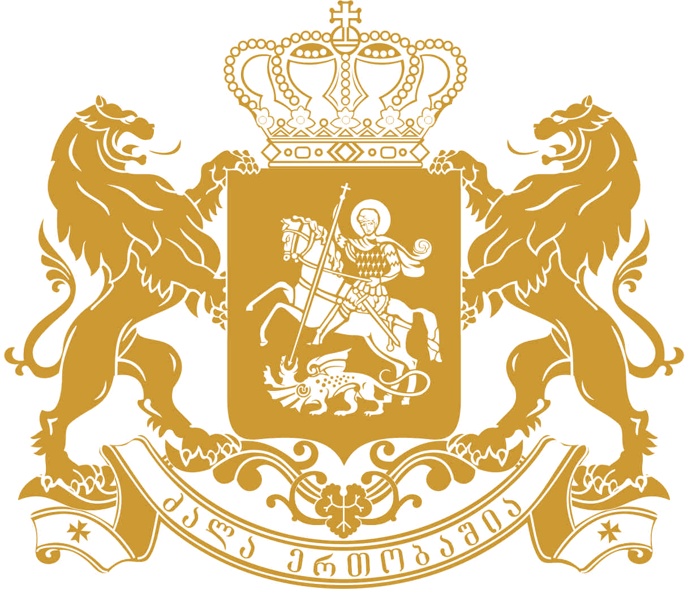
saqarTvelos saxalxo damcveli
Public Defender of Georgia
Written Contribution to the Office of the High Commissioner for Human Rights

As a Public Defender of Georgia, I have the honor to submit to the Office of the High Commissioner for Human Rights present information in the framework of Human Rights Council Resolution 27/31 on civil society space. In my contribution I would like to underline the role and impediments faced by civil society organizations in the protection of human rights in Georgia’s occupied regions of Abkhazia and South Ossetia.
The Public Defender is particularly concerned with the fact that civil society organizations in occupied regions of Abkhazia and South Ossetia are not viewed as institutions providing added value, civic participation or positive change. Instead they are seen as danger to the political monopoly of de facto authorities, are often labeled as traitors and foreign agents. In April 2014, South Ossetian de facto authorities adopted a law on “Non-profit Organizations” which in line with Russian legislation, stipulates that any organization receiving a foreign funding is a foreign agent. In June 2015, according to the information published in media a lady with an Ossetian ethnic origin, residing in South Ossetia, was recognized as an agent for cooperation with a non- governmental organization “International Alert”.
Criticizing de facto authorities, especially in Gali and Akhalgori regions, where Georgians form a clear majority, is dangerous and might lead to negative consequences. It can be argued that freedom of speech, assembly and association are violated in these regions. Even if some NGOs from occupied regions appeal to the Ombudsman of Georgia on human rights violations or participate in confidence building measures, they do it in private and confidentially, since that they are afraid to be persecuted. Given that civil society organizations are marginalized in occupied territories, they are unable to provide effective human rights protection, awareness raising or open advocacy campaigns.
Hereby, the Office of Public Defender (Ombudsman) of Georgia avails itself of the opportunity to renew to the United Nations High Commissioner for Human Rights assurances of its highest consideration.
Ucha Nanuashvili
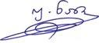
Public Defender of Georgia

http://sputnik-ossetia.ru/South_Ossetia/20150625/247517.html, last checked on 29.06.2015

