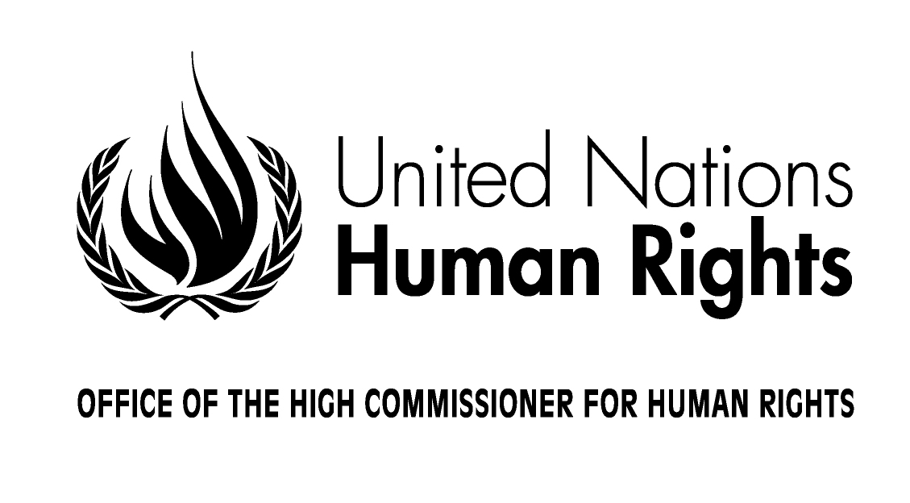
Check against delivery

STATEMENT

by Mr. Gianni Magazzeni

Chief, Americas, Europe and Central Asia Branch
Field Operations and Technical Cooperation Division
UN OHCHR

Workshop of regional and sub-regional courts on enhancing cooperation between regional and United Nations mechanisms for the promotion and protection of human rights

Strasbourg France
20-22 October 2014

Hon. President of the European Court of Human Rights;
Distinguished Representatives of the Council of Europe;
Hon Judges of regional, sub-regional and national courts;
Distinguished Members of UN and regional human rights mechanisms;
Representatives of permanent missions, members of national human rights institutions, representatives of the civil society, delegates, colleagues, ladies and gentlemen,

It is a great pleasure to welcome you to the First Workshop of Regional and Sub Regional Courts.
Over the years, regional and sub-regional courts have provided the necessary link between the global UN human rights system and state domestic institutions, which have the main responsibility to promote and protect human rights. This meeting is very timely given the human rights challenges confronting the world today, ranging from religious and political intolerance, to issues arising from refugees, migrants and asylum seekers, violence against women and girls, threats to human rights defenders, freedom of speech and assembly, and violations of the right to food, to health, or to social security. It is a unique opportunity for our organizations to take forward the complementary synergy between global, regional and sub-regional mandates and strengthen the effective monitoring, implementation and enforcement of human rights.
In this respect, I would like to express our warm appreciation to the President of the European Court and his staff for agreeing to host the meeting here in Strasbourg.
Ladies and gentlemen,
The human rights landscape has changed vastly since the beginning of the United Nations, 70 years ago. States commenced this journey by freely submitting themselves to binding rules, which established the necessary normative framework for the protection also of vulnerable individuals and groups. Treaties were adopted, detailing universal norms, with implementation systems including regular, independent review or monitoring of every State Party. Some even provided for the right to individual complaints by ordinary people – who now, for the first time, had formal access to remedy beyond their own borders. Each of these additions to the great body of international law bound our global community closer together.
Just like the UN Charter, the European Convention on Human Rights was constructed following the tragic experience of the Second World War. The strength of the Convention, unique at its time, was that it set up machinery to monitor its implementation, in the shape of the European Court and the Commission of Human Rights. Some of the changes arising from European Court rulings include stronger protection against child abuse; enhanced rights of people with disability; better care for the elderly; broader sexual orientation rights, and the abolition of corporal punishment in schools. The European Court went on to become a permanent court, among the most internationally respected tribunals of modern times and its jurisdiction stretches today from Iceland to Turkey; it has been the model for regional human rights courts in Latin America and Africa, and more recently the emerging systems in Asia and the Arab states.
Although each regional court has its own particular characteristics, each began as the global human rights system was developing and was inspired by universal norms contained in the Universal Declaration for Human Rights and the international human rights treaties. Regional courts have served as both institutional and normative building blocks for the realization of human rights.
Today the Human Rights Council, through its Universal Periodic Review, scrutinises in detail the human rights records of every one of the 193 members of the UN, in turn, every four and a half years. This tremendous shift in mind-set creates a heightened awareness, and a degree of constant pressure on governments that do not respect legal obligations resulting from ratified treaties.
We believe that ongoing cooperation between international and regional human rights mechanisms is a necessary process to ensure a universal application of human rights norms in a consistent manner at country level. This cooperation results in the dynamic exchange of ideas and good practices, and enhances emerging jurisprudence and human rights implementation.
I am therefore delighted to see here today representatives of mechanisms and institutions from all over the world. I am confident that the diversity of participants’ experiences and expertise will enrich the discussions on how to enhance cooperation between the UN human rights system and regional and sub-regional courts.
Distinguished participants,
The UN Human Rights Council through a number of resolutions, has requested the Office of the United Nations High Commissioner of Human Rights to bring together regional and United Nations human rights mechanisms to exchange views on good practices and lessons learned with a view to enhancing cooperation between them.
A number of continuous activities further enhance cooperation between OHCHR and regional and sub-regional courts. Currently, OHCHR’s Petitions Unit has an exchange program for staff of the European Court so as to learn from each other’s case handling procedures and jurisprudence. We are also in the process of developing a project for capacity building with the African Court on Human and Peoples’ Rights.
I would also highlight the successful cooperative relationship between UN human rights treaty bodies and regional human rights mechanisms. The positive engagement of the Council of Europe, notably its comprehensive reports are a source of valuable complementary information for OHCHR and international human rights mechanisms, with consistent attention to the rights of the most marginalized rights-holders such as Roma, migrants and persons in institutional care. The UN treaty bodies system often refers to court findings in its treaty implementation work. Likewise, the regional Courts continue to refer to the normative function of UN human rights mechanisms (including Treaty Bodies, Special Procedures, and the UPR) when dealing with cases where there is no established case law.
OHCHR actively pursues opportunities to contribute to court proceedings. Recently, a staff member from OHCHR provided expert witness testimony and an amicus brief to the Inter American Court for Human Rights on a case that dealt with the infection of a child with HIV through a blood transfusion in a private medical facility in Ecuador. OHCHR’s expert witness focused on the right to health, emphasising the standards of the Committee on Economic, Social and Cultural Rights, and related developments by the Special Rapporteur on the Right to Health.
Again, in the Inter American Court for Human Rights, a representative of OHCHR’s Regional office for South America testified as an expert witness in a case where there were alleged violations of human rights against five human rights defenders and their families in Colombia. OHCHR’s amicus brief was again instrumental in reaffirming international human rights norms in the case.
Reflecting on these examples, and the many more that will be discussed today, I would invite you to propose innovative ways and initiatives to strengthen strategic cooperation between courts and human rights mechanisms, with a view to greater consistency of human rights jurisprudence, strengthened monitoring and enforcement, and the most effective use of national judicial systems.
Ladies and Gentlemen,
This workshop will have seven interactive panel discussions, four of which will be chaired by judges from regional or sub-regional courts and we encourage you to contribute actively to the discussions. We are very privileged to have the opportunity tomorrow morning to observe a public hearing of a current case before the European Court for Human Rights. A rapporteur from OHCHR will synthesize the key areas of cooperation, challenges and best practices and a report of this meeting will will be included as an annex to the next report of the High Commissioner to the Human Rights Council in 2016.
OHCHR will host the third meeting of focal points on cooperation immediately after the workshop, on 22 October 2015. This meeting will result in a work plan that will follow up on the recommendations of this workshop and previous workshops and develop a concrete road map for cooperation.
Let me conclude, by reiterating that the complementarity between international, regional, and national human rights protection and promotion systems is a great asset. It is through systematic and regular cooperation that we can confront better together the many human rights challenges that we face around the world.
Thank you for your attention.

