Workshop on the impact of unilateral coercive measures
on the enjoyment of human rights

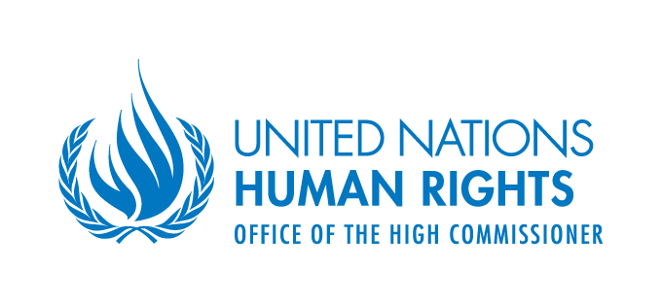

Opening remarks by
Ambassador Idriss Jazairy
Chairperson

Palais des Nations, Room XII
5 April 2013
Excellencies, Distinguished speakers, Honourable Delegates,
It is my privilege to welcome you to this workshop on the impact of unilateral coercive measures on the enjoyment of human rights. It is also a distinct pleasure for me to find myself once again in this auspicious UN building just over a year after I relinquished the post I had for over 7 years in Geneva.
I once had a dream that one day in the new forum of the HRC that I contributed in setting up, the positions of Member states would become aligned on the basis of universal values rather than on the basis of group political interests. As you will have noticed from the pattern of voting for the adoption of resolution 19/32 we are not there yet …
I will endeavour to promote a focussed discussion during our 4 sessions so that we can provide maximum value added to the issue at hand. For this purpose let me unpack the concept of “unilateral coercive measures” in relations to this impact on the enjoyment of human rights. I will ask you to take a stand on 4 issues:
Issue No 1
What do we mean by “unilateral coercive measures”?
- Does “unilateral” only encompass coercive measures applied by a single State to bring about a desired change in the policy of another State? If so only one or two basket cases stand out in terms of adverse human impact.
- Or should the term “unilateral” be interpreted to mean “not concerted within the UN” and include coercive measures resorted to for the same purpose by regional groups without Security Council clearance or WTO mandate? If so, there would be some 15 cases of main concern currently.
- What seems clear, however, is that multilateral coercive measures or counter- measures adopted within the UN system are not included in our mandate.
Issue No 2
Our mandate refers to “coercive measures” rather than to “sanctions”. The UN Charter itself in Article 41 refers to “measures”. Would you agree that “sanctions” imply the value judgment that those who resort to “sanctions” have the authority to do so and that those that are affected by them somehow deserve punishment, be it collective?
Would you therefore infer from the foregoing that” coercive measures” are a more neutral concept that does not prejudge the issue of whether the measures are legitimate or not?
Or would you regard “coercive measures” to be synonymous with “sanctions”? We need to be clear about this.
Issue No 3
In common parlance “coercive measures” are considered to be the sort of half-way house between diplomacy on the one hand and resort to the use of force including war on the other. As there has been some disillusionment of late as to the efficiency of recent wars in achieving the strategic objectives of initiating powers, we are witnessing a trend to resort to a greater extent to coercive measures. This is mitigated to some extent by the occasional lifting of such measures as has also happened happily on two occasions this year.
If you accept the half-way house connotation of “coercive measures” then we need to look at political, economic, financial, social and cultural coercive measures and their impacts on human rights.
If on the other hand you favour a broader and more asymmetrical definition of coercive measures, you may wish to include also threats of the use of force including threats to resort to WMDs. We should be clear therefore which of those two meanings we choose when addressing our mandate.
Issue No. 4
When discussing the impact of coercive measures on the enjoyment of human rights, do we take the measures for granted and address the topic of how to minimize their adverse impact on those rights or should we question the nature of the measures themselves?
Take for example a coercive measure adopted to force a change in the policy of a State seem as violating human rights but which itself by its very nature denies or violates some basic rights pertaining to innocent civilians. Where coercive measures target human rights violations through action equally leading to other human rights violations there seems to be a case for not just mitigating their impact but also for questioning the very nature of such measures. This raises the issue of legitimacy of coercive measures in human rights terms. Legitimacy in this regard may not itself be a once and for all situation. Measures can evolve over time from being legitimate to becoming illegitimate in human rights terms.
Being an evolving human rights situation participants may wish to consider how best to track, evaluate and redress, when appropriate, the adverse human rights impact of coercive measures.
This is a tentative menu of options that may be kept in the back of our minds when addressing our issues today.
Finally as to the way forward, I would invite participants to be specific in formulating practical proposals as to how greater salience can be given in the Human Rights Council to the need to review and assess periodically the nature and impact of coercive measures in human rights terms and to put forward suggestions for redressing the harm done through what the military refer to as “collateral damage”.
I thank you for listening to those more or less methodological comments, and now I give the floor to Ms. Marcia Kran, the Director of The Reasearch and Right to Development Division at the Office of the High Commissioner for Human Rights.

