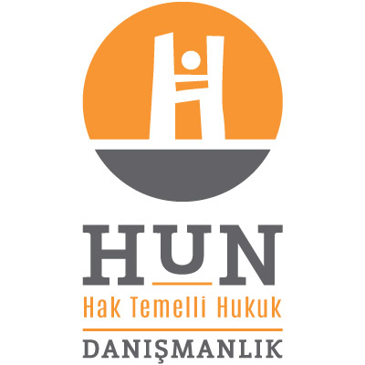 Subject: Written Submission to the UN Human Rights Council on the Situation of Vulnerable and Marginalized groups of Turkey (Roma people, sex workers and transgender people in the transition process) within the context of the article 6 of ICCPR and the fundamental economic, social and cultural rights

Who We Are?: Hun Consultancy is the first human rights law entity providing strategic and legal advice to local and international NGOs in Turkey. We have mainly active in three groups of vulnerable people in Turkey and closely working with relevant NGOs fighting for the rights of these mentioned groups: Sex workers (in collaboration with Red Umbrella Sexual Health and Human Rights Association), transgender people in the transition process (in collaboration with Counselling Center for Transgender People Association) and Roma people (in collaboration with European Roman Rights Center). In this one page written submission, we ground on the field findings we have had through collaborative works we have been conducting with the above mentioned NGOs.
Field Findings:
1-) Roma people: Roma people’s human rights is a relatively new fighting battle area in Turkey right after the State recognition of the problems of Roma people in 2008. After this date, the voice of Roma people within the civil society has scaled up. However, the field findings show that Roma people is the most unemployed ethnic group of Turkey with an unemployment rate going up to 80%. The main dynamic lying behind this high rate is the discrimination against Roma people in social and education life. According to the legal mapping study we have conducted in 12 cities of Turkey in 2015, there are Roma specific classes in all cities wherein the quality of education and fundamental infrastructure are really poor and these realities demotivate Roma children to go to school. The low rate of sustainability in education life leads very low attendance to the universities and directly diminishes access to the competitive job market which means being stuck on a life with very low quality standards. This also causes Romani young people to seek for future in drug cartels as a dealer or in local gangs as a burglar and hence they become a natural target of the police violence which obviously put their life at risk. The other problem is the housing problem which has turned out to be a very critical question recently with the urban transformation decision of the government. Historically, Roma people live in city centers and they perform their daily minor works like selling flowers or collecting waste in centers. However, the urban transformation that actually aims the gentrification of cities drags them from the centers to the periphery of cities. That is why Roma people cannot perform their survival works anymore and the quality of already low life standards worsens
2-) Transgender people in the transition process: Inequality in education life is one of the most important problem of this group of people. The unequal treatment and social and institutional discrimination based on their visibility start as from the elementary school and lead them to stop studying and mostly engage in unregistered and compulsory sex working for that reason. According to Transgender Europe (TGEU) datas, Turkey ranks the first among the Council of Europe countries in trans sex workers murders. The other issues are the problem with the social security and access to health services. According to Turkish law, in order to be legally recognized transgender people have to be sterilized and to get a gender reassignment surgery regardless their will. However, the field findings show us that these operations damage the bodily integrity of trans people since the number of qualified doctors employed in public hospitals is very low and the success of these operations are questionable.
3-) Sex Workers: Sex workers are one of the least visible groups of the contemporary Turkish judicial and political arena. Due to moral barriers, violations targeting sex workers remain hidden and undiscussed. The very first problem in terms of economic rights of sex workers is the barriers before the access to the job market. Unequal treatment causes these groups to engage in unregistered sex work in unsafe places and this jeopardizes their safety at risk and open to any threats. On top of possible threats such as client violence (rape, hijack, injury ect.), unregistered sex workers have to cope with police violence and arbitrary administrative fines that actually force them to more engage in sex work in order to pay these fines.
These are very short but main social and economic problems of these three groups that directly affect their right to life. If you need further information please do not hesitate to contact us

Regards,

Sinem Hun
Owner, Legal Adviser
sinem.hun@hundanismanlik.com
www.hundanismanlik.com
+90-536-674-4732
Twitter: @HunDanismanlik

For more information: www.errc.org
This report is going to be electronically published in July 2015 on www.hundanismanlik.com
For more information: http://tgeu.org/tmm/
For more information: www.t-der.org (in Turkish)

