Submission on General Comment for the Right to Life
to
the United Nations Human Rights Committee

By the Kaleidoscope Human Rights Foundation, with the assistance of DLA Piper

9 June 2015

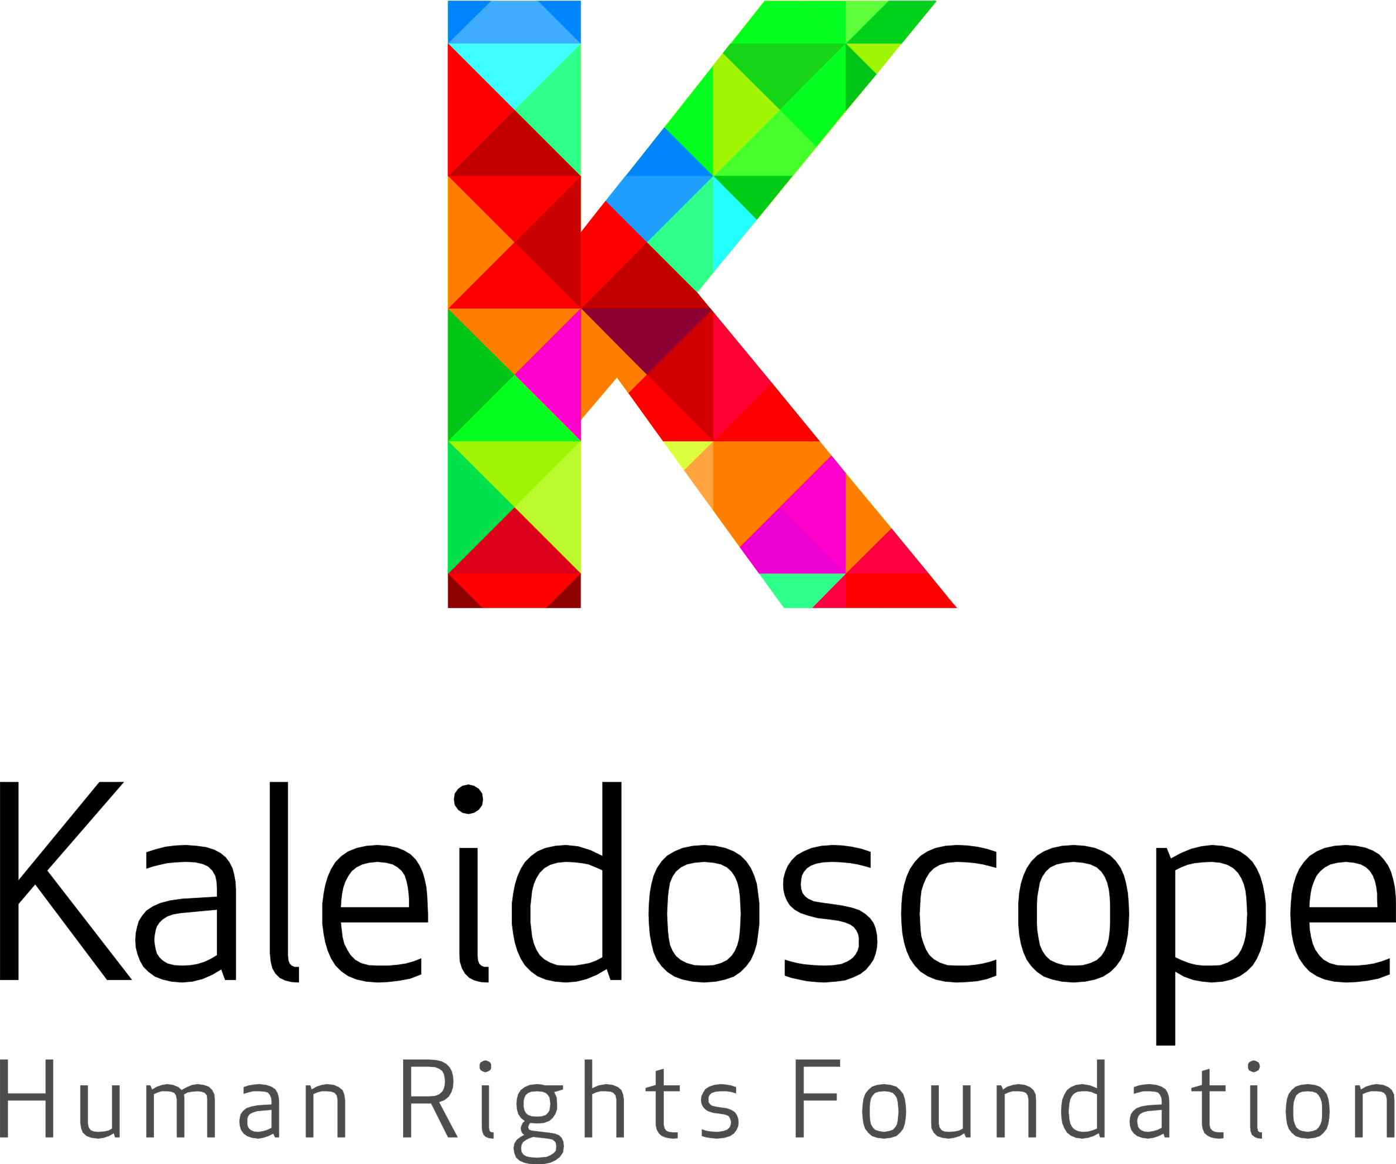

Dr Paula Gerber
President
Kaleidoscope Human Rights Foundation
paula.gerber@monash.edu

Introduction

The Kaleidoscope Human Rights Foundation welcomes the opportunity to provide a written submission for the discussion of Article 6 of the International Covenant on Civil and Political Rights (Covenant).

Kaleidoscope Human Rights Foundation is an NGO that works with local activists to protect and promote the rights of lesbian, gay, bisexual, transgender and intersex (LGBTI) persons in the Asia-Pacific region. Kaleidoscope has prepared this submission with assistance of global law firm DLA Piper International LLP.

We confine our comments to issues regarding the right to life faced by LGBTI persons. All persons enjoy the right to life regardless of their sexual orientation, gender identity or intersex status. However, LGBTI persons’ right to life is often violated, including by:

capital punishment and criminalisation of homosexual conduct;

hate crimes and disappearances;

non-deportation and recognition of asylum seekers; and

failing to prevent death through breaches of socio-economic rights, such as:

equal access to life saving health care;

access to safe and legal trans specific health treatments; and

mental illness and suicide.

capital punishment and criminalisation of homosexual conduct

There are 77 countries that continue to criminalise same-sex sexual conduct between consenting adults. Of these countries, 56 are parties to the Covenant, and 26 have ratified the Optional Protocol.

In a number of states which criminalise same-sex sexual conduct between consenting adults, the death penalty remains an available punishment, while others provide for imprisonment and corporal punishment. The criminalisation of same-sex sexual conduct between consenting adults is, in itself, a breach of Article 6(1), while the imposition of the death penalty is a breach of article 6(2)

Death Penalty

Art 6(2) provides that:

In countries which have not abolished the death penalty, sentence of death may be imposed only for the most serious crimes in accordance with the law in force at the time of the commission of the crime and not contrary to the provisions of the present Covenant and to the Convention on the Prevention and Punishment of the Crime of Genocide. This penalty can only be carried out pursuant to a final judgement rendered by a competent court.

In General Comment No 6 on Art 6, the Committee said:

The Committee is of the opinion that the expression "most serious crimes" must be read restrictively to mean that the death penalty should be a quite exceptional measure.

This statement of principle has been recalled in numerous decisions of the Committee. The Committee has previously expressed that the imposition of the death penalty for a crime that does not produce the death or wounding of any person would violate Art 6(2). Professor Schabas has observed that:

Recent case law of the Committee suggests that its interpretation of 'most serious crimes' is confined to murder, although the possibility that it might cover other crimes of violence with grave consequences, such as aggravated forms of rape, cannot be excluded.

We further refer to the 2007 report by Professor Alston, then UN Special Rapporteur on Extrajudicial, Summary, or Arbitrary Executions, where he notes that homosexual acts 'fall outside the scope of the "most serious crimes" for which the death penalty may be imposed.'

Principle 4 of the Yogyakarta Principles states that the 'Right to Life' requires states to 'repeal all forms of crime that have the purpose or effect of prohibiting homosexual activity and, until such provisions are repealed, never impose the death penalty upon any person convicted under them.'

Despite the above comments and principles, states continue to impose the death penalty for same-sex sexual conduct between consenting adults. The proposed General Comment should make clear that laws which impose the death penalty for such conduct are in breach of Article 6, must be repealed, and all persons imprisoned under such laws released.

Criminalisation of sexual conduct

The case law is currently unclear as to whether or not the criminalisation of homosexual activity itself amounts to a breach of article 6. We would contend that it should. We draw attention to the fact that Principle 4 of the Yogyakarta Principles (above) is not restricted to laws imposing the death penalty, but extends to all forms of crime that prohibit same-sex sexual conduct among consenting adults. Early decisions of courts applying the European Convention of Human Rights ('ECHR') readily found that laws criminalising homosexual behaviour was in breach of the right to life. The reasoning of those courts was that to 'make it an offence is a violation of the right to life, the corollary of which is the right to love' and that 'a person's sexual life is undoubtedly part of his private life of which it constitutes an important aspect'. We also refer to the effect that criminalisation has on other matters concerning life, such acting as a deterrence to seeking out vital treatment for conditions such as HIV AIDS and contributing to stigma and discrimination which may lead to violence, hate crimes and suicide.

It is this criminalisation of an important and inherent part of one's private life which we submit amounts to a breach of that person's right to life. Given the large number of parties who maintain laws criminalising homosexual acts, it is apt for the Committee to comment on the issue. We note that the Indian Supreme Court recently set aside a decision of the Delhi Supreme Court which found that laws criminalising homosexuality violated, amongst other things, the right to life. The direction of this decision is concerning and this is an appropriate opportunity for the Committee to confirm that criminalisation of homosexual acts breaches article 6.

obligation to prevent and investigate killings

The killing of, and violence against, LGBTI persons remains a serious issues across the world.

Homophobic and transphobic violence has been recorded in all regions and includes physical violence such as murder, beatings and kidnapping. Violence may be street based, but also be perpetrated by family and community. Lesbians and transgender women are at particular risk due to gender inequality and power relations. The Special Rapporteur on extrajudicial, summary or arbitrary executions has consistently referred to persons being subjected to death threats or killed on the basis of their gender identity or sexual orientation, as summarised by the Office of the High Commissioner for Human Rights in 2015. According to this report, since 2011 hundreds of people have been killed and thousands more injured in brutal, violent attacks. The Inter-American Commission on Human Rights reported that between 1 January 2013 and 31 March 2014, at least 594 LGBTI persons were killed throughout the Organisation of American States and 176 were the victims of serious injury.

The right to life should not be understood merely as a negative right. In the context of hate crimes, the obligation to protect life extends to the taking of positive measures to promote the deterrence, investigation, and prosecution of hate crimes. The UN General Assembly has urged all states to investigate promptly and thoroughly all killings, including those targeted at specific groups of persons because of their sexual orientation. States must also publically condemn such acts and record statistics on such crimes and the outcomes of any investigations, prosecutions and remedial measures. In Nachova v Bulgaria, the Grand Chamber of the European Court of Human Rights (ECtHR) held that the failure of authorities to investigate whether discrimination played a role in a fatal shooting was in breach of Arts 2 and 14 of the ECHR.

When read in conjunction with the other provisions of the Covenant, especially Arts 2(1) and 26, we submit that the General Comment should make clear that states have a responsibility to deter, investigate and prosecute hate crimes targeting persons on the basis of sexual orientation and gender identity. Failure to do so should be considered a breach of Article 6.

non-deportation obligations

States have an obligation not to extradite a person where there is a real risk that his or her rights under the Covenant will be violated in another jurisdiction. In terms of Article 6, this is not merely restricted to situations where they may face the death penalty, but to any situation where an individual's life may be at risk either from the state or others. As such, where an individual, by virtue of their gender identity or sexual orientation, faces a real possibility of murder or violence by state and/or non-state actors in a particular country, a state has an obligation to ensure they are not returned to that country.

Article 33 of the Refugee Convention provides that States Parties have an obligation not to expel or return a refugee to a place where their life or freedom would be threatened on account of … membership of a particular social group or political opinion. Individuals persecuted on account of their sexual orientation or gender identity are members of a 'particular social group'. State Parties therefore have an obligation not to return such individuals to a state where their lives would be at risk and, provided they meet the criteria for a refugee, recognise them as such. The UN High Commissioner for Human Rights has recognised this obligation as falling under the right to life.

Positive duty to prevent death and socio-economic rights

We draw attention to the Committee's previous comments that the right to life requires State Parties to adopt positive measures to protect against the deprivation of life. The Committee has previously held that this includes addressing socio-economic rights. For example, in General Comment 6, the Committee recognised that states have an obligation to reduce infant mortality and increase life expectancy, especially in adopting measures to eliminate malnutrition and epidemics. The precise scope of this positive obligation, beyond those specific examples, remains unclear and would benefit from clarification in the proposed General Comment. The new General Comment should also reflect the change over time in causes of death and reductions in life expectancy. While infant mortality and malnutrition continue to be of concern, attention should be given to the growing prevalence of other causes of death, such as suicide.

Since General Comment 6 was drafted, the Committee has regularly referred to State Parties’ obligations to prevent deaths which disproportionately affect a particular group of persons, with reference to the non-discrimination obligations in Article 2. Often this has been in relation to maternal mortality and the shorter life expectancy of women and a requirement that states report on measures taken to help women prevent unwanted pregnancies and ensure they do not have to undergo life-threatening clandestine abortions. Obligations where there is a high mortality rate have included ensuring the accessibility of health services and properly trained health workers.

The particular attention drawn to women and maternal mortality is to be commended. However, other vulnerable groups who face high mortality rates, or specific risks to their right to life, should also be referred to in the proposed General Comment, including LGBTI persons.

A number of socio-economic factors negatively influence LGBTI person's enjoyment of the right to life, including:

Inability to access life-saving medical treatment due to stigma and discrimination;

Lack of access to safe, legal surgery for transgender persons; and

High rates of mental illness and suicide.

Access to life saving medical treatment

Research reveals that there are disparities between treatment of the LGBT and non-LGBT population. The difficulties faced in access to health care are particularly exemplified in the treatment of transgender individuals. See, for example, the following stories:

Testimony from transgender individuals indicates that many healthcare professionals routinely refuse to treat even non-transition-related health issues. Robert Eads, for example, a female-to-male transperson with ovarian cancer, visited more than twenty physicians who all refused to treat him because they feared that taking on a transgender patient would harm their practices. Those who are able to access care may find that their insurance plan will not cover treatment for certain illnesses, even if they do not stem from transition. A female-to-male transperson interviewed in 2001, for instance, reported being denied coverage for uterine cancer by his insurance company because the insurer did not "treat uteruses in men." Common health problems that receive routine treatment in other contexts may not receive adequate attention when the patient is transgendered.

In Erikson v Italy, the ECtHR pointed out that the right to life imposed positive obligations requiring hospitals to protect their patients' lives. As the ECtHR said in Nitecki v Poland: 'It cannot be excluded that the acts and omissions of the authorities in the field of health care policy may in certain circumstances engage their responsibility under Article 2 [right to life].'

Safe and legal access to hormone and surgical treatment for trans persons.

Where necessary medical treatments and surgery are not readily and legally available, individuals are often forced to utilise more clandestine treatments, often at serious risk to their life and health. Anecdotal evidence indicates that individuals will often resort to unregulated and unsafe alternatives, in some cases resulting in death.

The Committee has, on a number of occasions, noted the failure to provide safe and legal health services can amount to a breach of the right to life, particularly where individuals are forced to utilise clandestine, unsafe services. The Committee has, in such situations, recommended ensuring access to health care services, treatments and education. We recommend that the proposed General Comment make it clear that in order to protect the right to life, necessary medical treatments and surgery for trans persons must be available and accessible.

Mental illness and suicide

LGBTI persons globally experience substantially higher rates of mental illness and suicide attempts than heterosexual and cis-gendered persons. A number of studies have revealed that same-sex attracted people are twice as likely to attempt suicide than heterosexual individuals and the lifetime relative risk of suicide attempts for gay and bisexual men is over four times that of heterosexual people. For example, in Australia, LGBT persons have the highest rate of suicidality of any population in Australia. Same-sex attracted Australians attempt suicide at a rate 14 times than their heterosexual peers, and up to 50% of trans people have actually attempted suicide at least once in their lives. In the UK, a study reported that 84% of trans participants had thought about ending their life at some point. Risk factors for suicidal behaviour specific to LGB individuals include prejudice and discrimination, particularly homophobia. Victimised and bullied LGB school students are 2.5 times more likely to engage in self-harm, while feeling safe at school and having supportive teachers and staff are seen as protective factors.

We note that the Committee has previously expressed concern regarding the high number of suicides of young women in Ecuador, relating to the prohibition of abortion. The Committee has held that such a situation was incompatible with the right to life and recommended that Ecuador assist young women obtain access to adequate health and education facilities.

The proposed General Comment should make clear that the state has an obligation to address the causes of mental illness and suicide among LGBTI persons, to ensure access to treatment and to adequately trained health professionals.

obligation to address factors leading to a breach of the right to life

On a more general level, we urge the Committee to make it clear in the proposed General Comment, that States Parties have an obligation to address the root social and legal factors which are known to lead to a deprivation of life, including discrimination, stigma and hatred. We note that the special rapporteur on extrajudicial, summary or arbitrary executions has called on states to address the social root causes of violence and recognises that, for example, criminalisation leads to social stigmatisation and makes people 'more vulnerable to violence and human rights abuses, including death threats and violations of the right to life, which are often committed in a culture of impunity.' Discrimination and stigma too can lead to higher rates of depression and suicide as described above.

As noted by the Committee in General Comment 6, the right to life should not be construed narrowly. The ability to enjoy the right to life is dependent upon a wide range of factors and a state is under an obligation to take steps to reduce mortality rates. In particular, where minority groups, such as LGBTI persons, enjoy the right to life on an unequal basis with others, and where the factors behind such inequality are known, the state has a clear obligation to take positive steps to ensure equal enjoyment of the right to life.

Conclusion
The Committee does not have a history of including issues pertaining to LGBTIQ people in its General Comments. Of the 35 General Comments it has published to date, only the most recent one on Article 9 (Liberty and security of person), made and reference to LGBT persons. This is in stark contrast with other treaty committees, which regularly include reference to LGBT persons in their General Comments, as illustrated in the figure below.
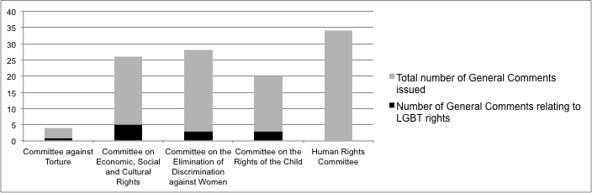
We encourage the Committee to make explicit reference to the right to life of LGBTIQ persons in the proposed General Comment, as outlined in this submission. This would be a valuable addition to its first coverage of such issues in General Comment 35.

Countries that still criminalise homosexuality <http://antigaylaws.org/all-countries-alphabetical> (Accessed 2 June 2015).
For example, Art 110 of the Islamic Penal Code of Iran of 1991 prescribes the penalty for sodomy, defined as sexual intercourse with a male, as death. Iran ratified the Covenant on 24 June 1975.
Human Rights Committee, General Comment No. 6: Article 6 (Right to Life), 16th sess (30 April 1982) [7].
See for example, Human Rights Committee, Views: Communication No 1132/2002, 85th sess, UN Doc CCPR/C/85/D/1132/2002 (18 October 2005) [7.4] ('Chisanga v Zambia'); CCPR/C/MRT/CO/1, para. 8; A/HRC/26/30/Add.3, para. 88.
Human Rights Committee, Views: Communication No 390/1990, 55th sess, UN Doc CCPR/C/55/D/390/1990/Rev.1 (31 October 1995) [7.2] ('Lubuto v Zambia').
William Schabas, The Abolition of the Death Penalty in International Law (Cambridge University Press, 2002) 110.
Philip Alston, Report of the Special Rapporteur on extrajudicial, summary or arbitrary executions, UN Doc A/HRC/4/20 (29 January 2007) [51]; citing Human Rights Committee, Consideration of Reports Submitted by States Parties Under Article 40 of the Covenant, 61st sess, UN Doc CCPR/C/79/Add.85 (19 November 1997) [8].
International Commission of Jurists (ICJ), Yogyakarta Principles - Principles on the application of international human rights law in relation to sexual orientation and gender identity, March 2007
Michele Grigolo, 'Sexualities and the ECHR: Introducing the Universal Sexual Legal Subject' (2003) 14 European Journal of International Law 1023, 1029.
Michele Grigolo, 'Sexualities and the ECHR: Introducing the Universal Sexual Legal Subject' (2003) 14 European Journal of International Law 1023, 1029.
Special Rapporteur on extrajudicial executions A/57/138 at [37]; Michael Kirby and Michael Wong, 'Decriminalisation integral to the fight against HIV', ABC (13 July 2012) http://www.abc.net.au/news/2012-07-13/kirby-and-wong---hiv-law/4128420;
Andrew Buncombe, 'India's gay community scrambling after court decision recriminalises homosexuality', The Independent (3 June 2015) <http://www.independent.co.uk/news/world/asia/indias-gay-community-scrambling-after-court-decision-recriminalises-homosexuality-9146244.html>.
Office of the High Commissioner for Human Rights Discrimination and violence against individuals based on their sexual orientation and gender identity A/HRC/29/23 May 2015
Office of the High Commissioner for Human Rights Discrimination and violence against individuals based on their sexual orientation and gender identity A/HRC/29/23 May 2015
UN General Assembly Resolution 65/208
Office of the High Commissioner for Human Rights Discriminatory laws and practices and acts of violence against individuals based on their sexual orientation and gender identity A/HRC/19/41 November 2011; See CCPR/C/KGZ/CO/2, para. 9, A/HRC/20/22/Add.2, paras. 5, 55, 76, CCPR/C/MWI/CO/1/Add.1, para. 10.
Nachova v Bulgaria (European Court of Human Rights, Grand Chamber, Application Nos 43577/98 & 43579/98, 6 July 2005) [162]-[168].
Kindler v Canada UNHRC 470/91
Warsame v Canada UNHRC 1959/10; Office of the High Commissioner for Human Rights Discriminatory laws and practices and acts of violence against individuals based on their sexual orientation and gender identity A/HRC/19/41 at [12]
UNHCR, Guidance Note on Refugee Claims Relating to Sexual Orientation and Gender Identity, November 2008
Office of the High Commissioner for Human Rights Discriminatory laws and practices and acts of violence against individuals based on their sexual orientation and gender identity A/HRC/19/41 November 2011
Human Rights Committee, General Comment No. 6: Article 6 (Right to Life), 16th sess (30 April 1982).
Human Rights Committee, General Comment No. 6: Article 6 (Right to Life), 16th sess (30 April 1982).
Concluding observations of the Human Rights Committee: Nepal, Concluding Observations/Comments, at 8, 12-19 UN Doc 10/19/94, CCPR/79/Add42 (1994)
General Comment No 28: Equality of rights between men and women (article 3) CCPR/C/21/Rev.1/Add.10 para 10.
UN Human Rights Committee Concluding Observations: Mali UN Doc CCPR/CO/77/MLI (2003)
Australian Human Rights Commission, Stories of discrimination (October 2007) <https://www.humanrights.gov.au/publications/stories-discrimination> [4].
J Lapinski, P Sexton and L Baker, 'Acceptance of lesbian, gay, bisexual, and transgender patients, attitudes about their treatment, and related medical knowledge among osteopathic medical students' (2014) 114(10) Journal of the American Osteopath Association 788.
Liza Khan, 'Transgender Health at the Crossroads: Legal Norms, Insurance Markets, and the Threat of Healthcare Reform' (2011) 11(2) Yale Journal of health Policy, Law, and Ethics 375, 381.
Nitecki v Poland, Decision as to admissibility (European Court of Human Rights, Chamber, Application No 65653/01, 21 March 2002) [1].
See for example in Vietnam: Being LGBT in Asia: Viet Nam Country Report (UNDP, USAID, 2014) 6.
UN Human Rights Committee Concluding Observations: Argentina CCPR/C/ARG/CO/4 (2010)
Skerrett, DM. Kõlves, K & De Leo, D (2012) 'Suicidal behaviours in LGB populations: A literature review of research trends. Brisbane, Australia: Australian Institute for Suicide Research and Prevention.
Commonwealth Department of Health and Aged Care (2000) Life - A framework for prevention of suicide and self-harm in Australia: Learnings about suicide.
Quoted in National LGBTI Health Alliance LGBTI People: Mental Health & Suicide Briefing Paper (2013) https://www.beyondblue.org.au/docs/default-source/default-document-library/bw0258-lgbti-mental-health-and-suicide-2013-2nd-edition.pdf?sfvrsn=2
McNeil J, et al. (2012) Trans Mental Health Study 2012. Scottish Transgender Alliance. Edinburgh.
Skerrett, DM. Kõlves, K & De Leo, D (2012) 'Suicidal behaviours in LGB populations: A literature review of research trends. Brisbane, Australia: Australian Institute for Suicide Research and Prevention.
UN Human Rights Committee Concluding Observations: Ecuador (1998) CCPR/C/79/Add.92
Special Rapporteur on Extrajudicial, Summary or Arbitrary Executions Mission to Mexico 28 April 2014
Special Rapporteur on Extrajudicial, Summary or Arbitrary Executions A/57/138 [37]
This figure is taken from Paula Gerber and Joel Gory ‘The UN Human Rights Committee and LGBT Rights: What is it doing? What could it be doing?’ (2014) 14 (3) Human Rights Law Review 403. It pre-dates the publication of General Comment 35 by the Committee, which is why it was not included in the statistics on which this figure was based.

