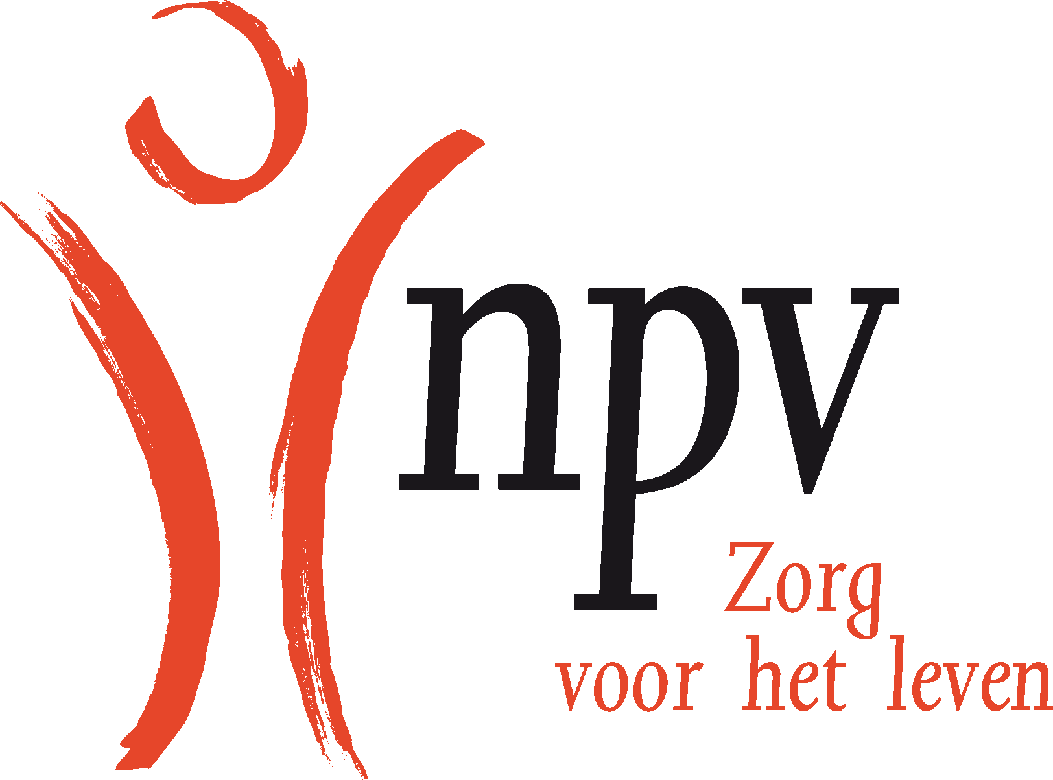
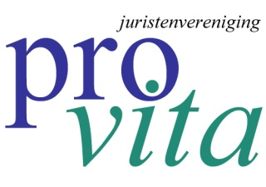

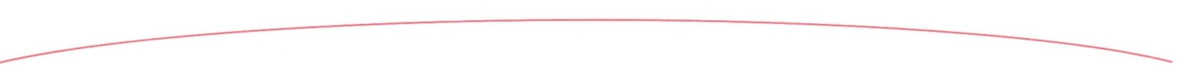
United Nations Human Rights Committee
Palais des Nations,
1211 Geneva 10, Switzerland

June 12, 2015

RE: Half Day of General Discussion on Article 6

Dear Sir, Madam,

The Dutch Patients Association (NPV) and the Legal Foundation Pro Vita (JPV) thank you very kindly for the opportunity to provide a written submission for the discussion on Article 6 of the International Covenant on Civil and Political Rights (further: Covenant).

The Nederlandse Patiëntenvereniging (NPV) (The Dutch Patients Association) (www.npvzorg.nl) is a Christian, pro-life organization with 58.000 members. We reject the practice of euthanasia. We believe God is the Creator of life. The NPV is not affiliated with a particular church. All churches are represented, Protestant (reformed/evangelical), Roman Catholic, some Jewish and single members without any church background.

The Dutch Juristenvereniging ProVita JPV (Legal Foundation Pro Vita) claims respect for the human dignity of every human being. The invulnerability of human life from earliest conception till natural death is the main commitment of our foundation. We focus on the legal protection of human life at all stages using either existing national and international laws to do so or in striving to change national or international laws to guarantee that protection.

Our vision is that every citizen can live free from the threat of euthanasia, assisted suicide and abortion, regardless of age, ethnicity, disability, health, or financial or social position.

Aims
- We oppose to the legalization of euthanasia and assisted suicide and abortion.
- We promote the best care and support for unborn babies and their mothers and vulnerable people who are sick, elderly, mentally ill or disabled.
- We support people to find meaning, purpose and hope in the face of suffering and despair.

Euthanasia
We would like to give you a brief overview on the development of the Dutch euthanasia situation.
Christian faith and moral (fundamental in Dutch history) have become contradictory to the euthanasia law. The Netherlands as a Christian nation has suffered from secularisation and demoralization for decades, which eventually has led to a public discussion about dying. The nineteen sixties and seventies were characterized by negotiation and discussion about a lot of ethical topics. In discussion, the individual choice was a very important criterion. Christian norms and were eventually replaced by the right to an individual choice.

The Netherlands was the first country where a law on euthanasia went into force.
The way Dutch citizens think and speak about “suffering” has changed significantly in the last decades. A little - but defining - elite started this discussion. In 1973 a Dutch physician, Ms. Postma, gave her mother a mortal injection. She was condemned by court to a week of imprisonment. This case initiated a new movement the NVVE (Nederlandse Vereniging voor een Vrijwillig Levenseinde), an association in support of death by choice. In 1984, the first bill concerning a euthanasia was presented by Ms. E. Wessel-Tuinstra (a politician of the party D66). The euthanasia law went into force on 1 April 2002. From this time, there is an increasing number of reported cases of euthanasia to the five regional euthanasia review committees. These committees review the practice of euthanasia after a patient’s death.

Line Chart reported cases in the Netherlands

Aantal euthanasiemeldingen in Nederland (bron: jaarverslagen Rte)

1998 349
1999 2.216
2000 2.123
2001 2.054
2002 1.882
2003 1.815
2004 1.886
2005 1.933
2006 1.923
2007 2.120
2008 2.331
2009 2.636
2010 3.136
2011 3.695 → increase of 18% compared to 2010
2012 4.188 → increase of 13% compared to 2011
2013 4.829 → increase of 15% compared to 2012

At the moment 3% of all deaths in the Netherlands are caused by euthanasia as reported to the committees.

There are a lot of indistinct cases, we believe are caused by a physician’s fear of a condemnation by court. On the other hand there is an increase in abuse of ‘terminal sedation’, a way of alleviation of pain when people are in their last phase of life whilst no cure is possible in that stage. The NPV for instance, calls this ‘het grijze gebied’, the grey area. We firmly request our government for an official inquiry to clarify these cases.

The character of the euthanasia requests has slightly changed in the last thirty years according to researchers of NIVEL (Nederlands instituut voor onderzoek van de gezondheidszorg) as presented in January 2012. In the seventies of the last century the most important reason for euthanasia was pain. Today loss of dignity and the meaning of life are also important reasons for a requests.

End-of-life clinic or Mobile Service Life Unit
An End –of-life clinic has opened its doors approximately a year ago. There is no medical relation between doctor and patient in these so called clinics. Our objection is that these ‘mobile doctors’ don ‘t focus on the entire medical or social problems of their particular patients as a whole. There is no focus on basic problems that lead to the patients demand to die or to seek for possible alternative solutions. Furthermore not enough time is taken to explore alternatives. Research shows that 10% of the euthanasia requests are withdrawn when qualitative healthcare is offered. The End-of-life clinic is simply a tool for patients with a death wish outside the standard medical procedures.
This development is contradictive to the development of palliative care in the Netherlands. How well-developed is palliative care in the Netherlands? What is the percentage of terminally ill patients (roughly) who have access to palliative care? How much effort is taken by the government to increase the number of palliative care facilities and to improve the specific training of medical professionals? A thorough research on the above mentioned questions ‘s would have been better instead of the creation of mobile clinics of death.
The attention for palliative care has increased since 1990. However good research on the possibilities of palliative care has never been done, but according to the ‘common sense’ theory in the Netherlands there is a decreasing demand for euthanasia during good palliative care. The government is stimulating palliative care and both people pro and contra euthanasia are convinced that palliative care is really necessary.

Citizen initiative “Out of free will”
In our country, there has been a citizens' initiative called Out of Free Will. We think this initiative is a clear example of the fact that the Netherlands are on a so-called ‘slippery slope’:
- The annual increase of euthanasia cases in relation to declining mortality rates of the population in the Netherlands (see the statistics above)
- Euthanasia on elderly, demented people, when they are no longer mentally competent.
- Euthanasia on Psychiatric patients.
- Government research on further liberalization on Euthanasia.

In the Netherlands the discussion about ‘completed life’ (“voltooid leven”) has started in 2010. According to this citizens’ initiative that was supported by 116,000 signatures, it should be possible for elderly people who are 70+ of age (but not ill!) to ask a ‘councelor’ to die. They ask for legalization by law. This initiative has been under research by the Dutch government but at the moment there is not enough consensus on several questions like:
-the number of citizens who are in favor,
-the comparison between this group of people in relation to the total population of sick elderly people,
-how to organize this in a careful way,
-but also, if this is the right ‘health care’ solution for elderly people at all. All of our citizens should be involved in such an important issue.

The NPV and the JPV consider that the main question is not: ‘How can we help people to die?’ but: ‘How can we help people to live?’

The NPV has a ‘declaration of intent’ (de NPV-Levenswensverklaring)
The NPV-Levenswensverklaring is a declaration of somebody’s last will in which people can indicate how they want to be taken care of in their final stage of life. People can elaborate on the medical and nursing care they would like to receive in the final period of their lives when they are incapable of pronouncing thus.

Topics that are mentioned in this declaration are:
- I want optimal medical cure and care, with the intention of healing.
- When healing is not possible, I want optimal care and concentration on welfare and relief of suffering.
- I do not want others to judge about my ‘quality of life’ and I want treatments which are proportional (with the purpose to improve my situation).
- Euthanasia is no option to alleviate my suffering.
- When I am dying, I do not want to receive treatments to lengthen my life.
- The physician has to communicate openly and honestly with my relatives or representative.

It is necessary to organize other interventions to prevent euthanasia.
Most people mention unbearable pain and suffering (as seen by relatives) as a reason for euthanasia. However, people are not aware of the increased opportunities in pain control of the last decennia. In the opinion of Dutch anesthesiologist Ben Crul, a pioneer in the field of pain management and palliative care, euthanasia is unnecessary for most people with a terminal illness with the current progress of pain management and palliative care. This view is expressed by many doctors in the Netherlands. Ben Crul is a respected emeritus professor of pain management at Radboud University in Nijmegen. He has dedicated his life to the improvement of palliative care. It is necessary to invest in palliative care. Even former health-care minister Els Borst (she was responsible for the introduction of the euthanasia law) admitted that ‘the law on euthanasia was introduced too quickly’ at the time.

At the moment, the most actual discussion concerns psychiatric patients and patients suffering from dementia. In 2013, the End-of-life clinic in the Netherlands, for patients with a death wish, has put nine psychiatric patients to death. These were all people of sound body. In total, 42 psychiatric patients, died by euthanasia in 2013.

Right to life
What is the meaning of “human dignity”, “mercifulness”, “solidarity” in relation to the right to life in our days?
The right to life is one of the most fundamental rights of man as anchored in several treaties like in Article 2 of the Convention for the Protection of Human Rights and Fundamental Freedoms (further: the Convention) but also in Article 6 of the Covenant. The right to life obligates a state to protect the human life of all men within the state ‘s jurisdiction. This also implies that governments are obligated to protect the invulnerability of the human body.
Does the right to life also implies a right to die? In the case of Pretty vs. United Kingdom ((2346/02) [2002] ECHR 423 (29 April 2002) the European Court of Human Rights ruled that Article 2 of the Convention does not imply a right to die. According to the Court, Article 2 has no negative dimension but only a positive obligation for governments to protect life.

According to the Court there is no link between the protection of life and the quality of life or what individual chooses to do with their life. Thus the Article 2 does not imply a right to self-determination of life. However the Convention grants member states a wide margin as how to deal with the right to life.
Conclusion: the Court constitutes no right to end life as far as the Convention is concerned but grants states a wide ‘margin of appreciation’ in relation to their national laws on assisted suicide.

Human dignity
The Court determines “human dignity” as the “very essence of the Convention”. Thanks to a reference in the Treaty of Lisbon (2009) the Charter of Fundamental Rights of the European Union is part of current law. Article 1 of the Treaty determines the immunity of human dignity and the obligation to uphold and protect this dignity.

Self-determination
It is important to know that at the time of the realization of the law on euthanasia in the Netherlands, the right of self-determination was an accessory issue. The law basically puts the physician in a unilateral position regarding the decision on euthanasia. According to recent
research most physicians are not very willing to help patients with a demand for assisted suicide who experience their lives complete and fulfilled. This is something to reflect on.

Relevant statements on abortion.
Since 1981 there is a law on abortion in the Netherlands. In 2015 one out of six pregnancies ended in abortion. One out of four Dutch women have undertaken an abortion in their lives. In the year 2013, 30.601 lives ended in abortion.

Reflections on abortion:

- Existing fetal homicide laws make a man guilty of manslaughter if he kills the baby in a mother’s womb (except in the case of abortion).

- Fetal surgery is performed on babies in the womb to save them while another child the same age is being legally destroyed.

- Babies can sometimes survive on their own at 23 or 24 weeks, but abortion is legal beyond this limit.

- Living on its own is not the criterion of human personhood,as we know from the use of respirators and dialysis.

- Size is irrelevant to human personhood, as we know from the difference between a one-week-old and a six-year-old.

- Developed reasoning powers are not the criterion of personhood, as we know from the capacities of threemonth-old babies.

- Infants in the womb are human beings scientifically by virtue of their genetic makeup.

- Ultrasound has given a stunning window on the womb that shows the unborn at eight weeks sucking his thumb, recoiling from pricking, responding to sound. All the organs are present, the brain is functioning, the heart is pumping, the liver is making blood cells, the kidneys are cleaning fluids, and there is a fingerprint. Virtually all abortions happen later than this date.

- Justice dictates that when two legitimate rights conflict, the limitation of rights that does the least harm is the most just. Bearing a child for adoption does less harm than killing him.

- Justice dictates that when either of two people must be inconvenienced or hurt to alleviate their united predicament, the one who bore the greater responsibility for the predicament should bear more of the inconvenience or hurt to alleviate it.

- Justice dictates that a person may not coerce harm on another person by threatening voluntary harm on themselves.

- The outcast and the disadvantaged and exploited are to be cared for in a special way, especially those with no voice of their own.

- What is happening in the womb is the unique personnurturing work of God, who alone has the right to give and take life.

- There are countless clinics that offer life and hope to both mother and child (and father and parents), with care of every kind, lovingly provided by people who will meet every need they can.

Final conclusion
The right to life is a fundamental right. We call on you never to relativize this right and ask you continually to speak out strongly and clearly for the right to life from conception to natural death.
Thank you very much.

Yours sincerely,

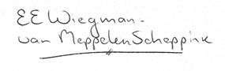

Namens de Juristenvereniging Pro Vita Namens de NPV
Mw. mr. M.D. Klaasse-Carpentier, voorzitter Mw. drs. E.E. Wiegman-van Meppelen Scheppink, directeur
secretariaat@provita.nl ewiegman@npvzorg.nl

