Your turn To Drive:
Roadway Safety as a Stark Example of the Link between
The Right to Life and Health and Survival of Civil Society
By Dr. ilise L Feitshans JD and ScM and DIR
hhealthwork@aol.com 917 239 9960

Executive Director, The Work Health and Survival Proejct
Former Chair of the Transportation SubCommittee for the USA NIOSH NORA (National Occupational Health Research Agenda) for Wholesale, Retail and Transportation (WRT)
Author, BRINGING HEALTH TO WORK (Emalyn Press 1997) and
DESIGNING AN EFFECTIVE OSHA COMPLIANCE PROGRAM Westlaw.com
Former Scholar in Law of Health, Institute for Health at Work (IST) University of Lausanne, and Former Coordinatrice, UN ILO Encyclopaedia of Occupational Health and Safety

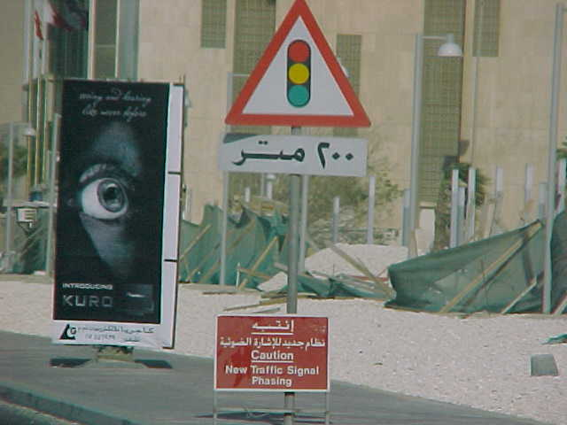
No one can avoid cars or roads, everyone is a consumer of this benefit of modern life, whether they leave their residence or not. There is no country without roads, there are few places without busses, trucks or cars, and the problems they raise literally cut across geography, jurisdiction and international borders, with common human needs at the bottom of solving these problems. Therefore Roadway safety is an occupational safety and health problem and also a cross-cutting social problem, which provides a great example of how best practices at work can lead safety and health protections for society as a whole around the world. According to the US Centers for Diseases Control and Prevention (CDC) in 1999 ,°Motor Vehicle Safety ranks number two in the top ten-hits list of “Ten Great Public Health Achievements” of the twentieth century, outdone only by control of infectious diseases. From 1925 through 1997 the number of drivers increased sixfold and the number of motor vehicles elevenfold. The number of miles travelled in motor vehicles annually increased tenfold to more than 2.5 trillion.. During the past 100 years, more than 2.8 million persons have died and nearly 100 million persons have been injured on US roads and highways. By early 21st century, motor vehicles accounted for more than 90% of all transportation related deaths in the United States. Effective public health measures included an admixture of research, application of research to practice, new legal requirements for crashworthiness of vehicles and diligent enforcement, °the number of deaths for every 100 million vehicle miles travelled fell by 90% from 1925 (17 per 100 million) to 1997 (1.7 per 100 million). Deaths per 10thousand registered vehicles declined by 94% despite the exponential increase in the number of vehicles registered, miles travelled and the number of drivers on the roads. Yet, motor vehicle deaths account for approximately 43,000 deaths annually in the United States. In less developed nations, risk taking is reportedly increased. Road signs are one of the best examples of the international need for harmonization of safety symbols, and therefore of course provide a natural bridge across multi lingual constituencies. Also, there is the universally shared problem that teenagers, inexperienced drivers, see all types of violence and stunts in cars, in movies videos and on TV without any harm occurring, and therefore lack a real-world grasp of the dangers on the roadways. Combined with the innate teenage desire for risk, our faltering global economy pays for an untold disease burden from roadway injuries, accidents and deaths. Anything that can reduce this global disease burden accomplishes a world of good. Thus, practical steps for outreach and risk avoidance communication to workers and the general public, can employ the vital of the lifeline between work and health to preserve civil society.
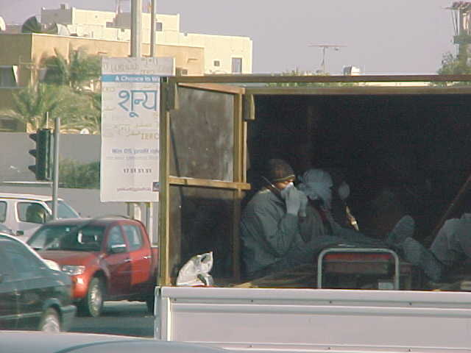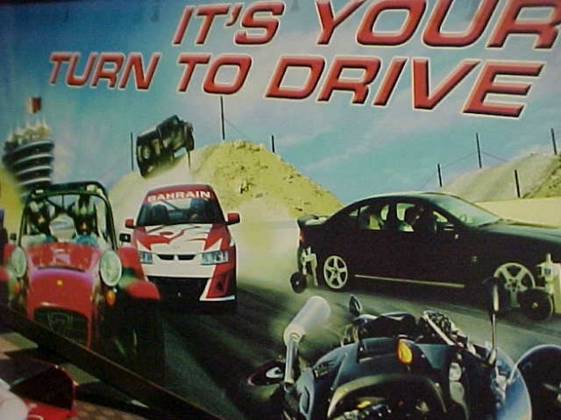
Protecting Workers on Roadways requires a societal effort, yet it makes good sense.The actual danger from automobile or vehicle deaths per millions of miles traveled has been reduced so much since the start of the use of cars in the twentieth century, that this achievement has been viewed as one of the ten top public health advances of the twentieth century, even though paradoxically, more cars ont he road and more roads means more deaths. This means that use of the roadways could be safe if we took greater care. But there are exponentially many more cars on miles and miles more roads, so there are plenty more opportunities for unintended harm. Every accident avoided protects the right to Life and represents less economic waste.
A Global Action Plan (http://www.who.int/roadsafety/decade_of_action/plan/en/index.html) includes a strategy that takes into account several painful realities:
Þ Nearly 1.3 million people are killed on the world's roads each year.
Þ Up to 50 million people are injured, and many remain disabled for life.
Þ 90% of casualties from road deaths occur in developing countries.
Þ Annual road traffic deaths are forecast to rise to 1.9 million people by 2020.
Þ Road traffic injuries are the number one cause of death for young people worldwide.
Þ The economic cost to developing countries for motor vehicle accidents is estimated to be at least $100 billion a year.
Þ Road traffic injuries place an immense burden on hospitals and health systems generally.
Þ Road crashes are preventable.

II. Work, Health and Survival: The Inextricable Link for Defending the right to Life
Sound health programs that implement best strategies are the grease for the machinery of powerful economic engines . Health programs help employers survive because accidents and disease are not simply expensive but wasteful. We cannot afford waste in this economy. The fat to be trimmed, however is not the same as the grease for the wheels and machinery that makes smooth commerce, and confusion about the role of regulation as a tool of governance makes the task of promoting occupational health much harder than it should be. Work health and survival have been inextricably linked throughout the history of human civilizations. Without work, society cannot survive, and no work can perpetuate society without health. No society has survived without producing things; without work, and to produce those things, people need health and the protection of the Right to Life.

As summarized in the Law in Public Health Practice Second Edition Richard Goodman Ed, Richard E Hoffman, Wilfredo Lopez, Gene W Matthews, et al Editors, Oxford University Press 2007 p 9)

