Submission on General comment No. 37 on article 21 of the International Covenant on Civil and Political Rights.
INTRODUCTION
African Policing Civilian Oversight Forum (APCOF) welcomes the opportunity to present this submission on the United Nations Human Rights Committee’s draft general comment No. 37 on article 21 of the International Covenant on Civil and Political Rights.
From the outset, APCOF would like to emphasize its endorsement of the draft general comment. The right of peaceful assembly is an essential condition for the exercise of other fundamental human rights. As such, the draft general comment offers an important opportunity for Human Rights Committee to articulate standards that underlie the right of peaceful assembly.
OBSERVATIONS
While we convey our support for the draft general comment, we would like to make the following observations, which we believe can contribute to strengthening the wording and contents of the general comment.
Firstly, paragraph 98 requires authorities to ensure the existence of adequate medical facilities, where officials are prepared to use force or where the eruption of violence is envisaged. While we commend the inclusion of the requirement to provide medical facilities, we think this paragraph can be expanded to also cover the provision of first-aid services to individuals injured during the assembly.
Secondly, paragraph 104 envisions the deployment of commercial security companies to police assemblies and prescribe that states take responsibility for their actions. We acknowledge that it might be difficult to completely disbar the use of private security companies to police assemblies. However, we believe this paragraph can be prefaced by stating that as a general rule, the general comment discourages the use of non-state actors to police assemblies. Our concerns relate to, inter alia, the training of non state actors and of the oversight mechanisms required to hold non state actors accountable.
Thirdly, paragraph 92 uses the words “wherever possible” when addressing the possibility of deploying law enforcement officials who have been trained to police assemblies. We think these words are permissive and create space for potential arbitrary use of the discretion to deploy trained personnel. This paragraph can be strengthened by rephrasing or substituting the words “wherever possible” in a manner that will prevent the use of non-trained law enforcement officials to police assemblies.
The final point of submission addresses the question of training of law enforcement officers to police assemblies. The draft general comment does not place any positive obligation on states to train law enforcement officers and equip them with requisite skills to police assemblies. The latter part of paragraph 39 highlights the significance of ensuring the existence of knowledge and expertise at the local level. The-

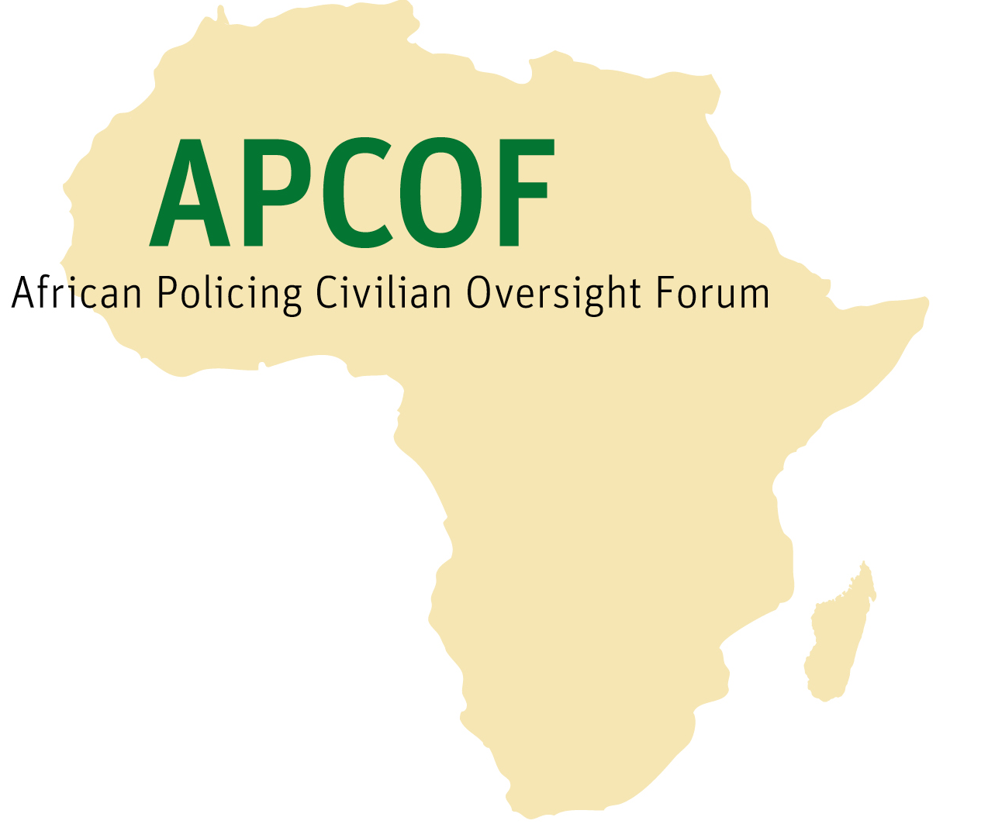 | African Policing Civilian Oversight Forum

draft general comment can be improved by including provisions which require states to offer training to law enforcement agents. This training can, among other things, cover aspects such as the provision of first aid and other essential services to injured individuals during an assembly.
CONCLUSION

APCOF would like to thank the United Nations Human Rights Committee for the opportunity to make this submission. We hope that our observations will be considered.

Contact

Abdirahaman Malim Gossar
Project and Research Officer
APCOF
gossar@apcof.org.za

21 February 2020

yyttttppp

