
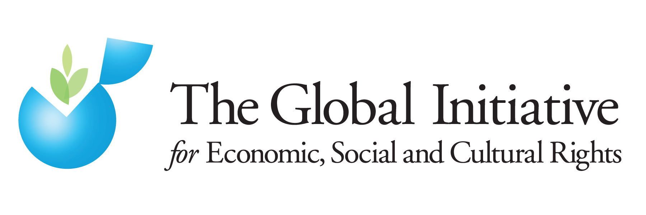


Please Compare Against Delivery

United Nations Committee on the Elimination of Discrimination against Women (CEDAW)

63rd session, 15 February to 4 March 2016

Half-day of General Discussion on Gender-related Dimensions of Disaster Risk Reduction and Climate Change

Women’s Land Rights and Climate Change

Oral Statement by

Asia Pacific Forum on Women Law and Development
Global Initiative for Economic, Social and Cultural Rights
Landesa Center for Women’s Land Rights

29 February 2016

Madame Chair,

Women in the regions of the world most affected by climate change bear the brunt of increased natural disasters, displacement, unpredictable rain fall, decreased food production, and increased hunger and poverty.

Women’s land rights are threatened directly by climate change through desertification, soil degradation, and increased contestation over and demand for arable land in many parts of the world. In addition, “land grabbing” for investment, large scale industrial agriculture, biofuel production, or as a result of market-based carbon schemes further undercuts women’s land rights. Indeed, a major impact of climate change is increased land-grabbing due to greater demand for energy and to shrinking supplies of arable land.

Because women’s land rights are already often tenuous and insecure due to both de jure and de facto gender discrimination, within the context of climate change they often come in last. This puts rural women at particular risk given their substantial reliance on land, and their indispensable role in agricultural and food production.

A critical missing piece in climate change strategies is the importance of women’s land rights. Securing women’s land rights could enhance resiliency to climate change and strengthen communities’ ability to respond well to shifting circumstances. While the 2015 Paris Agreement on Climate Change does not explicitly mention land rights, global and national plans of action will benefit from an enhanced focus on land rights, and particularly women’s land rights. Emerging evidence suggests that when women hold secure rights to land, efforts to tackle climate change are more successful, and responsibilities and benefits associated with climate change response programs are more equitably distributed. Conversely, without effective legal control over the land they farm or the proceeds of their labor, women often lack the incentive, security, opportunity, or authority to make decisions about ways to conserve the land and to ensure its long-term productivity.

We would like to highlight four areas of opportunity which are addressed in further in our written submission to the Committee:

First, States should address the multiple threats posed to women’s land rights by climate change by taking into account the differential impacts of climate change and related disasters on women in the planning and implementation of climate and disaster management strategies. States parties should further be encouraged to recognize and uphold women’s secure rights to land at all levels, both in law and in practice, as well as territorially and abroad, addressing legal and social barriers; as well as to document, research, report on and account for gender-specific climate-induced harms and their multilayered relationship to women’s rights to land and natural resources by collecting and disseminating gender-disaggregated data.

Second, States should ensure climate change strategies do not undermine women’s land rights and should be encouraged to ensure that global and national climate change strategies adopt a “do no harm” principle in regard to women’s land rights, and proactively advocate for securing women’s land rights, including within communities. The potential impacts of climate change strategies on women’s land rights are effectively assessed, both territorially and abroad, for example through the use of participatory gender-impact assessments.

Third, States should recognize and incorporate the positive impacts of women’s land rights into climate change mitigation and adaptation, and should be encouraged to reflect principles of gender equality and ecological sustainability (particularly agroecology) in development and climate change strategies, affective both both territorially and abroad, with specific acknowledgement that that women’s land rights are central to tackling climate change.

And, fourth and finally, States should promote women’s participation and leadership in tackling climate change. They should ensure women’s representation, meaningful participation and decision-making at all stages of climate change-related strategies and interventions; and ensure educational and awareness-raising about gender aspects of climate change and land rights among community members, including information about gender-specific impacts.

Thank you.

