Summary – Case study: Access to affordable low-cost solar water heating solutions as a basis for the first gender sensitive Nationally Appropriate Mitigation Action (NAMA) in Georgia, Sharing Lessons Learnt – Women in Europe for a Common Future (February 2016)

Introduction to this publication
This publication (full version: http://www.wecf.eu/english/publications/2015/gendersensitive-NAMA.php) is based on the assessments and evaluation of the lessons learned by WECF and its project partners, as well as the users and technicians involved in the solar water heater activities in Georgia. The publication gives an analysis of the lessons learned from the development of the appropriate low-cost solar heating technology, its implementation, the monitoring of the effectiveness and the added social and gender equality impacts. These findings and lessons learned have been used to formulate recommendations for how to scale up the results from 400 to 10,000 installed units, ensuring the same social and gender equality benefits.
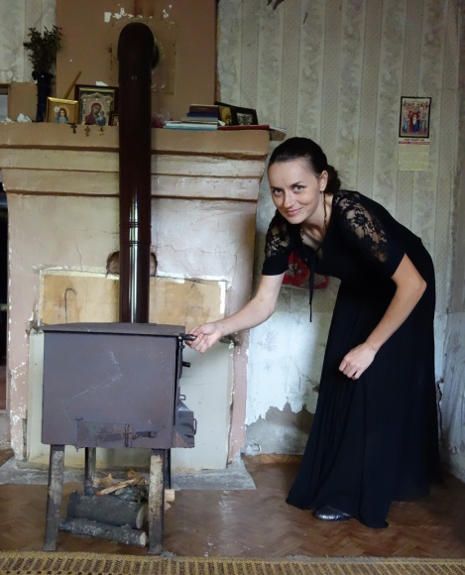
The population in Georgia, especially in rural areas, suffers from a lack of access to safe and sustainable energy, and this “energy poverty” is an important factor in overall poverty. Factors in this are a poorly maintained infrastructure, rising fuel costs, extreme weather conditions, and the increasing unpredictability of the climate. Gender roles are traditionally divided in Georgia and therefore the women are responsible for the unpaid work in and around the house, which gives them less access to income and makes them economically poor. Women and children make up the majority of the economically poor people and are most severely affected by energy poverty. They also suffer adverse health effects created by energy poverty. The burning of unsafe fuels such as plastic waste in the home out of poverty leads to respiratory problems created by exposure to dangerous substances and indoor air pollution. As women and children are typically at home for a larger proportion of time they are more acutely impacted. The lack of fuel has also severe environmental impacts e.g. local deforestation.
Prior to Solar Water Heaters, these typical stoves (Khobi region, Georgia) were used to heat the house in winter and to heat water all year round.
Preparing warm water and gathering of wood or other fuel is the task of women. From easy access to warm water women do benefit most as their labor burden is reduced which free their time for other activities such as education or income generation.
WECF strives to provide support for safe, appropriate and sustainable energy options. Whilst improving energy security in rural areas of Georgia, WECF also aims to work on gender equality, incorporating both men and women into the process and ensuring women’s needs are supported and their participation is prioritized. In 2008, WECF and its partners launched a programme to adapt solar heating technologies to local needs and capacities of man and women living in rural areas of Georgia. That same year WECF started piloting the implementation of low-cost solar water heaters based on local production with the involvement of women and men. A gender-sensitive training concept has been implemented to transfer knowledge to population of rural areas in Georgia. Since 2009, 400 solar warm water heaters have been installed and are monitored by locally trained men and women in Georgia, using local materials and creating local income. The programme has been successful in several areas: it has reduced energy poverty (easy access to sustainable energy and less costs for fuel), environmental degradation (less resources need, e.g. wood) and climate change (less CO2 emissions). The solar technology also protects people’s health. The programme has strengthened local capacity in regard to knowledge, gender equality and created business opportunities for women and men.
To scale up these results, WECF and its partner CSOs have developed in cooperation with the authorities, a proposal for a National Appropriate Mitigation Action (NAMA), which is the only “gender-equitable” one worldwide. This NAMA will install 20.000 units of solar heaters or energy-efficient stoves for rural households and public buildings, ensuring that all conditions are created for women to equally participate in the implementation and monitoring of the energy systems. The social benefits of the NAMA will be monitored, including how far it will reduce the burden of unpaid work on women in target villages of Georgia. This will contribute to target 5.4. of the “Sustainable Development Goals” which aims to redistribute unpaid care work.
1. International processes (UNFCCC and Post-2015 SDG) and gender equitable climate finance and national gender-sensitive implementation plans
1.1. SDGs
The lessons learnt from this case study are important not only for the development of the gender-sensitive NAMA in Georgia, but also in the light of national implementation of the Sustainable Development Goals Post-2015 agenda. The new 17 Sustainable Development Goals and their 169 targets constitute an integrated comprehensive agenda, which all countries will implement universally. The new agenda will not be seen as a success unless all goals are achieved. Therefore goal 1 on ending poverty needs to be implemented alongside goal 5 on gender equality and goal 13 on climate change mitigation. This case study provides some important lessons for achieving the goals in an integrated manner. Sustainable Development Goal 1 aims to end extreme poverty. Target 1.2 specifically addresses reducing all dimensions of poverty for women. Addressing income poverty is not the only concern, but also addressing a lack of assets as a “buffer” against accidents, invalidity and “climate-related extreme events and (…) environmental disasters” (target 1.5). Target 1.4 specifically states that by 2030, all men and women, should have equal rights to economic resources, as well as access to basic services, ownership, and control over land and other forms of property, inheritance, natural resources, appropriate new technology, and financial services such as microfinance. Target 1.b stipulates that this should be done through “pro-poor and gender- sensitive development strategies“, for which this gender-sensitive NAMA can be used as an example. It will also contribute to achieving target 13.b for “mechanisms and capacities for effective climate change related planning and management (...) including focusing on women.” The implementation of the gender-sensitive NAMA will help to achieve the implementation of SDG1 in rural areas of Georgia, as it will bring cost-savings to the households where the solar water heaters and efficient stoves are installed. It will also specifically build the capacity of women – as well as men – to develop business opportunities, and thus increase income. The gender-sensitive NAMA, when implemented, would also help to achieve SDG7 which aims to “Ensure access to affordable, reliable, sustainable, and modern energy for all”, to “increase the share of renewable energy” (target 7.2), and to “double energy efficiency” (target 7.3). For the first time a United Nations document sets a target (5.4) to “recognize and value unpaid care and domestic work”. The NAMA case study has shown that in Georgia, the burden of care work weighs almost entirely on the shoulders of women. It is a traditionally gender-stereotyped role that assigns women to caring for children, ill family members, and subsistence home food-production. Changing this stereotype is important for allowing women to equally participate in climate mitigation and sustainable development programmes. SDG target 5.4 makes this a specific aim for all countries, and Georgia is called on to develop awareness and education as well as policies in this area. An important step towards achieving target 5.4 is to reduce the burden of domestic care placed on women by reducing the time required to secure energy and heating for the household. The installation of solar water heaters and energy efficient stoves will reduce the burden on women and children. Additional benefits include improved indoor air quality and respiratory health (SDG 3), reduced deforestation (SDG 14), climate change action (SDG 13), increased work opportunities for women and men (SDG 8), innovative technology development (SDG17) and sustainable consumption and production (SDG12).
The implementation of the gender-sensitive NAMA, installing 10.000 solar water heaters and 10,000 energy efficient stove in rural and remote communities of Georgia, would contribute to the implementation of Sustainable Development Goals 1, 2, 3, 5, 7, 8, 12, 13, 14 and 17.
1.2. Climate UNFCCC
The United Nations Framework Convention on Climate Change (UNFCCC) aims “to achieve, in accordance with the relevant provisions of the Convention, stabilization of greenhouse gas concentrations in the atmosphere at a level that would prevent dangerous anthropogenic interference with the climate system. (…)”. [1] This can only be achieved by reducing emissions and ensuring sustainability in all sectors of society and the economy. One concept of the UNFCCC is the so-called NAMA (Nationally Appropriate Mitigation Action). It is a concept for developing countries to design and implement mitigation activities appropriate to their countries. It is important to be aware that these mitigation activities can also be activities which tackle future emissions, e.g. which prevent increase of emissions in the future by installing low-carbon technologies today. Particularly in transitioning and developing countries with cold winters, where heating is a matter of survival, energy poverty is recurrent, and poor communities struggle to get access to energy to fulfill their daily needs. The aim of the solar water heating and energy efficient stove pilot projects was to demonstrate how domestic energy needs can be assured in a sustainable way, benefitting and involving women and men equally. What is required are ‘Means of Implementation’, provided by developed countries, to ensure capacity building, technology transfer, assessment and adaptation, and (micro)-finance. These means have to be allocated carefully since resources are limited. Choosing one type of technology will bind resources and capital, which might not be available for other types of technologies. Appropriate solutions are needed that can provide women and men with safe and affordable energy and protect the environment, especially forests, thereby protecting the climate.
Looking at the gender dimensions of climate mitigation activities and technologies means to look at the realities of women and men in their daily lives and their needs, perspectives and responsibilities in their social, cultural, environmental and economic context. Women often do not have equal opportunities, access and control over resources and policy decisions. Gender-equitable climate finance and national gender-sensitive implementation plans have to reflect these realities.
2. Energy situation in Georgia and the relation to gender and poverty
The issues of energy and climate change are crucial for Georgia. The national Green House Gas (GHG) inventory for the years 2000- 2006 [2] has shown that the energy sector, including transportation, is the leading sector regarding CO2 emissions in Georgia. Development of alternative sources of energy is crucial for emission reduction. Renewable energy sources play a key role in providing energy services and mitigating climate change.
Water heating is the second largest energy expense in the average household in Georgia - it typically accounts for 23% of the utility bill [3]. The average rural household spends one third of their total household budget on energy. In rural areas approximately 70-80% of energy needs are met with wood and other conventional energy sources. In villages without natural gas it is as high as 97%. On average, households in rural communities burn more than 10 m3 of fire wood per year [3]. This has a severe impact on the environment, and produces large amounts of CO2 (More than 4 million tons of CO2 are emitted yearly by Georgia’s 500.000 rural households and public buildings using wood to meet their heat demands), contributing considerably to deforestation and thus to land degradation, which in turn has adverse effects on the quality of life and food security of the village population. Indoor air pollution created by burning plastic and other types of unsafe materials and fuels leads to respiratory illnesses. Insufficient availability of warm water for hygiene purposes likewise adversely affects people´s health.
Average income levels are extremely low in rural areas, and few households can afford to buy a commercial Solar Water Heater or other energy efficient devices to reduce their energy costs. Access to (energy) credit is virtually non-existent in rural areas. The WECF pilot project on sustainable energy looked into the possibilities for developing financial instruments that are accessible to rural women and men, with special mechanisms to ensure access to credit for women who don’t own land as collateral.

3. National strategies
The Ministry of the Environment and Natural Protection of Georgia is drafting a Low Emission Development Strategy (LEDS) and an Intended Nationally Determined Contribution (INDC) plan, both concepts of the UNFCCC. In the preparation of the plan, the government is making predictions of future emissions and their reduction potential in different sectors, relevant to climate change, together with the help of external experts. These national plans imbed another concept of the UNFCCC; sector focused nationally appropriate mitigation actions (NAMA). At the moment there are four different NAMA’s planned to be implemented in Georgia: 1. Forest protection, 2. Energy efficiency (EE) in buildings, 3. Implementation of 10.000 EE stoves and Solar Water Heaters (SWHs), and 4. Energy efficiency in the transport sector. A priority identified by the Ministry of Environment is the introduction of solar water heaters and energy efficient stoves in rural areas, based on their potential for emission reduction, poverty alleviation and forest conservation [4]. They have asked WECF and its NGO partner ‘Greens Movement’ to develop a Nationally Appropriate Mitigation Action (NAMA) on the implementation of these technologies.

A. Technology
1. Background
WECF and its local partners started introducing solar collectors to Georgia and other countries in Caucasus, Eastern Europe and Central Asia in 2008, through the framework of the “Empowerment and local action“ project funded by the Ministry of Foreign Affairs in the Netherlands.
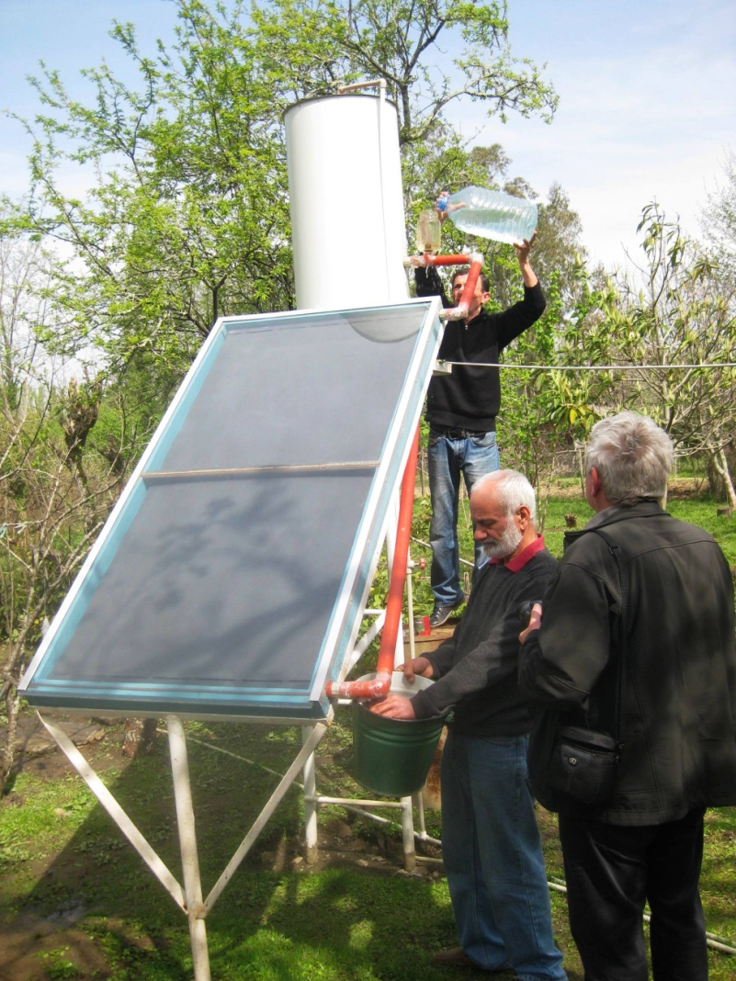
During the first years, the solar collector technology was adapted to the needs of the rural population of Georgia. The final collector model can be constructed by local workmen – and women of locally available materials and it can be used all year round. This solar collector type became the technology in the project “building local capacity for domestic solar heating, hot water and insulation for rural and remote areas in the EEC region”, funded by the European Commission from 2011-2015.
Solar collectors were implemented in 5 different regions of Georgia with different climate conditions: Khamiskuri, Kheta (Samegrelo-Zemo-Svaneti region), Ivandidi (Imereti region), Sagarejo (Kakheti region), Akhaltsikhe surrounding villages (Samtskhe-Javakheti region), Ereda, Chardakhi and Misaktseli (Mtskheta-Mtianeti region), and in other countries as well (Ukraine, Moldova, Armenia, Azerbaijan, Russia, Kyrgyzstan).
A ‘master’ and student trainer carrying out the maintenance of a SWH in Khobi region, Georgia

2. Gender Sensitive Approach
Gender equality is of high priority to WECF and this extends to all projects. The equal outreach and involvement of women and men, and responding to their respective needs with regards to energy issues have been taken into careful consideration. The project was however not designed with the main aim of changing gender stereotypes. The projects main aim was to develop safe and climate-friendly energy solutions for low-income rural households, in doing so in the most gender-equitable manner possible. A gender sensitive approach encompasses the ability to acknowledge and highlight existing gender differences that cause inequality and incorporate these into strategies and action [5].
The training programme for the construction of the solar collector was a crucial component of the project and therefore gender roles have been considered when designing the trainings to ensure that they are accessible to women without perpetuating essentialist and traditional ideas of women. Such roles create barriers to women’s development and the pursuit of gender equality. There has been a great amount of reflection on these roles on the level of the project, villages and nationally. It is important to note that men are also often challenged by their traditional gender role. In rural areas in Georgia, men often do not have work and lack meaningful activities. By conducting the first trainings on solar warm water heaters men were very interested in the issue and in the construction trainings provided by WECF and partners. It gave them something meaningful to do, which had a beneficial impact on them and their family members by reducing domestic struggles.
In order to achieve high women’s participation WECF developed a training format, responding to the traditional division of gender roles in Georgia and the EECCA region. The trainings highlighted existing cultural differences between the gender roles of men and women and raised awareness of gender inequality. As traditionally women are using most warm water, they are the first to notice in case the collector is not functioning optimally. It proved crucial for the correct use and maintenance of the solar collector that both men and women have a good understanding of its functioning, maintenance, possible problems and ways to solve them, and therefore participate equally in the trainings. Decisions that are taken by all members of a group (be it society of a family) are accepted more easily and implemented in a better way. Therefore, it is of importance for the success of the construction of a solar collector and its function that all members of a group agree on how to build it and what to use it for. Furthermore, the participation of all in the decision-making process provides for all concerns, needs and wishes to be taken into consideration in advance. Thus the project empowered women in three ways; 1. SWH reduces womens’ labor burden, and thus makes more time available for economic or political activities, 2. by raising awareness about gender and gender roles, 3. by actively involving women as key actors in the project.
2. Lessons learnt and recommendations
An evaluation of the project “Building local capacity for domestic solar heating, hot water and insulation for rural and remote areas in the EEC region” shows that the solar collectors implemented as demonstration objects during the last four years in Georgia are working efficiently.
In general, the most efficient way of avoiding or repairing construction flaws is to have a team of experienced, professional constructors located in the target community and well informed active women conducting regular monitoring. It is crucial to build capacity of the technical staff of national and local partner NGOs, so that they are aware what is required to solve problems.
2.2. Acceptance
It is possible to implement a SWH project successfully within one year, but it takes several years to create sufficient acceptance and support for the technology to adapt to new local contexts. Equal attention to the social, environmental and economic context is of the same importance as the focus is not solely on the technology.
2.3. Gender
A gender responsive training concept was developed and conducted to aim for equal involvement of women and men. Participants of the gender-responsive training acknowledged that there were gender differences, but were little inclined to change their social gender roles. The women usually did not (want to) get involved in the construction part of the training, and the men did not (want to) get involved in the maintenance/ monitoring group. The project benefited women and men differently, but both groups were equally motivated by the results and supported the project expansion.
As a recommendation for future projects, focus more on challenging existing gender roles and on collecting data which are disaggregated by sex. It would be interesting to see, if as a result, more women will be interested in the construction work and more men will be interested in the maintenance/monitoring work.

B. Capacity Building and Training
1. Preparation phase
From the experience gained through trainings on solar collectors in 2011-2013 WECF and partners developed a participatory, gender-sensitive training concept. This training concept consists of several training modules on construction, use, maintenance, monitoring and business opportunities. Additionally, training modules specifically to train trainers were developed. In order to achieve positive training results, a selection criteria for training participants was carefully developed and applied to guide the selection of participants. For example, participants should be able and willing to invest the needed contribution for materials to construct a solar collector. Women were strongly encouraged to apply for the training as WECF was aiming to achieve a balance in genders across the participants. However, an equal balance of men and women could not be fully achieved. The optimum number of participants per solar heater training group was 10; with two groups the total number of participants per training was 20 persons.
2. Training concept
The goal of the training was to build the capacity of interested local people on the issue of solar collectors (heaters) within a timeframe of approximately 5 days in a participatory, gender-sensitive and inclusive manner. The training also aimed at showing the benefits of the use of solar collectors and to raise general awareness of this new technology.
The training sessions aimed to provide an equal foundation of knowledge of all participants regardless of their gender to enable and encourage participation in decision-making processes regarding the construction, needs and use of the technology. Six interested and skilled trained constructors had the possibility to participate in a 3-week internship in Germany at the company Solar Partner Süd to acquire more detailed and practical knowledge of solar systems. These trainings proved to be extremely useful for deepening knowledge, but also a very important factor for motivation to implement the newly acquired skills in the target communities in Georgia.
2.1. Training of trainers
As a second step, the most interested and skilled participants (5 women and 7 men) from the first training round were invited to become trainers themselves. Now trained trainers can be hired by the project or other organisations, thus possibilities for some income generation are given to the trainers. Unfortunately, male trainers were more frequently hired because these organisations underestimate the importance of women’s involvement in general, and women’s capabilities regarding the maintenance and monitoring of the solar collectors in particular.
2.2. Community trainings
After being trained, the trainers conducted trainings in the communities and in neighboring countries according to the WECF modules. In Georgia, in total 69 women and 88 men have been trained in 8 community trainings, each lasting 4 days. In Armenia and Azerbaijan 6 additional trainings took place and 5 monitoring follow up visits occurred, led by the trained trainers.
3. Lessons learnt and recommendations
3.1. Construction teams
An important point is how construction is organized. Highest quality is achieved wherever trained individuals work together in construction teams (groups of 4-5 people) instead of constructors working individually. In this way, tools can be shared which leads to a reduction in costs and fewer errors are made as there are multiple people ensuring everything is being done correctly.

3.2. Number of people trained
69 women and 88 men were trained at the trainings for construction and maintenance/monitoring. Nearly 100% of the training participants followed up on the training as required by the training rules and were involved in the construction and monitoring of the solar collector after the training. Until now, just a few men and women started to really use the acquired skills for professional activities. However, when more collectors need to be constructed, there exist enough trained people who will be available to join and work on construction and maintenance.
3.3. Training fees
Initially, the original concept was that participants got the training for free but in return were obliged to build two solar collectors in order to gain their certification (master certificate). However, during the midterm evaluation of the project, it was suggested to create a ‘training registration fee’. This has positive psychological associations - if you are willing to pay (even a little) you are most likely more committed to the project and have a reason for acquiring and using the new knowledge.
3.4. Involvement of women
As a recommendation for the planned NAMA, in order to reach more female participants, the trainings should be adapted to a shorter training time per day and be organized as close as possible to their homes. Another proposal is to offer childcare opportunities during the trainings, and to provide lower training fees for female participants. A further recommendation is that for each of the households where solar heaters are installed, an experienced monitoring team that includes at least one trained female trainer, helps the women of the beneficiary households to fill in the monitoring forms and explain the basic monitoring tasks. This worked especially well when the women trainers were paid a fee for this work.
As a lessons learnt and recommendation for the planned NAMA, a basic maintenance training should be an obligatory part for constructors and beneficiaries of the project.
3.5. Support by local experts
The trained local constructors are able to construct solar collectors, but errors can still occur. When these local constructors and qualified masters from NGO’s technical stuff are working in construction teams, errors happened less frequently and high quality was guaranteed.
3.6. Conceptual component
The trainings as planned were highly successful and amongst training participants a high level of knowledge was achieved. As a recommendation for similar projects and for the NAMA, allowing more flexibility to address emerging issues in additional trainings would be beneficial.

C. Monitoring concept
Monitoring is an important theme and continues as an on-going process for the project described in this case study. This section focuses on the achievement of the main goals, which are the most important “hard indicators”, and which are needed as a basis for registration of “Gold Standard” and development of NAMA, as the main options to scale up the project results.
1. Preparation phase / Methodology: Monitoring concept
The monitoring concept was developed in a participatory way, together with local partners, based on ‘needs-assessment workshops’ with the participation of beneficiaries in the target communities. Most of the data could be gathered by the beneficiaries or monitoring teams in the communities themselves through a questionnaire. Monitoring was integrated in partner meetings and in all trainings for communities. A recommendation for similar projects is to provide incentives for better coverage of the household base-line data, and to ensure sex and gender disaggregated data.
2. Lessons learnt and recommendations
From 2011 to 2014, 90 out of 330 solar collectors provided useful monitoring data and showed considerable reduction of fuel consumption and costs. Calculations based on these results showed reduction of CO2 consumption of 1000 kg CO2 per SWH per year. The data also showed a reduction of 30% in energy costs, wood, electricity and gas use.
2.1. Quality of data
In quite a number of cases, the quality of the data collected by the participating households was not of a good standard. One reason for this is that there are too many steps from data source (beneficiaries) via data collection (local monitoring persons) to the local partners and from them to WECF. Furthermore, as consumption of fuel and costs are usually estimated rather than exactly measured, the accuracy of the collected data cannot be entirely assured. The data monitoring procedure could be improved and made easier if the whole data monitoring process were to be handled locally by local partners with assigned staff dedicated to this issue.
2.2. Social components and gender aspects
From a point of view of quality of monitoring, it is better to have one region completely covered with solar heaters, then have a few in different places. It turned out to be effective to form monitoring teams per village who received a small fee from the project to perform the monitoring tasks.

D. Steps towards Upscaling – success stories and challenges
The long-term objective of the project was that, after the successful introduction of solar systems, the project would help achieve the replication and upscaling. The success of this is determined by supply side - fundamentals for local production such as local knowledge and infrastructure; and by demand side – interest amongst the local population, and therefore readiness to invest, and political support.
1. Awareness raising
Local awareness about solar systems has been raised on different levels - e.g. press releases, radio spots, TV broadcasts and newspaper articles - with positive results. Women and men are equally active in awareness raising activities. The participatory needs assessment helped communities realize that they indeed had an energy problem that could be solved, which motivated them to become active. People in the project villages are convinced that the collectors work efficiently, save energy costs and increase comfort, so they are ready to invest, and there are long waiting lists of people who have applied for the installation of a solar collector.
The households and project partners with demonstration plants have agreed to show their solar collector and be part of awareness raising efforts. These demonstration objects are a very important factor to raise interest and spread the technology. To reach this goal, visibility is an important fact, so ideally, demonstration objects should be installed in a way that they are visible from the street and close to each other, to increase interest and acceptance in the neighborhood.

2. Local production
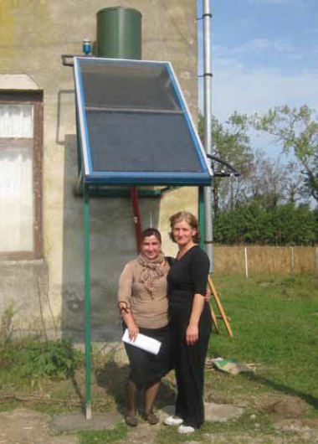
One of the main goals was to create opportunities for local workmen and women to start a small business with sales and maintenance of solar collectors. Selecting some 2-4 people per region for certification training, who were motivated, skilled and ready to learn new skills created the best conditions at a later stage for them to earn some additional income by working for a service center. Expansion of these service centers is planned when the NAMA starts. The lesson learnt is that indeed it is possible to generate local entrepreneurship based on solar collector construction, less so for the monitoring and maintenance. A recommendation from the project is that municipalities should provide support and stimulate the development of small producers of solar equipment (in cooperation with NGOs) in their communities.
3. Financial aspects
While interest in solar collectors has risen rapidly in the recent years, a typical problem amongst rural population remains: a lack of financial resources. Monitoring results show that the use of solar water heater reduced fuel costs by 43%, saving on average each household more than 150 EUR per year. A solar collector costs up to 375 EUR, therefore the payback time is 2-3 years. However, to invest in solar collectors lowest-income families need access to resources for capital investments like loans via community-based mechanisms such as revolving funds or savings-groups and micro-finance. Another option is provision of subsidies via national mechanisms or the international carbon market, like the Microscale Gold Standard and the concept of a Nationally Appropriate Mitigation Action (NAMA). At community level lease-purchase systems are also a good opportunity.
Every day life has become much easier for these two kindergarten teachers thanks to their Solar Water Heater
Within the project, one model has been created which was a subsidy of 100 Euro for low-income families. The remaining costs had to be covered by the beneficiaries. However, low-income families cannot provide the full amount in one single payment or even with a subsidy of 100 Euro the collector is still not affordable to the poorest segment of the population. This group often includes female single headed households.
3.1. Financial mechanisms at community level
The recommendation for the future implementation of solar collectors via e.g. the NAMA, a legal financial mechanism will be needed to give loans to the local population with an interest rate of not higher than 8% per year. A special “window” for women in vulnerable situations should be a condition for cooperation with a banking sector partner.
3.2. National level- NAMA
WECF and its NGO partners developed a proposal for a Nationally Appropriate Mitigation Action (NAMA) in discussion with the Ministry of Environment. The proposed large-scale NAMA project focuses on scaling up the construction of solar water heaters for domestic use in rural areas and combines it with energy efficient stoves, and Energy Efficiency measures to achieve a substantial reduction of emissions and linked deforestation. Greens Movement and WECF were explicitly asked by the Georgian Government, Ministry of Environment and Natural Protection, to develop NAMA in the country for 10.000 solar water heaters and 10.000 energy efficient stoves. The proposal as designed, now would make it the first “gender-sensitive NAMA” worldwide. It would not only focus on installing the 20.000 units, but also work on creating the broader enabling environment, for a more efficient energy sector, and the needed mechanisms to channel public finances and private investments towards sustainable energy business models with equal opportunities for women and men.

3.3. Voluntary carbon market - GS registration
The solar collectors developed in this project were submitted to certification as a “Gold Standard Micro Scale project”. The Gold Standard is an award winning certification standard for carbon mitigation projects that is recognized internationally as the benchmark for quality in both the compliance and voluntary carbon markets. Project partner ‘Atmosfair’ coordinated the submission. Through Atmosfair, the project collectors could receive carbon credits for compensating CO2 emissions. Certification means not only additional funding, but also recognition of the quality and scale of the project and promoted technology.

Recommendations for NAMA and other future projects / Conclusion
The implementation of solar collectors was well achieved and the acceptance and interest among local population was high. The training concept that was developed proved to be efficient and successful. Local workmen and women have acquired skills and knowledge that will be a base for further development of local businesses for the production of solar collectors. The solar collector technology has been successfully adapted to the conditions of the different target regions and is now ready for large-scale implementation under standard conditions. Solar collector owners report being content with the installations; they now have running warm water from the sun, available for free, increased comfort, often a new bathroom or running (warm) water has been installed in kitchen and bathroom. Women have benefitted especially from the improved situation for household activities, childcare and hygiene, resulting in better health. In the long term this provides children with better educational opportunities. The time saved by easier access to energy provides women in particular with better opportunities to participate in economic activities. According to monitoring results (2011-2014), after the installation of a solar collector energy costs reduced by 42%, which meant an overall 35% improvement of the household budget. The reduction of potential CO2 emissions amounted to 1000 kg CO2 on average for warm regions and 859 kg for cold regions per household per year, being thus beneficial in terms of mitigating climate change. At the same time, local forests were saved, and especially illegal wood logging was reduced, as survey results attest. Further improvements could be made to the concept, implementation and monitoring procedure. With regards to replication and upscaling of the technology, the programme in Georgia succeeded to create interest amongst the local population. However, lower-income families, which constitute a big part of rural population, cannot afford a solar collector without access to locally available subsidies, credits or loans. Additional programmes such as the planned NAMA and the creation of a financing instrument are needed. With regards to the inclusion of women and their empowerment as an additional benefit of the project, the recommendation is to develop a broader national policy that also works with the educational and financial sectors, to create an enabling environment for women’s equal participation, as well as implementing the “gender-equitable NAMA”. As part of the NAMA, the training modules can be extended to train young women on practical and technical skills before the training sessions for solar heater construction start to ensure a more equal departure. In this way the gender sensitive NAMA can aim to achieve 50% employment for women as a result. The gender trainings can be extended to work more on reducing gender stereotypes. Base line studies can be improved by gathering sex and gender disaggregated data, and apply disaggregation throughout the data collection as part of the progress monitoring. The financial mechanisms should have specific facilities for women as, due to their lack of assets and land ownership they are disadvantaged with regards to obtaining credits from commercial banks. Another recommendation is to make national plans for energy supply and climate mitigation gender equitable, and thus ensure they are fully in accordance with the Post-2015 Sustainable Development Goals (SDGs) and their aim of reducing poverty and inequalities.

Footnotes
[1] United Nations Framework Convention on Climate Change, Article 2, 1992
[2] The third national communication of Georgia to the United Nations Convention on Climate Change has not been published yet, May 2015
[3] N. Lazashvili, 2012; Energy study on large-scale introduction of energy efficient household stoves in Georgia
[4] Research of Greens Movement of Georgia/Friends of the Earth Georgia
[5] WECF, Gender in Sustainable Development – Collection of Exercises for Training of Trainers (TOT), 2014, p.51.

