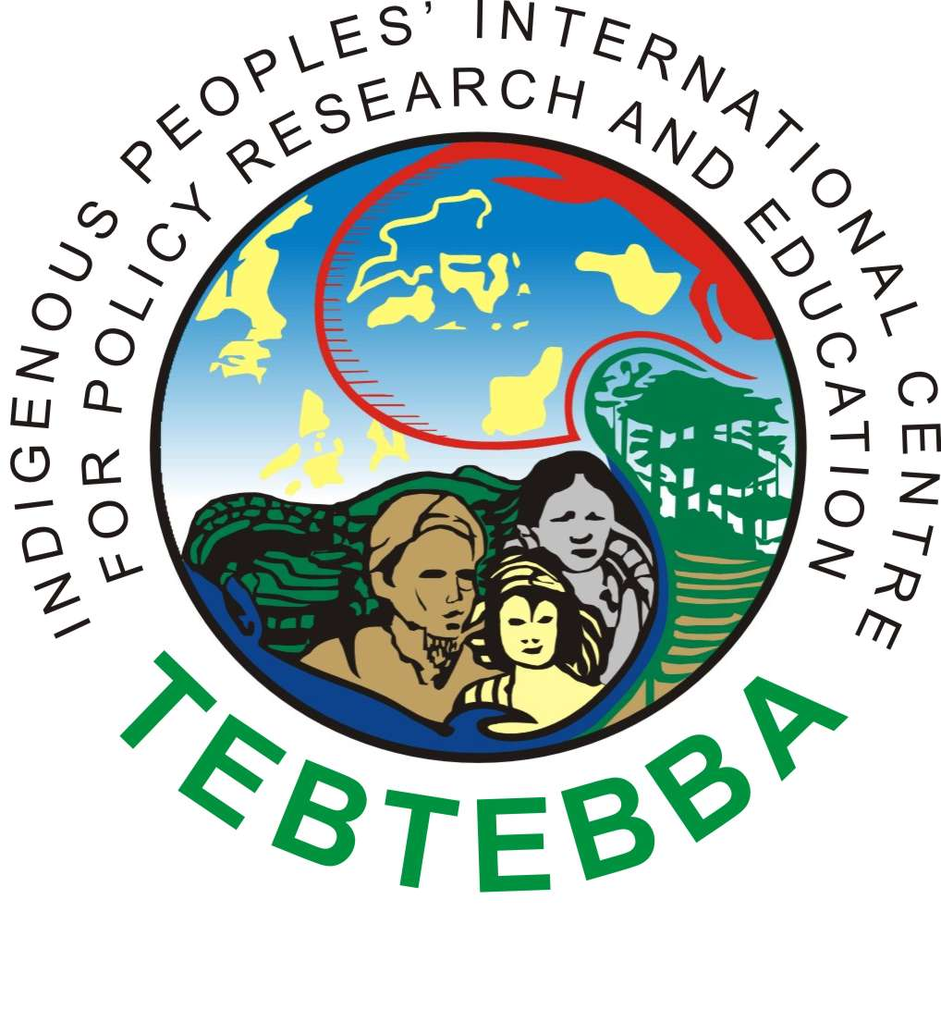
Tebtebba
Indigenous Peoples’ International Centre for Policy Research and Education
No. 1 Roman Ayson Rd., 2600, Baguio City, Philippines
Tel: +63 74 4447703 Tel/Fax: +63 74 4439459
Email: tebtebba@tebtebba.org Website: www.tebtebba.org

NGO in Special Consultative Status with the Economic and Social Council of the UN

The Committee on the Elimination of Discrimination against Women

24th June 2021
Virtual day general discussion on the rights of indigenous women and girls
Part 1: “Equality and non-discrimination with a focus on indigenous women and girls and intersecting forms of discrimination”

Victoria Tauli-Corpuz, Executive Director

Let me thank the CEDAW for inviting me to make a presentation in today’s session on the situation of indigenous women and girls who suffer from intersecting forms of discrimination and inequalities. I fully appreciate that CEDAW has included this as an agenda item and that efforts to develop a general recommendation on indigenous women and girls are underway. I was the UN Special Rapporteur on the Rights of Indigenous Peoples from 2014-2020 April and in performing my mandate I tried my best to look into the situations of indigenous women and girls during my country visits and in doing my thematic reports. My thematic report in 2015 focused on indigenous women and girls. In Tebtebba we have a dedicated program on indigenous women wherein we, ourselves and our partners, participate in many global and regional arenas where decisions on indigenous women and girls are being made. Political participation of indigenous women is a key issue which we focused on. Much of what I will present today is culled from the report which I referred to earlier.

Indigenous women experience a broad, multifaceted and complex spectrum of mutually reinforcing and intersecting human rights abuses. Their multiple identities based on race and ethnicity, gender and class place them in highly vulnerable situations which are brought about by systemic racism and discrimination and patriarchal power structures. Five hundred years of colonization still has serious residual impacts which have yet to be addressed in a satisfactory manner. While indigenous women and their men suffer collectively and individually from the violations of their basic human rights, it is important to understand the differentiated nature and impacts of these violations on indigenous women and girls and to address their distinct needs. It is equally important to recognize that they continue to play important roles in making their communities more sustainable and they possess unique knowledge and wisdom which can help solve the global crises we face such as climate change, biodiversity erosion, pandemics, food insecurity.
There is no doubt that there have been progress in putting into place policies and mechanisms which address indigenous peoples’ rights at the global, regional and national levels. Indigenous women have demonstrated their capacities in helping to give birth to the UN Declaration on the Rights of Indigenous Peoples, the UN Permanent Forum on Indigenous Issues, the Expert Mechanism on Indigenous Peoples’ Rights and the mandate of the UN Special Rapporteur on the Rights of Indigenous Peoples. Gender equality has been a principle adopted by these various bodies which allowed women to have equal participation. Indigenous women also have created their own organizations and networks which are focusing on gender inequality and discrimination.
The UN Declaration on the Rights of Indigenous Peoples (UNDRIP) provides a common, authoritative and global understanding of indigenous women’s rights. It represents a global consensus. The UNDRIP applies equally to indigenous men and women’s rights to freely pursue their economic, social, political and cultural well-being. Among other rights, the UNDRIP protects indigenous women’s individual and collective rights (Article 1), their right to be free from all kinds of discrimination (Article 2) and their right to self-determination (Article 3). Article 22(2) places a duty on the State to protect indigenous women from all forms of violence and discrimination. The UNDRIP recognizes indigenous women’s equality with men, their rights to their lands and their participation as citizens in their homes, communities and States. Under the UNDRIP Article 21(2), States have a duty to work for the improvement of indigenous women’s economic rights. That duty must parallel indigenous women’s rights to self-determination as State’s must consult and cooperate with indigenous women and their organizations to create access to services that forward indigenous women’s own economic goals.
In my report, I have stressed that when we examine the rights of indigenous women and girls, it is vital to consider the unique historical current experiences of indigenous communities. Many forms of violence and abuse against indigenous women and girls have strong intergenerational and collective elements. Violations of the foundational right to self-determination include, gross and sustained assaults on the cultural integrity of indigenous peoples; denigration and non-recognition of customary laws and governance systems; failure to develop frameworks that allow indigenous peoples appropriate levels of self-governance; and practices that strip indigenous peoples of autonomy over land and natural resources. Those patterns of violations are vividly exemplified by colonization, but have also been perpetuated by post-colonial power structures and State practices. Those violations of the right to self-determination have been highly detrimental to the advancement of the rights of indigenous women and girls in ways.
Right to Self-Determination
The right to self-determination, which is a collective right, has been regarded by some and misrepresented as a right which can potentially undermine indigenous women’s individual rights. A false dichotomy between collective and individual rights was promoted both within the women’s movements and indigenous peoples’ movements. Women’s rights were regarded as divisive and external to the indigenous peoples’ struggle and connected to “external values” or “Western values” that privilege individual over collective rights. On the other hand, there were those who looked at collective rights as inherently contradictory with the individual human rights of women. With the active participation of indigenous women in these debates and their assertion that as indigenous peoples they should enjoy both collective and individual rights, these debates are better handled now.
Within some indigenous communities I witnessed discussions around this issue as well. When I visited communities, I usually hold separate meetings with the women and reflect their views in my reports. Within the women’s movement, which I have and continue to be part of, I have been engaged in similar debates. I am mentioning this because I can foresee that this will emerge again in the attempts of CEDAW to come up with a general recommendation on indigenous women and girls. I hope CEDAW will be able to handle this issue in a profound and balanced way. The good practices of indigenous peoples in making their communities internal issues of gender discrimination can be shared with the CEDAW.
Right to Lands, Territories and Resources
The right to lands, territories and resources is a right which has been analysed from the lens of indigenous women. I stressed in my report that “..land appropriation is not gender neutral and indigenous women’s rights interact with violations of collective land rights. In indigenous communities where matriarchy and matrilineal practices exist, the loss of land will likewise undermine indigenous women’s status and roles. The gendered effects of those violations become manifest in situations where indigenous women lose their traditional livelihoods, such as food gathering, agricultural production, herding, among others, while compensation and jobs following land seizure tend to benefit male members of indigenous communities. The loss of land and exclusion of women can create vulnerability to abuse and violence, such as sexual violence, exploitation and trafficking. Additionally, the secondary effects of violations of land rights, such as loss of livelihood and ill health, often disproportionally impact women in their roles of caregivers and guardians of the local environment. “
The efforts of women to protect their lands, territories and resources have been met with violence and harassments from the State and from corporations. In a thematic report I made, as the Special Rapporteur, on criminalization of indigenous peoples, I identified several cases of indigenous women who have been unjustly accused of being terrorists or anti-development simply because they fought to protect their lands.
Right to Health
Health situations of indigenous women and girls further elucidate the inequalities and discrimination against them. In my investigations I came across information which show the profound inequalities between against indigenous peoples and the dominant populations in mental and physical health. While these are not disaggregated by gender it is safe to assume that at least 50 percent of these are women. Examples of these are as follows;
(a) In the United States of America, a Native American is 600 times more likely to contract tuberculosis than a non-Native American;
(b) Worldwide, over 50 per cent of indigenous adults suffer from type 2 diabetes;
(c) Indigenous peoples’ life expectancy is up to 20 years lower than the non-indigenous populations.
(d) Indigenous peoples experience disproportionately high levels of maternal and infant mortality, malnutrition, cardiovascular illnesses, HIV/AIDS and other infectious diseases, such as malaria and tuberculosis;
(e) Suicide rates of indigenous peoples, particularly among youth, are considerably higher in many countries. For example, the suicide rate for Inuit in Canada is around 11 times the national average;
(f) Child mortality rates among indigenous communities are usually above the national average.
A gender-specific health concern is the issue of indigenous women’s sexual and reproductive health. Indigenous women face many barriers to sexual and reproductive rights, such as a lack of culturally appropriate sexual and reproductive health advice, geographical access to facilities and lack of supplies, such as contraceptives, poor quality care and, in some cases, legislation banning abortion services, even in cases of pregnancy following rape. That leads to higher-than-average maternal mortality rates; disproportionate representation of indigenous girls in teenage pregnancy indexes; low voluntary contraceptive usage; and high rates of sexually transmitted diseases and HIV/AIDS.
The recent reports on Covid 19 and its impacts on indigenous peoples would show that mobility of indigenous peoples which is crucial in their livelihoods has been limited which led to food insecurity and loss of income. Access to markets were controlled so many of their crops rotted in their fields. Indigenous women have reported increased cases of loss of jobs, gender violence, including incest of young girls, and the their burdens as caregivers, food and water providers have increased considerably. Lack of information on the pandemic and lack of health services in many indigenous communities were reported repeatedly. I have come across good practices in relation to the handling of the pandemic and the roles of indigenous women in these. One is the practice of isolation. Many indigenous peoples have traditional systems where they isolate their communities whenever there are cases of pandemics. My own community has done this as long as I can remember and this is one reason why in our town there is only one case of death from Covid 19 and very few cases of infection. The current Special Rapporteur has made a report on this issue so I will not dwell on this further.
Gender-based Violence and Trafficking of Indigenous Women and Girls
Gender-based violence is commonly experienced by indigenous women. The violations of collective, civil and political, and economic, social and cultural rights can be seen as constituting a form of structural violence against indigenous women and girls. Structural violence results in women being victimized by the realities of the circumstances of their everyday life and routinely excluded from the rights and resources otherwise guaranteed to citizens. Structural violence is interlinked and mutually reinforcing with other forms of violence.
Indigenous women are significantly more likely to experience rape than non- indigenous women. It has been estimated that more than one in three indigenous women are raped during their lifetime. Behind these shocking statistics are multiple forms of sexual violence against indigenous women by a multitude of actors in different geographical regions. Coordinated and comparative information on sexual violence is very limited, due in part to significant underreporting and a lack of investment in disaggregated data collection that include indigenous women and communities. That makes analysis of systemic level prevalence and trends very difficult. Different forms of sexual violence have been reported, some of which are as follows;
(a) Large numbers of indigenous women and girls work in domestic households. Domestic work is outside of the regulatory framework for employers, which leaves women and girls isolated and vulnerable to rape and abuse by employers;
(b) Women have reportedly been subjected to harassment, extortion and rape by State officials at border crossings. For example, Miskito women, whose territories straddle Nicaragua and Honduras and who cross national borders every day to work their lands or to gather medicinal plants, are routinely exposed to sexual violence. In addition, military officials may perpetrate sexual violence as a weapon to weaken the resolve of indigenous communities in militarized disputes over land and resources;
(c) In the United States, large numbers of indigenous women have experienced rape perpetrated by men outside of their communities. According to statistics, Native American and Alaska Native women are more than 2.5 times more likely to be raped or sexually assaulted than other women in the United States; and 86 per cent of the reported cases of rape or sexual assault against American Indian and Alaska Native women are perpetrated by non-Native men;
Gender-based killings of indigenous women can take a variety of forms, including murder within communities; retaliation for defending their human rights; conflict-related; in the context of displacement from their communities due to dispossession of land; reports of “missing women” who are assumed to have been killed. The much publicized case of the missing and murdered indigenous women in Canada, represents a reality not just for those in Canada but also in the United States. I am pleased to note that the results of the national inquiry on this issue has been released already but the displeasure of many indigenous women who stated that their expectations in what this should contain have not been met have been communicated to me as well.
Criminalization of indigenous women who are defending their rights continue as we speak. Aside from being criminalized, indigenous women also suffer the burden of caring and sustaining their families and communities when their husbands are criminalized and jailed for long periods of time. Access to justice of the victims of gender-based violence and criminalization is very limited. Thus, many human rights organizations including those of indigenous peoples have to provide whatever support they can muster to support the victims and survivors in terms of providing sanctuaries, legal aid, using grievance mechanisms, among others.
Indigenous women and girls who leave their communities are highly vulnerable to trafficking, which can lead to multiple violations of their human rights, including severe economic and sexual exploitation and sexual violence. There are also cases of indigenous women being targeted by organized traffickers within their own communities. Some reports which I received on trafficking of indigenous women and children include the following:
(a) In the Miskitu communities of Nicaragua and among the Maya in Guatemala and Mexico, indigenous women have reported the phenomenon of selling and trafficking of indigenous girls and boys, citing communitarian violence as the cause;
(b) In a number of Asian countries, including Cambodia, India, Nepal and Thailand, Myanmar, Philippines, indigenous women are trafficked from their communities into domestic servitude or forced prostitution;
Conclusion and Recommendations
What I have presented today is just the tip of the iceberg. I cannot go further in the interest of time. More elaborated discussions on the issues of indigenous women and girls are found in the report (A/HRC/30/4) which I submitted to the Human Rights Council during my term as the Specail Rapporteur. So I request that this be used as a reference by CEDAW.
I would like to conclude by going through some general observations and a few recommendations especially in relation to monitoring of the situation of indigenous women and girls. It terms of gaps and weaknesses in the monitoring mechanisms of human rights bodies and mechanisms I have observed the following;
( a) The lack of geographical balance in relation to the comments made by the different mechanisms. Much of the data available are those from developed countries like Canada, the US, Australia and New Zealand. This tells me that data disaggregation on indigenous peoples, much less on indigenous women, is hardly done in the developing countries
(b) Failure to discuss the role that intersecting forms of vulnerability and discrimination plays in violations of the rights of indigenous women and girls;
(c) Limited exploration of the nexus between individual and collective rights;
(d) The absence of gender analysis when discussing issues that impact indigenous communities.
To effectively protect the rights of indigenous women there is a need for a paradigm shift and the development of a multidimensional approach. States must find a way to strike a delicate balance between protection of indigenous women and respect for self-determination and autonomy of indigenous peoples. Engagement and consultation with indigenous women and girls is central to finding that balance. The United Nations system must support Member States in striking that balance, as well as contribute to the paradigm shift needed through increasing attention to the needs of indigenous women and reconceptualizing rights issues to include the nexus between individual and collective rights, as well as the intersectionality between different forms of inequality and discrimination.
I will reiterate what I presented as recommendations to Member-States as far as monitoring and accountability is concerned.
Member States should:
(a) Consider developing national action plans on indigenous women’s rights, which are strongly linked with clear monitoring and accountability systems;
(b) Invest in research and data collection systems to collect data disaggregated by gender, ethnicity or race, religion, language and territory or geographical area. Such data collection and research should include information on human rights violations, with particular focus on the situation of women and girls;
(c) Ensure that the targets and indicators agreed to monitor the sustainable development goals include ways to measure and incentivize progress in relation to indigenous communities and women in a meaningful way;
(d) Work with the United Nations to ensure that a more consistent and robust analysis of indigenous women’s rights is included in the monitoring of all international human rights mechanisms;
(e) Monitor the full implementation of the recommendations made by the treaty bodies, special procedures mechanisms and universal periodic review.
I requested that the CEDAW make a general recommendation on indigenous women and girls. As well, I ask that the Commission on the Status of Women (CSW) include an agenda item on empowerment of indigenous women in its regular sessions. I appreciate that efforts have been made towards the implementation of these recommendations.
Finally, I will close with recommendations to the UN System. The United Nations organizations and mechanisms should:
(a) Ensure effective follow-up to all the relevant recommendations made by treaty bodies, special procedures mechanisms and the universal periodic review;
(b) Work with Member States to develop research into underdeveloped areas which particularly impact the rights of indigenous women and girls. Research should be developed on intersecting discrimination and vulnerability and the relationship between individual and collective rights;
(c) Recognize the agency of indigenous communities, women and girls as development actors within the sustainable development goal for development partnerships;
(e) Work with indigenous women to strengthen analysis of both collective and individual indigenous women’s rights within the monitoring of the Beijing Platform of Action.
I reiterate my appreciation and thanks to the Committee on the Elimination of Discrimination Against Women and I am willing to provide whatever support I can in the work that you are doing, especially in crafting the General Recommendation on Indigenous Women and Girls.

-ends-

A/HRC/30/4
Ibid, p.6.

