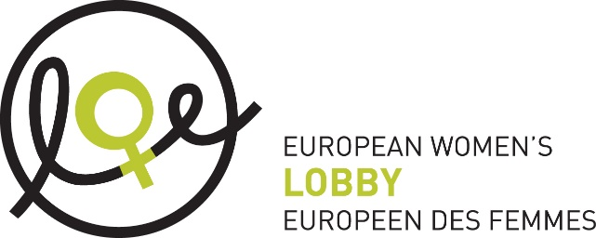

**Esteemed Committee members,**

As an organisation representing over 2000 women’s rights groups across Europe, the European Women’s Lobby welcomes consideration for a General Recommendation which will build on existing work by the Committee in recognising the inequality, exploitation and violence inherent to trafficking for sexual exploitation and prostitution.

We are concerned that the current focus of the General Recommendation is primarily upon only one aspect of the 1979 Convention, Article 6. While the Concept Note considers the issue of trafficking in human beings, it does not fully elaborate on the issue of the “exploitation of prostitution of women”. **The issues of prostitution and trafficking for sexual exploitation remain intrinsically linked in all contexts and thus, the full text of the article must be taken under consideration.**

Otherwise, you create a "political position" on prostitution without a "political discussion", and risk a false contribution which will not be able to deliver on its intention to reduce trafficking for sexual exploitation, and a **real reduction of the credibility and power of CEDAW in the context of equality between women and men.**

Therefore, we strongly urge the Committee to consider this General Recommendation in light of the full text of the Palermo Protocol; the numerous international treatise which recognise prostitution and trafficking as interconnected forms of violence and oppression of women and girls; and contemporary international research on the subject.

This means alignment with agreed language and ensuring all represented texts are not in contravention of human rights: including not using misleading terms such as “forced prostitution” or the implication that the rape of children could ever be considered a form of “labour”.

**At the core driving prostitution and trafficking is the demand for paid sex acts.** Thus, we particularly **welcome** the recognition that addressing demand is required as an aspect of prevention. **Any measures to address demand must target the prostitution system as a whole**, and all of those who seek to pay for sexual acts.

In the 40 years since the Article was first drafted, we have clear evidence that where prostitution is decriminalised and the focus is made solely on trafficking, trafficking levels do not decrease because the demand for paid sex is normalised and increases. The violence and murder rates of women in prostitution also increase: this can be clearly seen for example through levels of femicide of women and girls in prostitution, perpetrated by buyers, between New Zealand, the Netherlands, Germany when compared to Sweden.

To support effective, Government-led exit programmes, support the health, safety and well-being of women and girls, to curb the profits of traffickers and to truly tackle the demand for trafficking for sexual exploitation, these issues must be dealt with in tandem through a holistic system that credibly answers to the power inequality at the heart of the sex trade. Namely, the Swedish abolitionist model.

Thank you.