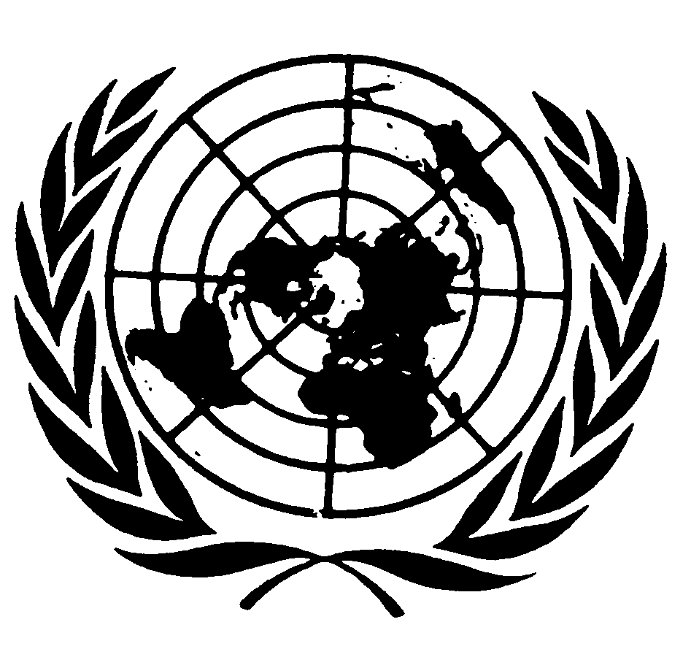
U N I T E D N A T I O N S N A T I O N S U N I E S

CHECK AGAINST DELIVERY

THE SECRETARY-GENERAL
--
ADDRESS TO THE COMMISSION ON HUMAN RIGHTS
Geneva, 7 April 2005

Thank you, Mr. Chairman. Like you I am deeply conscious of what we have all lost with the passing of Pope John Paul II. His was an irreplaceable voice speaking out for peace, for religious freedom, and for mutual respect and understanding between people of different faiths. Even as we mourn his loss, I hope all of us who are concerned with human rights can pledge ourselves to preserve those aspects of his legacy.

Excellencies,
Ladies and Gentlemen,

One year ago today, we stood together in this Commission in silent tribute to the memory of the victims of genocide in Rwanda. We recalled again our collective failure to protect hundreds of thousands of defenceless people. And we resolved to act more decisively to ensure that such a denial of our common humanity is never allowed to happen again.

Today we have reached another moment when we must prove our commitment.

First, because of the appalling suffering in Darfur. Valiant efforts have been made to deliver humanitarian assistance. I am glad the Security Council has now agreed, both to impose sanctions on individuals who commit violations of international humanitarian or human rights law, and to ask the International Criminal Court to play its essential role in lifting the veil of impunity and holding to account those accused of war crimes and crimes against humanity. And I think we should all be grateful to the troops deployed by the African Union, whose presence – wherever it is felt – is definitely helping to protect the population from further crimes. But in its present form that force is clearly not sufficient to provide security throughout such a vast territory. And meanwhile, there has been hardly any progress towards a political settlement. For all of us, as individuals and as an institution, this situation is a test. For thousands of men, women and children, our response is already too late.

But today I am also thinking of victims whose plight is not so well known. I have in mind the weak, the poor and the vulnerable. I am thinking of all people who are denied their human rights, or who may yet fall prey to violence and oppression. To all, our responsibility under the Charter is clear: we must do more to promote and protect fundamental rights and freedoms.

Indeed, nobody has a monopoly on human rights virtue. Abuses are found in rich countries as well as poor. Women in a wide range of countries continue to enjoy less than their full rights. Whether committed in the name of religion, ethnicity or state security, violations have a claim on our conscience. Whether carried out in public or in more insidious ways, breaches must compel us to stand up for the right of all human beings to be treated with dignity and respect.

Human rights are at the core of the package of proposals I have just put before the Member States in my report, “In Larger Freedom”. I argue that we will not enjoy development without security, or security without development. But I also stress that we will not enjoy either without universal respect for human rights. Unless all these causes are advanced, none will succeed. And unless we re-make our human rights machinery, we may be unable to renew public confidence in the United Nations itself.

The cause of human rights has entered a new era. For much of the past 60 years, our focus has been on articulating, codifying and enshrining rights. That effort produced a remarkable framework of laws, standards and mechanisms – the Universal Declaration, the international covenants, and much else. Such work needs to continue in some areas. But the era of declaration is now giving way, as it should, to an era of implementation.

The recommendations I have put forward reflect this evolution. Most of all, they attempt to build a United Nations that can fulfil the promise of the Charter. Thus I have proposed major changes in the three central pillars of the United Nations human rights system: the treaty bodies, the Office of the High Commissioner and the inter-governmental machinery. Let me take them each in turn.

The seven treaty bodies are the independent guardians of the rights and protections that have been negotiated and accepted over the years. Their dialogue with States emphasizes accountability, and their recommendations provide clear guidance on the steps needed for full compliance. The treaty body system has helped to create national constituencies for the implementation of human rights. But the system must be streamlined and strengthened, so that the treaty bodies can better carry out their mandates. And urgent measures must be taken to enable them to function as a strong, unified system.

I have also called on the membership to strengthen the Office of the High Commissioner for Human Rights. The role of the Office has expanded greatly. In addition to its long-standing advocacy work, today it is also engaged in conflict prevention and crisis response. And where once much of its energies were devoted to servicing the human rights bodies, today it also offers wide-ranging technical assistance.

Yet the Office remains ill-equipped in some key respects. It cannot, for example, carry out proper early warning, even though human rights violations are often the first indicators of instability. The High Commissioner and her staff continue to work admirably within real constraints. They would be the first to acknowledge shortcomings, and they are best placed to identify ways to overcome them. Accordingly, I have asked the High Commissioner to submit a plan of action by 20 May. I expect a request for additional resources to figure prominently in her recommendations. As central as human rights are in our work, the United Nations allocates just two percent of its regular budget to that programme. We need to scale up to meet the growing challenges that confront us.

I turn now to the most dramatic of my proposals. As you know, I have recommended that Member States replace the Commission on Human Rights with a smaller Human Rights Council.

The Commission in its current form has some notable strengths. It can take action on country situations. It can appoint rapporteurs and other experts. And it works closely with civil society groups.

At the same time, the Commission’s ability to perform its tasks has been overtaken by new needs, and undermined by the politicization of its sessions and the selectivity of its work. We have reached a point at which the Commission’s declining credibility has cast a shadow on the reputation of the United Nations system as a whole, and where piecemeal reforms will not be enough.

A Human Rights Council would offer a fresh start. My basic premise is that the main intergovernmental body concerned with human rights should have a status, authority and capability commensurate with the importance of its work. The United Nations already has councils that deal with its two other main purposes, security and development. So creating a full-fledged council for human rights offers conceptual and architectural clarity. But what is most important is for the new body to be able to carry out the tasks required of it.

I have proposed that the Council be a standing body, able to meet when necessary rather than for only six weeks each year as at present. It should have an explicitly defined function as a chamber of peer review. Its main task would be to evaluate the fulfilment by all states of all their human rights obligations. This would give concrete expression to the principle that human rights are universal and indivisible. Equal attention will have to be given to civil, political, economic, social and cultural rights, as well as the right to development. And it should be equipped to give technical assistance to States, and policy advice to states and UN bodies alike.

Under such a system, every Member State could come up for review on a periodic basis. Any such rotation should not, however, impede the Council from dealing with massive and gross violations that might occur. Indeed, the Council will have to be able to bring urgent crises to the attention of the world community.

The new Human Rights Council must be a society of the committed. It must be more accountable and more representative. That is why I have suggested that members be elected by a two-thirds majority of the General Assembly, and that those elected should have a solid record of commitment to the highest human rights standards. Being elected by a two-thirds majority of the General Assembly should help make members more accountable, and the body as a whole more representative.

A Council will not overcome all the tensions that accompany our handling of human rights. A degree of tension is inherent in the issues. But the Council would allow for a more comprehensive and objective approach. And ultimately it would produce more effective assistance and protections, and that is the yardstick by which we should be measured. I urge Member States to reach early agreement in principle to establish a Human Rights Council. They can then turn to the details such as its size, composition and mandate; its relationship with other UN bodies; and how to retain the best of the existing mechanisms, such as the special rapporteurs and the close ties with NGOs. Consultations with the High Commissioner would naturally be a very central part of this process, and she stands ready to assist. Let us all do our part to make this happen, and show that the United Nations takes the cause of human rights as seriously as it does those of security and development.

Ladies and Gentlemen,

Human rights are the core of the United Nations’ identity. Men and women everywhere expect us to uphold universal ideals. They need us to be their ally and protector. They want to believe we can help unmask bigotry and defend the rights of the weak and voiceless.

For too long now, we have indulged this view of our own capabilities. But the gap between what we seem to promise, and what we actually deliver, has grown. The answer is not to draw back from an ambitious human rights agenda, but to make the improvements that will enable our machinery to live up to the world’s expectations.

Our constituents will not understand or accept any excuse if we fail to act. So let us show them that we understand what is at stake.

Thank you very much.

