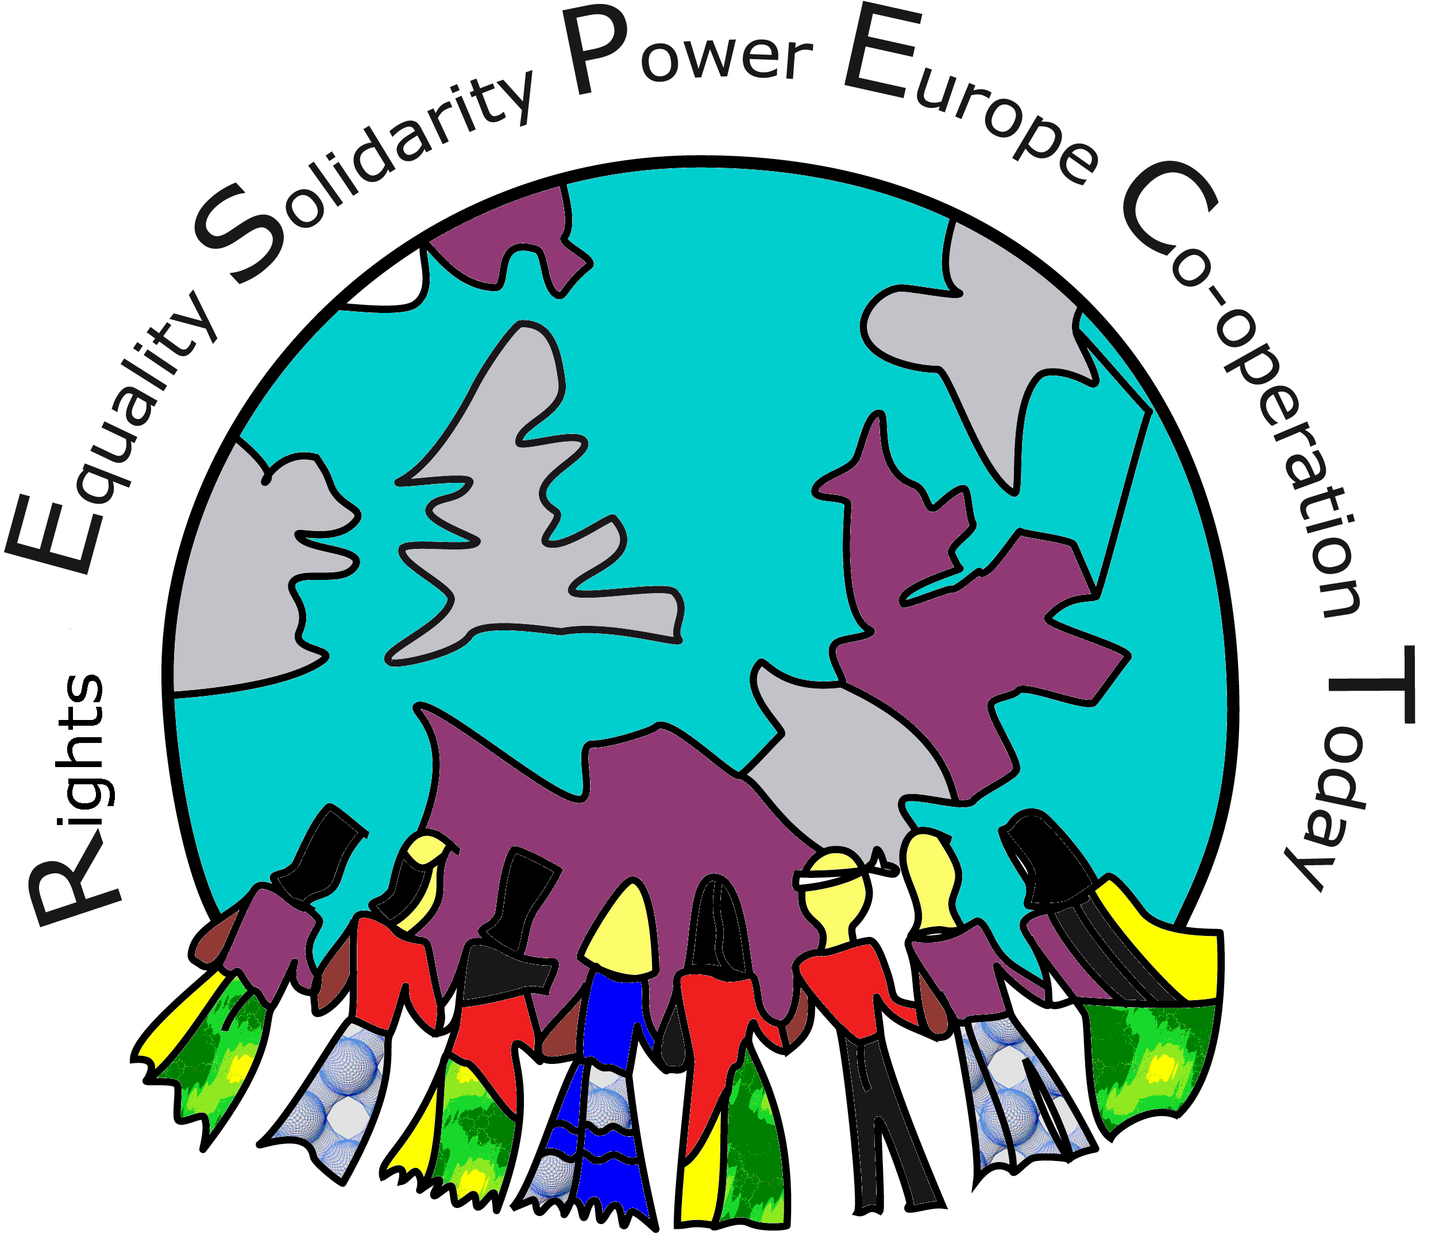
De Wittenstraat 25, 1052 AK Amsterdam, NL ; Tel: 00-31-20-6646927;email : eurespect@gmail.com; www.respectnetworkeu.org

Rights Equality Solidarity Power Europe Co-operation Today
RESPECT Network: Campaigning for the Rights of Migrant Domestic Workers in Europe & Internationally

Acting Together for the Protection of the Rights of Migrant Domestic Workers

Migrant Domestic Workers Perspectives

Submitted to

The United Nations Human Rights Council (UNHRC)
Committee on Migrant Workers
Office of the High Commissioner for Human Rights, UNOG-OHCHR
October 14, 2009

by

R.E.S.P.E.C.T Network

Campaigning for the Rights of Migrant Domestic Workers

in Europe and Internationally

Amsterdam, September 2009

Table of Contents

Introduction

- Who are Migrant Domestic Workers in Europe?

- What is the immigration status of Migrant Domestic Workers?

- What are the Living and Working conditions of Migrant Domestic Workers?
Some brief profiles in Europe
  - MDW in the UK – Kalayaan
  - MDWs in Greece – KASAPI HELLAS
  - MDWs in The Netherlands – Commission for Filipino Migrant Workers
  - MDW in Ireland – Migrant Resource Center Ireland

- What are the root causes of MDWs becoming Undocumented?

- Why are Migrant Domestic Workers denied their human rights?

- What is the role and responsibility of governments?

- What is the RESPECT Campaign for the rights of Migrant Domestic Workers?

Acting Together for the Protection of the Rights of Migrant Domestic Workers
Migrant Domestic Workers Perspectives

Introduction

Many European households are increasingly dependent on migrant domestic workers and without them their employers could not go out to work in the “productive” economy. In this way, the transnational, globalised economy is brought into the private home, not just in goods consumed there, but at its very core in the organising and delivery of “reproductive” labour. (B. Anderson 2000).

Migrant domestic workers (MDWs) in the private household and their living and working conditions in Europe have been gaining increased attention within migrant communities as well as from human rights advocates, trade unions, women’s networks, academe, media, and policy makers. A number of inter-related factors contribute to this:

Rapid globalisation of economies worldwide and its impact on changing labour conditions, labour migration, including the feminisation of migration
- The changing labour and social conditions in Europe with increased demand for care provision for both the young and the elderly

The “North-South divide” in terms of intensification of unequal trade, debt and impoverishment of developing economies of the South, with resultant widespread unemployment and increasing out-migration

Double standards vis a vis labour migration – in Europe, there is significant employment of MDWs in the private household either as ‘live-in” or “live-out” workers, without due acknowledgement and in fact denial of their labour and immigration rights, resulting in the process of many MDWs becoming “undocumented”

Campaigns in several European countries (UK, Spain, Italy, Greece) by migrant communities, trade unionists and migrant rights advocates have been successful in changing the immigration legislation and gaining recognition for the work in the private household as a category for migration.

More and more families in Europe are paying for household services where previously they had relied on unpaid family labour. The nature of these services and their relative scope varies within and between states, and includes work that ranges from childcare to elder care, to all-inclusive domestic work and garden maintenance.

- Who are Migrant Domestic Workers in Europe?

Increasingly in Europe, the focus is on the provision of care for both children - where both parents work outside the home - and of older people - within the context of Europe’s ageing population. Since the 80s and 90s and continuing in this first decade of the new century, there is an increased demand for affordable care services in the private home. But who is to do this work, particularly given the broader framework of concern about more general labour shortages as a result of demographic trends?

Migration has been proposed as part of a solution to this employment gap. However the work of domestic and care services in the private home still remain categorised mainly as “unskilled” and is not recognised in many countries as a category for immigration. Thus migrant workers who come to work in the private home in the EU are only allowed to enter in some countries on temporary visas or come as tourists. In this context, the worker is faced with an unsustainable status as a worker and frequently becomes undocumented.
Work in the private home is highly unregulated. Globally as well as here in Europe it is notoriously open to abuse and to violation of basic human rights as has been well documented. In the context where the workers are migrants and undocumented, their working and living conditions are highly vulnerable and subject to systematic violation of their labour and human rights.

- Who are Migrant Domestic Workers in Europe?

Migrant domestic workers (MDWs) work in private households in roles which include childcare, eldercare, cleaning and cooking. Migrant workers tend to concentrate in live-in work, which is particularly unpopular with EU nationals, and where employers may prefer to employ foreign workers on lower wages. However, migrants also live out, making a living by working for several employers. They come from many different countries of origin (from Asia, Africa and Latin America and more recently from Eastern Europe and CIS countries. Different nationalities may cluster in certain EU states – in Spain for example, Peruvian or Dominican Republic domestic workers are more common than in the UK. Domestic workers are predominantly female, but not exclusively, and indeed male domestic workers, who may be preferred in certain contexts where heavy lifting is required for example, are particularly invisible. MDWs themselves, may range from the young to those more senior who have not yet retired but who have worked most of their lives as domestic workers in Europe.

- What is the immigration status of Migrant Domestic Workers?

Despite the growing demand for their labour, a coherent EU strategy has not been developed around immigration and domestic work/childcare/ eldercare. This means that migrant domestic workers have a wide range of immigration statuses. This depends on their nationality and on the EU state in which they are residing and working. For non-EU migrants there are three “types” of immigration status that MDWs may have:
- they may be working on a visa that requires them to work in private households as is the case in Spain, and Italy as well as ‘au pair’ visa holders in the Netherlands. Or they may have access to the labour market for example with a student visa in the UK which allows people to work 20 hours a week.
- they may be residing legally but working in breach of conditions attached to their visa (e.g. a tourist visa holder who is not allowed to work, or a student visa holder who is working more than 20 hours a week)
- they may be residing as undocumented migrants (e.g. overstayers).

- What are the Living and Working conditions of Migrant Domestic Workers?

The work of Migrant Domestic Workers (MDWs) takes place in the private household, a place, which is often exempt from labour laws and where typically trades unions do not have access. MDWs are often exploited by the families they work for, and many face psychological, physical, sexual, and racist harassment from their employers and their employers’ children.

Several research studies have demonstrated that working conditions in the private household lead to violations of labour and fundamental human rights both in situations where the immigration status and labour conditions have recently changed (as in the UK in and in Greece in 1997) as well as in countries which do not recognise domestic work as proper work or a category for immigration as in The Netherlands and in Germany.

In the examples below, some brief profiles are given.

MDWs in the UK – KALAYAAN (Box 1)
Research has found that migrant domestic workers may be exploited and abused by employers. Kalayaan, an organisation working with MDWs in the UK keeps a record of the conditions of those registering with them. The following data was collected from the 340 MDWs who registered at Kalayaan during the financial year 2006 to 2007. 84% of MDWs who registered were women.

Physical abuse | 23%
Psychological abuse | 70%
Sexual abuse | 2%
Not enough food | 71%
Working more than 16 hours a day | 86%
Locked in the house in which they worked | 27%
No private room (sleeping in the children’s room or in public space in the house such as kitchen or lounge) | 56%
Passport kept by employer | 32%
While reporting of sexual abuse to case workers is low, more in depth interviews have led Kalayaan to estimate that many of the female migrant domestic workers have also been subjected to sexual abuse.

MDWs in Greece – KASAPI-HELLAS (Box 2)

KASAPI-HELLAS (a Filipino migrant organization) together with other migrant associations, trade unions and other civil society organisations achieved a successful outcome in its campaign for migrant rights in Greece in 1997. . This success however, brought to the surface a host of problems which had deterred migrants from taking advantage of the new law. Among these problems were:

- Employers refusing to pay IKA (state social insurance) contribution, therefore MDWs are forced to pay such social security insurance – this is the basis of their legal stay.
- Many employers refuse to have their MDWs to be regularized, as a matter of convenience or refused to allow migrants to take time out from their work to work on their application for residence permit.
- inefficient government bureaucracies, lack of personnel, ignorance in implementing the regularization measure – resulted that many migrants remained to work undocumented as they did not meet the deadline set by the law
- the chaos in the regularisation procedure in Greece, total lack of coordination between the various government agencies, resulted to times migrants getting their residence permit, either expired or about to expire.
- The bureaucratic nightmare created opportunities for enterprising lawyers to make money from this process. Rather than go through the rigors and humiliations of queuing, being pushed, beaten by the police, the migrants sometimes opted to give money to these lawyers.
- Migrant organizations and Greek NGOs including political parties supporting migrants have expressed their criticisms that Greek immigration laws are mostly intended to control, restrict and manage migration but has failed to take into consideration the social, cultural and political integration of migrants to the Greek society.

MDWs in The Netherlands – Commission for Filipino Migrant Workers (Box 3)

In the Netherlands for example, a Research carried out by the Commission for Filipino Migrant Workers (CFMW) based on interviews with 182 MDWs and published in December 20051 recorded the following conditions of MDWS:

Working Conditions | - No written contracts between family employers and worker;  - Work without social benefits, access to health care and education  - Insecurity of job - options for terminating employment are frequently unilateral on the side of the employer;  - Multiple part-time jobs when ‘live-out', including work at weekends;  - Total availability when ‘live-in' - can be called on to work at any time and frequently the agreed ‘day-off’ is cancelled or changed by employer;  - When employer is on holiday, or worker is ill, a practice of ‘No work – no pay' applies.  - MDWs are expected to be ‘always on the job' – they experience reprimands or threats to lose job even if legitimate reasons for absence such as illness or personal/family emergency;  - Most find it difficult to negotiate even a small change in their working conditions – and feel they are ‘totally dependent on the goodwill of employer’.
Living Conditions | - MDWs who live-in are constantly negotiating a dividing line between being a ‘worker’ and being ‘part of the family’;  - their accommodation is often in cramped conditions;  - MDWs who live-out are faced with frequent sub-letting of accommodation, high rents and unscrupulous landlords;  - ALL MDWs interviewed do not have access to public health care and are therefore not able to benefit from preventative health care services e.g check-up for cancer or tuberculosis;  - a few choose to pay a private health insurance;  - Fatigue and stress are common health complaints among MDWs.
Other Experiences | - Most are fearful to protest violations of their rights or experiences of abuse and threats, since the consequences of losing their job(s) are very high – MDW families in their home countries literally depend on their daily work;  - All MDWs interviewed report experiences of racism in different forms: racist remarks and stereotyping; racist put-down;  - African MDWs report discrimination on availability of work and exploitation in the lower wages paid to them as compared to MDWs of other nationalities.
- Although not widespread among those interviewed, some MDWs reported experiences of sexual harassment;
- Some also reported withholding of passport by the employer and threats to be reported to the police.

MDWs in Ireland – Migrant Rights Centre Ireland (Box 4)

Since 1995, Ireland has seen huge increase in inward migration. Ireland’s economic growth and demographic change saw a huge demand for migrant domestic workers. In response to the large number of domestic workers contacting MRCI with cases, in 2003, The Domestic Workers Action Group (DWAG) was established with the goal to affect positive policy change in respect to enhancing the terms and conditions of domestic work as a sector in Ireland. A long term goal of the group is to establish a Joint Labour Committee for domestic work, which would regulate and set minimum rates of pay and standards in the sector. The group has developed a framework, but there are challenges in finding employer bodies to negotiate this tripartite agreement.

Working for  Change | - The Code of Practice for Protecting Persons Employed in Other People’s Homes.  - In 2007, the group initiated a process to develop protections for domestic workers in Ireland. This process involved MRCI, DWAG, Irish Congress of Trade Unions (ICTU) and the Services, Industrial, Professional and Technical Union (SIPTU). In conjunction with the Labour Congress and SIPTU, the code of practice was developed to reflect the lived reality of migrant domestic workers in Ireland. This was negotiated and agreed by ICTU in Ireland’s Social Partnership process.  - The code is a voluntary set of recommendations that promotes best practice for employing persons in the private home sector. Although not legally binding, the code is evidence of migrant domestic workers engaging at policy level in processes that directly impact on their lives. Interaction at this level was further advanced recently when the Minister for Justice, Equality and Law Reform, Dermot Ahern, TD, announced a long-awaited scheme to regularise migrant workers who have become undocumented for reasons beyond their control.
Work Permits | - Despite the presence of the code of practice, the situation in Ireland is far from ideal. Domestic workers from outside of the EU EEA rely on a work permit system.  - Permits are tied to employers and are not specific to domestic work. This power imbalance in this relationship effectively restricts the movement of domestic workers increasing the risk of exploitation, and increasing the risk of becoming undocumented if they try to assert their rights and leave the employer.  - Domestic work is often not recognised as work with all the rights and responsibilities associated with this.
Inspecting the Private Home | - In Ireland the labour inspectorate has the responsibility to inspect the work place. However, inspecting the private home is problematic as in other states. Although the private house is recognised as a place of work, privacy laws take precedence. Without permission from the inspector may not enter the home without a search warrant.
Diplomatic Immunity | An additional problematic area for migrant domestic work involves embassies and diplomatic sector. This raises concern as workers cannot access their right to redress due to diplomatic immunity being exercised. MRCI has identified a number of such cases involving diplomats and gross violations of worker’s rights.
Trafficking and Forced Labour | Many of the women involved in DWAG have been trafficked for forced labour or found themselves in forced labour situations. This is number is growing with six new cases identified.

4. What are the root causes of MDWs becoming Undocumented?

While the demand for workers in the private household has increased significantly in Europe, there is as yet no adequate provision for the protection of the rights of MDWs.

Underlying the unequal power relation with the employer is the fact that many MDWs are undocumented. However, the fact that work in the private household is not recognised as a proper work and not currently accepted as a category for immigration in several countries creates the situation that MDWs become undocumented when their original visa expires. MDWs in the Netherlands interviewed by CFMW regularly described their situation like this:
“Circumstances force us to become undocumented – we have no choice”.

Or as another MDW, Allan expressed it:
“Now we are in a situation as if “our human rights are being privatised and depending on the good will of our employer…we are not criminal – why are we denied our human rights? We are workers – contributing to the Dutch society and to our home country. Why can't we be treated as workers and be given our rights?”.

Many employers value the work of MDWs and readily admit that they perform a very important function towards family and social life. Some employers would like to regularise the status of the workers and pay proper wages. MDWs likewise often re-iterate their willingness to pay their taxes.

- Why are Migrant Domestic Workers Vulnerable?

It is widely recognised that low waged migrants, whatever their legal status, and whatever type of work they do, may be vulnerable to exploitation by employers. It is important to remember that this is not simply a question of personal characteristics of the migrant, though issues such as language, isolation and unfamiliarity with culture may be taken advantage of by employers. There are structural reasons why migrants are vulnerable, particularly when immigration status ties them to a particular employer, which means that they are dependent on the employer, not just for work, but for their continued stay in the EU. Frequently, upkeep and maintenance (food, healthcare and education) of the family in the home country can depend on this Sometimes families’ lives can depend on this. This kind of dependence is a particular issue for domestic workers: the isolated and unregulated nature of their work; their dependence on their employer for their housing, food and other basic necessities of life; the difficulties, for workers and employers of negotiating working relationships in the private households. All these combine to make domestic workers a particularly vulnerable group of migrants.

- What is the role and responsibility of governments?

Exploitation and abuse of migrant domestic workers is not simply the responsibility of the employing household. Governments create through migration and labour policy the structures through which MDWs are more or less likely to have their basic human rights violated. In 1997, following a 10 year long campaign by KALAYAAN and the Transport and General Workers Union (TGWU) now UNITE, the newly elected Labour Government brought in changes to the immigration rules for MDWs in order to provide them with protection from the shocking levels of documented abuse which was occurring at the hands of employers. As a result of these changes MDWs are currently recognised as workers in the UK, with an independent immigration status and the right to change employer. This means that they can leave an abusive employment situation without breaking the law, join a Trade Union and access employment tribunals. They can also report criminal abuse such as rape and imprisonment by employers to the police.

However the UK Government intends to change the MDW visa as part of its introduction of the Points Based System (PBS) for migration to the UK. Under the proposals MDWs would remain outside of the system but would be brought in on an amended business visitor visa, as ‘domestic assistants’. The visa would be valid for 6 months and would be non renewable. After this time the worker would be expected to leave the UK. If the immigration rules are changed as proposed MDWs will once again be at the mercy of their employers. This dramatic change in power relations will inevitably facilitate exploitation of these already vulnerable workers. It would mean that MDWs would continue to be brought legally to the UK yet they will not be protected by UK employment law and risk undermining the local labour market, as research shows that EU workers are not prepared to stay in these kinds of jobs2.

- What is the RESPECT Campaign for the rights of Migrant Domestic Workers?

The RESPECT network facilitates the empowerment of MDWs as main actors in the campaign for their rights as a sector. As a common campaign strategy, RESPECT member organisations pursue the following objectives:
- Recognition of work in the private household as proper work
- Ensuring the protection of the rights of all MDWs as workers, whether live-in or live-out
- Putting in place an immigration status related to their work as migrant domestic workers

At the national level, where immigration law is still determined in the EU, this campaign is contextualised according to the prevailing immigration regime and the policy on work and resident visas applied to migrants undertaking work in the private household as indicated in point 2 above.

Even where migrant domestic workers have regular work visas, it is clear that work in the private household remains vulnerable to abuse as is seen in the research carried out both by Kalayaan even after the change in UK immigration in policy in 1979 (Box 1) and by KASAPI-Hellas in Greece (Box 2). Additionally, the immigration status of MDWs (often hard won in long campaigns) is often arbitrarily put under pressure when additional changes in immigration legislation is being planned.

Both at national and international level, RESPECT regards working with Trade Unions as a high priority. Throughout the development of the campaign for the rights of MDWs, Trade Unions have responded and opened membership to this vulnerable sector of workers. RESPECT member organisations have consistently worked with the trade unions and together we have been able to achieve changes in labour and immigration legislation and gain significant breakthroughs for the rights of MDWs – in the UK, Greece, Spain, Italy, and most recently in Ireland3.

In Switzerland, the Geneva Forum for Philippine Concerns (GFPC) together with other migrant organisations in the Contact Centre Swiss Immigrants (CCSI) campaigned with the Trade Union Syndicat Interprofessionnel de Travailleuses (SIT) achieved a “Procuration” in 2005, whereby the Geneva government allows undocumented migrants to continue to live and work if they demonstrate membership of SIT. In a related development, SIT also provides integrated services for its members, including health care and access to social benefits.
In 2006, the ABVAKABO FNV trade union in the Netherlands has also opened its membership to MDWs and in early 2009 the MDW membership has been Bondgenoten FNV. The International Trade Union Centre (ITUC) also called4 its affiliates to ensure representatives of the countries on the ILO Governing body support the proposal to draw up an International Convention specifically to protect domestic workers.

RESPECT and its network members actively campaign for the ratification of the UN Convention for the Rights of all Migrant Workers and members of their Families as the most comprehensive International Instrument so far protecting and defending the Rights of MDWs. We have also held a Dialogue with the UN Special Rapporteur on Migrants (September 2004 ) and also with the Special Rapporteur on the Convention on the Elimination of Discrimination against Women (2007) and campaigned for the CEDAW General Recommendation 27.

At this time we welcome the initiative of the International Labour Organisation (ILO) to develop a Convention on Domestic Work in 2011. Since October 2008, RESPECT together with the Asian Domestic Workers Alliance (ADWA) and Migrant Forum in Asia is actively participating in the preparatory global campaign that is emerging around this initiative. Here in Europe, we are working together with Trade Unions to ensure a strong rights based ILO Convention which will change the international legislative regime on Domestic work and guarantee the rights of all workers in the private household, including Migrant Domestic Workers.

On this occasion of the United Nations Human Rights Council (UNHRC) Day of General Discussion on Migrant Workers, we urgently call your attention to the prevailing situation of widespread violation of the rights of migrant domestic workers. We seek the support of the office of the UN Committee on Migrant Workers in addressing the root causes of this systematic abuse of migrant domestic workers rights and bring to your attention the following recommendations which we have presented to the ILO and its Member governments.
- The recognition of Domestic work: The recognition of domestic work as proper work and the inclusion of all domestic workers (women and men, young or old, national citizen or migrant, live-in or live-out) as an integral part of the work force, an immigration status that recognises migrant domestic workers.
- Comprehensive legal protections: Labour legislation that applies to all other workers to be applied to the domestic workers to ensure equal protection under the law – related to written contracts, agreed wages, hours of work and rest, health insurance and other social benefits, freedom of mobility and to form self-organisations and join trade unions, freedom to change employers, as well as provisions covering the unique circumstance of live-in domestic workers regarding living conditions and privacy.
- Effective mechanisms of enforcement of labour legislation: This should include protection against unjust termination; against the risks of homelessness of live-in domestic workers; paid holidays and sick leave days.
- Effective protection for migrant domestic workers: Migrant domestic workers should have a work permit independent of their employer to ensure avoidance of abuse and violation of rights regularly experienced in ‘tied’ employment. Domestic work is not a category for migration in most European countries. Therefore while migrant workers are on the one hand delivering an enormous contribution – socially and economically - to needed and important work in European societies, on the other hand they are vulnerable to exploitation (such as long hours of work, low payment and to personal abuse by members of the families) as a consequence of the separation of juridical residence and work permit.
- Effective protection for Domestic Workers in the employment of the Diplomatic corps: Domestic workers in the employment of the Diplomatic corps should be protected by existing and new labour legislation and be able to access legal redress in the case of unjust or abusive treatment.
- Effective protection for ‘au pairs’: This is a particularly vulnerable sector of people who work in the private home. It has been a practice to accept that au pairs undertake “light household work” as exchange for accommodation while undertaking a cultural exchange. However there is increasing evidence that this framework is exploited to access a flexible and cheap source of domestic workers. The ‘au pair’ framework should therefore be strongly regulated.
- Provisions to protect domestic workers against physical, sexual and psychological violence: These provisions include access to immediate and confidential redress as well as support for and access to legal redress.

We hope that this initiative of the UN Committee on Migrant Workers (UNOG-OHCHR) will contribute to placing the violation of rights of this vulnerable sector of migrants at the centre of the political agenda and to bringing us closer to a time when new binding international instruments are in place for the protection of all domestic workers, including
Migrant Domestic Workers.

Amsterdam
September 2009

1 This CFMW Report MDWs Visible and Making a Difference! was based on Interviews carried out in the Netherlands during the period September 2004-November 2005 with 182 Migrant Domestic Workers the majority of whom worked as ‘live-out’ MDWs.
2 Anderson, B. Ruhs, M. Rogaly, B. Spencer, S. (2006) “Fair Enough? Central and East Europeans in Low wage employment in the UK” York: rowntree Foundation.
3 Joint Press Release of the Irish Congress of Trade Unions and the Migrant Rights Center Ireland welcoming the introduction by the Irish Minister for Justice, Equality and Law Reform, Dermot Ahern, TD, of a long-awaited scheme to regularise migrant workers who have become undocumented for reasons beyond their control, September 14, 2009.
4 Press Release, Protection of domestic workers: the ITUC supports proposed ILO Convention see http://www.ituc-csi.org/spip.php?article1811, February 13, 2008 ANNEX 1. RESPECT Europe - Profile Who we Are: RESPECT, a Europewide network of migrant domestic workers’ organizations, trade unions, NGOs and supporters, campaigns for the rights of all those working in the private household, both men and women, whether live-in or live-out, regardless of immigration status. RESPECT initially set-up in 1998 with its current network in 11 countries, is entering a new phase of campaigning, addressing the current trends in EU immigration policy, building new alliances and creating new connections globally. What we Do: Empower and facilitate the development of MDW local, national and transnational self-organisations and networks; Research & Analyse the issues; Link with Trade Unions, human rights and other civil society organizations to campaign and lobby for MDW Rights in Europe and globally in the context of anti-racism and discrimination. The name RESPECT was chosen for the network after an intensive process of consultation among MDWs in six European countries in 1998: Rights, Equality, Solidarity, Power in, Europe and Co-operation To-day-RESEPCT. A Charter on the Rights of MDWs was also developed during this process. For further information see RESPECT at: http://www.respectnetworkeu.org Contact: RESPECT Europe Coordination Ms. Fe Jusay De Wittenstraat 25; 1052 AK Amsterdam, NL Tel: (00-31) + (0)20-664.6927; Tel: ++31-634204226 E-Mail: eurespect@gmail.com

