Annex III
Biographical data form of candidates to human rights treaty bodies
(Please respect the specified amount of lines when completing this form)

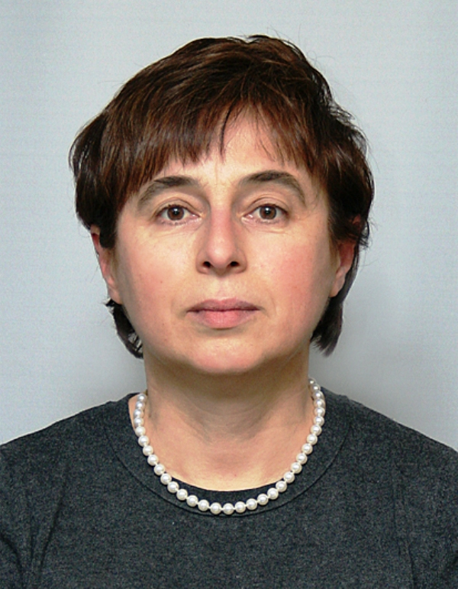
Name and first name: Todorova Velina

Date and place of birth: 03.05.58, Bulgaria

Working languages: Bulgarian, English, Russian

Current position/function:
(5 lines maximum)
Associate Professor (Docent): Law Faculty, University of Plovdiv and Bulgarian Academy of Sciences (1995-date). Research & teaching subjects: Civil & Family Law and Rights of Children. Member to the Experts’ Committee on the CoE Strategy on the Rights of the Child (2014-15). Board member of the Bulgarian Centre for Non for Profit Law (2015). Editorial Advisory Board Member of the International Journal on the Rights of the Child, BRILL, Nijhoff.

Main professional activities:
(10 lines maximum)
Deputy Minister of Justice (Dec 2011 – May 2013) (sectors i.a.: International Child Protection and Adoption, Juvenile Justice Reform). National Program Manager for International Labour Organisation (ILO)/ IPEC (2004–09): on child labour, WFCL, incl. sexual exploitation and trafficking in children. Director International Cooperation – Agency for Child Protection to the Council of Ministers (2001-04). Extensive legal expertise and experience in: law making {Family Code (2008), Child Protection legislation (1999-2000, 2003, 2009; incl. Draft Child’s Rights Act of 2010), Domestic Violence Act (2005), Supported Decision Making Draft Law (2014-16); new Juvenile Justice Legislation (2014-16); strategic planning (National Strategy on the Child (2008-18); Road Map on the Juvenile Justice Reform (2013-15). Awarded by the: President of the Republic of Bulgaria in the occasion of 25th anniversary of the UN CRC (2014) and by Chair of the State Agency for Child Protection (2016).

Educational background:
(5 lines maximum)
Last training: Oxford University, UK: Children & Family Law (2000); Human Rights Law; European Convention on Human Rights and Fundamental Freedoms, Nottingham University UK Law Faculty (Sept. – Dec.1997); Family Law & Children Law, Brunel University – London (April - May 1996). Ph. D. in Sociology of Law (1989). Lawyer, MA, Law Faculty, Sofia University (1976 – 1980).

Other main activities in the field relevant to the mandate of the treaty body concerned:
(10 lines maximum)
NGO activists since 1995 (Women in Legal Profession, GERT, Centre on Women’s Studies and Policies). Experience in reporting under the: CRC: Initial Report on Bulgaria’s Progress and Delegation member (1996-97) and Second (Periodic) Report (2003); CEDAW (contributor to the Periodic (6 & 7 consolidated) Reports. Member of the: Commission on European Family Law - CEFL: http://www.ceflonline.net/ and International Society on Family Law – ISFL. International consultancy on CRC, Family Law, Child Rights & Protection (Moldova, 2010, Tajikistan, 2011), on CRPD (Moldova, UNDP, 2014). Reporter to various national & international conferences.

List of most recent publications in the field:
(5 lines)
Family Code: Thematic Commentary. 2015, Sofia, Chapters: Adoption; Parents – Child Relationship. Family Justice in Bulgaria: The Old System and the New Demands. In: Delivering Family Justice in 21st Century. Hart Publishers, 2015. The New Paradigm of the Legal Capacity: article 12 of the UNCRPD. Pravna Misal, 1/2014, Mothers and Fathers Disputing Parental Rights: For a New Gender Order in the Family Law? In: Family Relationships in the Changing Society. Sofia, SIBI, 2014. Child Relocation: the Law and Practice in Bulgaria. Pravna Misal, 3/2011. Children’s Rights in Bulgaria after the End of the Communism. The International Journal of Children Rights, Vol. 17, No 4, 2009.

