
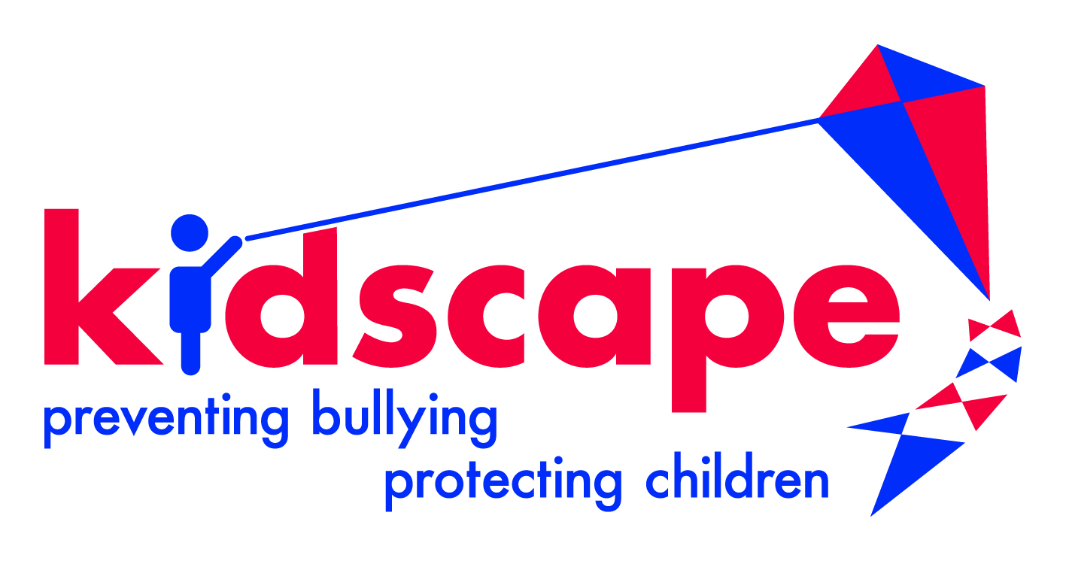
Children’s Charities’ Coalition on Internet Safety

Response to request for comments on the concept note for a General Comment on children’s rights in relation to the digital environment.

The UN Convention on the Rights of the Child embodies universal principles which are every bit as important today as they were in 1989 when the Convention was adopted. However, unquestionably, the Convention is a pre-Internet document. It is highly unlikely parts of it would have been written in the same way if we had known then what we know now.

The internet’s origins were in academia and the research community. For many years it was, essentially, a small “adults only” world where a high degree of trust, mutuality of interest and reciprocity existed between the users.

The problems with the internet that policy makers are currently having to grapple with started to arise when, following the release of the first web browsers, the internet broke from its moorings and began its long march towards the mass consumer market. We are therefore all living with an egregious example of the doctrine of unintended, unforeseen and unwanted consequences.

Today children constitute 1 in 3 of all internet users globally, rising to around 1 in 2 in parts. Against this background it is regrettable that we are constantly having to remind policy makers and online businesses of the need to have regard to children’s interests.

Shouldn’t the conversation be flipped? Shouldn’t we start from the proposition that the internet is a mixed environment in which children are a constant and major presence? We could then proceed to debate what steps need to be taken to guarantee or provide for adults’ rights insofar as they are qualitatively distinct from or additional to those of children?

The technical complexity of the internet environment, its transnational, multi-jurisdictional nature, the speed at which things happen, linked to the rate at which it has grown and continues to change presents unprecedented challenges.

The call to develop a General Comment is therefore timely and most welcome. It reflects the fact that in the 2st Century digital technologies play a much more important role in children’s lives than they did in the mid to late 20th Century.

There is a very strong argument to say that, today, having access to the internet should be regarded as a fundamental right for children.

Not having access to the internet puts children at a disadvantage when compared with their contemporaries who do. This is true both within individual countries and as between countries. Among many other things this is because of the role the technology plays in enriching and expanding educational opportunities.

CHIS would therefore like to see the General Comment reflect the importance of

- Recognising that reliance on self-regulation as the core principle of internet governance is a failed model. It should be abandoned. That is not to say there is no scope for self-regulatory or co-regulatory responses to address discrete issues but within a particular jurisdiction these must be embedded within a clear framework of laws which properly delineate the rights and obligations of all key actors. It is acknowledged that solutions or approaches that can work on an international basis are always to be preferred but given the polarisation of global politics and the weakness and sluggishness of too many international institutions, it is specious to argue that only an internationally agreed solution is acceptable. That is, in effect, an argument for preserving the status quo for a great deal longer. Working within a well-informed global network (see below paras 9 & 10) strong models can emerge in individual countries. These can give a lead which others can adapt to their local circumstances.

- Seeing the internet as a medium to empower, further and enhance children’s rights. This requires a major focus on developing and improving digital literacy, promoting greater awareness of norms of behaviour among children themselves, among parents and all the major components of the children’s workforce e.g. teachers, social workers, health care professionals and police officers.

- Reducing bullying and getting more help and support for children who are victims and perpetrators. This means empowering children to address bullying better themselves while also sensitising all parts of the children’s workforce and parents. App developers and platforms need to be able to demonstrate they have the capacity to respond quickly to problems as they arise. Companies should be willing to provide monetary and other forms of redress or compensation where they have failed to discharge their obligations.

- Acknowledging that all online businesses need to embrace the importance of the local context in which children live, seeking to be inclusive and in particular to deploy the mother tongues of their users. The idea that the internet should reflect or entrench the values, norms and outlooks of the country which happens to be the legal domicile of the principal developer or owner of a site or service is unacceptable.

- Reducing exposure to age inappropriate material and environments. The most obvious examples concern pornography, violence, terrorism, xenophobia and challenges around fake news and echo chambers or filter bubbles. This can be achieved through a combination of signposting, moderation and the deployment of technical tools. Algorithms should not become funnels which perpetuate, amplify or extend negative content or experiences.

- Reducing sexual crimes e.g. grooming, trafficking and csam. This will require greater harmonisation and standardisation of criminal laws and the laws and regulations which govern the collection, exchange and use of digital evidence across national borders. Companies should be required to publish independently certified reports which confirm they are taking all reasonable and proportionate steps, both technically and in terms of processes, to combat criminal behaviour directed at children. Such independent certification could also confirm that the business or platform concerned paid due regard to the wider best interests of children and sought their views in relation to matters of concern to them.

- Recognising the extra needs of children from more vulnerable or marginalised groups, emphasising the importance of ensuring these needs should be met without discrimination.

- Recognising that higher income countries have faced substantial and still unresolved difficulties when addressing challenges which have emerged since the arrival of the internet. There is therefore an urgent need to consider the position of countries with less well developed social, educational or law enforcement infrastructures because, as fast broadband access becomes more commonplace within their borders, so similar issues will start to arise. This is in part because children in all parts of the world are either using the exact same sites or online services, or the sites and services they use are very similar with their own internal logic which shapes the experience of the children, notwithstanding other important differences.

- Requiring international institutions linked to the internet’s infrastructure and governance e.g. ICANN, IETF, W3C and the IGF to show that children’s voices are heard and that children’s interests are properly considered at all relevant stages of their policy development and decision-making processes. International institutions and national governments should be encouraged to engage more directly with these bodies while, in the latter case, also ensuring civil society groups from their country can also participate on equal terms or at any rate on substantially better terms than exist at present.

- Recognising the lack of a global observatory which focuses on children’s rights in the digital environment is a severe handicap. Working in association with other agencies with complementary aims or skills, such an observatory should have the capacity to monitor policy, technical and legal developments and emerging best practice in different countries in all parts of the world. The observatory should aim to develop and become the focal point for a worldwide network of practitioners. The mandate should extend to ensuring information on best practice and available resources is made available to the network in the most useful, usable, targetted and timely way. Such an observatory might also play a role in encouraging the development of toolkits and model agreements that companies could adopt. It could report on the matters referred to in para 5 (above) in terms of how individual companies are behaving in relation to children’s rights. The observatory must be demonstrably independent, free to speak about any company or organization in any country of the world. It is recognised that creating it will require substantial resources and because of its long-term nature and ambition it is not an instantly attractive proposition for traditional sources of funds. These tend to prefer shorter timeframes with more immediate evidence of the beneficial impact of their investment.

- Acknowledging that the lack of on-the-ground capacity in many countries is a severe handicap. Emails, pdfs, web sites, mailing lists and newsletters, one off lectures, seminars or training sessions and Skype calls have their place, but they can never be a wholly satisfactory or complete answer, particularly in the early stages of a country’s engagement with these issues. Very often advice and assistance is needed readily to hand in-country at least until an appropriate framework for policy development has been established or is well underway and is becoming rooted in local structures. The observatory referred to in para 9 could play an important role in developing a greater capacity to assist national initiatives.

---ooo---
John Carr OBE
Secretary, Children’s Charities’ Coalition on Internet Safety
10, Great Queen Street London WC2B 5DD
www.chis.org.uk
13th May, 2019

