ISHRI
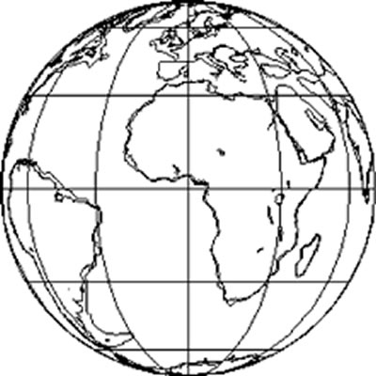

INTERNATIONAL SOLIDARITY & HUMAN RIGHTS INSTITUTE

Offices: P.O. Box 226, Bloomingdale OH 43910, USA Tel: (740) 381-2090 1025 Commons Circle, Naples, FL 34119, USA Tel: (239) 687-5373
contact@ishri.net www.ngovoice.com ishri.dbs@gmail.com

Board of Directors* & Officers
*D. Brian Scarnecchia, M.Div, JD
President & CEO

*Stephen M. Krason, Ph.D, JD
Vice President, Education & Research
*Ligia De Jesus, LLM, UNAH, Lic.
Vice President, International Human Rights

Stephen L Mikochik, JD
Vice President of Diversity

*Charles Menk, Jr., M.DT
Director of Fiscal Development
*James E. Coyle, Jr., Ph.D
Director of Communications
*David Dombrowski, Ph.D

Director of Information Technology

Board of Advisors +
Jane Adolphe, ll.B/BCL, JCD
Professor, Ave Maria School of Law
Rhonda Chervin, Ph.D.
Philosopher and Author
Patrick Monaghan, JD
European Center for Law & Justice
Raymond Noble, JD
New Jersey State Bar Association
Ronald Rychlak, JD
Professor, Univ. of Mississippi Law School
Joseph A. Varacalli, Ph.D
Co-Founder of the Society of Catholic Social Scientists
Mercedes Arzú Wilson
President, Family of the Americas
Wendy Wright
Vice President of C-Fam
Daniel Ziedler
Latin American Alliance for the Family

ISHRI has NGO consultative status with the UN
and the Organization of American States (OAS)

Main UN Representative & Legal Counsel, NYC:
Professor Brian Scanrecchia, JD

Main UN Representative in Geneva :
Dr. Ingrid Detter de Frankopan, D.Phil; Jur.Dr.

Main OAS Representative and Legal Counsel
Ligia De Jesus, LLM

+ All titles listed for informational purposes only

June 29, 2017
Jorge Araya
Secretary of the Committee on the Rights of Persons with Disabilities
Groups in Focus Section
Human Rights Council and Treaties Division
Office of the United Nations High Commissioner for Human Rights
52 Rue de Paquis
1201 Geneva, Switzerland
jaraya@ohchr.org

Re: Submission Luxembourg

Dear Secretary Araya:

The International Solidarity and Human Rights Institute (ISHRI) is a non-governmental organization in consultative status with the United Nations Economic and Social Council since 2011.
On behalf of ISHRI, I am pleased to submit the following statement and appendices of Professor Stephen L. Mikochik, ISHRI Vice President of Diversity, to the Committee on the Rights of Persons with Disabilities. It challenges Luxembourg’s initial report under the Convention on the Rights of Persons with Disabilities (CRPD).
It is our position that Luxembourg’s claim that its act of March 16, 2009, legalizing euthanasia and assisted suicide, does not discriminate against disabled people is false. For the Committee to accept that claim would set a dangerous precedent for States Parties considering end-of-life legislation in the future.

Sincerely,

D. Brian Scarnecchia,
ISHRI President and CEO

