NGO
Alliance Autiste
- France -

SUBMISSION
about education
for autistics
in France

for the Day of General Discussion (DGD)
on the right to education for persons with disabilities,
15 April 2015, Palais des Nations, Geneva

regarding the Article 24 of the
Convention on the Rights of Persons with Disabilities

March 15, 2015

Introduction: presentation of Alliance Autiste
This alternative report was prepared by the NGO "Alliance Autiste", a French national association of autistic persons aimed for mutual aid and general defence of autistic persons of all ages and from all parts of the spectrum of autism. Our group wants to promote understanding and cooperation with all organizations involved in autism, including parents' associations, NGOs, government and international agencies.
We work closely with the NGO Minority Autistic International, based in Geneva, the central organ of the "self -advocacy" movement for autism in the world, which is very active at the UN. We believe that the minority of autistic persons (about 1% of the world population) do not live in fair and decent conditions, and that substantial injustice could be reduced through better understanding of our particularity, autism, which is not a disease.
Autistics who are able to communicate are well placed to understand and to help understand autism, furthermore we believe that any category of people should have the possibility to defend themselves and take part in decisions affecting them.

This testimony serves to show that although French legislation guarantees the access of disabled children to the rights mentioned in article 24 of the Convention, the reality on the ground is quite different. We analyse in this report the different obstructions within the French system which deny access to these rights and we propose some recommendations in the light of the different situations and causes that led to these statements."

The context in France
France has been condemned 5 times by the Council of Europe for neglecting to uphold its educational obligations towards autistic persons, such as defined in the revised European Social Charter (2004, 2007, 2008, 2012, 2014).
In 2012, the European Action of the Disabled (AEH) filed complaints against France to the Council of Europe, alleging that France failed to respect the right to education for autistic children and teenagers owing to different treatments in the fields of education and vocational training between autistic persons and persons with other disabilities.
In September 2013, the European Committee of Social Rights condemned France, concluding that « there is a violation of Article 15§1 of the Charter with regard to the right of autistic children and adolescents to be educated primarily in mainstream schools [and] because the work done in medico-social establishments caring for autistic children and adolescents is not predominantly educational in nature. »
The French Equal Opportunity Act 2005 guarantees for every child the right to education in a mainstream school, to a compensation of the disability via teaching arrangements, human assistance, and benefits for parents to finance the interventions required for their advancement.
The French School Reorientation Act 2013 is deeply focused on the principle of inclusion.
Compensations are decided upon by the French Departmental Units for Persons with disabilities (MDPH), a public-interest organization. Decisions are taken depending on children skills assessments, the family’s choice, along with the judgement of educational staff and health professionals. The MDPH renders also educational decisions for children, in a mainstream school or a medico-social establishment.
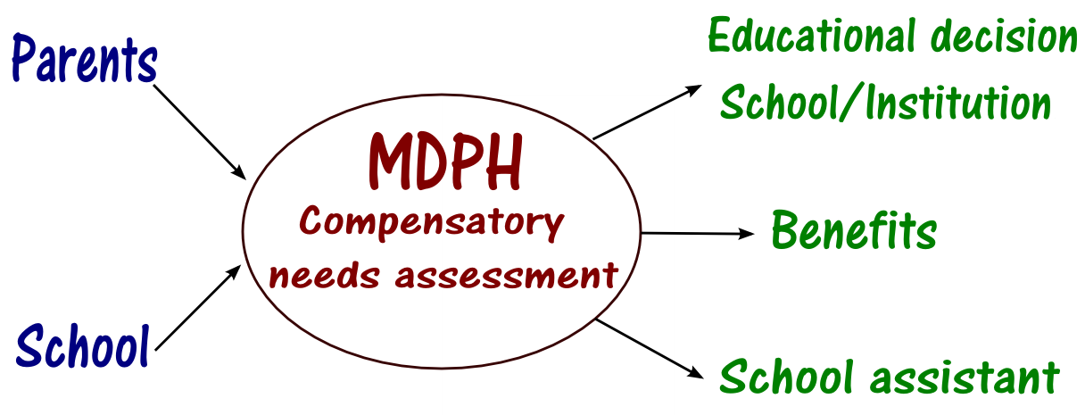

In France there are two distinct types of education: normal education for children without disability (school) and the medico-social sector for children with disabilities ("institutions"), restricting the inclusion of autistic children in mainstream schools. Those are mainly guided towards medico-social establishments. Professionals, teachers and establishments show strong resistance, fearing that inclusion (in normal schools) would affect the continuity of their vocational situation.

Discrimination
- Current situation
In 2012, the AEH asserted in a complaint to the Council of Europe against France
“that there was a general discrimination because of the situation of autistic children with regard to education.”
Indeed, as some media pointed out, many autistic children are considered ineligible for mainstream education, leisure and sport.
• E.g. Timothée, 15 years old, was to integrate his secondary school for the year 2013-2014, and everything was fine. However, he was physically barred from entering on the first day. Some days later, his mother attempted again to get him into the school: he was accepted but put apart from the other pupils, in an empty room. She definitely removed him from his school to avoid him the pain of rejection.

- The reasons behind the current situation
The grounds for such exclusion are a lack of human assistance in the school and the absence of education of educational staff or moderators about the syndrome. They have crowded classes, do not manage or take the time to elaborate learning objectives adapted to their special needs.
Moreover, because there are medico-social establishments, teachers do not really understand the reason why parents want their child to enter a mainstream school. So they do not feel that they practice discrimination by not letting in such children for their autistic features. In their opinion, such children come within the scope of disabilities, i.e. medico-social establishment.
And yet, autistic persons especially, need to live in an ordinary society to learn social codes to help reduce their social disabilities, which is very difficult when living in isolation, not to mention the feeling of exclusion and inferiority resulting from "institutionalization", while autistic children specifically need to develop their self-esteem.
As a consequence, they are not considered as pupils but children to take care of. At best, they are accepted as the law requires, until parents accept guidance towards a medico-social establishment.

Mainstream schooling very insufficient
- Current situation
On paper, the 2005 French Equal Opportunity Act forf persons with disabilities meets the requirements of Article 28. However, in reality, this law is almost never applied.
The following graph shows the distribution of autistic children by type of education in 2011-2012:

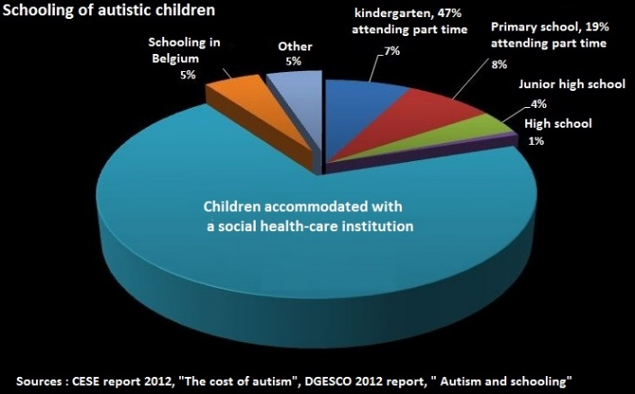

The French National Education Ministry indicates that 20 375 autistic children have access to mainstream school education, either on a full time or part time basis. This corresponds to less than 30% of the total population of autistic children.
This school education is delivered in either ordinary classes or in specialized classes where children with mental disabilities are grouped together with autistic children.
Furthermore, the number of autistic children attending school diminishes when the level of education increases: in 2012, 47% of autistic children attending school were in pre-schools and kindergarten, against 19% in primary school, 4% in junior school (lower secondary) and only 1% in high school (upper secondary).
When considering the above statistics, one must bear in mind that school education provided to autistic children is mostly ineffective: often autistic children are simply registered as attending a school in order to meet the legal obligation of school attendance by disabled pupils, but in reality the child is not actually welcome to attend classes, or is forcibly home-schooled, but nonetheless counted in the school statistics.
Furthermore, these statistics do not take into account the time autistic children actually spend at school. For instance, 47% of autistic children attend preschools and kindergarten on a part time basis, even on a very reduced part time, such as 3 hours per week. This figure is 19% for primary schools.
Where they exist, special education classes (12 pupils per class) are ghettoised within the school and offer virtually no opportunity for integration with ordinary classes. In general there is a specialised teacher, who is most often not trained to deal with autistic children, and an educational assistant for the entire class, while many autistic children require one-on-one assistance.
Finally, due to the lack of capacity in medico-social establishments and to the State’s inability to create and finance specialised classes, France is left with a paradoxical solution: to finance the education of French autistic children in Belgian schools, which have specialised classes led by professional educators who are trained in the management of autism.
- Consequence
An autistic student who is in school for a few hours a week is penalized compared to an ordinary student, thus adding to a further handicap to his autistic disability. There is no systematic inclusive education for autistic students, and inclusion remains the exception rather than the rule in France. Yet, inclusion has been proven to be the most effective answer to this handicap because autism is primarily a communications disability. Thus, the development delay in communications skills can gradually diminish only by maximizing interactions and exchanges with children without such disabilities. The efficiency of inclusion is evidenced by several scientific studies when comparing current approaches to autistic disabilities.
Yet, in France, most autistic children are “schooled” in medical establishments known as day-hospital units, where the autistic child is most of the time simply "kept an eye on". In these units, no one keeps the child from self-stimulating and no means of communication is taught to these children, nor are they given the opportunity to interact with non-handicapped children.
These children then develop behavioral problems which are mainly caused by an inability to communicate, aggravated by their isolation. These disorders are often handled with neuroleptic drugs, rather than behavioural therapy.
This situation hinders their emotional growth, and damages the development of their physical and mental abilities.
- The reasons behind the current situation
- Abusive institutional placement decisions
Today's adults grew up without being in contact with persons who were different from them; so they feel frightened when they meet one, because of a lack of knowledge, and think it is normal that these persons (children and adults) are concentrated in medico-social establishments, which is mostly the case today. They are unaware of the system of segregation maintained by the State. It seems natural that someone “different” has to live apart (leave society to live in an institution), instead of changing the society to encourage the inclusion of all, each one with their own particularities.
The State does not assume it's responsibilities towards these persons who are different and has left the parents' associations to themselves create and manage these medico-social establishments. They filled a void.

The children of those parents who are managers of institutions are today autistic adults and there is a generational conflict between these parents (for whom the notion of integration didn't even exist at that time) and parents of younger children, who want mainstream schooling and refuse specialised institutions.

At present the establishments are managed by the federations of associations of parents of handicapped children (mentally handicapped and autistics), which are firmly in place and well established. There is a whole economy in the disability sector behind the establishment and management of such institutions. The federations continually seek to fill them in a cost effective way and to develop other establishments. As mentioned earlier, they could be influenced by the fact that there is little or no state control: the Health Care finances them without adequate accountability, and nobody knows how it is actually used.

Some representatives of these associations are on the commission of the Departmental Units for the Disabled (MDPH) that makes placement decisions for disabled and handicapped children. They are judge and interested party, and they must reconcile the interests of the children and their own interests as establishment managers.
These representatives make their choices (they "do their market") in the commission, deciding to place this or that child in one of their medico-social establishments.

That's why a large number of autistic children are guided towards medico-social establishments instead of staying in regular schooling.
Moreover, even if all decisions are supposed to be made with the agreement of the family, in practice the commission often decides alone, without consulting the parents and this decision is almost always a placement in a medical-social establishment even if there is no place in the said establishment.
• Example
A mother of a boy, who was previously educated in secondary school, asked the Departmental Service for the Disabled (MDPH) to renew the contract for her son's school assistant for the 2014-2015 school year. The commission decided to place him in a medical-social establishment, saying that that her son will not need a school assistant, because he will be placed in an establishment.
- The lack of school assistants
When parents request a school assistant for their child, the Departmental Unit for the Disabled (MDPH) decides on the request, approving or not a school assistant. The Ministry of National Education is then responsible for recruiting this assistant.
Since the commission of the Departmental Unit for the Disabled (MDPH) tends to place children in establishments, it generally approves only a few hours of school assistance per week.
Furthermore, even when the Departmental Unit for the Disabled (MDPH) notifies hours of school assistance, the Ministry of National Education is having a difficult time recruiting school assistants, so even though a child is eligible for assistance, there is no-one to help them.
However schools allow an autistic child to attend school on condition that they are accompanied by a school assistant. The low number of hours approved by the Departmental Units for the Disabled (MDPH), combined with the difficulty in recruiting assistants, leads to discrimination against autistic children.
These assistants are not trained in autism, and have a very precarious employment status. For example, their contract can end during the school year, and the child, without an assistant, will be removed from school before the end of the school year.
When a family wants to contest the departmental unit for the disabled's (MDPH) decision about the hours of assistance or the non-attribution of the assistant by the national education ministry, they have to lodge an appeal. Unfortunately, because of the significant delays, this appeal is rendered de facto ineffective: indeed, even when the appeal has been accepted, the court's decision will not become effective until the next school year... So the child will not have a school assistant because the appeal takes too long: this constitutes a violation of the fundamental right to education and school enrolment.
- The pressures from school
Another reason for this creeping de-schooling (of autistic children) is that the Ministry of National Education, despite the French School Reorientation Act to promote an inclusive school, does nothing to encourage inclusion.
This Ministry was the most notable absentee when recommended best professional practices about autism were being developed. Consequently, the emphasis is not upon mainstream schooling.
Teachers are not trained for this, and the educational program for ordinary children is already overburdened. Moreover, because they didn't grow up in an inclusive society, they consider that the place of these children is in medico-social establishments.
Furthermore, the teachers who wish to get involved personally don't receive recognition from their hierarchy for the efforts they could make to improve schooling for the autistic pupil. Actually, the opposite is true, for school hierarchies generally favour their orientation in a «specialised environment» (i.e. in an "institution" ("Institut Médico-Social", medico-social establishment), i.e. one that doesn't depend on the Ministry of National Education.
The relationship between mainstream and special education has historically been compartmentalised. Inclusion is often perceived by the both sides as a threat on the professional front: fear of job losses in special education, fear of losing their points of reference by mainstream teachers. Indeed, a common argument to justify denying them schooling is « I am not a specialist teacher », implying that their enrollment in school requires a special needs teacher.
The psychologists and school doctors who participate in the meetings aimed to relay their needs to the departmental units for the disabled (MDPH) are often trained in psychoanalysis (which considers the mother responsible for her child's autism), so they usually support a decision to place these children in a psychiatric day-care hospital unit or local specialised institution.
Reports written during these meetings frequently highlight only the negative aspects of school enrolment, omitting the positive aspects. These reports are then sent to the departmental units for the disabled (MDPH) that takes its decisions on the basis of this simplistic and partial report.
• Example:
X., 5-year-old, is suspected of having Asperger's Syndrome (a form of autism). He is in nursery school, with a private follow up. The referent teacher (coordinating between school and MDPH) pressures the mother to accept a placement in a psychiatric hospital day-care unit. The referent sends to the MDPH doctor a report in which she affirms that the private care is not good.
During meetings in school, school doctor, psychologist, teacher and referent insist that the mother should accept partial hospitalisation for her son. In her report, the referent does not mention any positive aspects, and suggests that the child assaults other children (which is not true).

Autonomy and effective participation to the free society discouraged
The great majority of autistic children are concentrated in psychiatric day care hospitals or in medico-social establishments for disabled children with learning disabilities but without staff specialized in autism: the autism professionals do not apply the approaches recommended by the independent, scientific High Health Authority (HAS).
Some of these children are deported to Belgium, to institutions that the Belgians call “usines à Français“(factories with French). This is being financed by France.
In medico-social establishments, schooling is not very effective: when there is a class-room in the establishment, activities in the classroom often only represent a few hours a week, where all the children are together, without precise educational goals, neither taking into account the level nor the potential nor the specific profile of each child.
Following the study of the class action against France brought by AEH (European Action of the Disabled) in 2012, the European Committee of Social Rights at the Council of Europe unanimously concluded that there is a violation of article 15-1 of the Revised European Social Charter “because the work done in medico-social establishments caring for autistic children and adolescents is not predominantly educational in nature.”
In general, parents don’t really know what their children are doing in the institution all day long. (The child comes and goes by taxi, hence parents never really have the opportunity to speak with the staff). In addition, evaluations of the children's skill levels and the training objectives are usually very vague.
Their autonomy and participation in the social life of the institutions are in no way supported.
Practically speaking these institutions offer at best some kind of occupational therapy, at worst nothing at all or therapies based upon psychoanalysis (observation without interaction, storytelling workshops, working with clay, therapeutic puddle: a room with a shallow pool and a dry area where therapists observe the child at play, and packing: where the children are bound in tight, cold wet cloths which are allowed to dry and shrink).
As a consequence, an autistic child will have practically no opportunity to make progress and to acquire autonomy (without stimulation, the child will learn nothing). While growing up, behaviour problems will increase as he will not have learned how to communicate. This often leads to excessive use of psychotropics (in particular neuroleptics) used as chemical strait jackets to control behaviour problems, which a psycho-educational approach would have avoided or at least limited their aggravation.
As the National Ethics Advisory Committee for Health (CCNE) observed, all this constitutes abuse by neglect.

General recommandations that promote inclusion
We recommend:
- that the 2013 education law, which was founded on the principle of inclusive schools (adaptation of the school to the child's needs), be applied in concrete measures: all teaching staff should be trained in inclusion and inclusive education in order to promote inclusion and awareness that it is beneficial for the child, for themselves and for other students ;
- the end of the segregation between special education and “regular” education;
- a contribution of human and material resources (specialized teachers available in the school, specific educational materials available for all schools ...) ;
- that teachers be encouraged and recognized by their superiors concerning the inclusion of an autistic student in their class ;
- an up-to-date training related to autism for school psychologists and doctors;
- an up-to-date training related autism for persons working for regional authority responsible for funding special needs (Departmental Units for Persons with Disabilities, MDPH) ;
- adequate teacher training on the specifics of autism and educational strategies which can be implemented ;
- an improvement of the professional status of school assistants, as well as specific training on autism for these professionals ;
- an increase in the number of hours of school assistance allocated during school time ;
- an increase in the number of places available within SESSADs ("special education and home care services" involved in school to support teachers and suggest adjustments). The number of places announced by the Autism Plan 3 (850 places) is clearly insufficient;
- that the action brought by parents to dispute the non-attribution of school assistants be treated quickly and effectively, and followed through in action;
- that parents be informed of their rights. This can be done for example through practical training on disability laws, or sessions on how to fill in the complicated forms of the local authorities (MDPH) to request services and funding;
- that the assessment tools used to determine the child's needs be adapted for the disability of autism, and that they be based on the child’s competencies in order to better tailor an individual education plan to help the child progress.
- France should concretely follow European guidelinesfor the purpose of progressive de-institutionalisation, in order to stop segregation.
- Awareness campaigns concerning disability should be conducted in recreation centres, and also information campaigns concerning material, human and financial means that can be put in place.

Cf. Autism, France and the Council of Europe, Autisme France.
Cf. Decision rendered by the Council of Europe, September 2013. Complaint No. 81/2012 : the Committee concludes: unanimously, that there is a violation of Article 15§1: •with regard to the right of autistic children and adolescents to be educated primarily in mainstream schools ; •with regard to the right of autistic young persons to vocational training; •because the work done in specialised institutions caring for autistic children and adolescents is not predominantly educational in nature.
Cf. Act issued in France on February 11th 2005.
Cf. Act issued on July 9th 2013.
Special needs & education in Europe in 2003 European Agency for Development in Special Needs Education, p. 14: A few countries, like France, consider class sizes in mainstream schools to be a negative factor for inclusion. These countries point out that it is extremely difficult for teachers to include pupils with special needs when they already have a relatively high workload.
Complaint of AEH against France, submission of the parties, A-1, p. 30., Complaint No. 81/2012
Autistic children – France condemned for discrimination, article published in Euronews, February 2014.
« Fight against mother of an autistic child and his school », article published in Le Monde, September 2014.
Opinion on the Economic, Social and Environmental Council (CESE), on 2012 p.4
These figures do not really reflect the reality, because of the absence or the delay of diagnosis, it is impossible to know the number of autistic children, who is estimated in France at 100 000, on the basis of the prevalence rate of the autism of 1/150
Survey of the head office of the school education, on 2012
« A review of the quality of behaviorally-based intervention research to improve social interaction skills of children with ASD in inclusive settings », Camargo SP, 2014.
Thus the children of this generation grow up without having the opportunity to interact with their special needs peers. They will grow into adults who fear people with disabilities, or who simply ignore their existence. They will educate tomorrow's French society, a society where people with differences will still not be accepted.
"Ill-treatment for the disabled persons: breaking the code of silence" : report of a commission of enquiry n° 339 (2002-2003) made by MM. Jean-Marc JUILHARD et Paul BLANC, in 2003. This commission of inquiry considers that the fact that establishments are prioritizing their financial interests before the interest of the adult or the child establishes a kind of ill-treatment.
Even if there is no place in establishment, this decision is an argument for the ordinary school to refuse the child who, therefore, does not benefit any more from any schooling, and, often, stays at home.
“The alliance justice-MDPH-Inspection to exclude Tim, autistic, of the ordinary environment", L'Express, October, 2014
Situation of the supports of the pupils in situation of handicap, oral question N 1004S of Mrs Nicole Bricq to the Senate, in February 05th, 2015 “Hired with temporary employment contracts, educational assistants are paid at minimum wage and face a particularly precarious situation. There are 28 000 such jobs in France, and the precariousness of their contracts has a direct adverse effects on the care and integration of handicapped children, as these assistants may end their contracts during the school year.”
"The absurd eviction of a special needs assistant of Montpellier", Midi-Libre newspaper on 2014
Cf. Act issued on July 9th 2013.
"Handicap: when the Department of Education does not respect the choice of the parents", L'Express, on 2013
“Handicap: more and more factories with French along the border” RTBF, in january 2014
Decision of Council of Europe, 2013, page 34
.(…)the Parties undertake, in particular : to take the necessary measures to provide persons with disabilities with guidance, education and vocational training in the framework of general schemes wherever possible or, where this is not possible, through specialised bodies, public or private
Avis 102 of CCNE, 2007, (…)The absence of early diagnosis, access to the education, socialization, and adapted premature coverage thus leads, in this grave handicap, to a loss of luck for the child who constitutes a "ill-treatment" by default (…)
Common European Guideline on the Transition from Institutional to Community-based Care, 2012.

