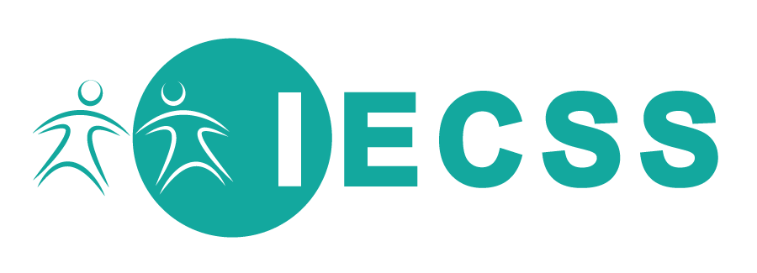

Policy Brief No. 2

March 2015
A submission to the Day of General Discussion (DGD) on the right to education for persons with disabilities, to be held on 15 April 2015, at Palais des Nations, Geneva

The right to inclusive education begins in early childhood

The Inclusive Early Childhood Service System Project (IECSS)

The Inclusive Early Childhood Service System project is a partnership between the County of Wellington and Ryerson University, working in conjunction with a number of academic, municipal and community partners (a full list of partners is available on our website). The project is informed by extensive consultation and ongoing collaboration amongst the partners for the purpose of identifying research questions, designing the research project, recruitment of project staff and participants, analysis, and dissemination. The work presented in this brief is informed by the consultation and partnership.
The purpose of the project is to better understand experiences of disability in early childhood, to understand how services are delivered in varied geographic and cultural contexts. Our aim is to build theoretical understanding that may inform social policy for the purpose of having more respectful and responsive supports that recognize the value of disability identities, and the need for universally designed services.
The research partners include representatives from the domains of child care, early intervention, social service planning, and research, as well as organizations that practice in these domains using Indigenous values. The researchers have expertise in social policy, disability studies, nursing, social work, and early childhood studies.

This is the second in a series of policy briefs that are prepared as part of the IECSS Project. To view the other briefs in this series please visit our website.
The Convention on the Rights of the Child (CRC, 1989) identifies the right of parents to have state funded facilities for the purpose of assisting parents in their child rearing responsibilities (Article 18, s. 2). The CRC further states that rights set out in the convention should be delivered without discrimination including on the grounds of disability (Article 2, s. 1). In addition, Goal 1 of the Education for All Declaration (2000) calls for expanding early childhood care and education for all children. Based on these international rights-defining protocols, we suggest that the Convention on the Rights of Persons with Disabilities (CRPD, 2007) should be interpreted to include young children with disabilities.
The Convention on the Rights of Persons with Disabilities clearly identifies the right of all children to “access an inclusive, quality and free primary education and secondary education on an equal basis with others in the communities in which they live”(A.24, s.2.b). This right to inclusive education does not make any reference to early childhood, leaving out this critical time in life for education and development.
Early childhood education and care (ECEC) includes child care, nursery or preschool programs, as well as family support and developmental programs. The fact that the right to early childhood education and care has not been specifically referenced in the CRPD should not preclude the interpretation that young children with disabilities also have a right to inclusive, quality and free early childhood education and care in their community.
“Persons with disabilities can access an inclusive, quality and free primary education and secondary education on an equal basis with others in the communities in which they live”
(CRPD, A.24, s.2.b)

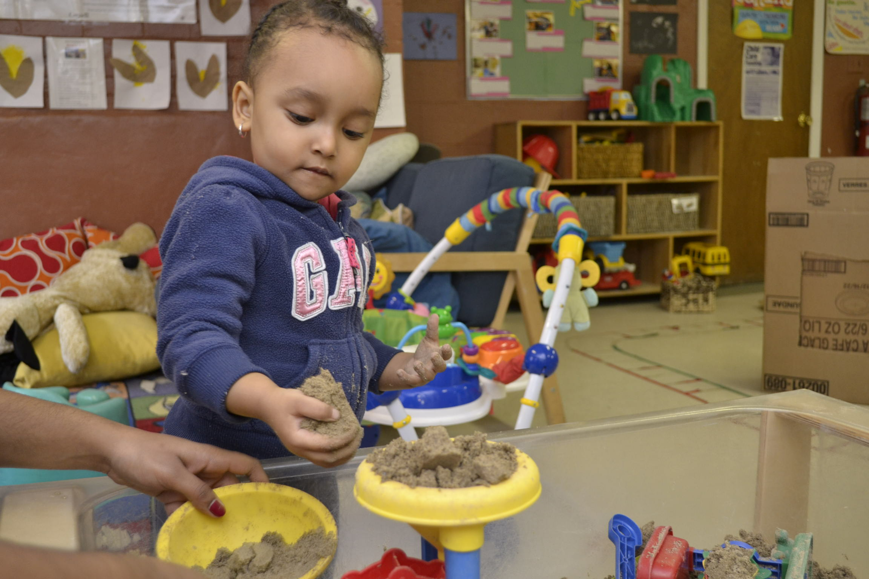
We believe that the early childhood education and care sector has a contribution to make in enacting the right to inclusive ECEC in three ways. First, education begins in early childhood and having education and care opportunities supports children at a critical time in their development. Second, the early childhood education and care sector are more effective than schools at connecting family support, community development, and child development as integrated and equally important outcomes of inclusive practice. Third, parents of young children with disabilities also need to be supported in their child rearing responsibilities. The ECEC sector, therefore, has the opportunity to embed inclusive values and support healthy interpretations of inclusive practice that children and their families can carry into school.

Evolving conceptions of disability need to include children who are not diagnosed and recognize cultural context
Many young children experience disability before it is recognized or identified by medical professionals. In many cases, services for young children, including early intervention services, are dependent on having a diagnosis. We believe that the right to early identification (CRPD, Article 25, s. b) should be enacted without formal identification, particularly for young children who are developing. Some specialized services, such as early intervention, may facilitate implementation of inclusive education. However, if these services are contingent on diagnosis, many young children with disabilities will not have access.
The identity of young disabled children should not be defined through medical diagnosis alone. For young children who are developing a sense of self, integration of a positive self-concept in relation to disability is critical. While disability advocacy and cultural movements are defining this identity for adults, we do not have the same “disability pride” movement for young children. Disability as an evolving concept should consider cultural identities integrated with disability identities.
“Respect for the evolving capacities of children with disabilities and respect for the right of children with disabilities to preserve their identities.” (CRPD, A. 3, s. h,
General Principles).
Additionally, evolving conceptions of disability should take into account the meaning of the term disability in local and cultural contexts. The term disability as it is used in the CRPD is not readily understood in various local languages and in cultural context. Further, the concept of disability within a family and community context is particularly important for young children who are learning and developing their identity within their family and community.
“disability is an evolving concept […] disability results from the interaction between persons with impairments and attitudinal and environmental barriers that hinders their full and effective participation in society on an equal basis with others”
(CRPD, Preamble, s. e)
“disability is an evolving concept […] disability results from the interaction between persons with impairments and attitudinal and environmental barriers that hinders their full and effective participation in society on an equal basis with others”

Early identification and early intervention should not be interpreted as a right under health alone, but should be considered as an educational right
The last 30 years of implementation of inclusive education has taught us that inclusion is not placement alone. Educators need support, and classrooms must acknowledge individualized needs of all children. In the only direct reference to early childhood in the CRPD the right to early intervention is identified (Article 25, s.b). We believe that this right should be interpreted to mean that all children have a right to appropriate opportunities for development.
The research evidence clearly identifies that early intervention is most successful when it is embedded in inclusive early childhood education and care settings (Guralnick, 2005).Early intervention has been linked to lower rates of special education use, parents who are better prepared to advocate and identify their children’s rights, and better child development outcomes (Guralnick, 2005; Epley, et al. 2011). More importantly, early intervention takes many forms, and one of the most effective interventions is high quality child care itself. We therefore interpret this right to be aligned with the right to high quality early childhood education and care as identified in the Convention on the Rights of the Child.

Canada Needs to Consider its Commitments to Inclusion of Young Children
While we believe our interpretation is relevant for a global discussion, we also would like to highlight apprehension regarding the Canada’s commitment to responsibility for these rights. Howe and Covell (2007) have identified concerns about Canada’s commitment to children’s rights in general. In particular given Canada’s lack of commitment to a universally accessible system of early childhood education and care, the right to inclusive education is not being enacted for young children.
The right to inclusive education for children with disabilities has been directly linked to quality, and to an approach that is inclusive of the whole community (Jones, 2011). Canada’s First Report on the Convention on the Rights of Persons with Disabilities makes does not clearly articulate inclusive practices in education or in the provision of early intervention.

Summary for action on early childhood inclusion
Early childhood education and care must be recognized as integral to inclusive education and the CRPD should be interpreted to include the ECEC system. Continuing to examine what it means to experience disability in early childhood will support children to preserve their identity. Acting to ensure that early intervention is not a health provision alone will support more inclusive early childhood experiences for children and their families.
“Provide those health services needed by persons with disabilities specifically because of their disabilities, including early identification and intervention as appropriate, and services designed to minimize and prevent further disabilities, including among children”
(CRPD, A. 25, s. b)
Our aims through research are to:
- Find collective identity for social action
- Ask: Is this working and who is it working for?
- Act to make others aware of when the system is not working
- Share experience and knowledge of what is working

References

Epley, P. H., Summers, J. A., & Turnbull, A. (2011). Family outcomes of early intervention: Families’ perceptions of need, services, and outcomes. Journal of Early Intervention, 33(3), 201-219.
Guralnick, M. J. (2005). The developmental systems approach to early intervention. Baltimore, MD: Brookes.
Guralnick, M. J. (2011). Why early intervention works: A systems perspective. Infants & Young Children, 24, 6-28.
Howe, R. B., & Covell, K. (eds.) (2007). Children’s rights in Canada: A question of commitment. Waterloo, ON: Wilfred Laurier University Press.
Jones, M. (2011). Inclusion, social inclusion and participation. In M. Rioux, Basser, L., & Jones, M. (eds.), Critical Perspectives on Human Rights and Disability Law. Boston: Martinus Nijohoff Publishers.
United Nations General Assembly. (2007). Convention on the Rights of Persons with Disabilities (UNCRPD). A/RES/61/106. Retrieved from http://www.unhcr.org/refworld/docid/45f973632.html
United Nations. (1989). Convention on the Rights of the Child (UNCRC). Retrieved from http://www2.ohchr.org/english/law/pdf/crc.pdf

