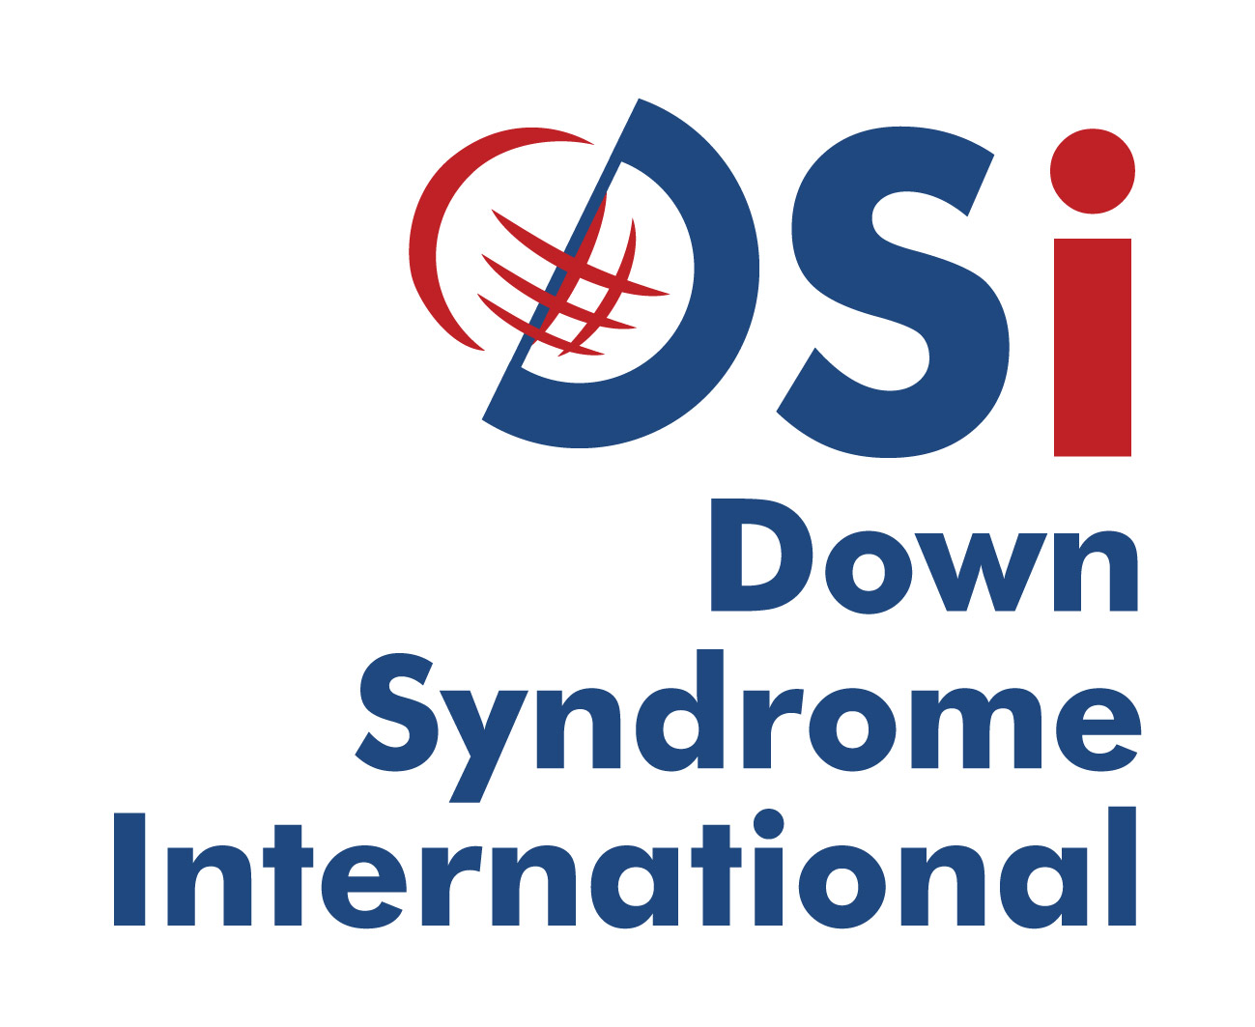
Langdon Down Centre
2A Langdon Park
Teddington TW11 9PS
United Kingdom

Down Syndrome International
Submission to the UNCRPD Committee on the
Rights of Persons with Disabilities to live independently and be included in the community (Article 19, CRPD)

Day of General Discussion 19th April, Palais des Nations, Geneva.

Summary
Down Syndrome International (DSi) affirms the rights of all people with disabilities to live independently and be included in the community with choices equal to others.
It supports its member organisations in their pursuit to live independently and to be included in the community around the world. We do this through advocacy, capacity building and outreach of international experts to areas of need, as requested.

Down Syndrome International
Down Syndrome International (DSi) is a UK based international charity, comprising of a membership of individuals with Down syndrome and their families, other interested persons and organisations from all over the world, who are committed to improving the quality of life for people with Down syndrome worldwide and promoting their inherent right to be accepted and included as valued and equal members of their communities.
Our mission is to improve quality of life for people with Down syndrome worldwide and promote their inherent right to be accepted and included as valued and equal members of their communities. This includes promoting the right to live independently and be included in the community with choices equal to others.

Introduction
Many adults with Down syndrome either live at home with his/her parents or are placed in institutions alongside other people with intellectual disabilities and mental health users. These institutions or segregated settings do not provide any quality of life and is not a suitable living arrangement.
Segregation has a negative impact on the social standing of people with Down syndrome and this exclusion denies them access to being included in the community, which creates negatives stereotypes towards people with the condition.
Down Syndrome International (DSi) affirms the rights of all people with disabilities to live independently and in the community with choices equal to others as acknowledged in the UNCRPD Article 19. To that end DSI further affirms the General principle in Article 3 (a) Respect for inherent dignity, individual autonomy including the freedom to make one’s own choices, and independence of persons;

Challenges to living independently
People with Down syndrome are intellectually disabled, mostly short in stature and are considered “forever children”. Because of this they are denied access to many services and are often hidden at home or placed in segregated settings. The belief is that people with Down syndrome cannot learn or be educated and therefore time should not be wasted on teaching them to be independent. This form of exclusion is discriminatory and a violation of their basic human right to independence.
Given the chance and support, people with Down syndrome can live independently, which leads to them being recognised as people in their own right and being included in the community.
Implementation of Article 8 Awareness Raising is core to the value of persons with Down syndrome. State parties should do as much as possible to change the negative perceptions of people with Down syndrome in order for them to be seen as people in their own right, give them the opportunity of learning to be independent and make their own choice of where and with whom they live.

Institutions and abuse
Being the most vulnerable of all vulnerable, people with Down syndrome are often exploited and experience sexual abuse (amongst other forms of abuse) in segregated settings such as institutions. This is one of the reasons parents choose to keep their adult child at home. Article 16 Freedom from exploitation, violence and abuse calls on State parties.

Parents and culture
In some countries/cultures it is the belief that children stays at home until they get married. They also believe that people with Down syndrome do not get married and therefore should never leave home. Some families choose to add on a cottage at the back of the house for their adult child with Down syndrome to live in, in order to give them some form of independence. By doing so, parents put a tremendous amount of pressure on themselves and have no chance for respite.
State parties should provide adequate support and respite possibilities for people with Down syndrome who choose to live at home with their parents.

Independence and quality of life
Research has shown that individuals with Down syndrome who have moved out of institutions, into the community, have significant improvement in their quality of life. In addition, their self-esteem and confidence increased when moving into their own homes, had more independence, control over their lives and made their own decisions. They were also less likely to develop depression.
‘Quality of life involves the principle of choice. If we give choices and opportunities to people with Down syndrome, we begin to understand what interests them. They begin to have control over their environment’ .
Quality of life requires being able to make decisions and choices. By being given the opportunity to making their own decision and choices, we learn more about the individuals. These need to be taught early in life.
We therefore recommend that States Parties include all children with Down syndrome into early intervention programmes and inclusive education.

Role of Down Syndrome International
DSi seeks to support the work of the UN in the promulgation of the CRPD, particularly with respect to Article 19. We undertake to do this through three key strategies:
- Global advocacy and awareness;
- Building capacity of our members;
- Outreach bespoke programmes;
DSi believes that people with Down syndrome should enjoy the freedom of living independently in the community with choice equal to others with the appropriate supports where necessary without prejudice. This can only be achieved through the 3 key strategies above and the support of the CRPD Committee.

Recommendations
DSi requests the Committee to call on State Parties to ensure that the General principles of the CRPD (Article 3) and the obligations (Article 4) are respected and Article 19 be implemented by:
- Collaborating with our respective organisations, locally, nationally and internationally to deinstitutionalise and provide supported living arrangements in inclusive environments;
- Ensuring adequate financing and budgeting to support the above and implement article 19;
- Participate in World Down Syndrome Day (WDSD) awareness programmes with the local or national organisation;
- Promote and support inclusive early intervention programmes to encourage independence from an early age;
- Promote and support inclusive community programmes that support people with Down syndrome.

Sexuality and Relationships Education for people with Down syndrome Amanda Wood Wood A. Sexuality and Relationships Education for people with Down syndrome. Down Syndrome News and Update. 2004;4(2);42-51. doi:10.3104/practice.330
Social development for individuals with Down syndrome - An overview doi:10.3104/9781903806210
Life for adults with Down syndrome – an overview Roy Brown

