Submission by the Swedish Disability Federation and the Independent Living Institute concerning article 19 of the Convention on the Rights of Persons with Disabilities: Living independently and being included in the community.

The Swedish Disability Federation is an umbrella organization for 39 organisations of persons with disabilities, together representing approximately 400 000 persons. The work of the Federation is based on human rights and its purpose an inclusive society. The Independent Living Institute is a policy development center specializing in consumer-driven policies for disabled peoples' self-determination, self-respect and dignity.

Summary:
The Swedish Disability Federation and the Independent Living Institute states the following. In accordance with article 19 subparagraph (a) it is of vital importance to stress the right to choose where to live and to not be obliged to live in particular living arrangements. Persons with disabilities who live in special living arrangements must be able to choose their place of residence as well and not be forced to move to another special housing. In accordance with subparagraph (b) it is of fundamental importance to ensure that personal assistance and other kind of support enshrined therein are sufficiently provided to enable independent living and full participation and inclusion in society. The social model of disability and the interdependence of the rights contained in the Convention are furthermore emphasized in assessing needs of support according to article 19. In accordance with subparagraph (c) community services and facilities for the general population must be fully accessible for persons with disabilities. This includes accessible public or special transport to these services and facilities as well as accessible communication.

The Swedish Disability Federation and the Independent Living Institute are delighted by the Committee on the Rights of Persons with Disabilities initiative to make a general comment on article 19. The right to live independently and being included in the community is of fundamental importance in order to ensure equality and full citizenship, with equal rights and obligations to others. Our organisations wish to emphasize the importance of the general principles in article 3 of the Convention when interpreting and applying the right to independent living: autonomy, full and effective participation, equality of opportunity etc.

The Swedish Disability Federation and the Independent Living Institute wish to convey the following inputs on the subparagraphs of article 19.

As concerns subparagraph (a) we wish to stress that it is of fundamental importance that no one is forced to live in a particular living arrangement. Instead, persons with disabilities should receive the support necessary, including personal assistance, to ensure independent living, regardless of where they happen to be or live, by themselves, together with family or other individuals. For persons with disabilities who do want to live in particular living arrangements, by their own free will and not forced by the lack of alternatives that might be better but more costly, we wish to put special emphasis on the right to choose where to live. Furthermore we would like to stress that persons with disabilities living in such a special living arrangement should not be forced to leave one special housing in order to move to another one. Such forced transfers of persons from one housing to another occur in Sweden today and is a significant problem. The reasons for this kind of transfers are often of a purely economic nature and do not respect the right of persons living in special housing to choose their place of residence. It is also important that special living arrangements are available in the local community, and that persons with disabilities do not have to move to other municipalities.

As concerns subparagraph (b) we would like to deliver the following notes. The Committee has criticized Sweden for the decrease in provision of state funded personal assistance in its concluding observations on the initial report on Sweden, paragraphs 43-44. The right to personal assistance as provided for in subparagraph (b) is absolutely necessary to ensure independent living for many persons with disabilities. Without such support, or too little support, persons will be confined to their homes. They will be unable to participate in the community, to work, to hold public office, to active participation in family life; including as parents and to leisure and cultural activities among other things. A violation of article 19 is therefore also a violation of many other articles of the Convention.

Since Swedish ratification of the Convention there has been an increase in the rejection of new applications for personal assistance and cancellations of previously provided support, see the Swedish Agency for Participation’s report What´s up 2015? (Hur är läget 2015?), pp. 48-50. According to our organisations, there has also been a decrease in the number of hours of state funded personal assistance granted. This is contrary to the above mentioned report, but supported by a report published by the National Board of Health and Welfare, Action and Support to Persons with Disabilities – progress report 2016 (Insatser och Stöd till Personer med Funktionsnedsättning – lägesrapport 2016), pp. 16-17. Most persons who have their state funded assistance benefit canceled do not receive sufficient support from the municipalities instead. As the increase in cancellations are acknowledged by the first report there need not be a discrepancy between these perspectives. Furthermore the financial compensation for personal assistance does not fully compensate for pay rises of personal assistants. The increasing regulatory demands on providers of personal assistance entails less influence for persons needing personal assistance on their assistance. This risks compromising their individual autonomy including the freedom to make one´s own choices, as enshrined in article 3 paragraph (a). It is again worth emphasizing that the fulfillment of article 19 shall comply with the general principles.

Notwithstanding the above mentioned critique of the Committee the Swedish government wishes to further decrease the provision of state funded personal assistance. This is apparent from the government’s regulatory note concerning allocation of resources for 2016 to the Swedish Insurance Agency, which is responsible for provision of state funded personal assistance. On the first page of this document it is stated that the Swedish Insurance Agency shall contribute to the breaking of the development of the number of hours within the assistance benefit. We are very concerned by this development and the probable implications for persons in need of personal assistance. If this instruction will be followed by the Agency Sweden will be moving backwards in its implementation of article 19. Our organisations therefore want to stress the general obligation in article 4 paragraph 2 of progressive realization. Article 19 is a social right and thus subject to progressive realization but it must be emphasized that States Parties are not allowed to limit current and already achieved fulfillment of this right. States parties are obliged to take measures to the maximum of their available resources in order to progressively fulfill the right to independent living. With the regulatory note the Swedish government wishes to limit the fulfillment of the rights enshrined in article 19 subparagraph (b).

The Convention provides for the social model of disability. A person with an impairment may or may not encounter barriers and obstacles to equality and full and effective participation in society depending on how society is constructed. The Swedish Act Concerning Support and Service to Persons with Certain Functional Impairments on the other hand provides for a more medical approach to disability. To be entitled to personal assistance a person with an extensive disability must be in need of help with some or all of the following: personal hygiene, eating, dressing and undressing, communication and other help which requires intimate knowledge of the person with a disability. These are the basic needs, paragraph 9 a of the act. According to the preparatory works to the act an individual assessment shall be made, taking into account medical, social and psychological factors. Our organisations wish to stress that this is what is required by the social model of disability. It is of vital importance that needs assessment are conducted holistically, with due consideration being paid to the social model of disability and the right of persons with disabilities to live independently and be fully included in the community.

As concerns subparagraph (b) we would furthermore like to stress the importance of other support services than personal assistance, such as escort service. The purpose of escort service is to assist persons with disabilities in visiting friends, take part in recreation and cultural life etc.

As concerns subparagraph (c) we would like to state the following. In order to ensure that community services and facilities for the general population are available on an equal basis to persons with disabilities these facilities must be accessible and there must be accessible public or special transport to them. Public transport should be able to accommodate powered wheelchairs as well as manual ones. In connection to this we would like to reaffirm article 9 and the Committee´s general comment number 2 as well as article 20 on personal mobility. Persons with disabilities should be able to enter and make use of community services and facilities independently and to understand and impart information. Community services and facilities should be able to communicate in individualized manners, including by texting and phone calls instead of conventional letters. It should also be possible to have one single agency administrator. We would also like to stress the general obligation in article 4 paragraph 1 subparagraph (f) of promotion and development of universal design concerning these services and facilities.

In conclusion the Swedish Disability Federation and the Independent Living Institute wish to state the following concerning article 19 as a whole.

To facilitate independent living and inclusion in society it is necessary to consider the interdependence of the rights contained in the Convention. To be able to participate fully in society persons with disabilities must be able to make their own choices and decide over their lives as provided for in article 12. Society, including information and communication, must be accessible as provided for in article 9 and 21, encompassing cognitive and perceptive accessibility. Personal mobility must also be ensured, as provided for in article 20, as well as the right to the highest attainable standard of health and habilitation and rehabilitation, articles 25 and 26. Health care and rehabilitation and habilitation are crucially important to facilitate independent living.

Support according to article 19 may many times be necessary in order to fulfill the rights to education, work, family life, participation in political and public life and participation in cultural life, recreation, leisure and sport, articles 24, 27, 23, 29 and 30. It should also be noted that a lack of provision of support according to article 19 could lead to violations of article 14 if persons with disabilities are institutionalized as a consequence.

It is of crucial importance that support in accordance with article 19 is granted to all persons with disabilities who are in need of it in order to live independent lives. States parties to the convention are obliged to make sure that support is granted on an equal basis, whoever is responsible on the national level, government agencies or municipalities etc. As article 19 is implemented it should be made justiciable in full.

On behalf of the Swedish On behalf of the Independent
Disability Federation, Living Institute,
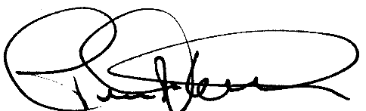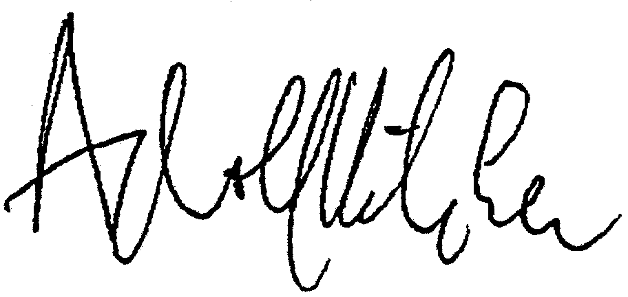
Pelle Kölhed, Adolf Ratzka,
Vice president of the Swedish Chair of the Independent
Disability Federation Living Institute

http://www.mfd.se/globalassets/dokument/publikationer/2015/a-2015-12-samlad-uppfoljning-av-funktionshinderspolitiken.pdf The Agency for Participation is responsible for monitoring and coordinating Swedish disability policy.
http://www.socialstyrelsen.se/Lists/Artikelkatalog/Attachments/20078/2016-2-20.pdf The National Board of Health and Welfare is a government agency that promotes health, welfare and equal access to health care and other care.

