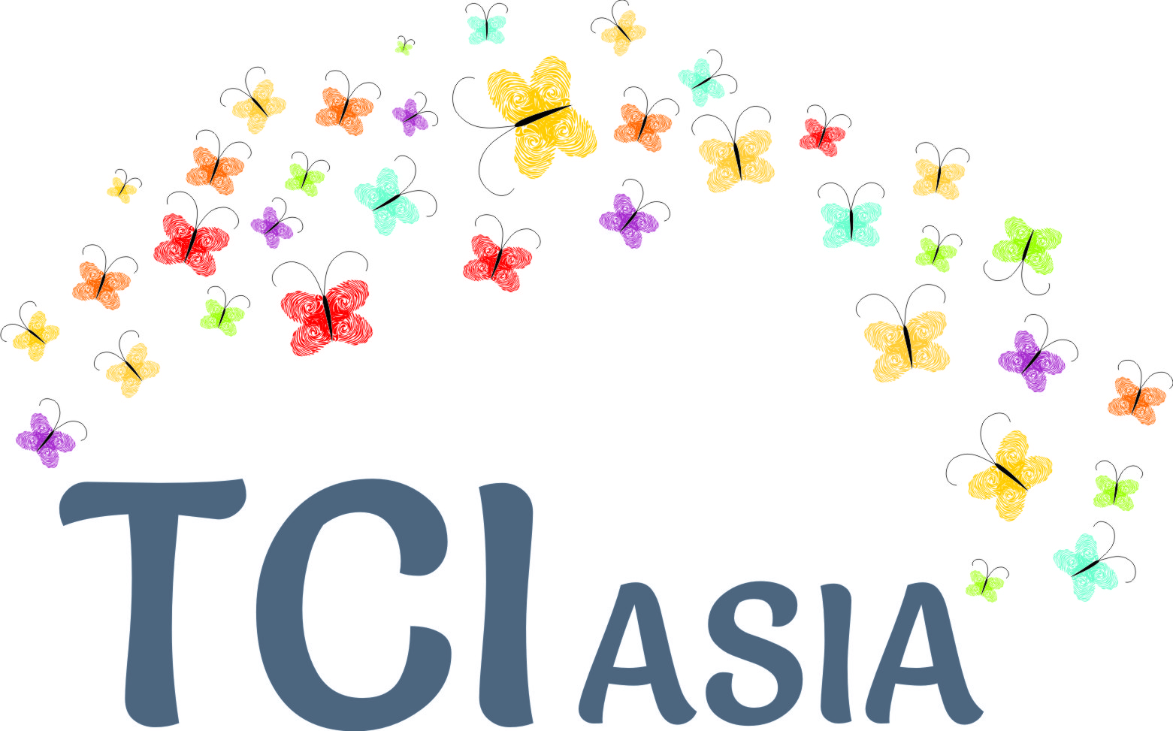Transforming Communities for Inclusion – Asia

(Draft) Submission to the UNCRPD Monitoring Committee, Day of General Discussion, Article 19

Executive Summary

TCI Asia is an Asian alliance of persons with psychosocial disabilities and their supporters, which exists to enhance the pedagogy and practice of Article 19 for the region. We are delighted to participate in DGD proceedings towards a General Comment on Article 19. Our submission appeals to the Committee to (1) elaborate on the meaning of ‘communities’ and ‘inclusion’. (2) Recognize that inclusive communities are a reflection of the human aspiration to love, support and share. (3) Recognize that a number of good practice models do exist, to explicate 19(2) of the CRPD, cited herein. (4) Stipulate those enabling CRPD compliant laws for states parties so that the right to live independently and be included in communities is a legally recognized human right everywhere (5) Ensure that international co-operation in implanting universal design in realizing Article 19 does not erase cultural / individual capability, Asian psychosocial healing practices and the rights of indigenous peoples.
About TCI Asia
TCI Asia (Transforming communities for Inclusion of persons with psychosocial disabilities, Asia) is an independent Asian Alliance of organizations and persons with psychosocial disabilities, and cross disability supporters, focussing on Article 19 and its realization in the Asian region. Since 2012, TCI Asia has made several country visits, 4 annual plenary consultative processes, 1 strategy development workshop, conducted research and trainings; and has engaged upto 15 member countries and over 100 members, to enhance the pedagogy and practice of Article 19 for the region. We are delighted that the Monitoring Committee of the Convention on the Rights of persons with Disabilities (CRPD) is holding a Day of General Discussion, towards a General Comment on Article 19 and we want to contribute constructively to this process.
General provisions of Article 19
Other than being a human right, Article 19 is the overall purpose of realizing the CRPD: All persons with disabilities will live independently and be included in communities, without discrimination and on equal basis with others. Article 19 may be considered as the heart of the convention, though it is not a new or a higher human right. Here, it is expressed with the full strength of Article 5 on Equality and Non-Discrimination provided for generally, and also in each and every provision. Article 19 compels us to locate the source of change, not in the individual, but in society which will establish equality, create opportunity, choice and support on equal basis with others. The four key stakeholders States must address in implementing article 19 are persons with disabilities, their families; neighbourhoods; service providers (both disability specific services mainstream services, government and private); and the society at large. The comprehensiveness of Article 19 invites an inclusive world for everybody, also ensuring the full and effective participation of all persons with disabilities on equal basis with others. The General Assembly interventions at the time of HLMDD and the making of the SDGs suggest that policy must shift the frame of access to Development from Welfarism to a framework of self-determination, inclusion, choice and human rights. The CRPD committee, in May 2013 , recommended that international communities should ‘Take measures to ensure that persons with disabilities enjoy their right to development on equal basis with others’.
Article 19 makes reference to “Community” [7] times. We urge the Committee to provide a rich picture of what an “Inclusive community” would have as key elements. The Thematic study by the OHCHR on Article 19 has exemplified what does not constitute community. The Thematic Study makes a contribution to guiding states parties in removing traditional barriers, echoed more recently by the OHCHR Expert meeting on Deprivation of liberty. It is important to also elaborate constructively on what is community, in a modern human rights compliant society that is inclusive of persons with disabilities.
In a meeting in Pune (May, 2013) TCI Asia members from 5 countries advocated that personal identity and experience cannot be reduced to a diagnostic label or being just a user of a medical service, as often happens in communities. Identity encompasses having opportunities in experiencing multiple roles with dignity and autonomy, such as parent, sibling, spouse, teacher, banker, pastor, farmer, artist, postman etc. and to be able to contribute emotionally and materially to the welfare of the society with dignity and autonomy.
In most cultures of the world caring for others, emotional connection and altruism prevail as a basic human duty or even a personal aspiration for living a happy and meaningful life. Article 19 could be interpreted as a reflection of this aspiration to give and receive support and care, while not compromising on the right to equality and non-discrimination. Extensive studies linking neuro-diversity with ‘happiness’, and recent Happiness studies in the field of economics, are evidence that empathy is essentially human.
A community is the availability of ‘social capital’ and ‘local actor networks, a collection of individuals, groups, families, neighbourhoods in local environments who come together on a platform of mutuality and respect, to reach a functional objective together, or to connect as human beings for sharing and caring without any necessary preconditions or outcomes. Such psychosocially founded networks bind families, individuals, cattle, plant life, other life forms, inanimate objects, land, water, food, and other actions and artefacts of human social living into an organic whole. This is the vision for a sustainable world contained within extant Development frameworks such as the Incheon Strategy and the SDGs. The Thematic Study also recognizes ‘virtual communities’ available in a variety of social media. The Committee may please strongly recognize the importance of transforming communities so that they become emotionally sustainable, to facilitate the inclusion of everybody, and for the preservation of a peaceful and caring planet.
New development theories provide concepts to capture this shift in thinking about community, the diversity and self determinism of peoples and the sustainability of human habitats, especially cities. In the ‘capability’ approach’, an economic theory based on the theory of Justice, there is a need to evaluate policy outcomes based on the equability in the range of opportunities a person has, to achieve a certain desired state of being. In this approach, two aspects are important to address (1) recognizing agency and personhood of all persons with disabilities and (2) creation of choice by improving community inclusion.
Specific provisions of Article 19
In the Asian region, even though mental health legislations do not exist in many countries, and some have recently adopted new coercive mental health laws, mental institutions are coming up quite fast, resulting in the escalation of barriers to inclusion . This trend to associate modernisation with imposing buildings and infrastructure, and closed door facilities as compulsory places of residence, has elicited strong Concluding Observations from the CRPD Committee in the Asian context, illustratively, in the case of China and Korea. We propose that, the General Comment on Article 19 must restrain this worrying trend emerging in Asia, by
(1) giving specific guidance to state parties to prohibit old or new laws that create barriers; and enact enabling laws and revise constitutional jurisprudence by unconditionally protecting the right to live independently and to be included in communities in the manner provided for in the CRPD.
(2) enlisting illustrative actions and programs that need to be supported by state parties to capacity build and transform families and communities for inclusion and for independent living of persons with psychosocial disabilities, including exemplifying ‘choosing the place of residence’.
We appeal to the Committee that local, cultural contexts may determine choice of residential facilities and services. Comprehensive enlistment of illustrative examples can be cited in the General Comment, which will explicate the diversity of services that need to exist, to fully embody the Article 19(b) provision of choice.
A number of ‘alternatives’ in community, neighbourhood and family development can be illustratively enlisted, such as Intentional Peer Support, Soteria house, Open Dialogue , etc. which may be applied universally. In high income countries of Asia, there exist self managed models that can be adapted such as the ClubHouse, Independent Living or Hostel models preferred by persons with psychosocial disabilities. Personal assistance would include simpler acts of companionship and offer psychosocial support, that come within the rubric of ‘Being with’ or ‘being present to’ someone with a psychosocial disability. There is strong advocacy globally, and in Asia region, for peer support and community based care giving systems, based on the values and principles of the CRPD.
Asian low income country examples also exist of ‘good practices’ when a person is in crisis, impoverished, homeless or wandering. A program provides peer support, night shelters and other essential services on the streets with the support of local authorities. Another program provides a ‘circle of care’ establishing a ‘neighbourhood alert’ system to be with persons who may be in need of crisis support , involving a diversity of trained non-formal care givers, community members, and family members. When there is conflict over the question of forced care, a community negotiation and capacity building module is initiated by the service provider, so that families feel empowered to give love, care and support. In such standardized community care programs, which are accessible and affordable, the community is reminded of their aspiration and duty to give love and care. The families are taught to provide reasonable accommodation, respect decision making and restore dignity of the person. Foster care giving and functional proxy relationships in neighbourhoods are accepted practices in some of these programs to expand and protect the right to live in place of choice. The programs also multiply emotional effects by plugging into and capacity building existing Local Actor Networks, for example, the education system, local healers, health workers, development workers, traditional healers, etc. While these social relationships may have their stresses and strains, they may be devoid of the legal normative power of penal admission, institutionalization or guardianship. Inclusion International, in the context of empowering families and communities, brought out two useful reports , on Inclusion within Development practise.
General Obligations of the State in realizing Article 19
Article 7- Childhood must be protected by state regulation, from needless ‘early intervention’, particularly the use of hazardous psychotropic medication and early institutionalization to contain behaviour in schools and at home. Nutrition of households must be recognized and regulated as a highly impacting factor on mental health of all, but particularly of children.
Article 8- State parties must (1) recognize the importance of raising awareness and enhancing skills of the community and the family, on psychosocial disabilities to remove stigma, encourage inclusion into the community, create nurturance and ‘circles of care’; (2) Capacity build communities in areas where de-institutionalization is planned, so that communities may receive, accept, adapt, support and include persons with psychosocial disabilities on equal basis with others; and also appreciate the contributions that the persons will make in turn to the community that welcomed them.
Article 10- State parties must ensure Right to life for persons with psychosocial disabilities who live in home environments and communities, as they may face higher risk for malnutrition, hunger, neglect, or other discrimination leading to poor health status, dependency and impoverishment.
Article 11- Asia region is prone to natural disasters, and other humanitarian strife and emergencies. State obligations and planning should responsibly cover for Inclusion aspects of all persons with disabilities.
Article 12 – States must ensure that laws exist that will recognize full legal capacity, recognize support systems for decision making, allow for autonomy, independent living, and full and effective participation in all life domains within families and communities.
Article 13- Ensuring an Enabling legal environment for Article 19, by fulfilling the obligation for a non-discrimination law inclusive of all persons with disabilities. The right to mental healthcare on the basis of personal choice may be a part of comprehensive health care legislation. If some countries in Asia choose to create mental health law, it must be CRPD compliant and recognize the right to live and receive healthcare in the community, with sustainable community supports towards de-institutionalization.
Article 14- Assuming the availability of new CRPD compliant laws ensuring de-institutionalization, and that the few existing mental institutions in Asia are in urban areas, a separate Guideline for a vibrant and Comprehensive Urban Psychosocial and Inclusion Program must be considered by the Committee. Such a design must include systems which are experience driven, contextual, keeping the person with disability at the center, and involving entire communities.
Articles 15, 16- State parties must address institutional abuses and those occurring in more voluntary community spaces on urgent basis.
Article 18- Constitutional support in enjoying nationality and full citizenship status on equal basis with others must be ensured by amending incapacity laws.
Article 22- (1) Colonial incapacity and guardianship laws found in many Asian countries, particularly Commonwealth nations; place at risk confidentiality of medical treatment records and admission in a mental institution, especially of women with psychosocial disabilities, in the context of property, marriage and divorce. (2) In communities, ‘self’ and ‘other’ boundaries may be culturally and socially defined; However, the privacy of persons with psychosocial disabilities must be protected and ensured, on equal basis with others.
Article 25 - The gatekeeping practice of medical professionals to prohibit the choices of persons with psychosocial disabilities to seek out and use non-medical or traditional alternatives, oftentimes leading to reduction in their social capital and self healing resources, must be addressed. No intrusion should be made upon self care choices and lifestyles of persons with disabilities.
Article 28- States will ensure that persons with psychosocial disabilities and their families living in poor socio-economic settings receive the support they require, inclusion in insurance, pension and other social protection schemes; housing; poverty reduction and public distribution schemes.
Article 32 – States will ensure that international co-operation in implanting universal design in realizing Article 19 does not erase cultural / individual capability, Asian psychosocial practices and ways of life and the rights of indigenous peoples.

TCI Asia Contacts:
Convenor (2014- ): Bapu Trust for Research on Mind & Discourse
704 Fillicium, Nyati Estate, Mohammedwadi, Pune 411 060, India
www.baputrust.com, bt.admfin09@gmail.com 91-20-26441989

This submission draws from the consultative processes done between 2012-2015 of TCI Asia. We are grateful to all member participants, allies, partners, and sponsors for the support and contribution.
WNUSP and Bapu Trust, (2013). “Human Rights of persons with psychosocial disabilities in the post 2015 Inclusive Development Agenda: Towards HLMDD, September 2013”.
‘Statement of the Committee on the Rights of Persons with Disabilities on including the rights of persons with disabilities in the post 2015 agenda on disability and development’, May 2013, United Nations Human rights, Office of the High Commissioner, Geneva.
OHCHR (2014) “Thematic study on the right of persons with disabilities to live independently and be included in the community” A/HRC/28/37 12th December 2014.
Expert meeting on deprivation of liberty of persons with disabilities 8-9 September 2015. http://www.ohchr.org/EN/Issues/Disability/Pages/deprivationofliberty.aspx accessed 26-02-2016
Matthieu Ricard, (2003) Happiness. A Guide to Developing life’s most important skill. Little, Brown and Company, New York.
McKenzie, K. “Globalisation, Social Capital and Mental Health”, in Global Social Policy, 2008, Vol. 8, pp. 359-377.
A concept developed by Latour, Bruno in his book, (2010) The making of law: An ethnography of the conseil d’etat. Cambridge: Polity Press.
? UNHABITAT, (2015). The right to adequate housing for persons with disabilities living in cities: Towards inclusive cities. [Eds.] Szporluk, M., Pal, A. and Bayer, M. UNHABITAT, Geneva.
Sen, A. K. (2009). The idea of justice. London: Penguin, Allen Lane.
TCI Asia, Working Group on Strategy Development Meeting, APCD Training Center, Bangkok, 9-11 June, 2015
KAMI, (2013). Parallel report on the situation of persons with mental illness in Korea. Submission to the UNCRPD Committee.
Mr. WonYong Kim, NHRC investigator, Korea, who presented the Parallel report before the CRPD committee, noted the higher occurrence of mental institutions in Korea, following adoption of a new mental health law. In Korea, 73.5% cases are involuntary, 4 times as high as other countries. 262 days average stay.
http://www.intentionalpeersupport.org/
Finland, https://www.youtube.com/watch?v=aBjIvnRFja4
Peter Statsny and Peter Lehmann, [Eds.] (2007). Alternatives beyond psychiatry. Peter Lehmann Publishing, Berlin.
TCI Asia, (2014). 2nd Plenary, Hotel Prince Palace, Bangkok.
Ishwar Sankalp, Kolkatta, India.
Seher program of the Bapu Trust for Research on Mind and Discourse, Pune, India. https://www.youtube.com/watch?v=t5PC0yBK3ow accessed on 25-02-2016
Shared in TCI Asia consultation on Legal capacity, Incheon, Korea, 18-19 November 2015, Orakai Sangdo Hotel, Incheon.
Inclusion International, 2012. “Inclusive Communities = Stronger communities. Global Report on Article 19”, London.
Inclusion International, 2014. “Independent but not alone. A global report on the right to decide”. London.
Dhanda, Amita (2000) Legal Order / Mental Disorder. New Delhi: Sage Publications.

