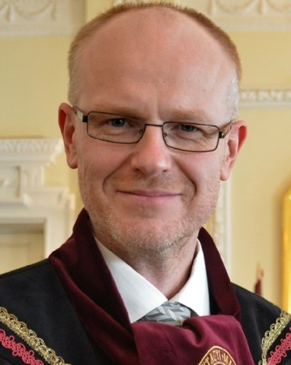
Professor Jonas RUŠKUS

Date and place of birth 11 May 1969, Lithuania
Languages Lithuanian (native), French, English, Russian

Professor Jonas Ruškus is a nationally and internationally recognized expert in the area of disability. Besides his studies in special education for children having intellectual disability in Lithuania, Jonas Ruškus has gained significant experience of voluntary and professional work with people having intellectual and other types of disability in the international l’Arche community in France. The experience of community-based living and inclusion of people with disability into community settings determined his decision to devote his professional career for the implementation of human rights and social justice dealing with disability issues on the individual, organizational and social policy levels.
Currently Jonas Ruškus works in the area of social work by teaching and conducting research. He acted as a supervisor of multiple national research projects in fields of social participation of people with disabilities, inclusive education, social policy, quality of social services, monitoring of national educational system with the collaboration of the Lithuanian Government (Ministry of Education and Science, Ministry of Social Security and Labour, Research Council of Lithuania) and Non-Governmental organizations (such as Lithuanian Welfare Society for Persons with Mental Disability HOPE).
Current position
- Since 2010 - Dean of the Faculty of Social Sciences at Vytautas Magnus University, Kaunas, Lithuania
- Since 2007 - Professor at the Department of Social Work at Vytautas Magnus University, Kaunas, Lithuania
Other main activities in the field relevant to the mandate of the treaty body concerned
- Since 2013 - Board member at Association “The Light’s Workshop” for people with and without disabilities in Kaunas, Lithuania (candidate for membership at International L’Arche community)
- Since 2008 - Council member at European Resource Centre for Social Work Research (CERTS)
- Since 2008 - Chief-editor of the journal “Social work. Experience and methods”
- Since 2007 - National expert in Academic Network of European Disability experts (ANED) by European Commission
- From 2004 to 2009 - Member of National Council of Education
- From 1992 to 1996 - Social worker in the international l’Arche community for people with and without disabilities (in France)
Educational Background
- In 2000 - PhD in social sciences (education). Thesis: Relation between attitudes of special educator, pedagogical interaction and school socialization. Šiauliai University, Lithuania
- In 1994 - Master of Advanced Studies (D.E.A.) in Communication & Safety. University of Technology of Compiègne, France
- In 1992 – Qualification of teacher, educator and speech therapist for children with intellectual disabilities. Pedagogical Institute of Šiauliai, Lithuania
List of most recent publications in the field
- Ruškus J., Kiaunytė A. (2012). Facing conflict: patterns of relationships amongst Lithuanian social workers in the workplace and the role of supervision. European Journal of Social Work, 16 (5), 671-688.
- Ruškus J. Gerulaitis D. (2009-2010). Parental Involvement in Individual Education Planning for Students with Mental Disabilities: A Lithuanian Experience. Illinois Child Welfare, 5 (1), 15-32.
- Ruškus J. (2009). Regard critique sur l’intégration des personnes handicapées en Lituanie / A critical look at integration of persons with disability in Lithuania. La nouvelle revue de l‘adaptation et de la scolarisation, 5, 211-222 / 223-235.
- Ruškus J. Mažeikis G. (2007). Disability and social participation. Šiauliai University Press (in Lithuanian).
- Ruškus J., Daugėla M. (2009). Studenti disabili negli istituti universitari in Lituania. L'integrazione scolastica e sociale. 8 (3), 271-280. Edizioni Erickson.
- Baranauskienė I., Ruškus J. (2004). Participation of disabled people in labor market. Interaction between vocational training and Professional adaptation. Šiauliai University Press (in Lithuanian).
- Ruškus J., Daugėla M., Blinstrubas A., Žukauskas S., Šaparnis G. (2007). Higher Education and Students with Disabilities in Lithuania. Šiauliai University Press (in Lithuanian).

