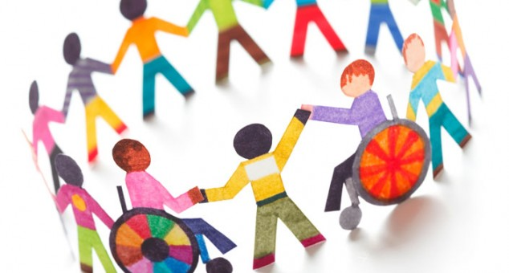
Consultation Package and Facilitator’s Guide

Reviewing the draft General Comment No. 4
Right to Inclusive Education

with Children and Adolescents

CONTENTS

Introduction
Step 1 - Preparation and Planning
Step 2 - Invitation and Initiation
Step 3 - Demographics
Step 4 - Consultation with children:
A - Welcome and Introductions
B - Expectations and Agenda
C - Rights Refresher
D - Quality Education
E - Committee on the Rights of Persons with Disabilities and General Comments

F - What is Inclusive Education?
G - Making a Plan
H - General Comment on Inclusive Education – What is the Committee Suggesting?
I - Evaluation and Team Wrap Up
Appendix A - Useful Resources
Appendix B - Minimum Standards in Children’s Participation
Appendix C - Summarized Version of the CRPD
Appendix D - Checklist for Rapporteurs
Appendix E - Sample Letter of Invitation
Appendix F - Handouts
Appendix G - Summary of General Comment No. 4 – Inclusive Education

INTRODUCTION

Dear partner,

Thank you for your interest in the Committee on the Rights of Persons with Disabilities’ General Comment No. 4 – the Right to Inclusive Education, and for supporting the participation of children and adolescents.

Within this document we have provided you with information and ideas for consulting with children and adolescents and collecting their views on the draft General Comment. We have provided this guide to help get you get started and to provide a few useful details and activities.

Also included with this guide is a PowerPoint presentation that you can use during your discussion with children. Within this guide and the PowerPoint, you will find the following information:

Before the consultation:
- Child protection considerations
- Needed resources
- Sending out an invitation

During the consultation:
- Group welcome, introductions and expectations
- Rights and the Convention on the Rights of Persons with Disabilities
- Defining quality education
- Committee on the Rights of Persons with Disabilities
- General Comments
- What is Inclusive Education?
- Group Discussion
- Evaluation and Wrap Up

You should feel free to adapt the presentation and details to suit your group’s preferences, abilities and existing knowledge. For example: if your group already has a good understanding of rights, you may decide to skip that section.

We encourage you to read through the entire Guide once and then begin to develop your consultation plan, taking into account your specific goals, resources and capacities. Again, please adapt the information as needed.

Step 1 - Preparation and Planning

If possible, we encourage you to involve children as early as possible in the planning process. For example: perhaps you can work with some young people to help facilitate the meeting and develop the agenda.

Before you invite any children and adolescents to participate, there are several things which should first be addressed:

Minimum Standards in Children’s Participation
Our goal is to ensure the minimum standards in children’s participation are upheld in any project/consultation involving children and adolescents. Minimum standards include: transparency, voluntary participation, creating a child friendly environment, equality, protection, safety, qualified staff and follow up.

The Standards can be viewed in detail at:
http://www2.ohchr.org/english/bodies/crc/comments.htm
See No. 12, “The Right of the Child to be Heard”, Paragraph 134, pages 29-31
Or please refer to Appendix B.

Safety and Protection

One of the Standards in Children’s Participation is to ensure the safety and protection of all children and adolescents. Please refer to your organization’s existing child protection policies to ensure all pertinent details are taken into consideration prior to, during and after the consultation process.

Rapporteur
Ensuring we accurately record and capture the recommendations and perspectives of the children and adolescents is a top priority. Please consider, ahead of time, who will be responsible for taking notes during the consultation(s). See Appendix D for further guidance.

Translation
Your group’s translation needs should be taken into account prior to the consultation. For example: Are there materials that need to be translated in advance? Do you require translators during the consultation itself? If needed, guidelines for translators can be found in Appendix A.

Supplies and Resources
Each consultation will be different and planning should take into account your office/program’s resources and capacity.

The following is a suggested checklist of needed resources and supplies:

- Flipchart paper or a board that can be viewed by all participants
- Markers or chalk
- Paper and pens/pencils for each participant
- Refreshments and snacks
- Venue (a location that is welcoming, accessible and child friendly)
- Medium sized cards/thick paper (approx. 6”x8”) in different colours
- Markers in different colours
- Tape
- Scissors
- Mixed art supplies (pending your group’s own preferences)
- Handouts

Energisers and Icebreakers
We provide some suggested activities for the opening and closing of the consultation, however, we recommend using energisers throughout the consultation to provide the participants with ‘breaks’ and opportunities to re-energise. As the facilitator, it is important that you pay attention to the participants and take breaks when needed. In Appendix A we have provided some useful resources, including tips for facilitators and energiser options for your consideration. It is a good idea to have a list of ‘energisers’ ready for when your group needs a bit of a boost.

Time

We estimate that you will need a total of 5-7 hours to complete the full consultation with children and adolescents. Times will vary pending the activities you choose and the size of your group. You may want to consider planning a two day consultation.

Participants
Participants should feel that the issue of ‘inclusive education’ is relevant to them and that they have a perspective/experience they would like to share. You may want to consider the following when sending out your invitation:
- Gender balance
- Diversity - e.g. young people from urban and rural settings; different economic backgrounds; children with disabilities; children belonging to indigenous and minority groups, etc.
- Perspective and experience – children who will have different perspectives and experiences about inclusive education, e.g. children in/out of the education system, child with/without disabilities, etc.

Accommodation and Resources
It is likely that you will have children with disabilities in your consultations. Your organization/partners will be in the best position to consider the most appropriate consultation approaches, methods and needed resources. Although some participants may have the same/similar disability, we do not assume that they will request the same accommodations. Accommodations are unique to each person and dependent on a variety of factors. This guide provides various options, however, the information needs to be adapted to fit your group’s preferences and needs.

Some general guidelines to keep in mind:
- Meeting venue should be accessible to participants, including toilet facilities
- Consider what accommodations may be needed for transportation to/from the venue
- Ensure there are space allowances made for participants who use mobility aids
- Ensure interpreters, interveners, advisors, note takers and captionists are introduced to the participants for whom they are providing service
- Have volunteers available to assist participants at the meeting
- Ensure the agenda includes regular health breaks (up to 20 to 30 minutes each)
- If needed, prepare signage using large print and contrasting colours and provide high-contrast name tags to all participants
- Consider the presence of attendants and interpreters during the entire meeting, including during breaks to allow inclusion and participation for all those attending
- Where appropriate, prepare handout materials/invitation/consent forms in alternative formats, such as Braille, DAISY, 13 Conducting the Meeting audio, large print, diskette, CD, DVD or flash drives.
- Meeting room should be large enough to accommodate a translation booth, captioning equipment, etc. (if needed)
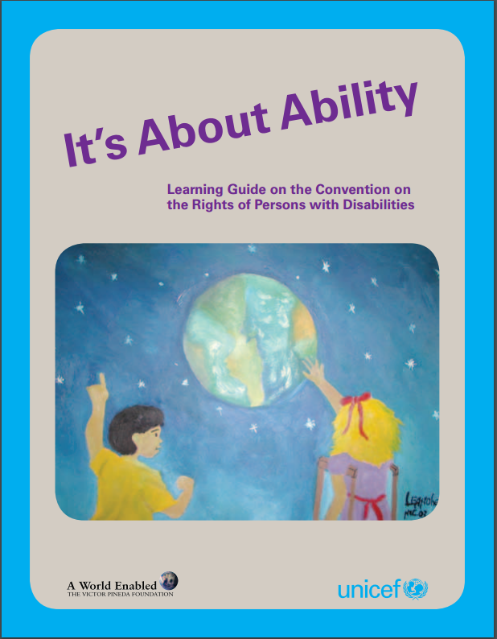
- A detailed evacuation plan should be created. Volunteers/focal persons should be assigned clear roles and responsibilities. Designate person(s) to help evacuate participants with specific needs.
This resource also has useful information about facilitating a meeting for children with disabilities:

It’s About Ability – Learning Guide on the Convention on the Rights of Persons with Disabilities

Download a copy here: http://www.unicef.org/publications/files/Its_About_Ability_Learning_Guide_EN.pdf

Step 2 - Invitation and Initiation

Once you have decided when, where, how and who will be invited to participate in the consultation, it is time to send out the invitation and other related materials.

Please see Appendix E for a sample ‘invitation’ that can be adapted and used to invite children and adolescents to the consultation. Ensure you ask participants about any special accommodations they need in order to participate. Provide enough time to make necessary arrangements.

Handouts are provided in Appendix F – Please consider sharing handout #1, #2, and #3 (in appropriate formats and languages) with children in advance of the meeting. You may also want to share a copy of the child-friendly Convention on the Rights of Persons with Disabilities (Appendix C) with participants.

Note: Before the meeting, you must circulate consent forms for children, parents/guardians as per your organization’s child protection policy. Consider whether or not pictures or video will be taken during the consultation and the required consent.

Now, we are ready to start the consultations...

Step 3 – Demographics

Where and when did the discussion take place?
Country:
City:
Location:
Date:

About you/the facilitator:
Name:
Position:
Organization:
Contact details (e-mail and phone):
Are you an adult, youth or child?

About the children and young people…

How many children participated?

Please explain the diversity of the group, check as many boxes as appropriate:

Children with disabilities
Children attending school
Children not attending school
Minority ethnic group
Minority language
Orphaned or without appropriate parental care
Children living in institutional care
Children living below the national poverty line
Children displaced by natural disaster or conflict
Religious minorities
Children who work
Other (please specify)

How many boys?
How many girls?

What are the ages of the children:

Is there anything else you would like to share about the group?
(For example: are they part of a group or organization?)

Please do not share the names of the children and young people participating.

A. Welcome and Introductions [slide 2]

Please adapt the following details to suit your group’s preferences, the following details are provided only as a guide...
Approximately 30-45 minutes required for this section, ‘welcome and introductions’.

Introductions
Start off by introducing the ‘team’ that will be supporting the meeting. For example: the facilitator(s); translator(s), the rapporteur(s), attendant(s), volunteer(s), etc.

Ask the young people to briefly introduce themselves and why they are attending this meeting.

If needed, remind participants to identify themselves each time they speak for the benefit of participants who have a visual impairment.


Icebreaker
Please select the most appropriate ‘icebreaker’ from the list below or chose one of your own.

String Conversation
- Cut string or yarn into pieces of different lengths.
- Each piece should have a matching piece of the same length.
- There should be enough pieces so that each participant will have one.
- Give each participant one piece of string, and ask them to find the person who has a string of the same length.
- After they find their matches, they should ask each other a few questions about themselves.
- After a few minutes, ask each participant to ‘introduce’ their partner to the entire group.

Common Ground
- Divide participants into small groups (of 3-4 people in each group).
- Give each team a piece of paper and a pen/pencil.
- Tell each team that their challenge is to list everything that all team members have in common (for example: maybe everyone in a team has a sister or they all like ice cream).
- They have only 3 minutes – announce the amount of time left during the 3 min. countdown.
- Ask each team to share their list. Ask how difficult/easy it was to find similarities.

Welcome and Introductions cont...

Share the following details and information with the participants:

Child Protection
Please share with the group the details of all child protection policies and procedures.
For example: issues relating to disclosure; if sensitive issues arise; where they can access support and other resources, privacy, emergency evacuation, etc.

Please remind participants that their participation is voluntary.
This may also be a good time to share with them the minimum standards in children’s participation (Appendix B).

Rapporteur
Please explain the role of the Rapporteur.
The Rapporteur may want to talk about their role and remind participants that their ideas and recommendations will be shared/documented, but that their names and personal details will not be shared (only ages, gender and country).

Explain that the group will be working with the Rapporteur throughout the consultation to ensure their views and recommendations are being accurately captured.

Photos or filming
If you have chosen to take photos or to film the consultation, before any pictures are taken or the filming begins, talk to the participants about their rights. Explain how the film/photos will be used.

Explore with the group any ideas they have about the photos/film, what do they want captured? As much as possible, they should feel ownership and control of the film/photos. Ask if there are any participants that would like to volunteer to work with the photographer/filmmaker after the consultation to edit and select images/footage.

At this time, participants should have the choice to express if they do or do not wish to be filmed or photographed.

Logistics
Make any relevant or needed announcements, for example:
- Location of the toilets
- Will snacks/lunch be served at any point?
- Details about transportation after the meeting
- If they need to make a call, etc.
- If they need any support or have questions

Ground Rules: Brainstorm with the group, their ‘ground rules’ during the consultation. Ask the group to think about and share their ideas and record them on a flipchart or board where it can be seen.
B. Expectations and Agenda [slide 3]

Now it is time to share with all participants the goals and objectives of the meeting...
Approximately 30 minutes required for this section, ‘expectations and agenda’.

Activity: Expectations Defined

Provide each participant with 3 pieces of paper (approx. 6” X 8”) and a marker
(If your group is larger, you may want to adapt this for small group discussion; participants can also share their ideas verbally as a group discussion, instead of writing on papers)

- On one piece of paper ask them to write (or ask in group discussion), ‘what do you personally hope to gain from this meeting/experience?’
- On the second piece of paper (or ask in group discussion), ‘what is something you hope to see happen during this meeting?’
- On the third piece of paper (or ask in group discussion), ‘what do you want to see happen after this meeting?’

Ask participants to stick their ‘expectations’ on the wall, in 1, 2, 3, columns.

Read each expectation out loud to the entire group. As the facilitator, look for similar ‘groupings’ – for example: expectations about learning new things are put together. Move the cards around into their ‘grouping’ as they are read out loud.

Explain: we will use these throughout the meeting and afterwards to ensure we are meeting expectations and understanding individual and group goals/priorities.

Please ensure the Rapporteur has carefully recorded the group’s expectations.
Where possible, include direct quotes with the participant’s age and gender (no names please).

Agenda [slide 4]

Briefly run through the agenda with the participants.
It is a good idea to have the agenda clearly displayed in the room and printed out.
Be sure to include details about breaks/lunch and time.

Agenda details might include:

- Introductions, expectations and overview of the agenda
- Break
- Discussion about Rights
- Discussion about Education
- Break/Lunch
- Introducing the Committee on the Rights of Persons with Disabilities
- What are ‘General Comments’
- Break
- What is ‘Inclusive Education’
- Group Discussion
- Wrap up

C. Rights Refresher [slide 5]
Approximately 60 minutes required for this section, ‘Rights Refresher’.

If your group already has a good understanding of Human Rights and the Convention on the Rights of Persons with Disabilities (CRPD), you may choose one or two of the exercises in this section as a ‘refresher’ or skip this section altogether.

For groups that are learning or that have a mixed understanding of Rights and the CRPD, these activities and information may be useful.

If your group needs information about: the United Nations; Conventions and Treaties; or more information about the Convention on the Rights of Persons with Disabilities, please see the resources listed in Appendix A.

Activity: Rights versus Needs
(Adapted from Save the Children, Youth to Youth a Program Guide. and A. Kapell and D. Keating, Monitoring Children’s Rights. Canadian Coalition for the Rights of Children, 2003. )

- Write the following words or ‘headings’ on three pieces of paper and tape each piece of paper on the wall so that they are a few feet apart from each other.
Rights
Needs
Wants

- Write the following words and ‘concepts’ on separate pieces of smaller paper:

Clean water
Fun activities
Fresh air
Housing
Clothing
Music
Respect
Designer clothes
Education
Sports Equipment
Family
Love
Medicine
Books
Food
Television
Eye Glasses
Play
A name
Art
Privacy
Health Care
No discrimination
Information

- Divide participants into 3-4 groups and then provide each group with an equal number of ‘concepts’.
- Ask each group to work together and place their ‘concept’ under the ‘headings’ (i.e. right, need, want), which they feel is the most appropriate. Explain to the group that, at this point, there may not be a right or wrong answer and that there may be more than one correct answer.
- Provide the participants an opportunity to explain why they have made some of the choices they have and ask participants from other groups if they agree or disagree.
- Inform participants that the exercise will be revisited a little later on. Leave the information on the wall for the next activity and ask the Rapporteur to record the information.

Provide each participant with a copy of the ‘Summarized CRPD’ found in Appendix C and handout #1, Appendix F. Give each participant several minutes to review the information and read through the text.
Group Discussion [slide 6]
Talk to the participants about their rights and their understanding of the CRPD.

Note: the discussion will vary pending your group’s current understanding of the Convention. Please choose the questions that are appropriate to your group.

Possible questions include:
- Was anyone surprised by what they found in the CRPD?
- Have they learned anything new about the CRPD and their rights?
- Which rights do they think are the least understood and supported?
- Which rights are the most understood and supported?
- Which rights does their current work/project/initiative address?

Activity: Rights versus Needs Revisited [slide 7]

This activity is a continuation of the first activity found in this section, ‘Rights versus Needs’.

- Ask each group to revisit the activity and their original placements of the ‘concepts’.
- After reviewing the CRPD, do they want to make any changes? (please record their discussion)
- What new information have they gained that makes them want to reconsider?
- Ask groups to explain their new perspective.
- In conclusion:
Some groups may find there is still some disagreement regarding the placement of papers and the line between a need and a right. It may be helpful to consider that the application or definition of many rights may vary in different countries and cultures.

To settle debates, your group may choose to look for exact language as found within the CRPD and define these words/concepts as rights. For example: a safe place to live, play, education and food are all words/rights that can be found within the CRPD. Books, love, sports equipment and eye glasses are not.

It could be argued, however, that in some cultures, in order to fulfill the right to education you need books; or to fulfill the right to health, you need medicine. It is also important to note that the participants are using a summarized/child-friendly version of the CRPD and that the official version provides substantially more details and descriptions.

D – Quality Education [slide 8]
Approximately 1-1.5 hours needed for this section.
In this section, we want participants to share their experiences with education and learning – their likes, dislikes and dreams.

Activity – Experiences with Education

- Explain: Article 24 of the Convention on the Rights of Persons with Disabilities deals with the issue of ‘Education’. For the rest of the day, we are going to focus on ‘education’ and the right to a quality education.
- As a large group or in smaller groups, ask participants to share and discuss, “education” – what do they think of when they consider the word, “education”?
Record their answers.

Note: If participants are currently part of a school/education program, please continue with this activity, if not, consider moving onto the next activity.

- Divide participants into groups of 3-4 people per group and provide each group with art supplies (papers, markers, glue, scissors, etc.)
- Ask participants to share details about their current learning environments. Participants can discuss as a group, draw individual pictures or do a group drawing/mapping (whatever is appropriate for your group).
- Ask participants to share and explain the following: (adapt questions to suit your group’s experiences)
What does their learning environment look like? (Draw a picture or describe, as a group or individually)
a) Who is there to help them? (Add them to the picture)
b) What are students doing – what kind of activities/resources are available?
c) Are there other students/people?
d) How do students feel in this space?
e) What do they really like about this space?
f) What do they not like about this space?
Please be sure to ask participants about their pictures/descriptions and record their explanations.

Activity – Ideal Education

- Explain: we are going to create our perfect learning environment. Using craft supplies, we can create a drawing, a 3D model or a story/role play about learning. Encourage participants to be creative.
- If your group completed the last activity, ‘Experiences with Education’, summarize some of the positive details and the things the students liked most about their current learning environment.
- Ask participants to consider and share their ideas about:
- Place and environment: where will it be located; what kind of room/building will it be? (start to draw the ‘space’ on large flip charts or begin your story)
- People: who is part of this environment; what role do they play?
- Resources: what is inside this environment; what tools and supplies are available?
- Activities: what are students doing in this place?
- Feeling: how do students feel when they are in this place and why?
- Problems: what if there is a problem or a child needs help in this space – where will they go and who should help them?
- Help participants ‘document’ the above issues in a creative way, for example:

Use various materials (cardboard tubes, boxes, tape, paper, glue, glitter, paints, etc.) and construct a 3D model of the learning space. Map out the different elements and how children envision their ideal space.

Provide young people with art supplies (markers, crayons, paints, paper) and ask them to draw their learning space. Map out the different elements with illustrations, pictures and examples.

Develop a story or role play where children can share their vision. They could, for example, create a ‘day in the life of…’ where a student goes to school and shares the details about the day, the people they saw, their activities and feelings.

- Provide an opportunity for each group to share their work with the other groups/participants. Encourage group discussion and sharing. Identify similarities and difference between each group. Be sure to record the information and discussions in detail.

E – Committee on the Rights of Persons with Disabilities and General Comments [slides 9-13]
Approximately 15 minutes needed for this section.
Briefly remind participants about the discussion you had earlier regarding rights and the Convention on the Rights of Persons with Disabilities. Now, we will be introducing the Committee on the Rights of Persons with Disabilities and some of their functions.
Please refer to the PowerPoint presentation.

Committee on the Rights of Persons with Disabilities

When a government ‘ratifies’ a Convention (like the CRPD) they are saying that they agree with it, and it becomes a legal duty for that country. In other words, by ratifying a Convention, a government is saying that they promise to do the things outlined in the Convention.

There is a special group known as the ‘Committee on the Rights of Persons with Disabilities’ that reviews progress and makes sure governments are keeping their promises, as outlined in the Convention on the Rights of Persons with Disabilities.

The Committee is a group of 18 independent experts.

[Independent Expert means that the people who sit on the Committee do not work for a specific country or government.]

All governments that have ratified the Convention on the Rights of Person with Disabilities have to submit regular reports to the Committee to show how the rights are being supported and realized at the country level.

After a government ratifies the CRPD, the first report to the Committee is due after two years and then they have to submit a report every four years.

The Committee looks at each Government report and then outlines its concerns and recommendations in a document called “Concluding Observations”. Concluding Observations are like report cards for governments, they outline some of the strengths but they also outline areas that need to be improved upon.

The Committee also takes special steps to help governments understand the Convention on the Rights of Persons with Disabilities, one way they do this is by creating ‘General Comments’...

General Comments [slides 14-15]

General Comments are created to help governments better understand specific parts of the CRPD and to support its full implementation. They can also be used by judges and lawyers during court cases to makes decisions affecting persons with disabilities, including children. They can also be used by others who work for children’s rights, and, of course, by young people who want to know more about a particular topic.

General Comments will take a part of the CRPD that might only be a few paragraphs in length and go into great detail to further define and explain the issue. General Comments are often 15-20 pages in length.

Group Discussion [slide 16]

Please ask your group if they have any questions about the Committee on the Rights of Person with Disabilities or General Comments.

How many people had ever heard of the Committee?

Is anyone aware of when your government has reported to the Committee?
When is the next repot due?

[Some participants may want to volunteer to do some research and look into when the government reports are due and to explore the recommendations the Committee made in its Concluding Recommendations]

Explain:
We are together today to talk about the most recent General Comment that is being drafted by the Committee. This General Comment focuses on ‘Inclusive education’.

The Committee has a ‘draft’ General Comment, but they would like to know what you and other young people have to say and what you feel is important to include.

The questions and discussions you will be having throughout the day will be summarized in a report and sent to the Committee on the Rights of Persons with Disabilities. The Committee will consider your recommendations in the next and final draft of the General Comment.

Before we look at the General Comment, let us first look at ‘inclusive education’ in more detail...

F – What is Inclusive Education? [slide 17]
Approximately 60 minutes needed for this section.

Now that we all have a clear understanding about rights and education, it is important that we also have a clear understanding of ‘inclusive education’.

In this section, we want to encourage participants to explore their own understanding, definitions and experiences with inclusive education, and then compare that information with the details found in the General Comment.

Group Discussions – Key Terms [slide 18]

As we review and consider the General Comment, there are a few key words and phrases we must understand. In this activity, we will take some time to review the participants’ familiarity with these key terms and help them to understand them further.

At this point, explain that it is OK if someone does not have a good understanding of any/all of these terms, we will be working together as a team to learn and develop our understanding.

Note: if you feel your group will not be familiar with any of these terms, consider skipping this activity and start by presenting the overview and definitions (below) to the group.

Note: it is also a good idea to share the handouts in Appendix F with participants prior to the meeting.

Encourage a brief group discussion where participants share their understanding of the following key words/terms:

- Segregation – can anyone explain ‘segregation’?
- Inclusive – what is your understanding of the word ‘inclusive’?
- Inclusive Education – what does ‘inclusive education’ mean to you?

Write their answers down on a board or flipchart.

Explain that the Committee on the Rights of Persons with Disabilities has been considering these same issues. Below (and within the PPT) is an overview of the Committee’s definitions (see handouts in Appendix F):

WHAT IS INCLUSIVE EDUCATION? [slides 19-25 ]

Inclusive education is about removing barriers to education and supporting the different needs of individual students.

Inclusive education is about making education systems stronger and reaching out to all learners. It focuses on attendance, participation and achievement of all students.

Inclusive education is about finding ways to teach and support every student so they may reach their full potential.

Inclusive education is about access to high-quality education without discrimination of any kind, inside or outside the school system.

Inclusive education is about ending discrimination, celebrating diversity, promoting participation and overcoming barriers to learning and participation for all people.

The goal is for all students to learn in inclusive environments.

(For more info, see General Comment no. 4, paragraph: 9)

WHAT INCLUSIVE EDUCATION IS NOT [slides 26-28]

Inclusive education is different from the segregation and integration style of education.

In the segregation style, students with disabilities are taught in a separate place away from the other students. This sometimes happens in a different classroom in the same school, or sometimes in a different location altogether.

The integration style is also different from inclusive education.
Integration is about placing persons with disabilities into existing educational settings and expecting them to adjust without making changes or providing needed support or help. In this case, students with disabilities may be taught in the same classroom with other students, but there has been little planning and teachers might not have the needed training for teaching persons with disabilities.

Neither the integration nor the segregation style can provide the good quality education that the inclusive education style can.

(For more info, see General Comment no. 4, paragraph: 11)

THE MAIN POINTS OF INCLUSIVE EDUCATION [slides 29-36]

The main points of inclusive education include:

- Whole Educational Environment:
Leadership of educational institutions (for example: principals, vice-principals, counsellors) must be committed to inclusive education. Their commitment must be shared and understood at all levels, including: in the classroom; in board meetings; in school budgets; in the community; with staff and teachers.
- Whole Person Approach:
Every child and adult has the ability to learn. Teaching methods should be developed to meet the different strengths, needs and learning styles of each person. When developing learning and teaching activities, the focus should be on students first. It is the responsibility of the education system to meet the needs of each student, not the student’s responsibility to fit within the system. There is also a commitment to ending segregation (the separation of people with disabilities from those people without disabilities).
- Support Teachers:
Teachers and other staff in schools should be given the proper training and materials needed for inclusive education. Teachers and students should be encouraged to work together, in partnership and to solve problems.
- Embrace Diversity:
All students should feel valued, respected, included and listened to.
- Learning-Friendly Environment:
Students should be able to learn in a safe place, where they feel comfortable. Students themselves should be involved in building a positive school community.
- Partnerships:
Parents and communities can help make inclusive education a reality. Teacher associations, student associations, student federations, organizations of persons with disabilities, school boards, parent-teacher associations, and other school groups should be encouraged to increase their understanding and knowledge of disability.
- Monitoring:
Inclusive education must be monitored on a regular basis. We must ensure that segregation or integration is not taking place. Monitoring should involve persons with disabilities, including children, as well as parents of children with disabilities where appropriate.

(For more info, see General Comment no. 4, paragraph: 12)

THREE REASONS WHY INCLUSIVE EDUCATION IS GOOD FOR EVERYONE
[slide 37]

Education
Inclusive education leads to a better quality of education for all children, including children with a range of abilities. Teachers gain new skills and expertise by supporting inclusive education.

Society
Quality inclusive education is good for society. Inclusive education ends discrimination and builds respect for diversity, inside and outside the classroom. Inclusive education creates “a culture of diversity”. This means that when children with disabilities learn and play with children without disabilities, everyone – the students, the teachers, parents, family members and caregivers – can become more accepting of one another’s differences.

Economy (the way a country manages its money and resources)
Quality inclusive education is also good for the economy. Inclusive education is an investment and something that can reduce poverty. Inclusive education helps persons with disabilities become less dependent on others. Inclusive education can also give persons with disabilities more confidence and help them to find employment and to participate in society.

(For more info, see General Comment no. 4, paragraph: 3)

Group Discussions – Key Terms Wrap Up [slide 38]

Please ask:

- Does anyone have questions or comments about ‘inclusive education’?
- Do we generally agree with the points being made by the Committee on the Rights of Persons with Disabilities? Is Inclusive education and good thing? Why or why not?
- Are there any differences or similarities with the group’s earlier discussion and understanding of “inclusive”, “segregation”, or “inclusive education”?
- Following this discussion, ask participants to revisit their ‘ideal school’. Is there anything they would like to change or add to their learning environments to make them ‘inclusive’? Had they already included aspects of ‘inclusive education’ within their plans/mapping? Help participants draw these linkages and apply the definition/elements of ‘inclusive education’ to their work.
- Please be sure to capture these discussions and any changes the participants have made.

G – Making a Plan [slide 39]
Approximately 45 minutes needed for this section.

Now that we have a vision of our ideal learning space/environment, how can it become a reality? We want participants to think about the actions needed and the actors that should be involved.

Activity – Making a Plan

- As one large group, ask participants to consider the following 2 questions:
- What are some of the challenges or obstacles standing in the way of inclusive education? Why don’t all children have access to inclusive education?
- Who needs to be involved in creating an ideal learning environment and overcoming these obstacles (i.e. which people must support inclusive education)?
- Record their answers on flipcharts.
- Create smaller groups/teams and assign 1 or 2 of the ‘people’ listed above to each team (for example: team 1 might look at the role of governments, team 2 might look at the role of students, etc.)
- For every person/group listed, each team should explore: what role (duties) does this group have? What actions do they need to take?
- What support might they need in order to take these actions?
When needed/helpful, draw linkages to the obstacles identified and how each stakeholder can help overcome the challenges.

Example of discussion chart:

People and Groups | Actions and Responsibilities | Resources and Support | Challenges and Obstacles (general)
Government | - laws  - funding |  | - Fear  - Discrimination  - Not enough information  - Not enough money
Teachers | - guide students  - resolve conflict | - training
Students
Families
Principals

H - What the Committee is Suggesting
The amount of time required for this section will depend on the approach you choose.
For example: you may choose to complete this exercise after the consultation with only a few volunteers, instead of the full group.

In Appendix G, we have prepared a summary of the Committee’s General Comment and the recommendations for governments.

Remember: the General Comment is currently only a draft and the perspectives of your group may help to shape the final version.

Please compare the group’s discussion with the recommendations of the Committee on the Rights of Persons with Disabilities.

Pending your group, this could be done as follows:

- The adult support people/facilitators can draw comparisons from the group’s discussion.
- You can identify a few young people/participants who would like to help summarize their discussions, review the draft text (appendix G) and draw comparisons.
- You can introduce the information in Appendix G to the entire group and have a group discussion.

All of the activities completed thus far (e.g. defining an ideal education, exploring key terms, action planning) have touched on the key elements of the General Comment.

Your detailed notes of all activities will help the Committee understand how these issues are seen and experienced by children. Your further support, in reviewing the draft text and making comparisons, will provide added clarity and insight.

Things to consider while reviewing the draft text (appendix G):
- Are there similarities? How does the draft General Comment and children’s recommendations/experiences align?
- Are there things missing? Are there issues discussed by children that cannot be found in the draft General Comment?
- Are there contradictions or disagreements? Are there areas where the children’s recommendations do not align with the draft General Comment?

I. Evaluation and Team Wrap Up [slide 40]
Approximately 30-45 minutes needed for this section, ‘evaluation and team wrap up’.
Group Activity – Evaluation

Please ask the group if they have any final questions or comments.

Explain: every event, consultation or get together is an opportunity for us to learn. We get to learn new information and we get to learn more about our process, what works and what can be improved next time.

We would like to hear from you, your feedback about this consultation.

Please choose the activity that is most appropriate for your group.

- Finish the statement…

Please share the following statements in a way all participants can access them:
- The best thing about this consultation was…
- If I could change one thing…
- I am leaving with the hope that…

Please go around in a circle and ask participants to finish the statements.

- Evaluation Form

In advance, prepare a 1-2 page ‘evaluation form’ for participants to fill out.

For example:

 | Excellent | Good | Not so good | Bad
Overall
Group Discussions
Food and Drink
Venue

A detailed evaluation form can be obtained from, ‘Children as Advocates, Strengthening Child and Young People’s Participation in Advocacy Fora’
Resource details provided in Appendix A.

Group Activity – Team Wrap Up

Please thank all participants for their time, input and valuable recommendations.

Remind them of any key details relating to next steps; who is doing what; next meeting; etc.

And choose the activity that best suits your group:

- Appreciations

Ask participants to form a circle.
Ask each person to share something they appreciate about the person standing to their right side.
Continue until everyone has shared and everyone has received an ‘appreciation’.

- Reflection Time
Ask the participants to find a place where they can sit quietly alone and undisturbed for 10-15 minutes.

During that time, invite them to reflect on the day (or days) of the consultation.

Ask them to be aware of any thoughts or images that come to mind.

With so much focus on “doing” there can be a great benefit in shifting to a few minutes of “being.”

When time is over, invite people to share whatever they want. For some, the few minutes of quiet has created an opening for profound inspiration, and you will experience a reflection session with a great impact.

Appendix A

Useful Resources

Publications and Guides

It’s About Ability – An explanation of the Convention on the Rights of Persons with Disabilities:
This publication explains the Convention on the Rights of Persons with Disabilities to children. Its main purpose is to empower children, with and without disabilities, to play their part in challenging discrimination and promoting the Convention's principles.
Available in English, French and Spanish at: http://www.unicef.org/publications/index_43893.html

It’s About Ability: Learning Guide on the Convention on the Rights of Persons with Disabilities
This learning guide is a companion resource to It’s About Ability: An explanation of the Convention on the Rights of Persons with Disabilities, developed by UNICEF and the Victor Pineda Foundation. Designed to empower children and young people aged 12–18 to speak out on the convention and become advocates for inclusion in their communities, the learning guide offers lesson plans and suggested activities to be used by young leaders, peer educators, teachers and other educators at the community level.
Available at: http://www.unicef.org/publications/index_50687.html

‘What is...’ leaflets
There is a series of books called the ‘What is...’ leaflets. These 10 leaflets have been developed for children and young people and help to explain many different things about the United Nations.
For example:
* What is... the United Nations?
* What is... the UN General Assembly?
* What is... the Human Rights Council?
* What is... a Convention and a Treaty?
* What is... a Special Representative?
* What is... the UN Convention on the Rights of the Child?

Please visit the website: http://resourcecentre.savethechildren.se/content/library to access all of the ‘What is…’ leaflets. Once you are at the site, type in ‘What is…’ into the search field and you will receive a full listing of all the leaflets.

Children as Advocates, Strengthening Child and Young People’s Participation in Advocacy Fora
The Handbook was compiled in response to a growing need to consolidate the existing protocols, guidelines and resource documents in strengthening children and young people’s participation in advocacy at various national, regional and global meetings and events that
UNICEF has supported over these last years. It aims at providing minimum standards and guidance on how to organize a children and young people’s meeting. Although a multitude of standards and guidelines are available on children and young people’s participation in meetings, it is not always easily accessible or well organized. This Handbook has been developed for organizers of such meetings, UN staff, and others interested in children and young people participation in global advocacy.
See included:
- Guidelines for translators
- Sample consent forms
- Tips for facilitators
- Media Training
- Evaluation form and more…
Available at: http://www.unicef.org/southafrica/SAF_resources_childrenadvocates.pdf

Child and Youth Participation Resource Guide
This guide presents resources on child and youth participation from Asia, Europe, North America, Latin America, Africa, Australia and the Pacific. The main audiences for this resource guide are practitioners and managers involved in promoting child and youth participation in government, community-based organizations, child-led organizations, NGOs and UN and donor agencies.

It provides an overview of existing resources and assists readers in seeking further information through the listed websites and organizational links. The guide focuses on materials in English that have broad relevance and applicability (including issues addressing disability) and are available electronically.
Available at: http://www.unicef.org/adolescence/cypguide/resourceguide_intro.html

So You Want to Involve Children in Research?
A toolkit supporting children’s meaningful and ethical participation in research relating to violence against children. It promotes research that sees children as active agents in their own lives rather than passive victims or research ‘subjects’. The booklet presents research techniques and pointers for involving children in secondary and primary research which can be adapted and applied to numerous settings. Available at: http://www.unicef.org/adolescence/cypguide/files/So_you_want_to_research_apr2004.pdf

Energizers and Icebreakers
Ideas can be found at:
http://wilderdom.com/games/Icebreakers.html
http://www.mwls.co.uk/icebreakers/
http://www.excellerate.co.nz/freeicebreakers.html

Appendix B

Minimum Standards in
Children’s Participation

Basic requirements for the implementation of the right of the child to be heard

The UN CRC Committee urges States parties to avoid tokenistic approaches, which limit children’s expression of views, or which allow children to be heard, but fail to give their views due weight. It emphasizes that adult manipulation of children, placing children in situations where they are told what they can say, or exposing children to risk of harm through participation are not ethical practices and cannot be understood as implementing article 12.

If participation is to be effective and meaningful, it needs to be understood as a process, not as an individual one-off event. Experience since the Convention on the Rights of the Child was adopted in 1989 has led to a broad consensus on the basic requirements which have to be reached for effective, ethical and meaningful implementation of article 12. The Committee recommends that States parties integrate these requirements into all legislative and other measures for the implementation of article 12.

All processes, in which a child or children are heard and participate, must be:

  - Transparent and informative - children must be provided with full, accessible, diversity-sensitive and age-appropriate information about their right to express their views freely and their views to be given due weight, and how this participation will take place, its scope, purpose and potential impact;

  - Voluntary - children should never be coerced into expressing views against their wishes and they should be informed that they can cease involvement at any stage;

  - Respectful - children’s views have to be treated with respect and they should be provided with opportunities to initiate ideas and activities. Adults working with children should acknowledge, respect and build on good examples of children’s participation, for instance, in their contributions to the family, school, culture and the work environment. They also need an understanding of the socio-economic, environmental and cultural context of children’s lives. Persons and organizations working for and with children should also respect children’s views with regard to participation in public events;

  - Relevant - the issues on which children have the right to express their views must be of real relevance to their lives and enable them to draw on their knowledge, skills and abilities. In addition, space needs to be created to enable children to highlight and address the issues they themselves identify as relevant and important;

  - Child-friendly - environments and working methods should be adapted to children’s capacities. Adequate time and resources should be made available to ensure that children are adequately prepared and have the confidence and opportunity to contribute their views. Consideration needs to be given to the fact that children will need differing levels of support and forms of involvement according to their age and evolving capacities;

  - Inclusive - participation must be inclusive, avoid existing patterns of discrimination, and encourage opportunities for marginalized children, including both girls and boys, to be involved. Children are not a homogenous group and participation needs to provide for equality of opportunity for all, without discrimination on any grounds. Programmes also need to ensure that they are culturally sensitive to children from all communities;

  - Supported by training - adults need preparation, skills and support to facilitate children’s participation effectively, to provide them, for example, with skills in listening, working jointly with children and engaging children effectively in accordance with their evolving capacities. Children themselves can be involved as trainers and facilitators on how to promote effective participation; they require capacity-building to strengthen their skills in, for example, effective participation awareness of their rights, and training in organizing meetings, raising funds, dealing with the media, public speaking and advocacy;

  - Safe and sensitive to risk - in certain situations, expression of views may involve risks. Adults have a responsibility towards the children with whom they work and must take every precaution to minimize the risk to children of violence, exploitation or any other negative consequence of their participation. Action necessary to provide appropriate protection will include the development of a clear child-protection strategy which recognizes the particular risks faced by some groups of children, and the extra barriers they face in obtaining help. Children must be aware of their right to be protected from harm and know where to go for help if needed. Investment in working with families and communities is important in order to build understanding of the value and implications of participation, and to minimize the risks to which children may otherwise be exposed;

  - Accountable - a commitment to follow-up and evaluation is essential. For example, in any research or consultative process, children must be informed as to how their views have been interpreted and used and, where necessary, provided with the opportunity to challenge and influence the analysis of the findings. Children are also entitled to be provided with clear feedback on how their participation has influenced any outcomes. Wherever appropriate, children should be given the opportunity to participate in follow-up processes or activities. Monitoring and evaluation of children’s participation needs to be undertaken, where possible, with children themselves.

Appendix C

Summarized Version of the
Convention on the Rights of Persons
with Disabilities

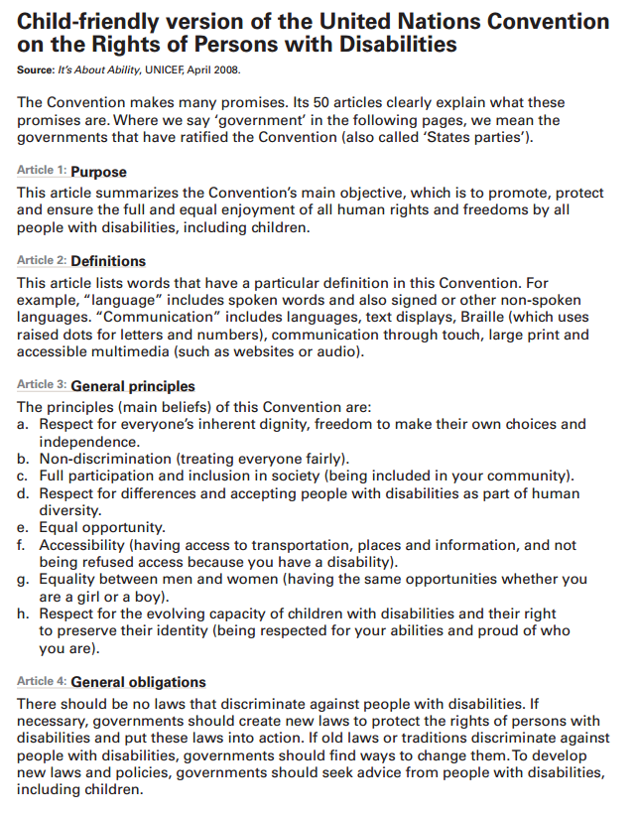

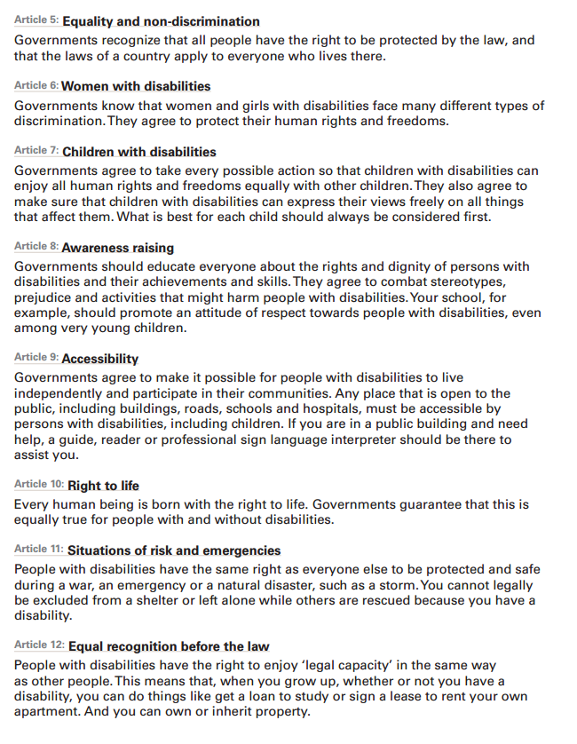

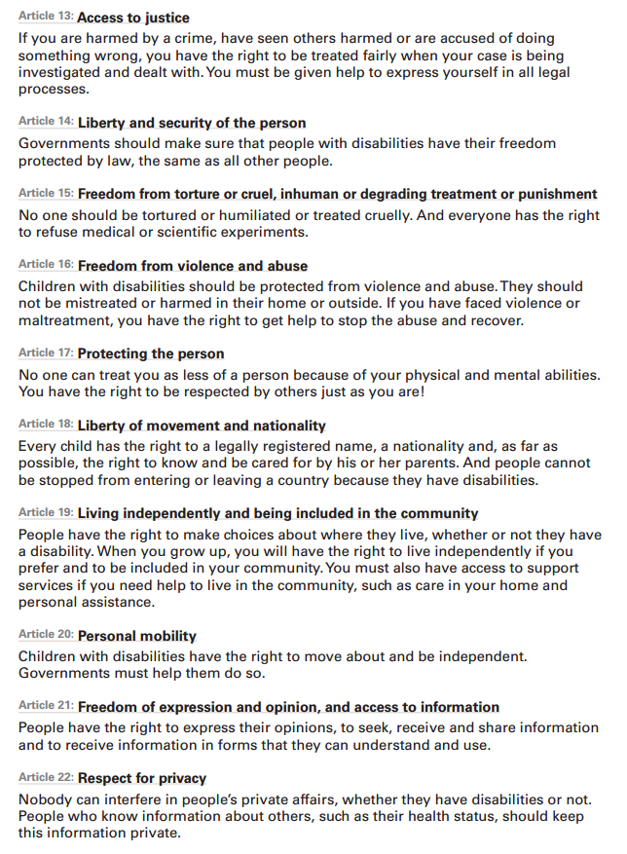
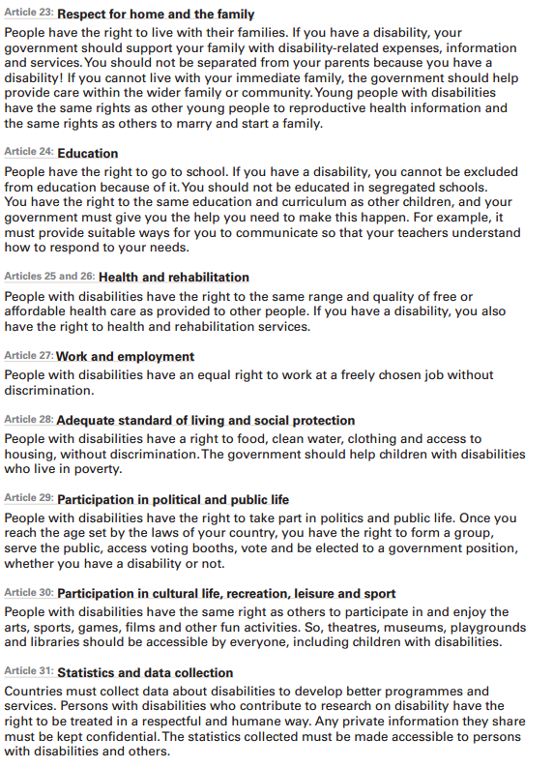

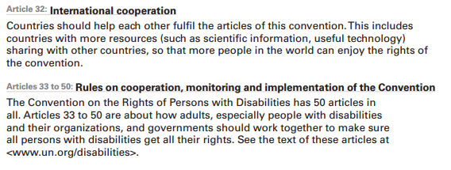

Appendix D

Checklist for Rapporteurs

CHECKLIST
QUESTIONS AND GUIDELINES FOR DOCUMENTING CHILDREN’S AND ADOLESCENT’S VOICES IN CONSULTATIONS
A lot of preparation is often done for national or regional consultations of children or adolescents but these are seldom comprehensively documented to capture a genuine analysis of young people’s voices and actions. It is vital that this is done during the forthcoming country and regional consultations so that young people’s voices and actions can be used to influence the development of the General Comment. This documentation can also help to evaluate young people’s participation in the process.
The following checklist can be used for documenting young people’s voices at the consultations. The outcome report should be focused, highlighting achievements, constraints and final outcomes. It should be written, wherever possible, in a child or reader friendly style and produced in a similar format.

NOTE: Please use the information provided throughout this guide to accurately capture your group’s discussions. The following checklist has been developed to help ensure key points have been recorded:
CHECKLIST POINTS
- Describe the Pre-Consultation Process
- Describe the background and objectives of the consultation
- Describe in brief the number and names of cities/ regions in which consultations have taken place
- Describe in brief the background preparation for these consultations
- Describe in brief the kinds of background preparation information shared with young people (reader friendly CRPD, local language material, material in Braille, sign language, etc.)
- Describe in brief the young people’s backgrounds – age, sex, class, region, religion, ethnicity, and disability
- Describe in brief, who the young people represented
- Describe in brief the selection criteria for the consultations
- Describe the facilitation Process. Describe how the facilitators were selected and what training/capacity building they received (minimum standards on consulting with children and young people)
- Describe in brief the methodology used for facilitating children and young people to express themselves
- Describe in brief the methods used to ensure participation and expression of all the young people coming from various backgrounds – age, sex, class, region, religion, ethnicity, and ability
- Describe if an analysis of the young people’s voices who could not attend the consultation was presented
- Describe the key Discussion and Issues
- Describe in brief the key issues raised by children and young people. If possible, with a breakdown according to different age, sex, class, region, religion, ethnicity, ability, disabilities.
- Describe the Priorities set by Young people
- Describe in detail the priorities made by young people.
- Highlight priorities made by according to age, gender specific groups, disable and ethnic minorities, etc.

Appendix E

Sample Letter of Invitation

Dear _________________ (children and adolescents),

Ever think about rights? Ever think about the rights of persons with disabilities?
Ever think about education and education for person with disabilities?
Even wonder who is responsible for making sure your rights are supported and protected?

We would like to invite you to participate in a meeting to discuss and explore the rights of persons with disabilities and education.

This meeting is being hosted by:
Participants will include:

Please attend and share with us your ideas and recommendations.

Meeting details
Location:
Date:
Time:
Other details:

Your recommendations will be shared with the ‘Committee on the Rights of Persons with Disabilities’, and will help inform an important document they are preparing. Learn all about it when you attend the meeting.

If you require documents in formats other than conventional print, or if you have specific accommodation or dietary needs, please let us know so we can make arrangements in advance. Please also identify any assistance you may require in the event of an emergency evacuation. For more detailed information, call __________ at ___________.

We look forward to seeing you soon.

For more information, please contact:

Appendix F

Handouts

Handout #1

About the Convention on the Rights of Persons with Disabilities

When a government ‘ratifies’ a Convention they are saying that they agree with it, and it becomes a legal duty for that country. In other words, by ratifying a Convention, a government is saying that they promise to do the things outlined in the Convention.
Conventions are legal agreements made by governments to protect girls, boys, women, men and also our planet. They highlight the promises governments have made on an issue (for example: to protect children and women’s rights) and they are part of international law.

The Convention on the Rights of Persons with Disabilities (CRPD for short) is an agreement by countries around the world to make sure that all people, including children with disabilities, can enjoy their rights and that they are treated equally.

To see if your country has ratified the CRPD, please visit this link:
Country ratification of the CRPD

Handout #2

Committee on the Rights of Persons with Disabilities

When a government agrees with (or ‘ratifies’) the Convention on the Rights of Persons with Disabilities (the CRPD for short), it becomes a legal duty for that country.

There is a special group known as the ‘Committee on the Rights of Persons with Disabilities’ that reviews progress and makes sure governments are keeping their promises, as outlined in the Convention on the Rights of Persons with Disabilities.

The Committee is a group of 18 independent experts that monitors the implementation of the Convention on the Rights of Persons with Disabilities.

[Independent Expert means that the people who sit on the Committee do not work for a specific country or government.]

All governments that have ratified the Convention on the Rights of Person with Disabilities have to submit regular reports to the Committee on how the rights are being supported and realized at the country level.

After a government ratifies the CRPD, the first report to the Committee is due after two years and then they have to submit a report every four years.

The Committee looks at each Government report and then outlines its concerns and recommendations in a document called “Concluding Observations”. Concluding Observations are like report cards for governments, they outline some of the strengths but they also outline areas that need to be improved upon.

The Committee also takes special steps to help governments understand the Convention on the Rights of Persons with Disabilities, one way they do this is by creating ‘General Comments’.

General Comments

General Comments are created to help governments better understand specific parts of the CRPD and to support its full implementation. They can be used by judges and lawyers during court cases to makes decisions affecting persons with disabilities, including children. They can also be used by others who work for human rights, and, of course, by young people who want to know more about a particular topic.

General Comments will take a part of the CRPD that might only be a few paragraphs in length and go into great detail to further define and explain the issue. General Comments are often 15-20 pages in length.
Handout #3

Inclusive Education

Inclusive education is about removing barriers to education and supporting the different needs of individual students.

Inclusive education is about making education systems stronger and reaching out to all learners. It focuses on attendance, participation and achievement of all students.

Inclusive education is about finding ways to teach and support every student so they may reach their full potential.

Inclusive education is about access to high-quality education without discrimination of any kind, inside or outside the school system.

Inclusive education is about ending discrimination, celebrating diversity, promoting participation and overcoming barriers to learning and participation for all people.

The goal is for all students to learn in inclusive environments.

What Inclusive Education is Not

Inclusive education is different from the segregation and integration style of education.

In the segregation style, students with disabilities are taught in a separate place away from the other students. This sometimes happens in a different classroom in the same school, or sometimes in a different location altogether.

The integration style is also different from inclusive education.
Integration is about placing persons with disabilities into existing educational settings and expecting them to adjust without providing needed support or help. In this case, students with disabilities may be taught in the same classroom with other students, but there has been little planning and teachers might not have the needed training for teaching persons with disabilities.

Neither the integration nor the segregation style can provide the good quality education that the inclusive education style can.

(For more info, see General Comment no. 4, paragraph: 11)

The Main Points of Inclusive Education

The main points of inclusive education include:

- Whole Educational Environment:
Leadership of educational institutions (for example: principals, vice-principals, counsellors) must be committed to inclusive education. Their commitment must be shared and understood at all levels, including: in the classroom; in board meetings; in school budgets; in the community; with staff and teachers.
- Whole Person Approach:
Every child and adult has the ability to learn. Teaching methods should be developed to meet the different strengths, needs and learning styles of each person. When developing learning and teaching activities, the focus should be on students first. It is the responsibility of the education system to meet the needs of each student, not the student’s responsibility to fit within the system. There is also a commitment to ending segregation (the separation of people with disabilities from those people without disabilities).
- Support Teachers:
Teachers and other staff in schools should be given the proper training and materials needed for inclusive education. Teachers and students should be encouraged to work in partnership and to solve problems together.
- Embrace Diversity:
All students should feel valued, respected, included and listened to.
- Learning-Friendly Environment:
Students should be able to learn in a safe place, where they feel comfortable. Students themselves should be involved in building a positive school community.
- Partnerships:
Parents and communities can help make inclusive education a reality. Teacher associations, student associations, student federations, organizations of persons with disabilities, school boards, parent-teacher associations, and other school groups should be encouraged to increase their understanding and knowledge of disability.
- Monitoring:
Inclusive education must be monitored on a regular basis. We must ensure that segregation or integration is not taking place. Monitoring should involve persons with disabilities, including children, as well as parents of children with disabilities where appropriate.

(For more info, see General Comment no. 4, paragraph: 12)

THREE REASONS WHY INCLUSIVE EDUCATION IS GOOD FOR EVERYONE

Education
Inclusive education leads to a better quality of education for all children, including children with a range of abilities. Teachers gain new skills and expertise by supporting inclusive education.

Society
Quality inclusive education is good for society. Inclusive education ends discrimination and builds respect for diversity, inside and outside the classroom. Inclusive education creates “a culture of diversity”. This means that when children with disabilities learn and play with children without disabilities, everyone – the students, the teachers, parents, family members and caregivers – can become more accepting of one another’s differences.

Economy (the way a country manages its money and resources)
Quality inclusive education is also good for the economy. Inclusive education is an investment and something that can reduce poverty. Inclusive education helps persons with disabilities become less dependent on others. Inclusive education can also give persons with disabilities more confidence and help them to find employment and to participate in society.

(For more info, see General Comment no. 4, paragraph: 3)

Appendix G

Summary of General Comment No.4
Article 24
The Right to Inclusive Education

(Note: Handout #3, in Appendix F, is also part of the Draft General Comment)

WHY ISN’T EVERYONE USING INCLUSIVE EDUCATION?
While many governments and people around the world know that inclusive education is a good thing for everyone, there are still some issues which have prevented everyone from following the inclusive education style. In fact, there are still millions of persons with disabilities who are not getting any education at all. And there are many more persons with disabilities who are not getting the best possible education.

Some of the reasons why this is still happening include:

- Discrimination: Many people look at the person’s disability as being the problem, instead of paying more attention to the other problems, such as a lack of good laws, the negative attitudes of some people, lack of funding, and communication issues between those with and those without disabilities.
- Fear: Some people feel that if we include persons with disabilities in the classroom, it will mean that the quality of education for everyone else will be poorer.
- Lack of Information: There is a lack of good information about the importance of inclusive education and how it can help persons with disabilities. This has slowed down important changes in laws and education plans that could help persons with disabilities.
- Lack of Awareness: Many people still don’t know what inclusive education means and how it can be a good thing for everyone. Because of this, there has not been enough money invested in, or even interest in making inclusive education happen for everyone.

(For more info, see General Comment no. 4, paragraphs: 4 and 5)

WHAT ARTICLE 24 ASKS GOVERNMENTS AND OTHERS TO DO:

RESPECT, PROTECT AND FULFIL
Governments should respect, protect and fulfil the main features of inclusive education, for example:
- Governments should respect the right to inclusive education by making sure that students are not kept out of the classroom because of a disability they may have.
- Governments should protect the right to inclusive education by making sure that persons with disabilities are not kept from attending school by others (for example, by parents who refuse to send girls with disabilities to school).
- Governments should fulfil the right to inclusive education by making sure that schools and the education plans are available, accessible, acceptable and adaptable to persons with disabilities.
- Governments should do all of this as best and as quickly as they can, and by using all available resources.

(For more info, see General Comment no. 4, paragraphs: 18, 38, 39 and 40)

INVEST IN INCLUSIVE EDUCATION
Governments should commit enough money and people towards providing quality inclusive education. Some of the areas that might need funding and people include:
- Educating teachers in the inclusive education style.
- Giving persons with disabilities support and making sure they have everything they need to succeed in school.
- Investing in technology that could help persons with disabilities in school.
- Raising awareness about discrimination against persons with disabilities.
- Moving funding away from the segregation style and putting it into inclusive education.

(For more info, see General Comment no. 4, paragraphs: 63, 70 and 71)

MAKE INCLUSIVE EDUCATION AVAILABLE
Governments must make sure that all persons with disabilities can receive quality inclusive education at primary and secondary school for free. Along with being free, primary school must also be “compulsory”, in other words, all children must go. Governments must also take steps to make sure that secondary education is available and accessible to every child and that this too should be free.

Persons with disabilities should not be sent away from home in order to participate in inclusive education. Instead, governments should make sure that there are enough primary and secondary schools using the inclusive education style in every community.

(For more info, see General Comment no. 4, paragraphs: 19, 20, 23, 27 and 63)

MAKE INCLUSIVE EDUCATION ACCESSIBLE
Governments, people involved in the education system, and those who build schools should make sure that all new schools are “accessible” to persons with disabilities. This means that persons with disabilities should be able to easily get to school, get into the school, the classrooms, the toilets, as well as places where they might play sports or other activities. It also means that the schools should have the proper furniture for students with disabilities to take part in the inclusive education setting.

Textbooks and other learning materials need to be in an accessible format for persons with disabilities. And schools should also try to use the latest technology to help deliver the lessons to persons with disabilities.

(For more info, see General Comment no. 4, paragraphs: 21, 22 and 63)

MAKE INCLUSIVE EDUCATION ACCEPTABLE
The right to inclusive education means that persons with disabilities should be able to receive an education that respects their needs, culture, language and views. Education should always promote understanding, tolerance and mutual respect for each other. Education should show why it is important and good to have different kinds of people learning and working together.

(For more info, see General Comment no. 4, paragraphs: 24 and 63)

WORK TOGETHER WITH ALL STAKEHOLDERS
In order to achieve inclusive education for everyone in the country, all parts of the government have to work together. This means that the different departments (or “ministries”) have to make education plans together. Those departments include education, finance, health, transport, planning, social welfare and child protection. Education plans and standards should be the same for all of the schools in the country.

The government, local authorities, student groups and organizations, non-governmental organizations, schools, universities, teachers and teacher schools, parents and, of course, persons with disabilities should all work together to help achieve the right to inclusive education.

(For more info, see General Comment no. 4, paragraphs: 60, 61, 63, 81 and 82)

MAKE LAWS THAT RESPECT, PROTECT AND FULFIL INCLUSIVE EDUCATION
Governments must make sure that laws – both old ones and new ones – do not allow for discrimination against persons with disabilities. All new laws and new education plans should clearly state inclusive education as the goal. In order to achieve inclusive education for all, any new laws that are made have to support new education plans, and any new education plans that are made have to support new laws. These laws and plans should affect all of the schools in the country. New laws should also guarantee that all children, including those with disabilities, have the right to be heard within the school system.

(For more info, see General Comment no. 4, paragraphs: 62, 63 and 77)

GET CHILDREN WITH DISABILITIES OUT OF LONG-TERM INSTITUTIONS
Inclusive education will not work if persons with disabilities are in long-term institutional care. There are too many persons with disabilities living in long-term institutions. Governments should make sure that persons with disabilities are taken out of these institutions and put into schools that follow inclusive education. Funding for these sorts of institutions should instead be redirected to services that can be provided within the community. For inclusive education to happen, everyone needs to follow Article 19, the right of persons with disabilities to live within the community.

(For more info, see General Comment no. 4, paragraph: 66)

PERSONALIZE EDUCATION
Education should be directed to each individual student. Individual students – including those with disabilities – often do not learn the same way. It is important that teachers try to find ways to teach every student. This is sometimes called “personalized education”.

Teachers should try to do this in a way that meets the needs of all students – including those with disabilities – and suits the individual students’ personality, talents and creativity. The evaluation of a student with disabilities should be based on the progress of that individual student and not on standard test score that often puts some students with disabilities at a disadvantage.

(For more info, see General Comment no. 4, paragraphs: 32 and 33)

TRAIN TEACHERS
In order for persons with disabilities to fulfil their potential, teachers must know what these students will need in order to succeed. This will mean that teachers will need to know different ways of teaching, have different kinds of teaching materials, and know how to properly communicate with students with disabilities so that they can teach and support them. The government, organizations for persons with disabilities, parents, the community and students with disabilities can all help teachers learn how to teach students with disabilities.

There are different ways that governments can support the training of teachers in inclusive education:
- Teachers teaching other teachers: this could happen when a small group of teachers receive training in inclusive education and then teach the other teachers and staff in their school. This is sometimes called a “trainer-of-trainers” model.
- Resource Centres: these centres could employ people with a lot of inclusive education experience. Teachers, families and caregivers of persons with disabilities could go to this centre to receive training on inclusive education from these experts.
- Resource Teacher: this is where schools would have their own resource teacher whose main job would be to help teachers and students learn more about inclusive education.
- Partnerships: this is where teachers and staff from one school would work and train together with teachers and staff from other schools. Everyone involved could share information about inclusive education and share “best practices” (in other words, the best way of doing things).

People learning to become teachers should be trained in the inclusive education style. Hopefully, all teachers will someday have experience teaching in an inclusive education setting.

The government and everyone involved in education should also support teachers with disabilities. Hiring teachers with disabilities will inspire other persons with disabilities to become teachers. Teachers with disabilities will bring their own experience and skills into the schools and the classroom, and will improve everyone’s inclusive education experience.

(For more info, see General Comment no. 4, paragraphs: 35, 36, 72, 73, 74, 75 and 76)

SUPPORT PERSONS WITH DISABILITIES
Governments should provide “reasonable accommodation” to persons with disabilities. This means that governments should make sure that persons with disabilities have everything they need to achieve their right to inclusive education, and governments should do this as quickly as possible.

Persons with disabilities need support so that they can achieve their full potential. Governments and people who make education plans need to think about the learning styles, the culture, the languages and other needs of all learners in the inclusive education classroom.

This sometimes means that persons with disabilities might need special aids or technology to help them learn. These aids and technologies can help persons with disabilities to see or hear better, to become more independent and allow them to participate more with others in the classroom.

The government and people who make education plans should make sure that:

- Blind and partially sighted students have access to and/or can learn Braille (this is language for blind people which they read through their fingertips), or other kinds of communication through investment in technology.
- Deaf and hearing impaired students have access to and/or can learn sign language (this is a language that deaf people use to communicate with using their hands).
- Schools ensure the right of children to be taught in their own language.

Support will be different for different persons with disabilities. For example, a person with low vision may want to use technology that makes his/her screen bigger. While another student with the same disability, may prefer to have the same learning materials in large print. Whatever the support may be, governments and everyone involved in education should to try to help blind, deaf and deafblind students achieve their full potential and to participate in the inclusive education setting and society.

(For more info, see General Comment no. 4, paragraphs: 28, 29, 31, 34 and 63)

HELP WITH EARLY DETECTION
Governments should also help with the early detection of disabilities. Children with disabilities have a better chance of succeeding if their disability is detected early on. Governments (especially the ministry or department of health), non-governmental organizations, parents and caregivers should work together to detect disabilities in those children who are not yet in school. Everyone should also work together to help support and train parents and caregivers of young children with disabilities.

(For more info, see General Comment no. 4, paragraph: 67)

MAKE SURE CHILDREN WITH DISABILITIES ARE HEARD
Everyone who makes the plans for inclusive education should also consider the voice of students with disabilities. Children with disabilities have a right to be heard. Some of the ways that the opinions of students with disabilities might be heard could be through school councils, government and non-governmental organizations, and through “mechanisms” where students with disabilities might safely raise issues and make complaints about their own education.

Students with disabilities should also be involved in helping to develop education plans and programmes for themselves. Everyone involved in making plans for education should see students with disabilities as partners who can help develop the plans that will make sure inclusive education happens.

(For more info, see General Comment no. 4, paragraphs: 63 and 81)

ENSURE ACCESS TO A COMPLAINTS MECHANISM
Governments should also do their best to make sure that persons with disabilities can safely access a “complaints mechanism” to raise issues with the education they are receiving and to let their voice be heard. Mechanism, in this case, means a “set way” of doing something. For example, there are established rules or steps when someone makes a complaint. A complaints mechanism is used when a person or group of people feel like their rights are violated, for example, when a person feels that he or she has been discriminated against because of their disability. With a complaints mechanism, that person would be able to make a complaint and have it reviewed by a committee.

(For more info, see General Comment no. 4, paragraphs: 63 and 65)

INVOLVE FAMILIES
Governments should make sure that teachers and everyone involved with education work closely with the families of students with disabilities. Families should also be involved in helping to develop education plans and programmes for students with disabilities. Family members can also help out in the classroom. Involving families can help to bring the community closer together.

(For more info, see General Comment no. 4, paragraph: 80)

MONITOR
Schools and teachers should be “monitored” to make sure that all students are receiving an inclusive education. This means that governments should collect good information about young people with disabilities and their education.

Governments should also collect information about the reasons or issues that prevent persons with disabilities from achieving their right to quality inclusive education. Governments should pay particular attention to some important facts and statistics; these are sometimes called “indicators”. Some “indicators” might be:

- The number of teachers who have been trained in inclusive education.
- The number of accessible schools in a particular region, or in the entire country.
- The number of persons with disabilities attending schools that practice inclusive education.

After this information is collected and studied, governments should make recommendations that might solve key problems.

(For more info, see General Comment no. 4, paragraphs: 63, 68, 69, 77, 78 and 79)

R Karkara et al, Adolescent Development and Participation (ADAP) Unit, Gender Rights and Civic Engagement Section, Policy and Practice, Children as Advocates: Strengthening Child and Young People's Participation in Advocacy Fora, (New York: UNICEF, June 2010),

