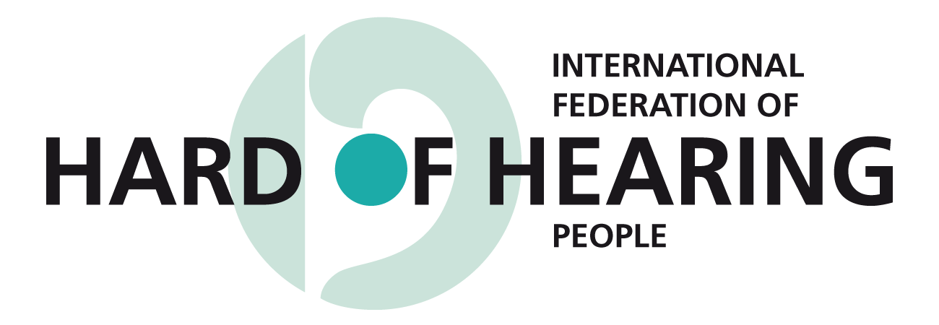
www.ifhoh.org

International Federation of Hard of Hearing People Submission to
the UN Committee on the Convention of the Rights of Persons with Disabilities
on the Draft General Comment on Article 5 on Equality and Non-Discrimination

Introduction

The International Federation of Hard of Hearing People (IFHOH) welcomes the opportunity to comment on the Draft General Comment No. 6 on Article 5 of the CRPD and we hope that our comments will be helpful to the Committee.

The International Federation of Hard of Hearing People (IFHOH) was established in 1977 as an international, non-governmental organization, registered in Germany. IFHOH represents the interests of more than 360 million hard of hearing people worldwide. This includes late deafened adults, cochlear implant users, and people who experience Tinnitus, Meniere’s disease, Hyperacusis and auditory processing disorders. IFHOH has over 40 national member organizations from most regions of the world.

IFHOH, its members, and, in agreement with, the European Federation of Hard of Hearing People and the Asia Pacific Federation of the Hard of Hearing and Deafened, works to promote greater understanding of hearing loss issues and to improve access for hard of hearing people.

IFHOH has special consultative status with the United Nations Economic and Social Council (ECOSOC), affiliation with the World Health Organization, and membership in the International Disability Alliance. For more information please see IFHOH’s website: www.ifhoh.org

Recognizing that Stigma is a Form of Discrimination

First of all, we applaud the Committee for recognizing, in particular in #2 & #4, that there is still much stigma faced by persons who have a disability, and we find this to be particularly challenging and of great significance for persons who are hard of hearing.

Hearing loss is an invisible disability and persons who are hard of hearing may appear to be like everyone else because they function auditorily in a hearing world. Yet, the devastating impact of not being able to hear cuts the person off from communication, affects their self-development and their opportunity to participate in society.

The person with a hearing loss may seek to minimize the impact of their disability because of the stigma and discrimination associated with it. Non-disclosure of the hearing loss then makes it challenging to obtain needed services and supports.

In a society that is free of discrimination, individuals who are hard of hearing would be able to seek the support required without fear of reprisal, stigma and negative consequences.

Inclusive Equality

The concept of inclusive equality provides a positive way to recognize that disability impacts on the individual, along with other factors that intersect together creating an identity. This inclusive and holistic approach is necessary to truly ensure for equality. The concept recognizes that gender and social class, to name two factors, are also important and integral parts of an individual’s identity.

In our view, the Committee’s comment does not go quite far enough in addressing that inclusive equality requires the provision of accessibility and the elimination of barriers to the full inclusion of persons who have a disability.

The existence of barriers creates an unequal and injustice society. For persons who are hard of hearing and deafened these barriers include lack of access to hearing aids, cochlear implants, assistive technology, hearing loops, captioning in broadcast and other forms of media and event subtitling.

Regarding hearing aids and and cochlear implants as well as assistive devices such as FM equipment (remote microphones), sadly, there are many countries in which there is limited provision of these devices for hearing access. In many countries, both developing and developed ones, hearing aids and cochlear implants are beyond the capacity of individuals to afford.

According to the World Health Organization (WHO), there are 360 million people with a hearing loss, defined as a hearing loss greater than 40 decibels in the better ear of persons 15 years and older and a loss of 30dB in the better ear for those 14 years and younger. The current production of hearing aids meets less than 10% of global need and in developing countries less than 3% (Source: www.who.int/features/factfiles/deafness/en/).

There is a severe lack of provision of event subtitling (also known as captioning). In a survey about the situation conducted by IFHOH and the World Federation of the Deaf, 90 per cent of the over 300 respondents answered that there are insufficient numbers of captioning service providers. Without sufficient numbers of providers, there are insufficient services. The situation is actually worse than indicated in the report because of the under-representation of participants from developing countries in the survey. In most developing countries, captioning services do not exist. (Source: www.ifhoh.org – under news)

In addition, the following services and technology are essential for hard of hearing people:
- Access to audiological rehabilitation, including hearing aids with a telecoil
- Well-functioning hearing loops and good audio technical solutions in public premises
- Visual information in public transport
- Text messaging to emergency authorities in case of an emergency
- Accessible information from the media
- 100% TV captioning/subtitling
- Problems related to hearing loss being addressed in schools/education systems and working life
- A positive attitude toward hard of hearing people
Realizing the above would remarkably improve the lives of people who are hard of hearing and deafened.

Reasonable Accommodation

With respect to the section on Reasonable Accommodation in the General Comment, it behooves the Committee to articulate that reasonable accommodation is an obligation of the State and does not fall to the individual. All too often the burden of acommodations is placed on the individual. In too many countries, individuals are expected to pay for their own accommodation needs. They are expected to pay for the purchase of their hearing aids, assitive devices and for the provision of captioning. This is an unjust and unfair burden on the individual.

To fully achieve the tenets of Article 5 on Equality the state must recognize it needs to remove this barrier for equality for persons with disabilities. This concept could be incorporated in the initial paragrpahs regarding Article 5(3) on Reasonable Accommodation.

Consultative Obligation of States

Our community fully supports the comment in #38 that DPOs have a decisive role to play in the implementation and monitoring of the Convention. Our involvement in this process is particularly important. It should be recognized that involvement must be of the multitude of disability groups who are persons with a disability in the majority. As well, it needs to be recognized that financial support is required for the involvement of DPOs and that the State has an obligation in this regard.

Implementation at the national level

In this section, additional wording should highlight that examinating barriers to equality should ensure that the burden of cost for accessibility does not fall on the individual. Persons with disabilities should be able to fully participate in society and must not be faced with economic barriers by the costs and lack of provision of hearing aids, cochlear implants, asssitive devices and captionig.

In closing, the International Federation of Hard of Hearing People thanks the Committee for this opportunity to comment and looks forward to receiving the finalized General Comment on Equality and Non-Discirmination.

Sincerely yours,

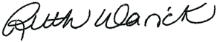

Dr. Ruth Warick
President, IFHOH
president@ifhoh.org

