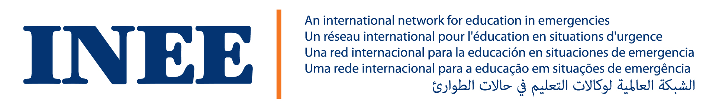
INEE Response to the UNCRPD Article 24 General Comment on Inclusive Education

This response focuses specifically on issues of inclusive education for learners with disabilities in situations of risk, including situations of armed conflict, humanitarian emergencies, and the occurrence of natural disasters. The response is based on feedback from several members of the INEE Inclusive Education Task Team (inclusivetaskteam@ineesite.org).

Para 1
We suggest adding “at all times” to this sentence: “with a claim to the right to education without discrimination and on the basis of equal opportunities”. This could help remind readers that inclusive education always needs to be considered, even in situations of conflict, humanitarian emergency, and natural disaster.

Para 3
It would be good to add a line about the ‘educational case’ for inclusion in times of risk/conflict/emergency/disaster.

Under the ‘social case’ it would be good to add “in all situations” (or similar) into the first sentence, again to remind readers that there is a social benefit from inclusion in situations of risk as well as in situations of stability/peace.

Similarly, in the ‘economic case’, it would be good to add “in all situations/at all times” to the line about quality inclusive education reducing dependence.

Para 5
There could be a bullet point relating to barriers in situations of risk (e.g. a perceived difficulty with achieving inclusion during the emergency phases, and an attitude that ‘normal’ education has to be sorted first before moving on to inclusive education or education for learners with disabilities).

Para 14
It is noticeable that the term ‘inclusive education’ is not used in this paragraph, potentially signaling that inclusive education is not considered pertinent/essential in situations of risk.

At the moment, the paragraph feels weak and not really presenting inclusion as an expectation during situations of risk, armed conflict, humanitarian emergencies and the occurrence of natural disasters. The paragraph could be strengthened by opening with a clear statement that the fundamental right to inclusive education applies at all times and in all situations, including in situations of risk, armed conflict, humanitarian emergencies, and the occurrence of natural disasters. While some may feel it is more difficult to fulfil and protect the right to inclusive education in such situations, this points to the need for the GC/Committee to provide greater guidance.

The paragraph needs to mention “ensure and protect” the right to education. Rather than saying “investment must be made” the paragraph could be made stronger and more direct, for instance: “‘immediate’ or ‘concrete steps’ must be taken to…”.

It would be good if the paragraph could highlight the disproportionate impact of humanitarian emergencies (including armed conflict) on people with disabilities and upon their right to inclusive education.

The paragraph refers to ‘particularly children with disabilities’, but learners may not all be children. Here, and throughout the GC, there is a need to ensure clarity and consistency in relation to lifelong learning and learning opportunities for people with disabilities.

The language learning needs of displaced/refugee or asylum-seeking learners could be mentioned, particularly in relation to learners who use sign language. The paragraph could also briefly mention the training needs of teachers/educators working in situations of risk, and the importance of ensuring that personnel who receive training to work/teach in these learning situations receive fundamental training on disability and inclusion. The Committee could consider including mention of accessible/inclusive disaster risk reduction education and school safety frameworks/procedures.

Overall, the language/terminology in Para 14 needs to more closely reflect that used in Art 11, which refers to “situations of risk, including situations of armed conflict, humanitarian emergencies and the occurrence of natural disasters”. Using different terms in the Art24 GC could be confusing, when the GC is seeking to provide States with greater clarity around Art24.

