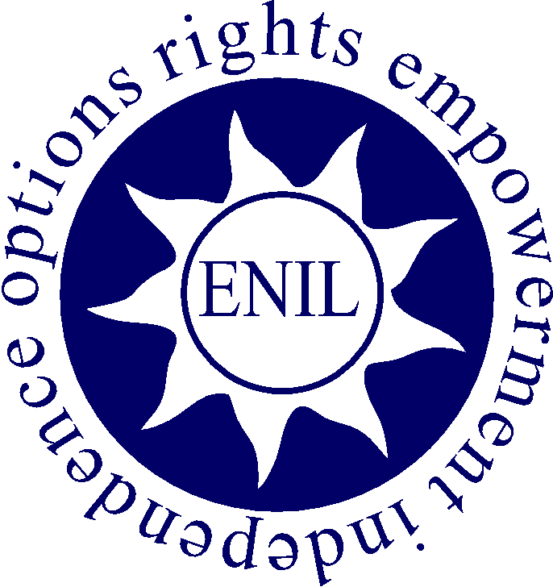

ENIL submission to the Draft General Comment on Article 24 of the UN CRPD

Introduction
The European Network on Independent Living (ENIL) is a Europe-wide network of disabled people, with members throughout Europe. ENIL brings together Independent Living organisations and their (non-disabled) allies to promote the right on Independent Living for all disabled people. ENIL supports the human rights vision on disability and social inclusion based on solidarity, peer support, deinstitutionalisation, democracy, self-representation and self-determination across disabilities.
ENIL promotes equal opportunities for disabled people and fights against discrimination in Europe, its mission is to advocate and lobby for IL values, principles and practices, namely for a barrier-free environment, for the provision of personal assistance support and for adequate technical aids, which together make full citizenship of disabled people possible. The targets of ENIL activities are administrations at European, national and local level, as well as politicians, media, and the civil society.
ENIL welcomes the Draft General Comment on Article 24 of the UN CRPD and would like to thank the CRPD Committee for giving us the possibility to contribute to it.
ENIL considers as a strength that the General Comment takes into account that the right on inclusive education can only be realised in combination with other human rights. ENIL welcomes the statement in paragraph 7 that “the General Comment is applicable to all persons with disabilities including those who have long term physical, mental, intellectual or sensory impairments which in interaction with various barriers may hinder their full and effective participation in society”. Furthermore, ENIL welcomes the fact that the General Comment confirms that disabled persons are subjects of rights with a claim to rights such as the right to inclusive education.
However ENIL has recommendations and adjustments for several paragraphs of the Draft Comment which will be addressed below in chronological order.

Submission to the General Comment
Additions to paragraph 21 on accessibility and paragraphs 28 and 29 on reasonable accommodation
ENIL welcomes the mention of inclusive assessment systems in §77 but would like to see more attention for the fact that alternative accessible assessment forms can and must be considered reasonable accommodations to active inclusive education. Many disabled students are still faced with assessment forms that do not take into account their disabilities. This discourages the students and results in a high dropout rate. Inclusive assessment forms are also a prerequisite towards schools based on the principal of universal design.
Article 2 of UN CRPD mentions universal design. “Universal design means the design of products, environments, programmes and services to be usable by all people, to the greatest extent possible, without the need for adaptation or specialized design. Universal design shall not exclude assistive devices for particular groups of persons with disabilities where this is needed.”
Universal Design for Learning (UDL) extends this concept to education and the design of curricula that accommodate diverse learning needs. UDL is a framework to improve and optimize teaching and learning for all people. Anne Meyer and David Rose, who first laid out the principles and framework of UDL in the 1990s, now influence educational policy and practice throughout the world.
Many educators have a history of working with traditional types of assessment tools, but these forms of assessments can create barriers to diverse learners. Students learn differently, they also demonstrate their progress toward learning differently. Often “one size fits all” assessments are developed and adaptations or accommodations are made only after multiple failed tests. In order to achieve inclusive education it is essential to reconsider assessment procedures and provide a variety of different inclusive assessment forms.
Universal Design for Learning is the way forward but there is still a long journey ahead in order to achieve it. The notion of “traditional vs non-traditional” students is still dominant within education. This creates an over-simplistic understanding which limits the development of inclusive, engaging teaching. A change of perspective is needed - shifting the focus from the “individual problem” to the institutional perspective. This means that the current educational environments should be investigated. The whole educational system should reflect on and (re)conceptualise the notion of student diversity in order to consider how teachers can redesign their curricula and teaching methods to allow for greater student involvement. The “institutional perspective” also involves evaluating programmes, courses and modules not only in terms of their learning outcomes but also in terms of the ways in which they engage and include the needs and interests of all students.
UDL tries to include people with different learning needs to the greatest extent possible. It does not rule out individual adjustments where needed, but primarily focuses on effective ways to make the general educational setting as inclusive as possible for all.
Another obstacle that disabled students often face is the difficult transition between different stages of education. Beginning a new stage in education is like jumping off a cliff for many disabled students. At the start of a new stage they have to re-explain and reapply for all the reasonable accommodations which were provided during their previous educational stage. Teachers and school boards should be encouraged to exchange information and good practices in order to ensure a successful transition.
In a real inclusive education system however the reasonable accommodations are attached to the student not to the school. The prime example of assistance that is controlled by disabled students themselves is personal assistance (PA). ENIL recommends including the use of personal assistance in the list of reasonable accommodations. This would not only improve the allocation of resources by increasing tailor made assistance but also promote participation of disabled students in mainstream education. This would help to decrease the number of “special schools” and remove an important institutional barrier for inclusive education. In “special schools” disabled students are often overprotected and they are not encouraged to fully develop their personal, social and professional skills which are essential to be successful in mainstream education or work settings.
In short, promoting inclusive education based on universal design and an individualized approach would not only advance inclusive education as provided in Article 24 but will also increase labour market access (Art 27) and independence (Art 19).
Addition to paragraph 48 on Article 9 UN CRPD
An accessible environment, accessible personalized services and PA are essential for the realization of inclusive education. All three of them are essential because disabled students have to be able to reach their school and because accessible schools are of little value in a non-accessible environment. Therefore ENIL would like to emphasize and highlight the point only briefly mentioned in §70 about the need to invest in an accessible environment.
New paragraph 48b
ENIL would like to add a paragraph about the connection between art 24 and art 11 UN CRPD.
According to art 11 “States Parties shall take, in accordance with their obligations under international law, including international humanitarian law and international human rights law, all necessary measures to ensure the protection and safety of persons with disabilities in situations of risk, including situations of armed conflict, humanitarian emergencies and the occurrence of natural disasters.”
Today disabled students are often either excluded from education for safety reasons or they have to accept the fact that they have to stay in the building in case of an emergency (for example because the elevators cannot be used in case of fire). ENIL would appreciate if the General Comment made clear that safety requirements cannot be used as an excuse to exclude disabled people from mainstream education and that reasonable accommodations have to be made to guaranty the safety of all students and staff.
New paragraph 49b
ENIL would like to add a paragraph about the connection between art 24 and art 15 UN CRPD.
According to art 15 “No one shall be subjected to torture or to cruel, inhuman or degrading treatment or punishment. In particular, no one shall be subjected without his or her free consent to medical or scientific experimentation.”
However until today disabled students are still victims of forced restrained or sedation which is in clear contradiction with art 15 UN CRPD. ENIL urges the Committee to condemn these inhumane practices in the General Comment.
Addition to paragraph 50 on Article 16 UN CRPD.
ENIL would like to stress that bulling is not only a problem between students. Disabled students are also faced with teacher based bulling. This can take the form of disclosing information about the student’s disability without their permission.
This closely relates to the right to respect of privacy guaranteed by Art 22 UN CRPD. Disclosure of disability is a complex issue in which many factors are at play, such as self-identity, personality, type of disability, context and previous experience. Disclosure of disability can ensure that disabled people receive appropriate accommodations and can help education centres respond more effectively to diversity and ensure the inclusion of disabled people. However, disclosure may also result in negative consequences, such as stigmatization and discrimination. In order to reduce the likelihood of negative consequences of disclosure it is essential to make teachers aware of the risks of disclosure and create a safe and welcoming environment that encourages dialogue about disability.
Sometimes educators feel they should know about a disability at the earliest possible stage in the education process. This desire for information often comes from a willingness to make necessary preparations, address any potential health and safety concerns etc., in order to make sure that the student can participate fully in all schools activities. In this respect it is important to highlight a person’s right to choose disclosure or non-disclosure. It is also essential to underline that if disabled students choose to disclose information the disclosure should happen to a relevant person (for example, the main teacher, an access or disability officer) and this person should keep this information confidential. Other teachers should only know what the impact of the disability is and what is required to ensure full participation. Knowing the title of a disability is of limited value.
ENIL would like to urge the Committee to include a paragraph on both the unacceptability of teacher based bulling and the need to respect the privacy of disabled students.
New paragraph 50b
ENIL believes that it is important to include a paragraph about the connection between Art 24 and Art 17 UN CRPD.
Art 17 states that “Every person with disabilities has a right to respect for his or her physical and mental integrity on an equal basis with others.”
In order to guarantee this right for disabled students ENIL would like to include in the General Comment the obligation to provide separate or gender natural accessible toilets and care rooms in all schools.
Addition to paragraph 51 on Article 19 UN CRPD.
ENIL would like to point out that inclusive education is an essential tool for Independent Living and being included in the community. If disabled people can discover and develop their talents they are better prepared to live an independent live. Although it is mentioned in §70-71 ENIL believes that it is important to underline the fact that in order to achieve accessible inclusive education for all a shift in resources from segregated to inclusive education is required.
Addition to paragraph 81 on Article 4§3 UN CRPD
Although Art 4 only obliges state parties to consult disabled people and children through their representative organizations ENIL would like to emphasize that it is even better to consult disabled people themselves directly.
This is true in all settings but especially significant in the field of education. Disabled students are experts by experience and as a consequence best placed to give information about their needs. Not all representative or expert organizations are managed by disabled members so however well intended their feedback might be they will still overlook some barriers to inclusive education a disabled student will spot.
Acknowledgements
This submission was written by Agnes Sarolta Fazekas, Frank Sioen and Zara Todd.
Agnes Sarolta Fazekas is currently a Social Policy PhD fellow at the Faculty of the Social Sciences, Eötvös Loránd Science University in Hungary. Her research area is access and inclusion for people with disabilities in higher education. She graduated with a Masters in Social Policy in 2013 and has been an active member of the Rezső Hilscher Association of Social Policy, ‘Independent Living’ working group. Agnes has been volunteering as Partnership Manager of ExchangeAbility and MapAbility within the Erasmus Student Network in 2013/2014.
Frank Sioen works for ENIL as Advocacy Officer. He has obtained a master in European politics and European law.
Zara Todd is a disability rights campaigner based in the United Kingdom. She is currently the chair of Inclusion London, a Deaf and disabled people’s organisation, which supports DPOs in London to build capacity. Zara has worked for a number of disabled people’s organisations, including the Alliance for Inclusive Education. In September 2015 the ENIL General Assembly elected Zara as one of the ENIL board members.

(Meyer, Rose, Gordon, 2014)
(Mislevy (CAST), 2009)
see for example the case of a Scottish boy with learning disabilities who was injured after being constrained (http://www.scotsman.com/news/education/scots-mother-calls-for-ban-on-restraint-in-schools-1-3719675)
AHEAD, 2013 Guide to Disclosure

