


WORLD FEDERATION OF THE DEAF

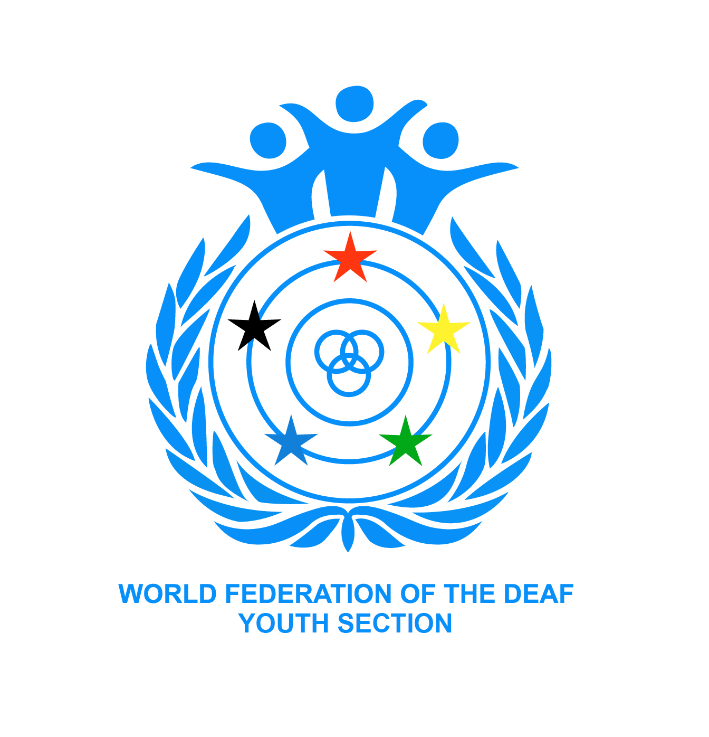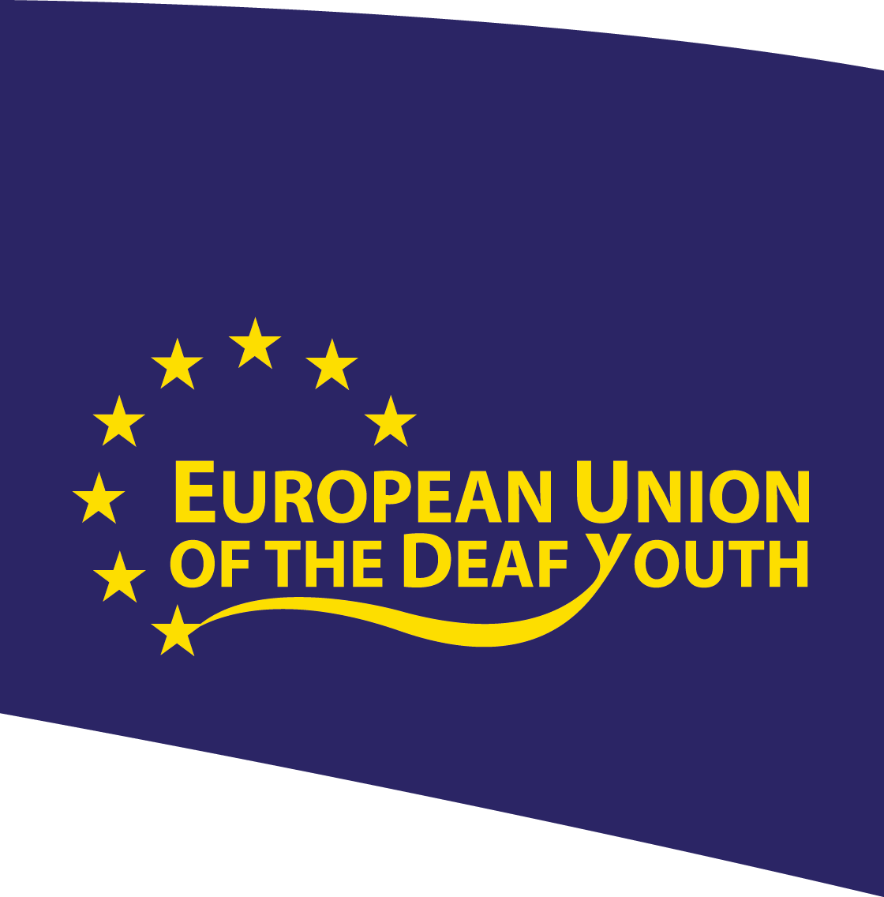

Submission on the Draft General Comment no. 4 on Article 24
Introduction
The World Federation of the Deaf (WFD), European Union of the Deaf (EUD), World Federation of the Deaf Youth Section (WFDYS) and European Union of the Deaf Youth (EUDY) are pleased to be granted the opportunity to comment on the draft General Comment on Article 24 of the United Nations Convention on the Rights of Persons with Disabilities (CRPD).
Although deaf and sign language issues have been mentioned in several parts of the draft, all organisations have grave concerns about the draft General Comment in its current form.
Firstly, the draft General Comment does not reflect the linguistic and cultural perspectives of deaf people according to Articles 2, 21, 24 and 30 of the CRPD. These elements should not be overlooked when implementing the CRPD.
Secondly, whereas the CRPD highlights inclusive education systems, the organisations making this submission feel that the draft focuses mainly on regular (or ‘mainstream’) education and it seems as if the innovative approach of the CRPD towards challenging and changing the whole education system has been sidelined.
Thirdly, several paragraphs on accessibility in the draft General Comment have not taken into account or adequately addressed concepts of cultural and linguistic accessibility. Similarly, the focus should be on promoting and increasing the accessibility of the education instead of focussing simply on providing individual supports in a mainstream education system.
Fourthly, we believe that the importance of having teachers with disabilities and role models for students according to Article 24 of the CRPD is not sufficiently highlighted in the draft.
Finally, despite being a lengthy text, the draft does not explicitly clarify what “full inclusion” means. It would be good to have this explicitly clarified at the beginning of the document.
Paragraph-specific comments
Paragraph 3: WFD, EUD, WFDYS and EUDY strongly believe that the assertion in this paragraph that “children with disabilities, for example, have greater overall gains in academic outcomes and behaviours in inclusive environments than their peers with similar disabilities in segregated classrooms” does not necessarily apply in the case of deaf students. It must be remembered that education provided for the deaf in sign language is based on the importance of language and culture, not on disability. We believe that the General Comment must be based on evidence. The evidence shows that deaf students who have not been provided with education in a sign language learning environment tend to have lower academic and social skills than those who have had opportunities to learn in sign language environments. Classes providing education in sign language should be viewed similarly to classes that provide education in minority or foreign languages, that is as meeting the linguistic and cultural needs of the learners.
The last part of this paragraph 3 concerning the economic case could reflect more positive perspective on successful inclusive education. We propose that the Committee consider an amendment to: “Opportunities for quality inclusive education will lead to equal possibilities for persons with disabilities to advance higher education and careers of their choice.”
Paragraph 4: The definition of ‘peers’ used in this paragraph is not clear. For deaf students, other deaf students would be their linguistic and cultural ‘peers’. Placing deaf students in regular schools without other deaf students would lead to their isolation, no matter how much individualised ‘support’ is provided. Linguistically and culturally specialised education in sign language is necessary to support the development of identity of deaf students.
Paragraph 5: The beginning of this paragraph lists various barriers – we draw to the attention to the Committee that this should include ‘language’ barriers. Article 2 of the CRPD must not be forgotten (i.e. "Language" includes spoken and signed languages and other forms of non-spoken languages).
WFD, EUD, WFDYS and EUDY would like to suggest adding two issues to this list:
- Lack of focus on individuals (initiatives on inclusive education have often taken group perspectives with assumption that one model fits all)
- Lack of consideration of the totality of Article 24 in the implementation process (e.g. the right to receive education in national sign language is not being respected despite Article 24.3(b), 24.3(c) and 24.4.
Paragraph 9: The third sentence should be amended to read “It focuses on the attendance, full participation and accessibility...”
Paragraph 11: The third sentence listing factors that need to be changed and modified should be amended to also include learning environment.
The sixth sentence of the paragraph states that (specialist) units for particular groups of persons with disabilities in mainstream school remain a form of “segregation”. The WFD, EUD, WFDYS and EUDY believe that the draft General Comment needs to clearly articulate how sign language learning environments and the diversity of students must be promoted, as required by CRPD Article 21(e) and Article 24(3)
Paragraph 12b: The fifth sentence could be amended to read: “It commits to ending segregation within educational settings and outside them because of its inherent discriminatory nature by ensuring inclusive classroom teaching with accessible learning environments and appropriate supports.”
Paragraph 12c: The WFD, EUD, WFDYS and EUDY believe the General Comment must be more clearly articulated how support systems are related to modifying learning environments to become accessible. Teachers with disabilities are not mentioned in this paragraph, which is a matter of concern. We believe that deaf teachers are often excellent role models and mentors for deaf students. We believe that the General Comment should focus on the creation and promotion of accessible systems rather than support services. For this reason we submit that the second sentence of paragraph 12c should be modified to read: “The inclusive culture provides an accessible and supportive environment…”
Paragraph 12d: Cultural diversity is not mentioned, and the paragraph should be amended to ensure that this concept is included.
Paragraph 12e: We submit that this paragraph be amended to read: “Inclusive learning environments must create an accessible environment where…”
Paragraph 13: We submit that ‘Language’ must be added to grounds of discrimination listed in the fourth sentence, as a key concept of the CRPD (Article 2).
Paragraph 17: The last sentence leads to the organisations wondering how lifelong learning (Article 24.5 of the CRPD) is reflected in the General Comment.
Paragraph 21: We submit that linguistic and cultural accessibility could be further emphasised in this paragraph by adding the following words: “This will necessitate a gendered consideration of: factors within the community; design of the school site; entry to the school; transport to and circulation within the school; classrooms; toilets, play and sports facilities; use of sign language, visual environment, recruitment of teachers with proficiency in national sign language; and finally provision such as furniture within the classroom.”
Paragraph 22: We submit that this paragraph be amended so that the first sentence should end with the following words: “… textbooks and learning materials in accessible formats and languages.” and similarly the last sentence should be amended to read “… printed material into accessible formats and languages and to make accessibility a central…”
Paragraph 27: The WFD, EUD, WFDYS and EUDY would like to know why schools closest to homes of persons with disabilities are reflected as the only valid option and how the freedom of choice and flexibility of inclusive education system can be promoted to ensure that a person with disabilities receives the best educational possibility. The fourth sentence should be amended to add following words: “However, it is not appropriate for States parties to rely exclusively on technology as a substitute for direct involvement of students with disabilities within the educational environment itself and interaction with teachers and role models.”
Paragraph 29: We submit that this paragraph could be greatly strengthened by adding words to the list in the fifth sentence (i.e. the penultimate sentence) to include the following additional elements: “providing students with professional national sign language interpreters, making it possible to take exams and do assignments in sign language.”
Paragraph 31: The last sentence could be illustrated with practical examples such as: “… within a given classroom through multiple representations, for example, in respect of language such as national sign language, learning styles, sensory input, perception, culture including deaf culture, or levels of background knowledge.”
Paragraph 32: This part appears to reflect the focus being overly concerned with providing ‘support systems’ than on creating accessible environments for particular learners. We believe this paragraph needs to clarify better that it is the education system that needs to be modified, not an individual with disabilities. The WFD, EUD, WFDYS and EUDY are very concerned about the absence of any mention of linguistic and cultural perspectives in this paragraph. (For example if a deaf student learns in a sign language/bilingual environment with other deaf students, then special or additional individualised ‘supports’ are not needed). There is nothing about the importance of role models for students with disabilities in the education system either. We submit that the draft General Comment could be greatly strengthened by mention of the benefits of e.g. deaf teachers as linguistic and cultural role models for deaf students beyond being teachers.
Paragraph 33: “Full inclusion” is mentioned here but a comprehensive definition of this term is missing from the document.
Paragraph 34: The WFD, EUD, WFDYS and EUDY note the importance of emphasising the linguistic identity of the Deaf Community in this paragraph but believe that the principles and concepts expressed here need to be better reflected throughout the whole of the document. Cultural and linguistic perspectives of deaf people need to be reflected in - and transform - the whole education system, including curricula, learning materials, teaching methods, design of the learning environment and in teacher training. With regard to terminology, the WFD, EUD, WFDYS and EUDY would like to emphasise the word “choice”. Additionally, a memorandum of understanding between the WFD and the International Federation of Hard of Hearing people has made clear that “hearing impaired” is not acceptable terminology. We propose that this paragraph be amended to refer to “deaf and hard of hearing students”. We are concerned that the needs and rights of deafblind people are not mentioned in this paragraph at all, and must be better addressed and articulated.
Paragraph 36: Teachers should be ready to teach when entering their workplaces. For instance, national sign language skills should be one of the advanced requirements for any teachers who will teach deaf children. It is not appropriate to expect teachers to learn sign language from deaf students. Students have the right to receive qualified teachers provide education in their language of choice - i.e. the relevant national sign language.
Paragraph 37: We submit that this paragraph could be strengthened by amending it to read: “To this end the Committee emphasises that attitudinal, physical, linguistic, communication, legal and other barriers…” The last sentence should be clarified as follows: “Reasonable accommodation as a temporary solution must be provided without additional cost for students to ensure that persons with disabilities do not face discrimination and exclusion.” For instance, we are aware that some deaf students at public or private educational institutions have been expected to pay for professional national sign language interpretation themselves, which means they are not being given access to education on ‘an equal basis with others’.
Paragraph 44: Because women or girls with disabilities may be e.g. a member of minority groups, there can be more grounds of discrimination in addition to gender and disability. For this reason we submit that the end of the third sentence could be modified as follows: “… right to education is not impeded by either gender or disability discrimination, stigma, prejudice or any other ground of discrimination.”
Paragraph 52: We submit that the last sentence should be amended to read: “… and through all forms of communication and language of their choice.”
Paragraph 57: Article 30(4) of the CRPD emphasising support for sign language and deaf culture should also be highlighted and cross referenced more clearly in this paragraph as being necessary to achieve these rights for deaf people.
Paragraph 60: We submit that the list of ministries in the last sentence should also include ministry of culture, e.g. amend to read: “ministries of education, culture, finance, health...”
Paragraph 63i: Article 2 of the CRPD needs to be better reflected here. The paragraph should be amended to read: “… including in the most appropriate languages such as national sign language…”
Paragraph 63k: The role of organisations of persons with disabilities should be more explicitly highlighted here because there are several charities and NGOs that work for persons with disabilities having stronger position in various platforms compared to organisations led by persons with disabilities. We propose that this paragraph be amended to read: “Creation of partnerships and coordination between all stakeholders, including different agencies, development organizations, and non-governmental organizations (NGO), and particularly with Disabled Persons Organisations (DPOs) recognising their role under the CRPD, and with parents and individuals with disabilities.”
Paragraph 70: A comma should be used instead of “and” to clarify the difference between assistive technology and sign language in the last sentence, i.e. amend to read: “… ensure assistive technology provisioning, Sign Language, and provide…”
Paragraph 71: Linguistically and culturally based sign language learning environments should not be seen as “segregated” environments but positively as one part of a unique inclusive education system that is appreciated by many deaf students worldwide.
Paragraph 72: The WFD, EUD, WFDYS and EUDY have concerns about the tone of this paragraph. The draft General Comment focuses on challenging and changing the whole learning environment to ensure access to learning, but this paragraph seems to take a different tone and emphasises support system. We note for example that what is a ‘regular’ classroom for e.g. hearing students may not be ‘inclusive’ or ‘accessible’ for deaf students.
Paragraph 75: We are concerned that this paragraph does not adequately address sign language perspectives and submit that the paragraph can be strengthened to amend the second sentence to read: “Teacher education should include learning about the use of appropriate augmentative and alternative modes, means and formats of communication, about sign language, deaf culture and linguistic identity, education techniques…” The last sentence should be strengthened to highlight the importance of having linguistic role models available in school settings (e.g. deaf teachers and school counsellors etc to ensure students who are deaf have role models and opportunities to develop cultural and linguistic identity).
Paragraph 76: The second sentence emphasises inclusive teachers and should also be amended to ensure it references “including teachers and staff with disabilities who can serve as important role models”.
Paragraph 77: The end of the second sentence should be amended to read as follows: “… and the diversity of inclusive education and disability groups.”
Paragraph 78: The General Comment should emphasise the special position of organisations of persons with disabilities (DPOs) in this paragraph (in line with Art 4(3) and Art 33(3)). We are concerned that a reference to simply consulting individuals with disabilities - who might in some cases work in the government system or be members of a politically influenced national disability council - does not necessarily represent the wider disability community constituency and its views.
Paragraph 80: Articles 24.3(b), 24.4 and 30.4 should not better and more clearly highlighted in this paragraph. We submit that the second sentence should be amended to include “Family members, volunteers and community, for instance deaf (youth) community, members should be encouraged…”
Paragraph 81: We submit that this paragraph makes a very important point concerning the role of organisations of persons with disabilities, and should be placed either in the beginning of the text or between paragraphs 43 and 44 to have stronger visibility.
Conclusion
It is important to take a holistic approach when discussing inclusive education. This means that access to accessible education systems and learning environments, learning materials, teacher skills, reasonable accommodation and individual support must all be considered in respect of all disability types. For deaf learners, full accessibility to the teaching language, i.e. sign language allows for full participation as well as full integration in the classroom.
Although the term “special schools” could have the appearance of being segregated, “specialised schools” does not necessarily mean education that ‘excludes’ or segregates. The best quality education is provided in a learning environment where the individual child can be fully included such by providing for a full sign language environment, whether this is in a specialised deaf/sign language school or in a fully accessible mainstream school where promotion of the linguistic and cultural identity for deaf students is fully provided for and promoted. The organisations making this submission believe that States Parties should provide the option of different schooling types to facilitate choice - to allow for the best development possibilities for the particular child and his/her individual needs and preferences.
It is important to have the meaning of inclusive education mainstreamed into areas such as reviewing government support to the educational system, the teacher training and education, the curricula and school materials used. To provide deaf students with inclusive education, high quality training of teachers who are deaf and use sign language and the inclusion of deaf persons in the preparation of school materials and curriculum are essential.

Contact details:

Ms Eeva Tupi Ms Petra Söderqvist
Human Rights Officer Policy Officer
World Federation of the Deaf European Union of the Deaf
eeva.tupi@wfd.fi petra.soderqvist@eud.eu

Mr Laith Foad Fathulla Mr Dennis Hoogeveen
Secretary Secretary General
World Federation of the Deaf Youth Section European Union of the Deaf Youth
laith@wfdys.org d.hoogeveen@eudy.info

Authorised by:

Mr Colin Allen Dr Markku Jokinen
President President
World Federation of the Deaf European Union of the Deaf

Ms Cecilia Hanhikoski Mr Timothy Rowies
President President
World Federation of the Deaf Youth Section European Union of the Deaf Youth

The Right to Education of Persons with Disabilities: The Position of the International Disability Alliance. July 2015. Page 2.
Humphries, Kushalnagar, Mathur, Napoli, Padden, Rathmann & Smith: Bilingualism: A Pearl to Overcome Certain Perils of Cochlear Implants. Journal of Medical Speech-language Pathology, Vol. 21., No. 2. p. 114-116.
http://wfdeaf.org/wp-content/uploads/2013/11/MoU-IFHOH.pdf Article 2.

