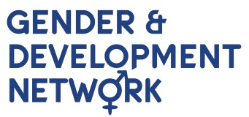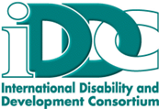

Mr. Jorge Araya
Secretary of the Committee
Committee on the Rights of Persons with Disabilities
Office of the High Commissioner of Human Rights
Palais Wilson, 52 rue des Pâquis
CH-1201 Geneva, Switzerland

24 July 2015

Dear Mr. Araya,

Please find attached the joint submission to the CRPD Committee on the Draft General Comment on Article 6: Women with Disabilities by the International Disability and Development Consortium (IDDC) and the Gender and Development Network (GADN).
The IDDC is a global consortium of 25 disability and development NGOs, mainstream development NGOs, and DPOs supporting disability and development work in more than 100 countries to promote human rights and inclusive development internationally. GADN is a diverse membership network made up of UK-based NGOs, academics, consultants, and practitioners working on gender, international development and women’s rights issues. This document is a joint submission from both networks and reflects the experience and expertise from both networks.
The rights concerning women and girls with disabilities is a central issue deeply connected to IDDC’s and GADN’s priorities and the priorities of the members of IDDC and GADN. We welcome the Committee’s commitment to tackling multiple discrimination on the grounds of gender and disability and its recognition of the complexity of this cross-cutting issue. We also recognise the potential impact of this General Comment in bringing greater clarity regarding multiple discrimination issues more broadly beyond gender and disability. This submission intends to build on the strengths of the Committee’s analysis of gender and disability.
In summary, this submission focuses on the following issues:
- The need for greater clarity on normative definitions and explanations
- The duty of States Parties to provide special temporary measures and clarity on permissible scope of differential treatment
- The need for greater clarity on non-discrimination obligations relating to provisions that are subject to progressive realisation
- The need for further guidance on violations of Article 6
- The need for recognition of and further guidance on gender and disability issues relating to substantive provisions
- The need for further guidance on international cooperation and humanitarian aid
- The need for further detail concerning national implementation
Following a discussion with Committee Member, Ms Diane Kingston, we have converted our joint submission into track changes to the original Draft General Comment (also attached) in order to assist the Committee in its review of submissions. Therefore, the briefing version of this submission is fully reflected in the track changes version, resulting in two identical submissions in different formats.
Should you require any additional information, please do not hesitate to contact me as the joint IDDC and GADN representative at bailey.grey@senseinternational.org.uk or +44 (0) 20 7014 9370.

Sincerely yours,

Bailey Grey
Advocacy and Policy Manager
Sense International
bailey.grey@senseinternational.org.uk

