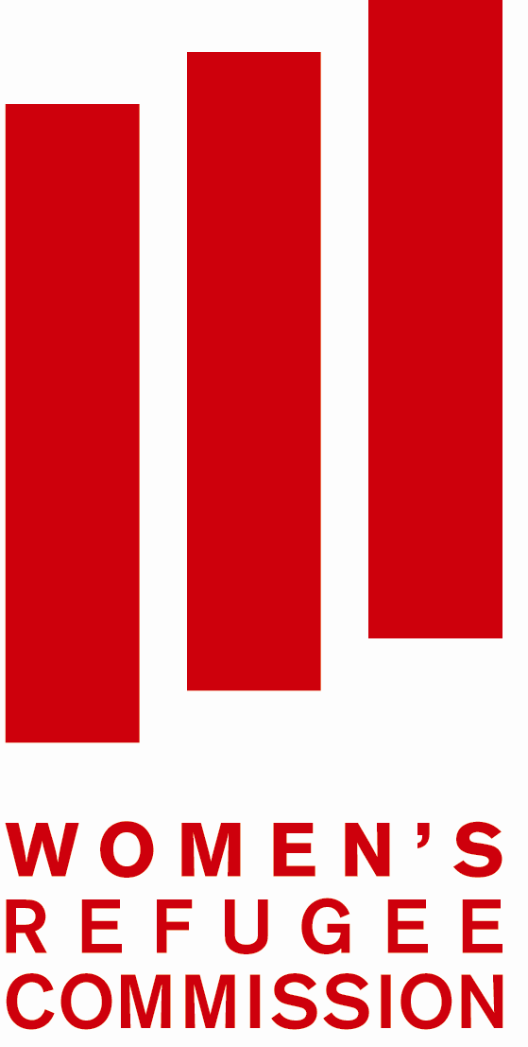
Draft general comment on Article 6 of the UNCRPD

Comments and feedback submitted by the Women’s Refugee Commission

The Women’s Refugee Commission (WRC) is a research and advocacy organization dedicated to improving the lives of women, girls, children and youth who are affected by conflict and displacement. Our aim is to raise awareness and improve protection and assistance for the most socially excluded, marginalized and at risk groups amongst refugee and displaced populations. We carry out in-depth, field-based research in displacement settings; publish our findings and make practical recommendations; and advocate for change through trainings, meetings, social and conventional media. We work on issues ranging from access to livelihoods for women and girls, safe access to fuel and energy (SAFE), prevention of and response to gender-based violence, access to sexual and reproductive health services, the needs of adolescent girls, statelessness and migrant rights, as well as disability inclusion.
The WRC appreciates the opportunity to review the Draft General Comment on Article 6 of the UNCRPD and submits the following comments and feedback for consideration by the Secretariat.
- Introduction
Article 1 of the UNCRPD highlights that the provisions of the Convention apply to all persons with disabilities: “The purpose of the present Convention is to promote, protect and ensure the full and equal enjoyment of all human rights and fundamental freedoms by all persons with disabilities, and to promote respect for their inherent dignity”. The universality of the Convention requires that States also protect the rights of non-citizens with disabilities within their territory, including those who have been displaced across a border. Hence, all the provisions of the Convention that apply to women and girls with disabilities, also apply to non-citizen women and girls, including those who are refugees, asylum seekers, migrants and displaced persons.
Paragraph 6
Women and girls with disabilities face greater risk of violence, particularly sexual violence, in situations of crisis and conflict, where social, community and state protection mechanisms are weakened. Displacement poses added risks due to the breakdown of familial and peer networks and new barriers in the physical environment. The WRC has documented that women with physical disabilities who are isolated in their homes and women and girls with intellectual disabilities are particularly at risk of rape and other forms of sexual violence in both camp and urban refugee settings. Despite this, women and girls with disabilities are often excluded from programs and services designed to prevent and respond to gender-based violence in humanitarian settings.
Paragraph 7
Refugee women and girls with disabilities have limited access to sexual and reproductive health information, and report that the attitudes of service providers are the most significant barrier to their accessing sexual and reproductive health services. Pregnant women and girls with disabilities face added discrimination when accessing services, and may be “scolded” by care-givers and family members for becoming pregnant and bearing children. Refugee women and girls with disabilities report mixed ability to exercise their sexual and reproductive rights ranging from a perceived full autonomy over decisions to those with no autonomy, who may face forced abortions and / or forced use of family planning methods in some circumstances.
Paragraph 8
Displaced women and girls with disabilities face multiple and intersecting forms of discrimination based on not only gender and disability, but also their migration and / or refugee status. Insecurity, changes in their social and physical environment, loss of protective familial and peer networks, and reduced income generation opportunities, all contribute to the inequality and discrimination of women and girls with disabilities who may be displaced by crisis and conflict. This point could be integrated into this paragraph and / or paragraph 18 as mentioned below.
- Normative content of article 6
Paragraph 18
As mentioned above, displaced women and girls with disabilities may also experience discrimination on the basis of their refugee or migration status. This could be mentioned in this paragraph along with the many other factors that contribute to intersectional discrimination of women and girls with disabilities.
Paragraph 26
The General Comment makes important note that the development, empowerment and advancement of women with disabilities must include appropriate measures that reflect “their current situation and environment, in terms of human rights, fundamental freedoms and social development”. This paragraph could also mention the importance of including women and girls affected by crisis and conflict, strengthening their capacity to participate in peace-building processes, and facilitating networking between women with disabilities and those that are more isolated and excluded, as well as with non-disabled women’s groups.
- State parties’ obligations
Paragraph 28
As mentioned earlier, the universality of the UNCRPD text is such that States also have obligations to protect the rights of all persons with disabilities within their territory. Hence the rights enshrined in article 6 apply to all women with disabilities, including those who are non-citizens, such as migrants, refugees, asylum seekers and displaced women and girls. We would recommend recognizing this point within the scope of this paragraph through the following addition (in bold): “As such, the rights provided for in article 6 apply at the moment of ratification and are subject to immediate realization for all women and girls with disabilities within States parties’ territories.”
- Interrelation between the provisions addressing women and girls with disabilities and their link to other CRPD provisions.
Paragraph 37 – Article 8 on awareness-raising
Gender and disability stereotyping can be compounded with racial discrimination / xenophobia and other forms of negative stereotyping for refugee, displaced or migrant women with disabilities, making them even more marginalized and disempowered. Paragraph 37 could be expanded to require States parties to adopt effective education and awareness raising programs that not only combats respective stereotypes relating to gender and disability, but also reflects the diversity of identities among women and girls with disabilities, and how this shapes the discrimination and inequality they may experience.
Paragraphs 38-40 – Article 9 on accessibility
Refugee and displaced women and girls with disabilities live in both urban and camp settings, and often face protection concerns, including gender-based violence, due to a lack of transportation and inaccessible services and facilities. We suggest highlighting the needs of displaced and refugee women and girls with disabilities (in bold) under the following points:
- Paragraph 38 - “The built environment and urban design must be planned in accordance with civil safety standards to enable citizens to circulate safely, while ensuring that groups at greater risk of violence and abuse (such as women, boys and girls, older people, refugee, asylum seeker and internally displaced persons with disabilities) feel safe and protected.”
- Paragraph 39 – “All care services and information for women (and especially those related to health, motherhood, violence against women and childcare) must be fully accessible to all women and girls with disabilities, including those who are migrants, asylum seekers refugees or internally displaced.”
- Paragraph 40 – “…it is essential that in designing, developing and monitoring transport policies, the intersection of aspects related to disability and gender are considered, and that different groups of women and girls with disabilities are consulted, such as those from rural areas, lower socio-economic backgrounds, or with migrant, asylum seeker and refugee status, in order to ensure that women with disabilities have equal opportunities and protection against discrimination.”
Paragraph 42 – Article 11 on humanitarian assistance
We recommend that this section also highlight the attitudinal, environmental, communication and policy barriers that women and girls with disabilities may face in accessing humanitarian assistance in situations of risk, including access to gender-based violence prevention and response programs, and sexual and reproductive health services. States’ parties should work with UN agencies, humanitarian actors and crisis affected communities to ensure that women and girls with disabilities are consulted in the design, implementation and evaluation of humanitarian programs and assistance, and to monitor their access through age, sex and disability disaggregated data. Service providers delivering humanitarian assistance should analyze the barriers that may hinder women and girls with disabilities from accessing their activities, and on occasion even expose them to added protection concerns, through working with women and girls with disabilities, their families and their communities to develop appropriate strategies to promote their access and inclusion.
Paragraph 44 – Article 13 on access to justice
Displaced women and girls with disabilities often face additional challenges and barriers when accessing justice systems, due to their migrant, refugee or asylum seeker status. As this group is also at greater risk of discrimination, they could be mentioned under this paragraph as a group of particular focus for information, training and awareness raising programs on rights and access to justice.
Paragraph 50 – Article 24 on education
Displaced women and girls with disabilities face added barriers to accessing both formal and non-formal education opportunities, which in many crisis settings also provide safe spaces for women and girls to access information and build protective peer networks and could be mentioned as a group “at risk of exclusion” in this paragraph.
Paragraph 58-60 – Article 32 on international cooperation
Women and girls with disabilities have a right to not only benefit from, but also to participate in, development and humanitarian programming. Women and girls with disabilities should be consulted in the design, implementation and evaluation of such activities, recognizing and valuing their skills, capacities and contributions to wider community development. Women and girls with disabilities should also be prioritized for capacity development opportunities that will strengthen their leadership in communities and subsequently their voice in decisions relating to international cooperation. These points could be added to the end of paragraph 59.
As international cooperation also involves humanitarian agencies, we would recommend including UNHCR, IOM, WFP and OCHA into the list of intergovernmental organizations and specialized UN agencies mentioned in paragraph 60.
Paragraphs 61-68 – Article 33 on implementation at national level
While all these provisions should also apply to displaced women and girls with disabilities, we wanted to suggest a few points where they could be highlighted (in bold) to reflect the multiple levels of discrimination that they experience in most countries.
- Paragraph 65 – “Guarantee appropriate forms of gender- and age-sensitive assistance and support for women and girls with disabilities who become the targets of violence, including through the provision of information and education on how to avoid, recognize and report instances of exploitation, violence and abuse. Ensure that protection services are age-, gender- and disability-sensitive, and are available to women and girls with disabilities in situations of risk, including those who may be internally displaced, refugees or migrants.”
- Paragraph 67 – “Networks and organisations of women and girls with disabilities need to be adequately facilitated, and strengthened to reach out to refugee and displaced women and girls who are often more isolated from host country disability networks.”
- Paragraph 68 – “At the same time, States Parties shall take all measures to incorporate women and girls with disabilities, including those facing multiple and intersecting forms of discrimination (for example, based on race, age, sex, language, religion, political or other opinion, ethnic, indigenous or social origin, refugee or migrant status), in the implementation of the Post 2015 Development Agenda, its sustainable development goals, targets and indicators.”

For more information please contact:

Rachael Reilly Emma Pearce
Geneva Representative Senior Program Officer – Disability
Women’s Refugee Commission Women’s Refugee Commission
RachaelR@wrcommission.org Emmap@wrcommission.org
Tel: +41 22 919 7102 Tel: +1 212 551 3159

Art. 1 (1) CRPD
Mary Crock, Ron McCallum, and Christine Ernst, Where disability and displacement intersect: Asylum seekers with disabilities (2011). www.iarlj.org/general/images/stories/BLED_conference/papers/Disability_and_Displacement-background_paper.pdf.
Women’s Refugee Commission (2015). “I see that it is possible”: Building capacity for disability inclusion in gender-based violence programming in humanitarian settings. Available at: http://wrc.ms/disability_GBV
Women’s Refugee Commission (2014). The intersection of sexual and reproductive health and disability: Research from Kenya, Uganda and Nepal. Available at: https://womensrefugeecommission.org/programs/disabilities/research-and-resources/1084-srh-disabilities-uganda-2014
Women’s Refugee Commission (2015). “I see that it is possible”: Building capacity for disability inclusion in gender-based violence programming in humanitarian settings. Available at: http://wrc.ms/disability_GBV
UN Security Council, Security Council resolution 1325 (2000) [on women and peace and security], 31 October 2000, S/RES/1325 (2000), available at: http://www.refworld.org/docid/3b00f4672e.html [accessed 29 July 2015]
Women’s Refugee Commission (2015). “I see that it is possible”: Building capacity for disability inclusion in gender-based violence programming in humanitarian settings. Available at: http://wrc.ms/disability_GBV
Women’s Refugee Commission (2014). The intersection of sexual and reproductive health and disability: Research from Kenya, Uganda and Nepal. Available at: https://womensrefugeecommission.org/programs/disabilities/research-and-resources/1084-srh-disabilities-uganda-2014
Art. 16 (2) CRPD

