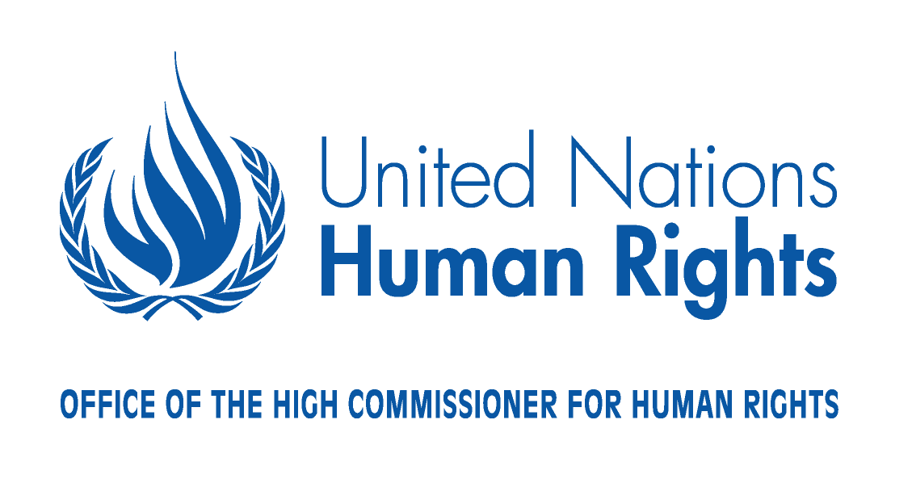
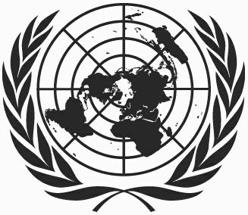

Right of Peoples to Peace

Questionnaire
as part of the consultations undertaken by the Human Rights Council Advisory Committee with all relevant stakeholders, at the request of the Human Rights Council pursuant to resolution 14/3 of 17 June 2010, on the possible elements for a draft declaration on the right of peoples to peace.

Background:
In its resolution 11/4, the Human Rights Council reaffirmed that “the peoples of our planet have a sacred right to peace, and that the preservation of the right of peoples to peace and the promotion of its implementation constitute a fundamental obligation of all States” and stressed the importance of peace for the promotion and protection of all human rights for all.
In its resolution 14/3, the Council requested the Advisory Committee to work on a draft declaration on the right of peoples to peace, in consultation with Member States, civil society, academia and all relevant stakeholders. In January 2011, the Advisory Committee issued a draft progress report (A/HRC/AC/6/CRP.3), a revised version of which is to be submitted to the 17th session of the Human Rights Council(A/HRC/17/39).

QUESTION 1: Do you have any comments on progress report A/HRC/17/39, in particular with regard to the proposed standards for a draft declaration on the right of peoples to peace?

QUESTION 2: What do you see as core components of the right of peoples to peace, which should be taken into account in the draft declaration?

QUESTION 3: With regard to the implementation of the right of peoples to peace at the national level:

- What mechanisms are necessary for the State to better enhance this right? Could you provide observations/proposals and/or examples of good practices?

- What should be the role of civil society?

- Experiences of international and regional organisations?

QUESTION 4: With regard to the implementation of the right of peoples to peace at the international and regional level:

-What mechanisms are necessary to better enhance this right? Could you provide observations/proposals and/or examples of good practices?

- Experiences of international and regional organisations?

QUESTION 5: With regard to peace education:
- What is your Government doing to provide peace education during primary, secondary and tertiary education?

- What should be the role of civil society?

- Experiences of international and regional organisations?

6. Further comments?

