*Organization for Defending Victims of Violence (ODVV)*

*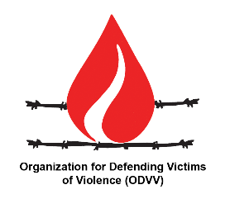***Oral Statement to the 26th session of the Advisory Committee**

**“Situation regarding racial equality in the world”**

**UCMs Discriminate against Nationality**

**Madam President,**

The Convention on the Elimination of All Forms of Racial Discrimination warns Sate parties against any discrimination based on race or nationality. ODVV is seriously concerned about the continuous and systematic discrimination based on nationality against all people living in countries targeted by Unilateral Coercive Measures (UCM)s.

ODVV is alarmed by the bitter reality that all economic social and cultural rights including the right to life is being persistently violated by the regime of unilateral sanctions round the world, taking many lives in silence.

The legal argument that sanctions may have a discriminating effect on the basis of the country of residence or nationality of the targeted populations is also presented in the report of the former Special Rapporteur on the negative effect of UCMs on human rights (A/HRC/39/54).

**Madam President,**

While noting the previous report of the Advisory Committee on the negative effect of UCMs on human rights, ODVV urges the members of the Committee to study the lethal effects of this form of discrimination based on nationality, that limits access of the people living in targeted countries to medicine, medical equipment, food and even Covid-19 vaccine threatening many lives during the pandemic.

Also ODVV, urges the Committee to offer recommendations to the HRC on how to prevent discrimination based on nationality through UCMs.