Check against delivery
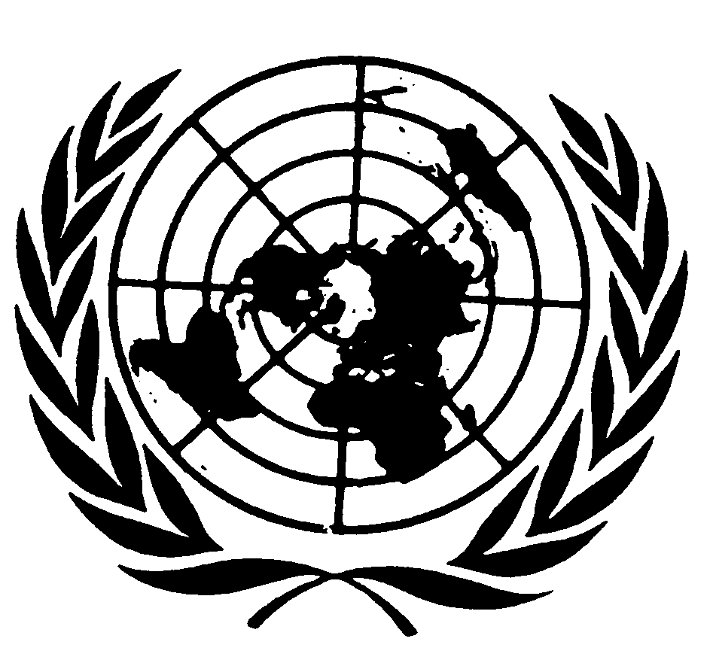

Statement by Mr. Michael Kirby
Chair of the Commission of Inquiry on
Human Rights in the
Democratic People’s Republic of Korea

68th session of the General Assembly
Third Committee
Item # 69 B&C

29 October 2013
New York



Mr. Chairperson,
Distinguished delegates,
Ladies and gentlemen,

Understandably, the world’s spotlight has been on the nuclear weapons developed by the Democratic People’s Republic of Korea. But it is high time to broaden the focus to shine light onto its human rights record.

I will share with you a brief update on the work of the Commission of Inquiry. It has been mandated by the Human Rights Council to investigate the systematic, widespread and grave reports of violations of human rights in the Democratic People’s Republic of Korea, with a view to ensuring full accountability, in particular for violations which could amount to crimes against humanity.

We have received good cooperation from many states. The Democratic People’s Republic of Korea, however, has so far not cooperated, despite our repeated efforts to reach out to its authorities, including in letters to its Supreme Leader H.E. Mr. Kim Jong-Un and its Permanent Representative here in New York. I reiterate this offer today before this Assembly and in the presence of the distinguished delegates of the Democratic People’s Republic of Korea.

In the absence of access to the Democratic People’s Republic of Korea, the Commission of Inquiry has conducted public hearings involving victims and witnesses in Seoul, Tokyo and London, which were open to the public, media and other observers. Later this week, we will hold additional public hearings in Washington D.C.

The harrowing testimonies received during the public hearings shocked our senses and moved us, at times, to tears. We heard from ordinary people who faced torture and imprisonment for doing nothing more than watching foreign soap operas or holding a religious belief. Others were subjected to torture, sexual violence, imprisonment and other atrocities, because they tried to exercise their human right to leave their own country. One repatriated woman, for instance, described how she was forced to drown her own baby in a bucket because the child had a foreign father. Those who thought that “racial purity” was an evil notion of the past, need to think again.

We heard from witnesses who spent their entire childhood in gruesome political prison camps, punished for the “political sins” of their fathers or grandfathers. Satellite images we obtained clearly support that at least four political prison camps remain fully operational. In recent years, the Democratic People’s Republic of Korea has apparently significantly downsized a fifth camp and closed another camp. The Commission will seek to establish to what extent the prisoners of these two camps were transferred, released, or died.

The families of persons abducted from the Republic of Korea, Japan and other countries described to us the agony they endured ever since the enforced disappearance of their loved ones at the hands of agents of the Democratic People’s Republic of Korea. Reflecting the yearnings of these families, the mother of Ms. Megumi Yokota, who was 13 years old at the time of her abduction, appealed to the Democratic People’s Republic of Korea’s Supreme Leader: ‘Tell us where our daughter is. Is she alive? Is she happy? Is she dead?’

The Commission of Inquiry invited the Democratic People’s Republic of Korea to attend and make representations at the public hearings. Our invitations have all remained unanswered. Instead, its Delegation to the Human Rights Council accused us of relying on “faked materials… fabricated and invented by the forces hostile to the DPRK, defectors and other rabble.”

Having worked 35 years of my life as a judge, I spent much time distinguishing between fabricated evidence and genuine accounts of truthful witnesses. But do not take my word for it. I encourage the delegates to watch the video recordings of public hearings. These are available on our webpage to people worldwide who can form their own opinions about the credibility of the testimonies and the transparent, rigorous and fair procedure under which they were given.

The individual stories of suffering emerging from the public hearings are also entirely consistent with over 200 confidential interviews with victims, witnesses and experts conducted by the Commission, including during its visits to Seoul, Tokyo, Bangkok and London, and an even larger body of written submissions and other documents studied by the Commission.

Our final conclusions and recommendations must await the end of the investigation. However, the entire body of evidence gathered so far points to what appear to be large-scale patterns of systematic and gross human rights violations. I therefore repeat our call to the Democratic People’s Republic of Korea to produce evidence to substantiate its claim that none of the violations highlighted by the Commission of Inquiry exist. Or better still, to indicate what has been done to address long-standing concerns.

Much work lies ahead. In line with our mandated focus upon ensuring accountability, we will seek to determine which state institutions and officials carry responsibility, including for potential crimes against humanity. We will also seek to track the evolution of the human rights situation over time. We have noted, for instance, the reported limited improvement of the food situation since the Famine of the 1990s. Yet, according to UNICEF, 27.9% of young children in the Democratic People’s Republic of Korea remain of stunted growth due to chronic malnutrition. This is a shocking statistic in today's world and a consequence of the policy of weapons before food.

A Commission of Inquiry is neither prosecutor nor judge. However, we are the eyes, ears and voice of the United Nations and will provide you with a truthful, comprehensive, balanced and credible report on human rights violations in the Democratic People’s Republic of Korea. When our final report is delivered in March 2014, the international community will be obliged to face its responsibilities and decide what concrete action it will take to protect the people of the Democratic People’s Republic of Korea from what appear to be grave and systematic human rights violations. These violations challenge the global conscience of humanity and have gone on far too long.

-----

The video recordings of the public hearings are available at : http://www.ohchr.org/EN/HRBodies/HRC/CoIDPRK

