Helicopter
The hands and the feet of victims are tied behind their back and they are made to lie on the ground, face down, or suspended in the air.
Helicopter
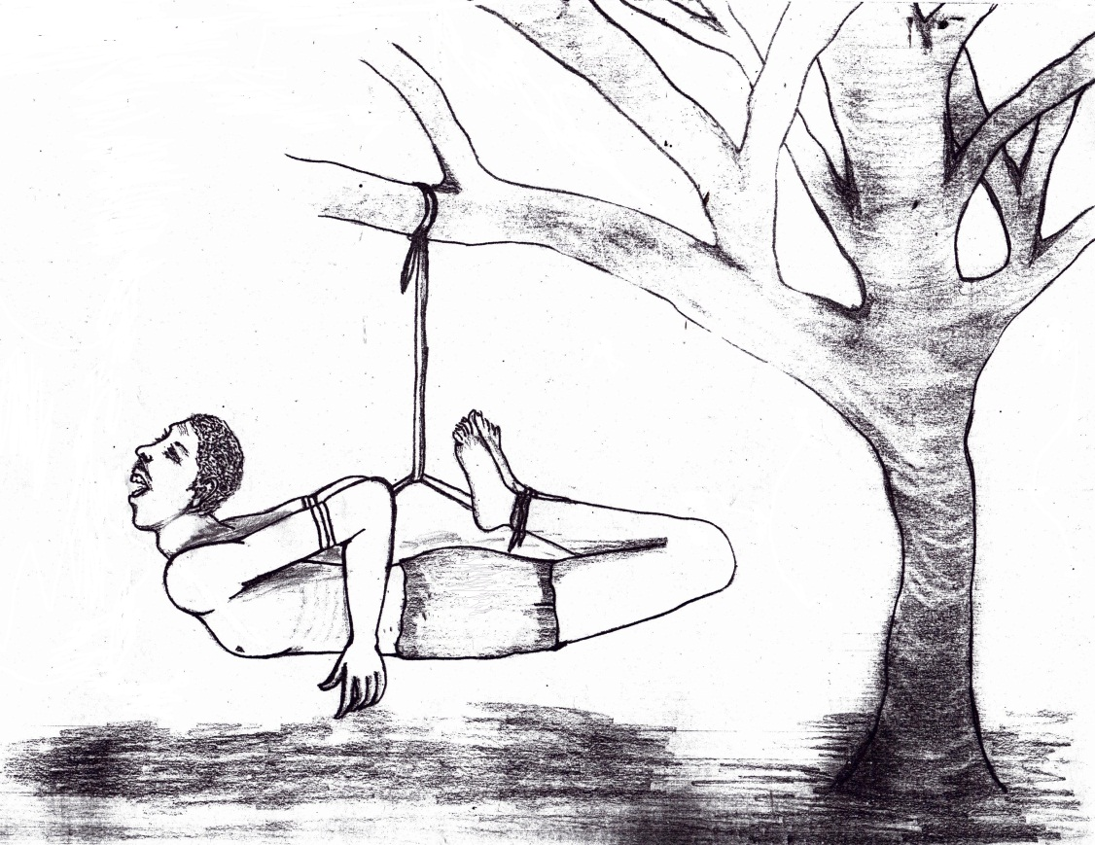
© 2015 Eritrean torture survivor
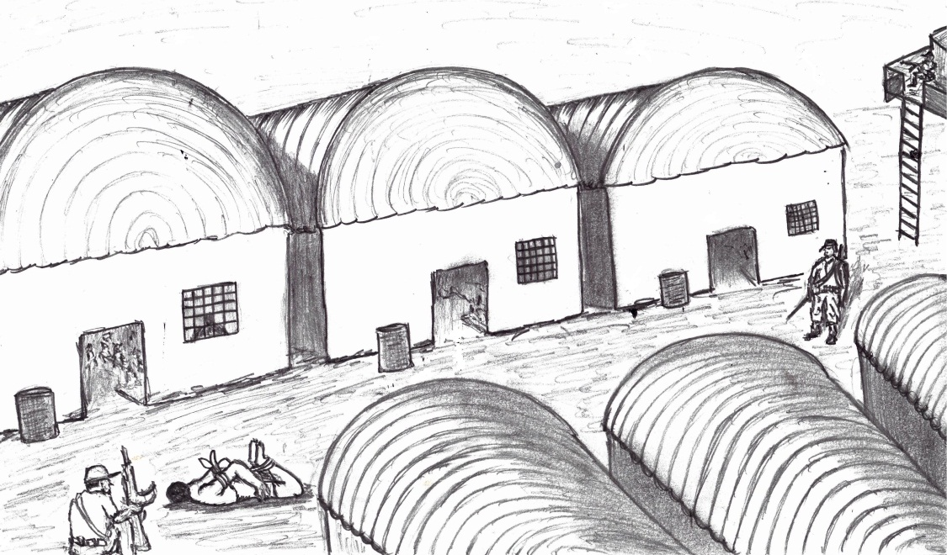
© 2015 Eritrean torture survivor

Otto
The arms are tied behind the back of victims who are often made to lie on the ground, face down.
Otto
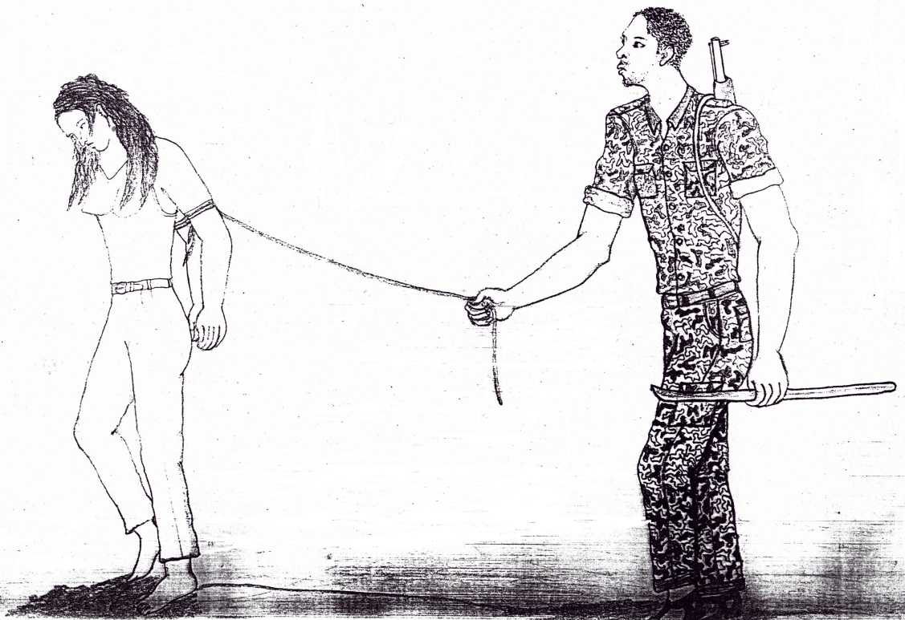
© 2015 Eritrean torture survivor

Almaz (diamond)
Victims are generally hung to a tree with their elbows tied behind their back and forced to stand on tiptoes.
Almaz
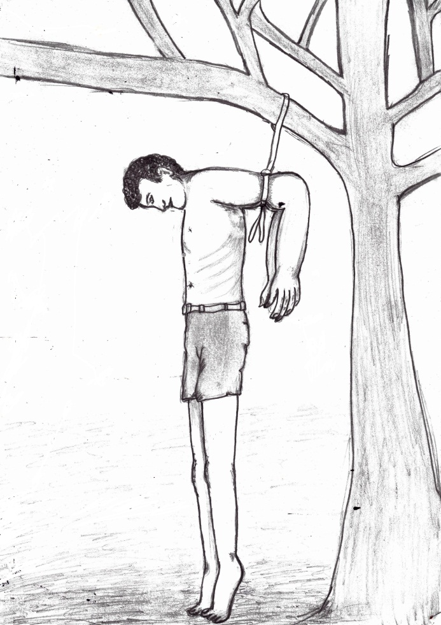
© 2015 Eritrean torture survivor

Torch
Victims have their hands and sometimes legs, tied or handcuffed, a stick placed under the knees. They are hung upside down and beaten, especially on the soles of the feet.

Torch
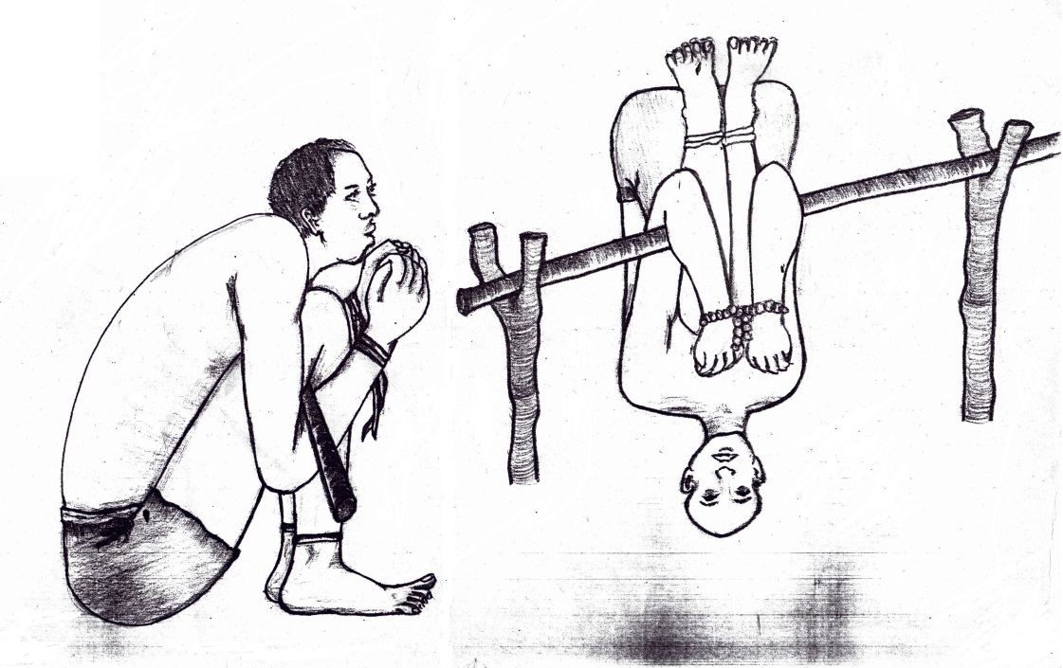
© 2015 Eritrean torture survivor

Ferro
Victims are often handcuffed with ferro during interrogations. These ‘special’ iron handcuffs have bolts that can be screwed from underneath to tighten them, which creates severe pain and stops the blood flow. Depending on the replies given to the questions of the interrogator, the ferro are tightened or loosened.
Ferro
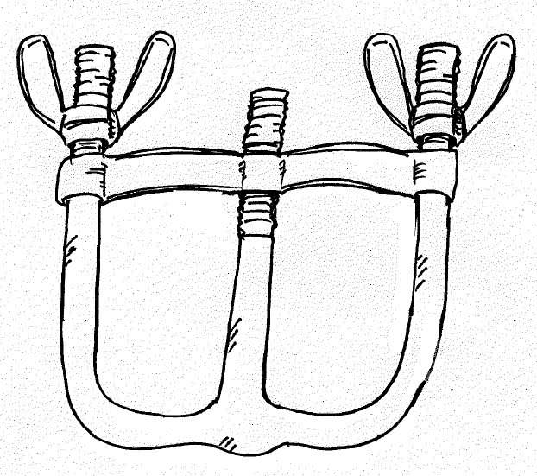
^{© 2015 UN/OHCHR}

Toilet breaks

Inmates can generally go out for toilet breaks once or twice a day to urinate and defecate, often in open spaces covered with human waste while guarded at gunpoint. Former detainees reported being forced to release themselves under extreme time pressure and in humiliating ways.

Detainees relieving themselves

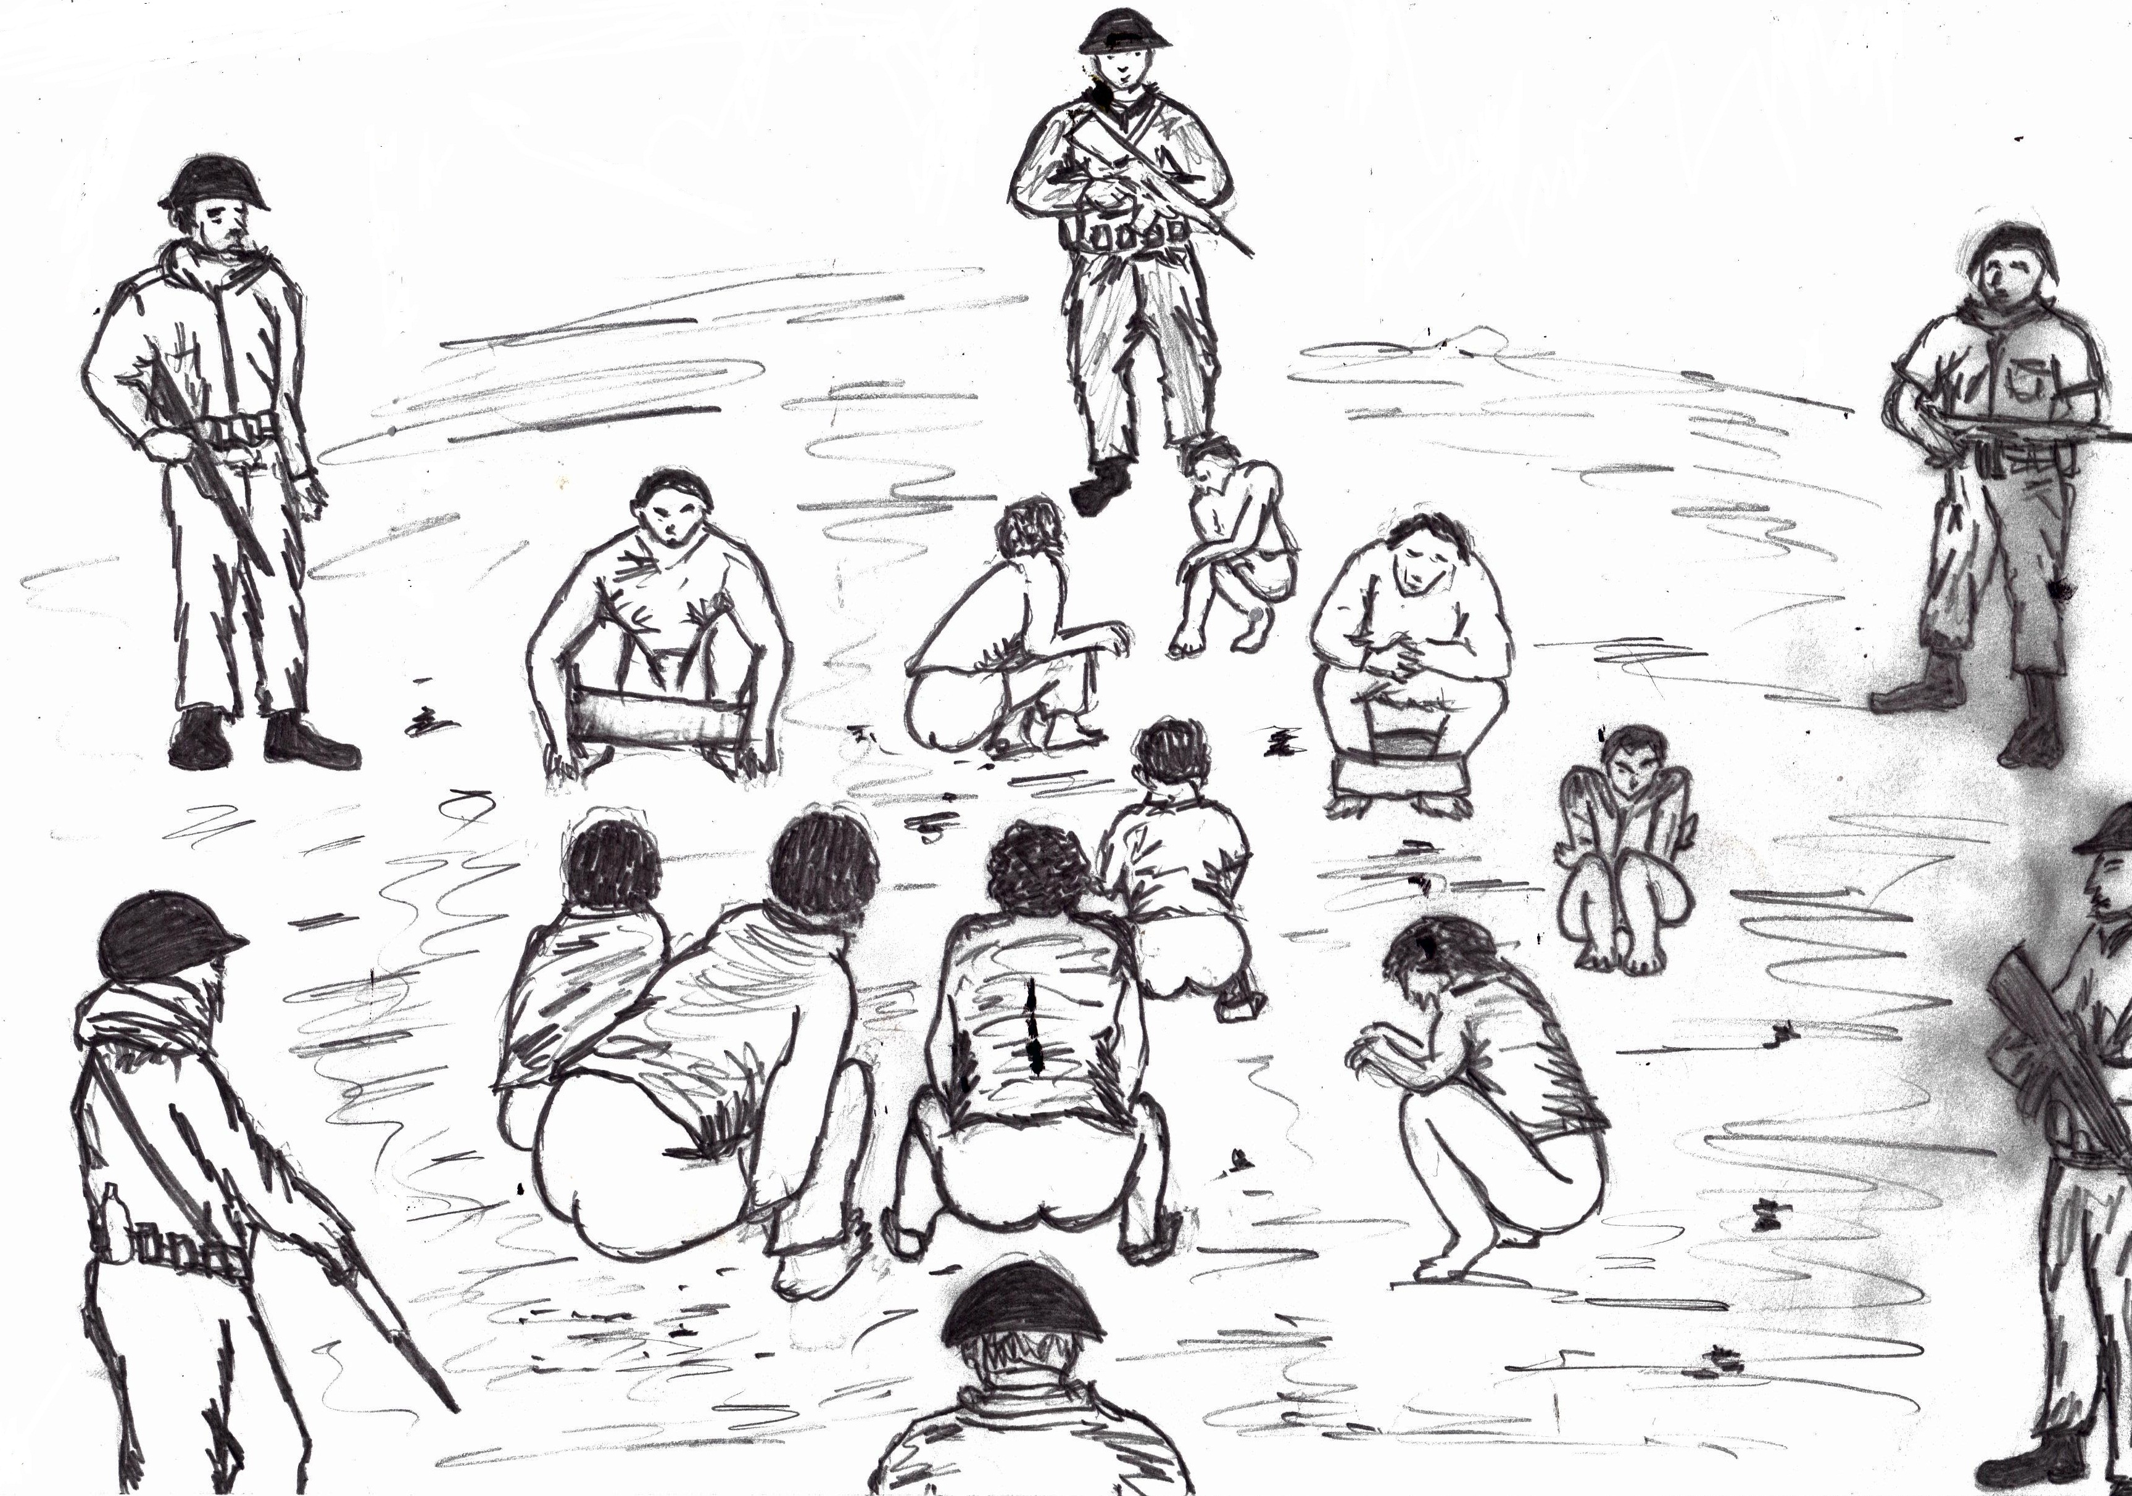
© 2015 Eritrean torture survivor

? Drawings provided to the Commission by an Eritrean torture survivor and published with permission of the artist.
? Drawing provided to the Commission by an Eritrean torture survivor and published with permission of the artist.
? Drawing provided to the Commission by an Eritrean torture survivor and published with permission of the artist.
? Drawing provided to the Commission by an Eritrean torture survivor and published with permission of the artist.
? Drawing provided to the Commission by an Eritrean torture survivor and published with permission of the artist.

