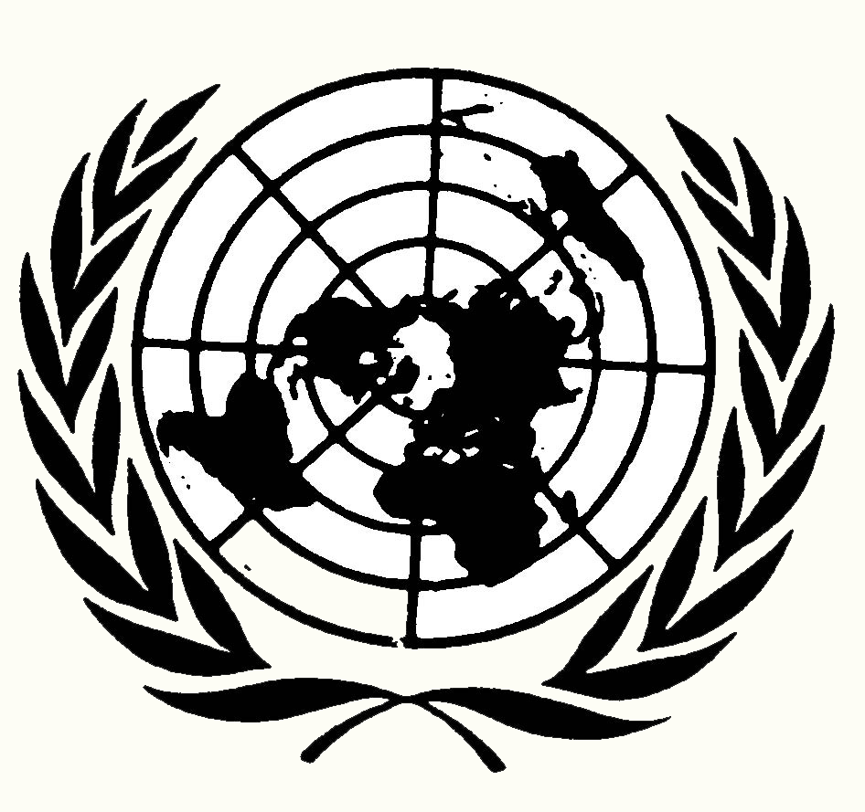
United Nations Nations Unies

THE COMMISSION OF INQUIRY ON HUMAN RIGHTS IN ERITREA

Mandate of the Commission

The Commission of Inquiry on Human Rights in Eritrea (the Commission) was established on 27 June 2014 by the United Nations Human Rights Council under Resolution 26/24.

The Commission was mandated to investigate violations of human rights in Eritrea since 24 May 1991, the date Eritreans consider their independence day.

The violations to be investigated included, but were not limited to:

- Extrajudicial killings
- Enforced disappearances
- Arbitrary arrest and detentions
- Torture
- Violations occurring during compulsory national service
- Restrictions to freedoms of expression and opinion, assembly, association, religious belief and movement

The Commission of Inquiry is supported by a team of experienced human rights officers. Investigations were conducted with a view to identifying possible patterns of systematic violations of human rights; make recommendations on how to improve the general human rights situation in the country; and to seek to ensure accountability in the future. Through its work, the Commission also aims to raise awareness of the human rights situation in Eritrea.

The Commission was only mandated to investigate violations of human rights and therefore interpreted its mandate as not including the investigation of international crimes, such as crimes against humanity. Nevertheless, on the basis of the body of information collected by the end of its investigation, the Commission concludes that some of the violations identified may constitute crimes against humanity and recommends further investigation.

In March 2015, the Commission provided an oral update on its work to the Human Rights Council. The Commission is scheduled to present the written report of its findings and recommendations to the Human Rights Council in Geneva on June 23, 2015. In October 2015, it is scheduled to report to the UN General Assembly in New York.

Methods of work

In carrying out its work, the Commission is guided by the principles of independence, impartiality, objectivity, transparency, integrity and of “do no harm.” The latter principle is of particular importance in relation to guarantees of confidentiality and the protection of victims and witnesses.

The Commission will not share any information with any State, entity or individual without the explicit and informed consent of the witness, victim or other source. All interpreters whose services are used by the Commission are briefed on the requirements of confidentiality and bound by written agreements.

Although the Commission sought the full cooperation of the Government of Eritrea and requested access to the country and to information, it received no response.

The Commission collected and documented testimonies and the accounts of survivors, witnesses and other sources in eight countries (Djibouti, Ethiopia, Germany, Italy, Sweden, Switzerland, the United Kingdom and the United States.) In all, more than 550 confidential interviews were conducted and 160 written submissions received.

Members of the Commission

The Commission of Inquiry is composed of:
• Mr Mike Smith, Chairperson
• Ms Sheila B. Keetharuth
• Mr Victor Dankwa

The Commissioners serve in a non-remunerated independent expert capacity.

Secretariat and Contact

An international secretariat of United Nations staff provides support to the Commission. For any query relating to the Commission or to provide information relevant to its mandate, please write to:
coieritrea@ohchr.org

or

Commission of Inquiry on Human Rights in Eritrea
Office of the High Commissioner for Human Rights
United Nations Office at Geneva
CH-1211 Geneva
Switzerland
Please, note that the Commission cannot assist with asylum claims or other forms of immigration relief.

More information on the Commission is available at: http://www.ohchr.org/COIEritrea

