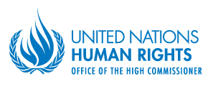
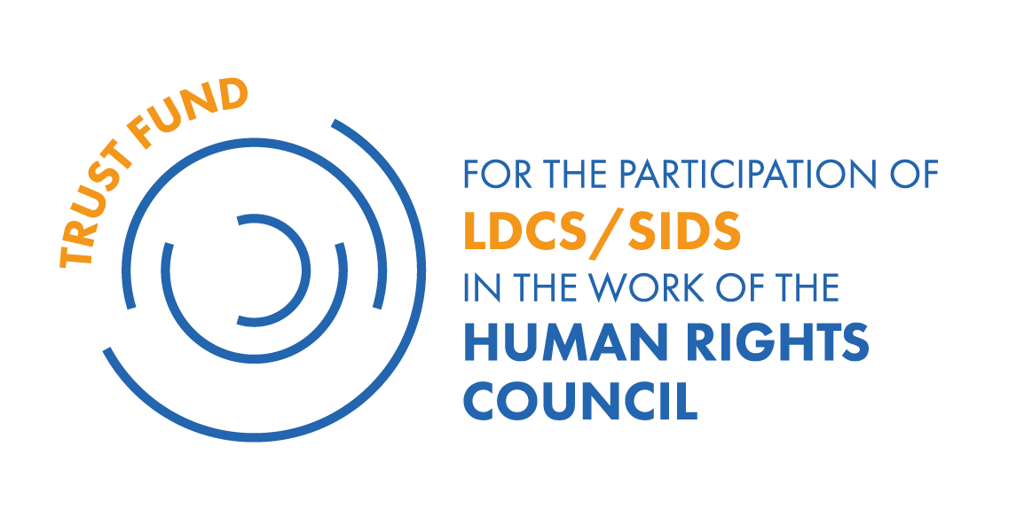

BIOGRAPHIES OF THE LDCs/SIDS DELEGATES ATTENDING HRC31

Voluntary Technical Assistance Trust Fund to support the participation of LDCs/SIDS in the work of the Human Rights Council

Ms. Olive Justine Vaai, Senior Foreign Service Officer, Samoa

Ms. Olive Vaai attended Victoria University in Wellington, New Zealand where she majored in Political Science and International Relations. Ms. Vaai is a Senior Foreign Service Officer for the Ministry of Foreign Affairs and Trade in Samoa where she has been working in the Political, International Relations and Protocol Division for 4 years. A core responsibility of the division is to provide comprehensive policy advice and representation in key areas of multilateral cooperation such as international security and disarmament, international environment issues and human rights to name a few. Ms. Vaai works with one colleague on human rights, dealing specifically with women and children’s rights under CEDAW and CRC in Samoa.
This is her first time in Geneva, Switzerland and attending a Human Rights Council Session. She hopes the knowledge and lessons gained from participation in HRC31 will help assist Samoa in its preparations for the Second Universal Periodic Review to be held in Geneva in May 2016.

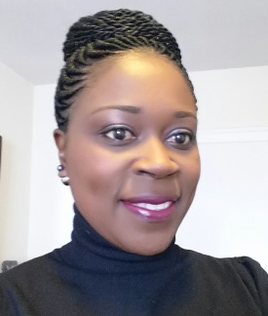
Ms. Thouvia France, Foreign Service Officer, Saint Kitts and Nevis

Ms. Thouvia France has been employed with the Ministry of Foreign Affairs and Aviation of St. Kitts for six (6) years.
Of those six years, she has served at the Permanent Mission of St. Kitts and Nevis to the United Nations in New York from 2010 to 2015 where she served as Third Secretary. At the United Nations, she served initially on the Second Committee which deals with economic and financial issues including issues relating to economic growth, sustainable development, poverty eradication and financing for development. She later served on the Fifth Committee which is responsible for the Administration and Budgetary matters of the United Nations.

At the Ministry of Foreign Affairs in St. Kitts and Nevis, Ms. France has most recently assumed responsibility for the geographical regions of Europe, the European Union and Turkey. Her other desk duties includes Human Rights Issues and Sustainable Development which have also been recently assigned.

Ms. France was assigned to the Latin America and Caribbean region prior to being assigned to Europe, with responsibility to the Community of Latin America and Caribbean States (CELAC), an organization that consists of 33 sovereign countries in the Americas representing roughly 600 million people.

Ms. France earned a Bachelor of Honors degree in Managing International Tourism at Leeds Beckett University in the United Kingdom.

Ms. Thouvia France lives on the sister island of Nevis, the smaller island of the twin island Federation of St. Kitts and Nevis. This is her first time in Geneva attending a HRC session.
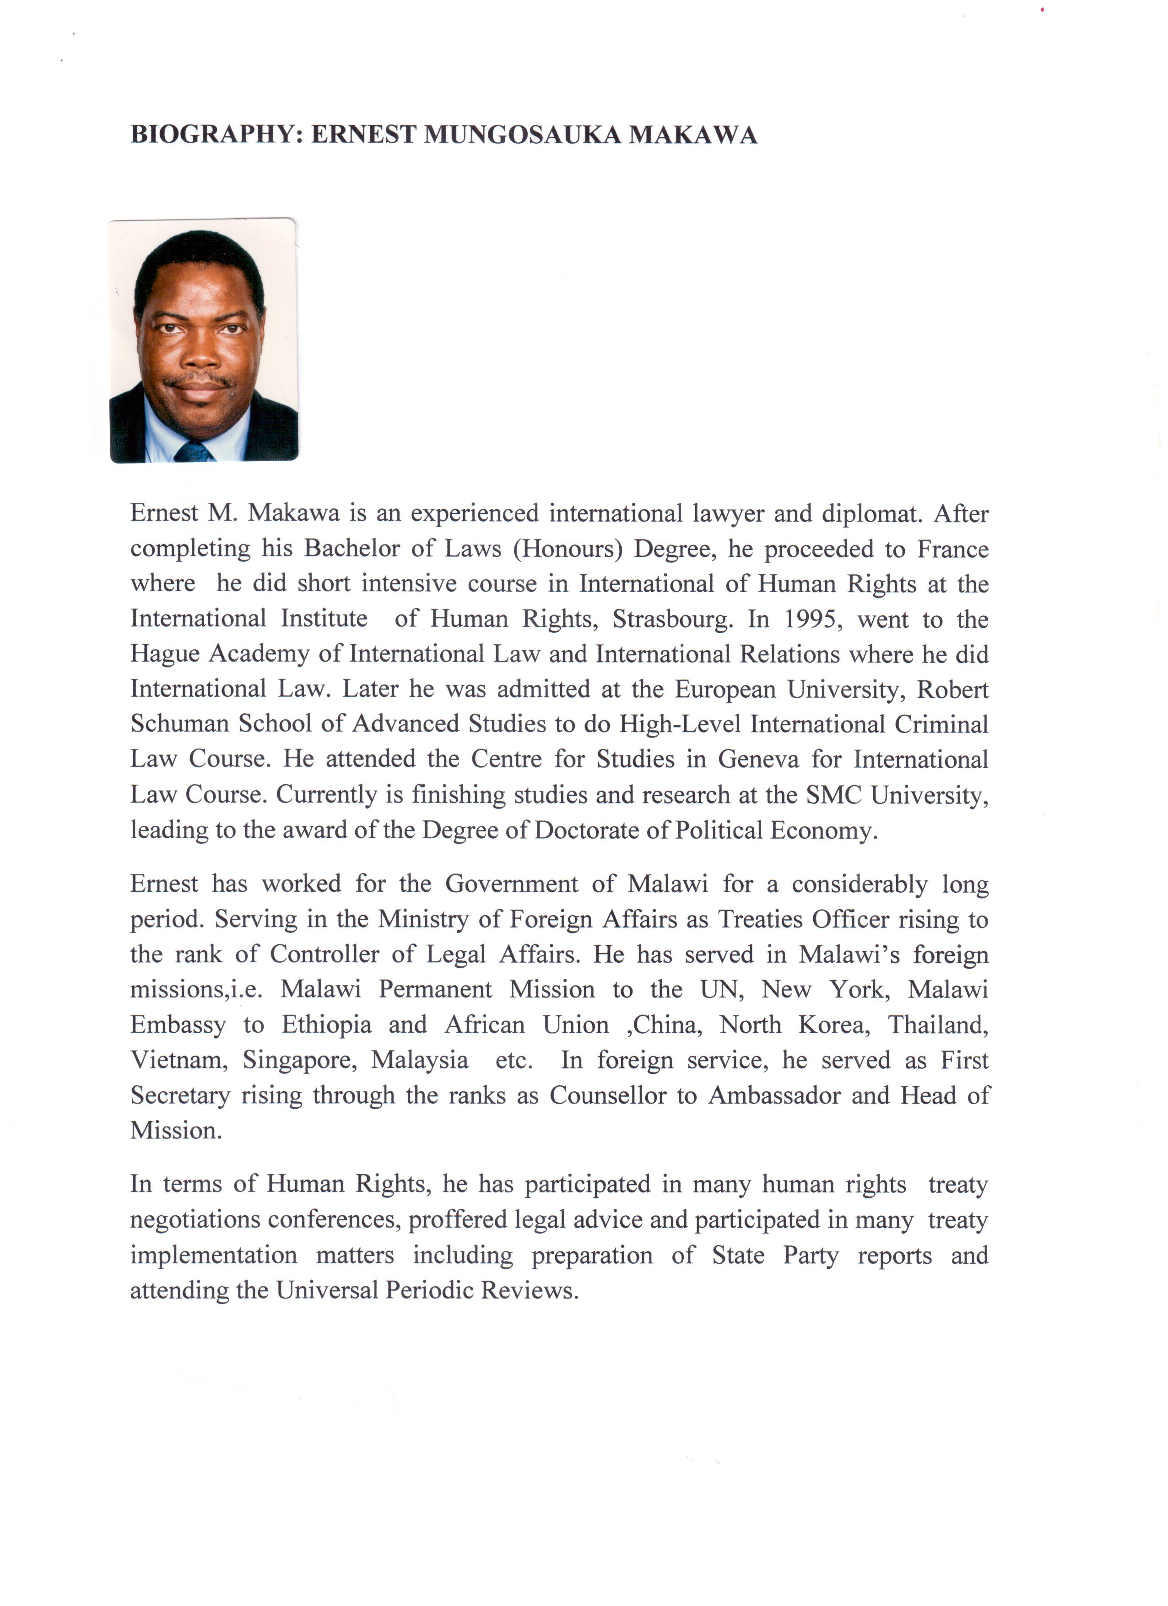

Ms. Jinelle Adams, Foreign Service Officer, Saint Vincent and the Grenadines

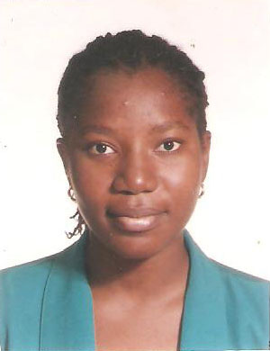
Ms. Jinelle Adams works with the Ministry of Foreign Affairs, Trade, Commerce and Regional Integration of Saint Vincent and the Grenadines, and has been attached to the department of Foreign Policy and Research since 2010.
Ms. Adams holds a Bachelor's degree in International Business, a Master's in International Law and a Master's in Diplomacy. Her current responsibilities include assisting with the coordination and execution of the foreign policy of Saint Vincent and the Grenadines as it relates to the day to day operation of the Ministry.
Ms. Adams is managing the bilateral relationships of Saint Vincent and the Grenadines and countries in Asia, and assisting with international law issues under the Ministry's purview, such as the Universal Periodic Review.
Ms Adams represented Saint Vincent and Grenadines at various overseas short term training seminars. Her participation in the thirty-first session of the Human Rights Council signifies her first time at the Council and her first time Geneva.

