37th Session of the United Nations Human Rights Council

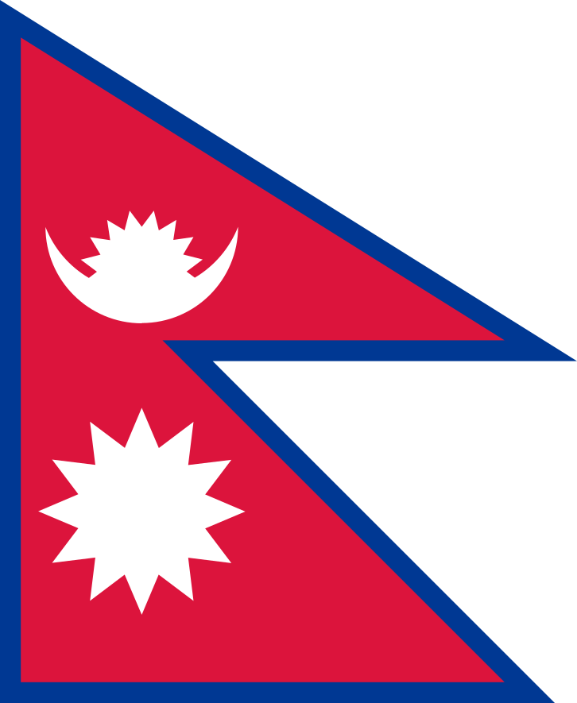

Joint Statement delivered by
Ram Babu Dhakal
Nepal

On behalf of the 12 LDCs/SIDS beneficiary of the Voluntary Technical Assistance Trust Fund to Support the Participation of Least Developed Countries (LDCs) and Small Island Developing States in the work of the Human Rights
On
High Level Panel Discussion on the 70th Anniversary of the
Universal Declaration of Human Rights and the 25th Anniversary of the Vienna Declaration and Program of Action

Geneva, 28 February 2018

Mr. President, Excellencies and distinguished delegates;

I feel privileged and honoured to speak on behalf of twelve beneficiary delegates of the Trust Fund: Afghanistan, Antigua and Barbuda, The Bahamas, Bangladesh, Burundi, Democratic Republic of the Congo, Haiti, Mozambique, South Sudan, Saint Vincent and the Grenadines, Yemen and my own country, Nepal.

We would like to extend our sincere greetings from our respective governments and peoples to you all. This year, we are celebrating the 70th Anniversary of the Universal Declaration of Human Rights and the 25th Anniversary of the Vienna Declaration and Program of Action.

The Universal Declaration, a hallmark for equal rights and dignity for everyone, has set global human rights standards, paving the way for development of various international instruments. Likewise, the Vienna Declaration and Program of Action reinforced interrelationship between peace, security, human rights and development. Since then, a new institutional mechanism known today as the Office of High Commissioner for Human Rights (OHCHR) has played a significant role to advance the regime for protection and promotion of human rights around the world. The Council and UPR mechanism created by UNGA serve as a global platform for generating cooperation among member states in the fulfillment of their obligations on human rights at national, regional and international levels.

Building national capacity for legal, administrative and institutional arrangements plays a significant role in advancing the human rights agenda. Sharing best practices between member states should be encouraged to the extent possible. Consequently, participation of small developing countries including LDCs and SIDs in the HRC and its related processes is important. We would like to express our sincere appreciation and gratitude to donor countries and friends of LDCs and SIDS for their contributions to the Trust Fund. Support for participation has made the Council more inclusive and contributed to enhance dialogue. Gender equality has been given due consideration to the selection of beneficiaries. The program designed by the Trust Fund is invaluable to enrich understanding of substantive agenda items and procedures of the Council. The beneficiaries at this session represent the regional groups of Asia, Africa and Caribbean countries; some of us do not have Permanent Missions in Geneva.

Mr President,

We would like to urge you and all members to lend valuable support to the resolution under Agenda item 10 regarding Promoting the Voluntary Technical Assistance: Trust Fund to Support the Participation of LDCs and SIDs in the work of the Council.

We would also like to convey our deepest appreciation to the OHCHR, particularly to the coordination of the implementation of the Trust Fund, for their appreciable work carried out by them.
Last but not the least, let us rededicate ourselves to a holistic approach, as stressed by the UNSG, that recognizes nexus between peace and security, sustainable development and human rights. Let us also work together to advance human rights in the dignity and the worth of human being while we celebrate the 70th anniversary of UDHR and the 25th Anniversary of the Vienna Declaration and Program of Action to make a real difference for human rights for all.

Thank you all for your kind attention.

