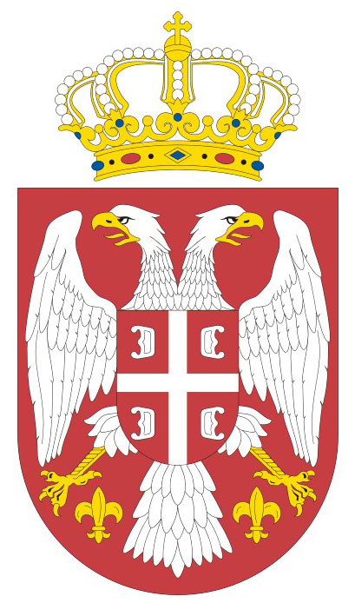
Republic of Serbia

Human Rights Council
Forum on Minority Issues Geneva, 12-13 November 2009
Second Session
Item 5

Statement by
Mrs. Marija Stajić - Radivojša
Third Secretary

Madame Chair,

The Republic of Serbia is deeply committed to the promotion and protection of human rights, including rights of minorities. We share the view of the Independent Expert on Minority Issues, Mrs. Gay McDougal, that an adequate representation of minorities in policy is instrumental in breaking the cycle of discrimination and exclusion, and a basis for the full enjoyment of civil, political, economic, social and cultural rights.

The Constitution of the Republic of Serbia guarantees special individual and collective rights to persons belonging to national minorities in addition to the rights guaranteed to all citizens. Among others, these rights allow minorities to take part in decision-making or deciding independently on certain issues related to their culture, education, information and official use of languages and script through their collective rights. In addition, when taking up employment in state bodies, public services, bodies of autonomous province and local self-government units, the ethnic structure of population and appropriate representation of members of national minorities are to be taken into consideration.

Let me highlight some of the latest developments and accomplishments in the Republic of Serbia aimed at effective participation of minorities.

In order to exercise the right to self-governance in the field of culture, education, information and official use of their language and script, persons belonging to national minorities have the constitutional right to elect their national councils. To further enforce this right, the National Assembly of the Republic of Serbia adopted on 31 August 2009 the Law on National Councils of National Minorities. In accordance with the Law, National Councils have important role to play in numerous fields, such as maintaining relations with governmental institutions or initiating procedure for the adoption of laws and monitoring their implementation. So far, National Councils have been elected by members of sixteen national minority groups (including the Federation of the Jewish Communities of Serbia that has the same status as national councils), while four more are expected to be elected by the end of 2010. Establishment and functioning of these councils should make significant contribution to the promotion and protection of the rights of persons belonging to minorities, including in the sphere of public life.

Let me emphasize that special attention has been given to the rights of Roma. Bearing in mind vulnerable position of this population, the Government has adopted the Strategy for improving the situation of Roma and the Action Plan for its implementation. Among others, the Action Plan includes measures and activities for the inclusive political participation of Roma. These measures have been complemented by the establishment of the Council for improving the situation of Roma, which has the responsibility to monitor implementation of the priorities identified in the Strategy and Action Plan. This Council effectively involves Roma in development plans and programmes concerning their rights and needs.

In conclusion, Madame Chair, let me assure you that the Government of the Republic of Serbia will continue its efforts aimed at promotion and protection of human rights of all of its citizens, including persons belonging to minority groups.

Thank you Madame Chair.

