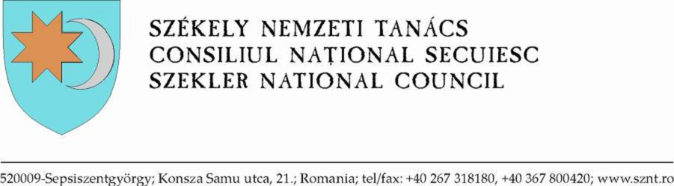

Dear Chairman, fellow participants, ladies and gentleman!

It is an honour to be here again, representing the Hungarian speaking Szekler community of Romania. “The Draft recommendations on preventing and addressing violence and atrocity crimes targeted against minorities” are of utmost importance to us, as a community that has previously suffered from violence. Although our situation has improved since the political transition of 1989, and the election of Klaus Werner Johannis as President of Romania has opened up a realistic chance of deepening democracy, we still live in a country where ethnic tensions continue to exist. According to the Council of Europe‘s Recommendation 1334 (2003), which was adopted based on the report of Andreas Gross, the roots of these tensions in most countries, including Romania, “can very often be traced to the dichotomy between the principle of indivisibility of states and the principle of identity, and are rooted in tensions between states and minority groups which demand the right to preserve their identities.”
In our point of view the Draft Recommendations before us, should specifically refer to the various forms of territorial and cultural autonomy as the best possible means to ensure a truly inclusive decision-making process. Countries of the international community need to surpass the approach of treating the various forms of autonomy as concessions that are being granted after the resolution of conflicts. In reality, autonomy is an institution of democratic balance, and a factor of lasting stability in international relations, as well as of course a guaranty for fundamental human rights.
The virtue of the cited document lies in its multi-sided nature, which dismantles the fears of those states who are suspicious towards their minorities, by stating that the benefits of autonomy cannot undermine the internationally recognized borders of the states. The interpretation, implementation and management of autonomy is a jurisdiction of the national parliaments.
The Human Rights Council of the UN can contribute to conflict prevention, inter alia, by reaffirming the recommendations and principles enshrined in the mentioned resolution of the Council of Europe, so as to transform these principles into promoters of human rights, democracy, and peace all around the globe. For this reason, it would be appropriate to incorporate several findings and provisions of the Gross report into the present Draft Recommendations.
Finally, we agree with paragraph 40 of the Draft, stipulating that “the United Nations and its partners should improve their collective response to future risks of serious violations of minority rights”, and would like to add that the UN should also encourage that best practices regarding minority protection are shared between member states.

