State of minorities & human rights in Iran
(9th Session of the United Nations Forum on Minority Issues, 2016)

After Islamic revolution in Iran, there was a committee selected by top revolutionary figures surrounding supreme leader Ayatollah Khomeini (1980 AD), to create the Constitution of Islamic Republic of Iran, but there was a very tough and strict order from supreme leader that; the constitution should be based purely on Shiite Sharia law and by those who has expert in this regards, therefore the committee had no representative from women which make %50 of population, no representative from ethno-linguistic minorities which make about a bit more than %65 of population, and no representative from none-Shia religion people which make about %20 of population of Iran.

You may see the order of Ayatollah Khomeini about Constitution here:
https://www.youtube.com/watch?v=ke0k9bclwdY
قرائت پیام آیت اله خمینی (1358 شمسی) توسط هاشمی رفسنجانی: قانون اساسی جمهوری اسلامی ایران بایستی صددرصد مطابق قوانین شرعی شیعه اثنی عشری باشد و فقط مجتهدین روحانی حق تدوین قانون اساسی را دارند (در واقع حضور زنان، اقوام و ملیتها، و ادیان و مذاهب غیر شیعه در تهیه قانون اساسی اکیدا ممنوع شدند).

The demands of indigenous people and ethnic minority/nationality groups in the region of North of Khorasan from the government of Iran is overlooked entirely. Education and teaching in Kurdish - Kurmanji language is one of the cultural demands of the indigenous people in the region of North of Khorasan from the state administration of President Rohani (so called government of devise and hope), and it was one of his promises to the Iranian ethnic nationality groups, which is completely legal based on article 15 and 19 of Iran’s constitution law and the international conventions which has signed by state of Iran, but our legal demand is not attained in the schools of North of Khorasan region yet (Minister of Education, is direct responsible for this discrimination, injustice and human inequality), there is no any plan about Kurdish - Kurmanji language in the universities of North of Khorasan neither to get student to begin study for academic degrees in this field and nor to train academic staff and teachers for Kurdish - Kurmanji language in the region. The faculty members of universities in North of Khorasan are mostly exotic and not from native regional people, which is feasibly formed and organized deliberately, to distort and destroy the indigenous ethnic nationality identities in this region, most of the people in the region are unhappy and worried too much in this regards. This situation and mentality must be changed and education in native mother language to be started in the region as soon as possible.

In this regards you may see a demanding letter to UN about human rights breaches (including education in Kurdish – Kurmanji language) in North of Khorasan region, here: http://www.kurmanj.org/en/modules.php?name=News&file=article&sid=8

Also you may see a recent case (25 August 2016) which a teacher got captured (and is under pressure, oppression, torture etc. in prison), just because of teaching Kurdish language (Bojnurd, North of Khorasan) here;
http://www.nnsroj.com/fa/detiles.aspx?id=100792

Who is minority?

Those ethnic, religious and linguistic communities, who may not necessarily be numerical minorities but their rights, are denied by state rulers and they are non-dominant. Those indigenous people, tribal, and migrant nomadic people (Ashayer), who do not wish to be classified as minorities for various reasons but nationalities, are also non-dominant.

Why should people be discriminated against because they are minority? Everybody has something positive to contribute; working together and respecting each other, we all learn from one another in favor of prosperity and progress for a better life.

Iranian rulers should come clear firstly; to recognize all minorities of Iran constitutionally, and secondly; to consider their lingual/cultural & civil rights, political demands and human rights and implement them on the ground in practice.

Minorities of Iran

Iran is an ethno-linguistically and religiously diverse country. Shia majority amounts about 82% and Sunni minority about 13% of the state total population and the other religions are about 5%. The Sunnis includes; Baluchis, Turkmen, and large number of the Kurds, Talyshis and some Fars and Arabs.

Minorities of Iran are not homogenous, most of them are from different nationalities; they face further oppression and marginalization due to religious, cultural & linguistics, illiteracy, politic affairs, poverty, gender and some other factors. Government has also implemented a systematic and organized policy of integration of all minorities, and assimilation of their culture and languages.

Minorities in Iran are the poorest and most marginalized people in the society. They lack access to political power, with no political parties and no cultural forums, face discrimination and severe human rights abuses, and there is development policies imposed upon them. What they want is: their basic rights to be protected and promoted by international community. It is crystal clear that recognition of minority and indigenous peoples' rights is crucial to establishing and maintaining just, stability and peaceful societies.

There are 11 main ethno-linguistic minorities in Iran, which is as following:

- Persian (Fars or Pars)
- Azeri Turks
- Kurds
- Lor & Bakhtiyari
- Mazendarani
- Gilaks
- Baloch
- Arab
- Turkmen
- Talyshi
- Ghashghayi (Qashqayi)
- Others
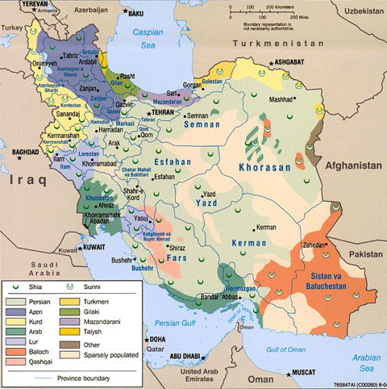
Figure 1: Map of ethnic minorities in Iran. http://www.parstimes.com/people/

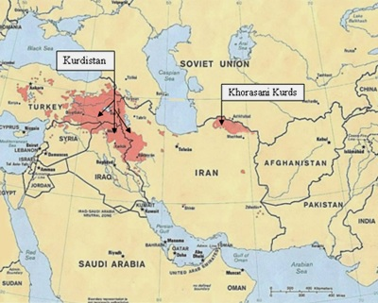
Figure 2: Kurdish inhabited regions in Iran.

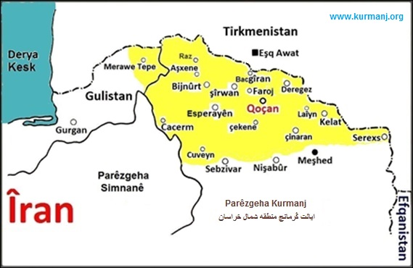
Figure 3: Kurdish inhabited region in North of Khorasan. منطقه کُرمانج شمال خراسان

Discussion

Basically there has never been any census on the number of Iran’s ethnic groups. In the national census of 1986 there was a box asking people about the language spoken at home. But later, the officials changed their mind and asked people not to check that box. But now it seems it is necessary to have a census to find out the exact number of ethnic minorities/nationalities (such as; Azeri Turks, Kurds, Baluchis, Persian, Arab, Talyshis, Gilakis, Mazendaranis, Lor & Bakhtiyari, Turkmen people) in order to determine accurately, Iran’s ethnic diversity.

United Nations has 191 members. About 179 of them are multinational countries. At the top of the multinational countries is India with 1300 nationalities. Only 12 countries have nearly one nation. Iran is among top ten multinational countries of the world with about eleven distinct major minorities / nationalities and some a few others.

In 1948, the United Nations General Assembly adopted the Universal Declaration of Human Rights, which proclaimed that all human beings are born free and equal in dignity and rights. Sadly, for all minorities and indigenous peoples in Iran, this inspirational text, with its emphasis on equality and non-discrimination, remains a dream, not a reality.
Iran was called the United States of Iran (Mamalek-e Mahrooseh Iran with a decentralised system / Anjoman-haye Eyalati-va-Velayati), 1911 AD. The name of Anjoman-haye Eyalati-va-Velayati of that day is reshaped and updated on today as Congress of Nationalities for a Federal Iran (CNFI) at present time (www.iran-federal.org ). The struggle of minorities in Iran for decentralizing the ruling system has taken a long time with very high prices so far, which is so sad, and it is time that some things to be done.

Iran has 30 provinces, which 20 of them are dominated by minorities such as; Kurds, Baluchs, Lor & Bakhtiyari, Azeri Turks, Turkmen, Mazendarani, Gilakis, Arab and Taleshis. The others are mixed. Fore example: About 65% of the population of Tehran are from Iranian minorities (none-Persian). There are 11 provinces which have Sunni minority, and some of them are Sunni dominated. These Provinces include: Kurdistan, Baluchistan, West Azerbaijan, Northern Khorasan, Southern Khorasan, Golestan, Bushehr, Khuzistan, Kermanshah, Gilan (Talyshis areas) and Ilam.

Iran is divided into 31 Provinces
Province | Population | Area(km.²) | Area(mi.²) | Capital
Alborz | 2,412,513 | 5,122 | 1,977 | Karaj
Ardebil | 1,248,488 | 17,800 | 6,873 | Ardebil
Bushehr | 1,032,949 | 22,743 | 8,781 | Bushehr
Chahar Mahall and Bakhtiari | 895,263 | 16,328 | 6,304 | Shahr-e-Kord
East Azarbaijan | 3,724,620 | 45,651 | 17,626 | Tabriz
Esfahan | 4,879,312 | 107,018 | 41,320 | Esfahan
Fars | 4,596,658 | 122,608 | 47,339 | Shiraz
Gilan | 2,480,874 | 14,042 | 5,422 | Rasht
Golestan | 1,777,014 | 20,367 | 7,864 | Gorgan
Hamadan | 1,758,268 | 19,368 | 7,478 | Hamadan
Hormozgan | 1,578,183 | 70,697 | 27,296 | Bandar-e-Abbas
Ilam | 557,599 | 20,133 | 7,773 | Ilam
Kerman | 2,938,988 | 180,726 | 69,779 | Kerman
Kermanshah | 1,945,227 | 25,009 | 9,656 | Kermanshah
Khuzestan | 4,531,720 | 64,055 | 24,732 | Ahvaz
Kohgiluyeh and Buyer Ahmad | 658,629 | 15,504 | 5,986 | Yasuj
Kurdistan | 1,493,645 | 29,137 | 11,250 | Sanandaj
Lorestan | 1,754,243 | 28,294 | 10,924 | Khorramabad
Markazi | 1,413,959 | 29,127 | 11,246 | Arak
Mazandaran | 3,073,943 | 23,842 | 9,205 | Sari
North Khorasan | 867,727 | 28,434 | 10,979 | Bojnurd
Qazvin | 1,201,565 | 15,567 | 6,011 | Qazvin
Qom | 1,151,672 | 11,526 | 4,450 | Qom
Razavi Khorasan | 5,994,402 | 118,851 | 45,889 | Mashhad
Semnan | 631,218 | 97,491 | 37,641 | Semnan
Sistan and Baluchestan | 2,534,327 | 181,785 | 70,188 | Zahedan
South Khorasan | 662,534 | 95,385 | 36,828 | Birjand
Tehran | 12,183,391 | 13,692 | 5,287 | Tehran
West Azarbaijan (Orumiyeh) | 3,080,576 | 37,411 | 14,445 | Orumiyeh
Yazd | 1,074,428 | 129,285 | 49,917 | Yazd
Zanjan | 1,015,734 | 21,773 | 8,407 | Zanjan
31 provinces | 75,149,669 | 1,628,771 | 628,872
Data from the 2011 census, statistical centre of Iran (in Persian Language),
(http://www.statoids.com/uir.html)
(However, the figures might be imprecise because state rulers have never allowed an honest census for political gains. population growth rate in Iran is high, Iran has got a young population. Birth rate estimates: 16.57 births/1000 population, Death rate estimates: 5.65 deaths/1000 population).

There are 11 main ethno-linguistic minorities in Iran, which are as following:

1- Persian [Fars / Pars, (34.6%)], 2- Azeri Turks (25.4%), 3- Kurds (15.5%), 4- Lor & Bakhtiyari (6.2%), 5- Arab (2.8%), 6- Mazendarani (4.4%),7- Gilaks (3.5%), 8- Baloch (3.2%), 9- Turkmen (1.1%), 10- Talyshi (1%), 11- Ghashghayi [(Qashqayi), (0.8%)], 12- Others (1.5%), [Table 1].

No | Ethnics | Languages | % in Iran | Population in Iran
1 | Persian / Fars | Farsi (Persian / Parsi) | 34.6 | 26001785.5
2 | Azeri | Azeri Turkish | 25.4 | 19088015.9
3 | Kurd | Kurdish | 13.5 | 10145205.3
4 | Lor & Bakhtiari | Lori & Bakhtiari | 6.2 | 4659279.5
5 | Arab | Arabic | 2.8 | 2104190.7
6 | Mazendarani | Mazendarani | 4.4 | 3306585.4
7 | Gils | Gilaki | 3.5 | 2630238.4
8 | Baloch | Balochi | 3.2 | 2404789.5
9 | Kurd | Kurdish (Kurmanji) in North of Khorasan | 2 | 1502993.5
10 | Turkmen | Turkmeni | 1.1 | 826646.3
11 | Talyshi | Talyshi | 1 | 751496.7
12 | Qashghayi | Qashghayi Turkish | 0.8 | 601197.3
13 | Others | Others | 1.5 | 1127245.1
Sum | 11 | 11 | 100 | 75149669
Table 1: Ethnic minorities’ languages and population in Iran, Dr. Afrasiab Shekofteh, 2016.

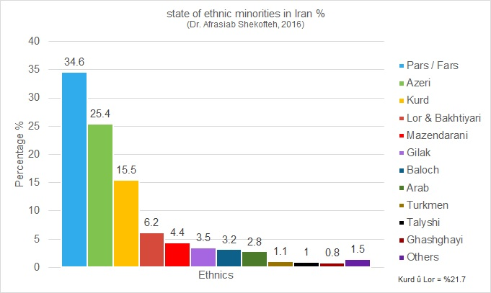 Graph 1: illustration of Iranian ethnic minorities’ percentages, 2016.

Graph 2: The percentages (%) of Iranian minorities’ population as plotted, 2016.

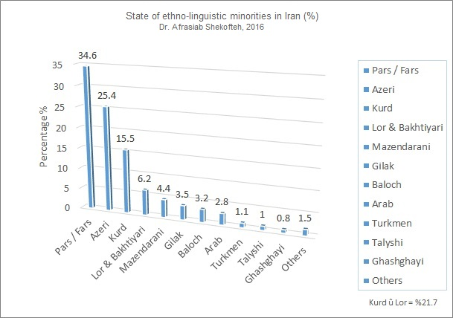
Graph 3: The percentages (%) of Iranian minorities’ population as plotted, 2016.

While, all of these ethnic minority have their own language, culture, and often literature, but their languages, traditions and cultures are banned without any prosperity, which has created an unpleasant situation for all minorities. Their differences usually emerge as political ambitions and demands.

The mosaic of peoples living in Iran reflects the geographical situation of the country throughout history. One of the major internal policy challenges during the centuries up until now for most or all Iranian governments has been to find the appropriate and balanced approach to the difficulties and opportunities caused by this diversity, particularly as this internal diversity has often been readily utilized by foreign powers.

International human rights organization should lobby the government of Iran and work to secure rights for ethnic, religious and linguistic minorities and indigenous people in Iran. Minorities should be provided education and training in their own languages to enable them to claim their rightful place in their own society and region.

International human rights organizations and UN should take steps on behalf of minorities in the world for advancing the protection of them under international law.

Conclusion

If Iran’s rulers declares genuine amnesty and allows genuine participation of all minorities and their political organisations and ordinary citizens in democratic political process in Iran, then there would be no violence of any sorts including state terrorism. This is part of the peaceful nature and tolerant culture of all Iranian nationalities. This sort of participation can only be genuine and real if the Iranian constitution is amended to recognise all the diverse ethnic - linguistic and religious elements of Iran.

There is no State’s TV stations and Radio in minority’s languages, no education in regional languages, neither in schools nor in universities and institutions of higher education.

Tehran’s ultra centralized development strategy has resulted in a wide socioeconomic gap between the centre and the peripheries, where there is also an uneven distribution of power, socioeconomic resources, and sociocultural status. The violence in remote regions such as Kurdistan, Khuzistan, Azerbaijan and Baluchistan clearly has ethnic components, but the far greater causes of the poverty and unemployment that vexes members of ethnic minorities are government organised corruption, inefficiency, and a general sense of lawlessness, which all Iranians, including Persians, must confront.

The policies like restriction on opposition’s political parties (minorities are not allowed to have any official political parties and cultural forums), stricture on minorities’ civil society, suppression of none-state media, subordination of the judicial system, and abolition of the direct election of regional minorities are absolutely routine actions.

The vast revenues that government accrues due to high global energy prices, not only gives more power to suppress minorities, but also the appeasement policy of Russia, China and also some EU (so called democratic) leaders and turning blind eyes on despotic Islamic rulers, is an indirect confirmation and encouragement to this inhumanity and discrimination.

Minorities’ oppression is evident in many parts of Iran. They have boiled over into bitter violence. The situation continues to deteriorate and they fear for their very survival, there were eye gouging in Khorasan (Mashhad city) on 2007, and limbs amputation in Baluchistan on 2008, and there are many executions by hanging them on the crane, and many cases of raping and severe torturing and so on, across the State. The crisis is deepening, as government-sponsored ideological armed forces (Pasdaran / IRGC) and Para-militia (Basijis) continue to carry out massive human rights abuses against minorities.
World leaders and policy makers must insist that the rights of minorities and indigenous people to be respected. The participation of minorities in the state affairs and electoral representation is essential if conflict is to be prevented and lasting peace to be built.
The inclusion of minorities leads to the stronger and more cohesive societies. It is crystal clear that exclusion results in instability, conflict, and in the most extreme cases leads to genocide such as; gassing the Kurds in the city of Sardasht (although Supreme leader and his surrounding figures tease and encouraged Saddam to invade Iran But the man-made Sardasht’s disaster and crime, which have had disproportionate impact on the Kurds, could be avoided through if the government of Islamic Iran let ethnic/national minorities to be shared in the governing establishment power), mass grave in Khavaran, and many other mass graves across Iran, massive oppression is on right now, and execution is on almost on daily basis based on bogus allegations, which is so sad.

US, EU and UN should follow the Declaration on the Rights of Persons Belonging to National or Ethnic, Religious and Linguistic Minorities (UN resolution 47/135 of 18 December 1992) and also the Declaration on the Rights of Indigenous peoples and by that to pressurize the Islamic republic rulers to respect the obligations.
We, as member of minorities want to ask international community to call on Iranian Government to respond with policies that to address effectively the widespread, entrenched and institutionalized discrimination, and the organized assimilation of languages & cultures in the society of Iranian minorities. United Nations independent experts should inspect the minorities’ situation, and also supervise the unfair elections that minorities have no representatives. Iranian minorities have no cultural and civil forums, no political party is allowed to be built on their own (for instance Organisation of Kurmanj People are not allowed to do its activities in the region of North of Khorasan), and literary and academic curricula in their languages are violently banned.

IRGC (ideological armed forces which is separated from regular state armed forces) and Mullah’s performances as decision makers have been a dilemma so far, and it has been failed. Their term as state rulers demonstrates key characteristics of social injustice, unemployment, disorder, systemic corruption, nepotism, gender discrimination, inflation, fundamentalist monopoly, unaccountability and state intervention businesses. With no growth in infrastructure, the state remains undeveloped, especially in minorities regions. Opaqueness rather than transparency is dominating Iranian rulers’ policies. The rule of law remains too weak, with no desire to real reform.

Middle East has been the centre of civilization and incivility throughout the history. After invasion of Islam to Iran, the Shiite envy and reactionary fundamentalist rivalry has played a major role in changing civilized Iran to uncivil one, whenever they got power.

On today as the globalisation era, apparently the rivals feel that it is just the time to change the course again but this time globally. In this critical time it is important to remind all civilised parties about Iran’s (rulers) uncivil behaviours and blueprint, so they come to their senses, and with a suitable rapprochement they should be off the power once for ever in favour of popular secularism and social & plural democracy based on human rights.

Dr. Afrasiab Shekofteh (shekofteh.afrasiab@gmail.com)
Organisation of Kurmanj People
www.kurmanj.org
November 2016

