UNITED NATIONS FORUM ON MINORITY ISSUES
MINORITIES AND THE RIGHT TO EDUCATION
Oral Testimony of Daniel J. Losen (U.S.A)
Senior Education Law and Policy Associate
The Civil Rights Project at UCLA

Speaking Truth to Power

My name is Dan Losen and I am a Senior Education Law and Policy Associate with The Civil Rights Project at UCLA (CRP). The CRP at UCLA, (formerly at Harvard University) is a research center that produces and commissions studies on civil rights that have been utilized in improving the design and implementation of education policy at many levels of government. On behalf of CRP, I am deeply honored to present to this esteemed forum.

My subject is the importance of data in our efforts to ensure that minority children enjoy their right to an education.

Simply put, we only count those whom we care about. Uncounted children are invisible.

If we cannot keep track of minority children, their educational outcomes and their access to educational resources, then we cannot protect their right to be educated. From a human rights perspective having access to disaggregated quantitative data increases our capacity to reveal injustices and speak truth to power.

My efforts on behalf of the Civil Rights Project have focused on using data to reveal inequalities in educational opportunity, and to raise public awareness including educators and policymakers in order to generate effective remedies to these problems.

In the remedy phase, access to quantitative data is critical for developing systems of monitoring, evaluation, and accountability, which are central to protecting the rights of minority children to an opportunity to learn.

I commend the draft document where it highlights the need for quantitative data. I would seek to go further by encouraging the PUBLIC reporting of accurate data, disaggregated by race and ethnicity. I also would specify the need for data on gender and disability status along with race. Data on poverty status, and on language minorities, are also critically important. Such public reporting must always contain privacy protections for individual students and clear safeguards against misuse.

I offer three examples to illustrate the importance of data to protecting the right to education.

1. My first example emphasizes the need to look at racial data together with data on disability status.

In 1999, The Civil Rights Project responded to concerns about Black children being labeled mentally disabled and relegated to substandard and segregated educational facilities across the U.S. Very similar to the plight of Roma children throughout Europe, in the U.S., there is a legacy of labeling minority children disabled in an effort to avoid integrating them. But outside of this context, students with disabilities have a parallel history of being excluded from school and discriminated against on the basis of their disability.

The Civil Rights Project conducted research on these problems and brought quantitative findings and policy recommendations to Congress. The national news media broadcast the fact that Blacks were three times as likely as Whites to be labeled mentally retarded. Our full report also showed that Black and Latino students with disabilities were far more likely than their White counterparts, to be suspended from school, to dropout, or to wind up incarcerated.

Revealing this data elicited a human reaction. Most members of Congress were deeply disturbed, and soon the relevant education law was amended making remedying racial disproportionality in special education a top government enforcement priority.

2. My second example highlights the importance of further disaggregating racial data by gender: While internationally the denial of education to females is of primary concern, the example I use for the U.S., shows that Black males are often the subgroup experiencing the greatest harm.

For example, when rates of discipline or school failure are disaggregated by gender and race, Black males are often significantly worse off than other groups, including Black females.

Slide 1: Middle school suspension rates for all children broken down by race and gender: 2005-2006.
Data Source: U.S. Department of Education: Office for Civil Rights (over 9000 middle schools). Analysis by Losen and Skiba (Pending Publication: 2009)

As this graph on 12-14 year old students demonstrates, there are dramatic differences in rates of suspension both between racial groups and within racial groups, when the data are broken down by gender.

Slide 2. U.S. Estimated Graduation Rates by Race and Gender (Class of 2001)

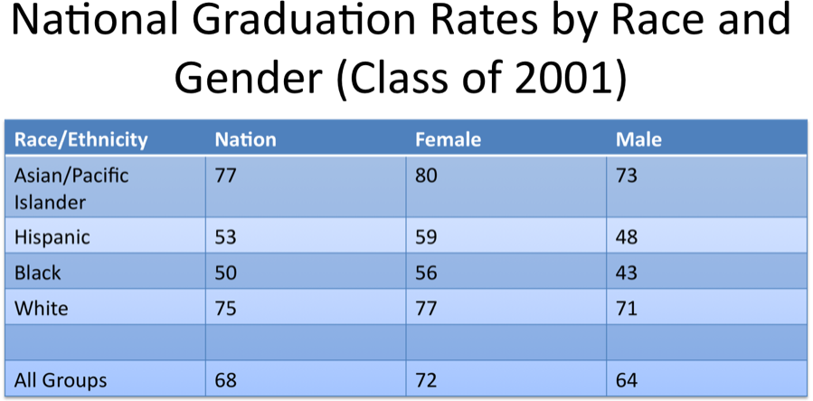

Source: Losing Our Future: Orfield, Losen, Wald & Swanson (2004)

3. My final example highlights the importance of accurate and accessible quantitative data: Following a conference convened by The Civil Rights Project with research from leading scholars across the nation, CRP published the analysis above to confront a major problem the conference papers had revealed. We knew that minority youth were failing to finish high school at very high rates, but that the public was largely unaware of this problem. The U.S. Department of Education was not reporting any data to the public on graduation rates, despite the capacity to do so. State governments filled the void with grossly misleading reports that masked over this educational crisis for minority students.

Fortunately, our report on graduation rates, with a focus on the crisis for minority youth, as well as a book of the scholarly studies called “Dropouts In America: Confronting the Graduation Rate Crisis,” generated national attention. The Civil Rights Project then convened over 6 regional conferences while independent organizations and researchers also began analyzing the data and reporting similar findings. Public awareness grew steadily and several politicians, including President Elect Obama, included improving graduation rates as part of their campaigns. This year the U.S. Department of education responded by requiring the reporting of more accurate, disaggregated rates, and calling for states to provide greater oversight and accountability for very low graduation rates of minority students.

Despite these examples of success, the hard reality is that we know the least about the minority children who are suffering the most. The United States fails to regularly collect and report data on the thousands of children who are arrested (many for school offenses while in school) and put in jail. These untracked children, are the most vulnerable, in part because we know the least about them. From the few reports that have been conducted we know these children are disproportionately minority males, and students with disabilities. We also know that children in U.S. prisons are exposed to a high risk of abuse, and substandard education, if education is even provided. Therefore, I would further recommend the collection of disaggregated data on rates of incarceration and access to education for minority children behind bars.

Conclusion:

The disparities I’ve highlighted in special education, graduation rates, and disciplinary exclusion reflect deep educational resource inequalities. I conclude by recommending the tracking of education resource data within each nation to reveal where minority children have an unequal opportunity to learn. Recently I have been assisting the Schott Foundation for Public Education and others with developing just such an initiative in the U.S.

There can be no question that tracking the condition of education, generally, country by country, is essential to the effort to ensure all the world’s children have their right to an education fulfilled. But where there are concerns about differential access to educational opportunities within each state, differences that flow along the lines of race, ethnicity and gender, it is equally important that this document recommend tracking and publicly reporting the extent of such differential access. Significant inequalities in the opportunity to learn, predictably, results in unequal learning.

While the kinds of educational resources may differ dramatically from state to state, there are at least some universal educational resources, such as per pupil expenditures on education and access to qualified teachers, that we know have an important affect on outcomes. We can often predict educational outcomes for minorities by looking at their access to these key educational resources. Access to the most critical resources could be monitored in every nation. Therefore, my concluding recommendation is that the draft document begin this process by calling for the tracking of within-nation differences for each minority group, in access to qualified teachers, and in per pupil expenditures.

My call for more “ disaggregated, quantitative data,” may sound impersonal or mechanistic, but in truth, it goes to the heart of why we have gathered here. All of us care about the human right to education. In English, when something matters a great deal we say, “It counts a lot!” If it doesn’t matter, we say, “It doesn’t count!” Since we all care a great deal, it would be appropriate for the final recommendations to include a lot of counting, to reveal both the access of minority children to critical educational resources as well as to reveal their educational outcomes.

Thank you once again for the opportunity to present to this esteemed forum!

Signed: December 18, 2008

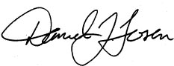

Daniel J. Losen
Senior Education Law and Policy Associate
The Civil Rights Project at UCLA
harvardlosen@gmail.com
www.civilrightsproject.ucla.edu

