GUIDELINES ON THE USE OF THE NGO REGISTRATION SYSTEM FOR ORAL STATEMENTS FOR THE HUMAN RIGHTS COUNCIL

Important General Information:
These Guidelines are issued in relation to the online system for making a request for oral statements by non-governmental organizations (NGOs) in consultative status with ECOSOC. The overall system of processing requests for oral statements, as described in the Practical Guide for NGO Participants, remains unchanged.
NGOs wishing to make an oral statement should submit a request using the online form. Requests can be submitted online during the week preceding the opening of the Session of the Human Rights Council (HRC). Kindly consult the HRC website for the exact date and time of opening of the online form.
The list of speakers is automatically generated by the system, based on the requested priority, time of registration, number of requests received and availability of time.
Online requests shall be made at the latest 24 hours prior the relevant debate through the online system.

These illustrated Guidelines include a step-by-step description of the on-line procedure as follows:

First step: create a username and password or Log in

Second step: Register your request(s) for debates.
- Select oral statement registration
- Sign up for debate
- Select the Debate Type
- Select the Debate Title
- Select the Priority
- Select add debate
- Save (when the choices are finalized)
- Click on continue (for upload documents)

Third step: Upload documents
- Enter the speaker’s name
- select the statement
- Upload the statement

Fourth step: LOG OFF

Fifth step: Additional options
- Sign up for additional debates
- View reports
- Upload video messages

STEP 1: How to create a username and password:
This NGO registration system uses the same platform for the submission of written statements as the one used for requests for oral statements speaking slots. You will need to register before every session of the Human Rights Council. NOTE: The same Username and Password should be used for both written and oral statements, as well as for parallel events!
You can access the page from: http://www.ohchr.org/EN/HRBodies/HRC/Pages/NgoParticipation.aspx
Direct access: https://ngoreg.ohchr.org
You will be directed to the page below:
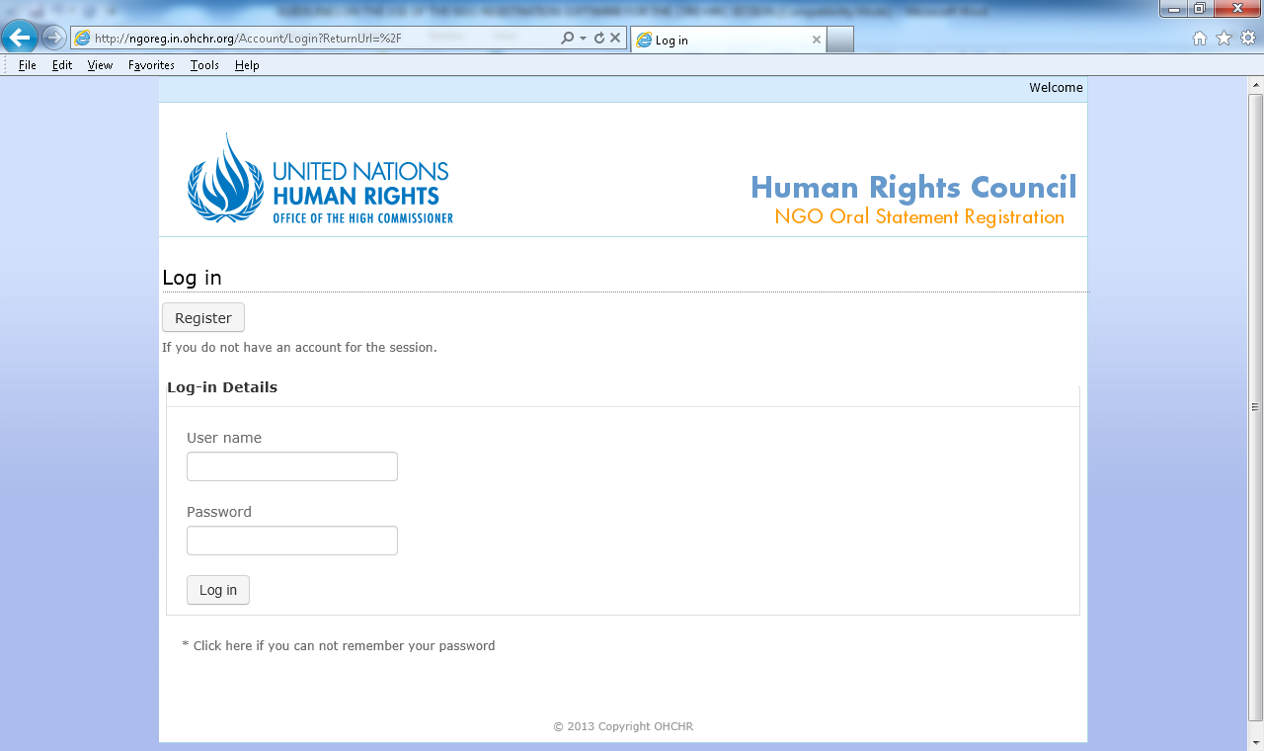
#1
#2
The first time you log-in the registration webpage, you will have to register your NGO in consultative status with ECOSOC.

Click “register” to create your account for the session. You will then be directed to the page below:
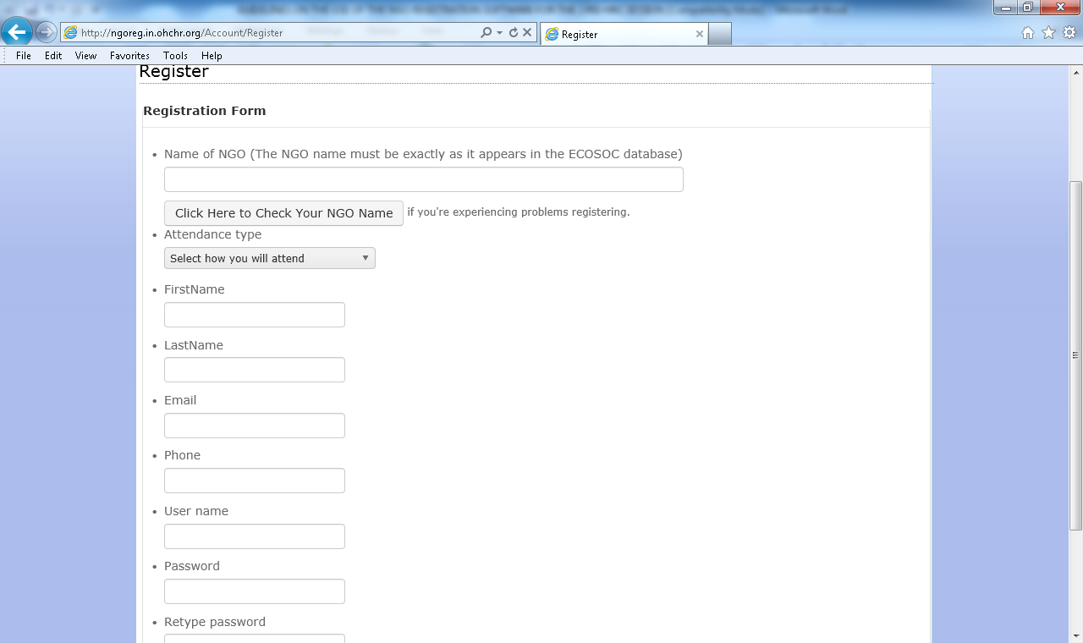
All fields are mandatory, except for the phone number.
This part will enable you to choose your attendance type. If you choose to participate through video-message, please see page 11.
I M P O R T A N T **NB **
If more than one representative is going to submit statements for the same NGO, it is important to coordinate with your colleagues and use the same #1) User Name, and #2) Password, so that you can verify what has already been submitted by others representatives with the same username.
Important: the name of your NGO should be exactly identical to the name with which the NGO is registered in the ECOSOC database.
In case of doubt on the exact name of your NGO, a link below will enable you to consult the ECOSOC database: http://esango.un.org/civilsociety/displayAdvancedSearch.do?method=search&sessionCheck=false:

In order to search the name of your NGO as registrered in the database, enter the name in the “Advanced Search” box below and hit the “Go” button.
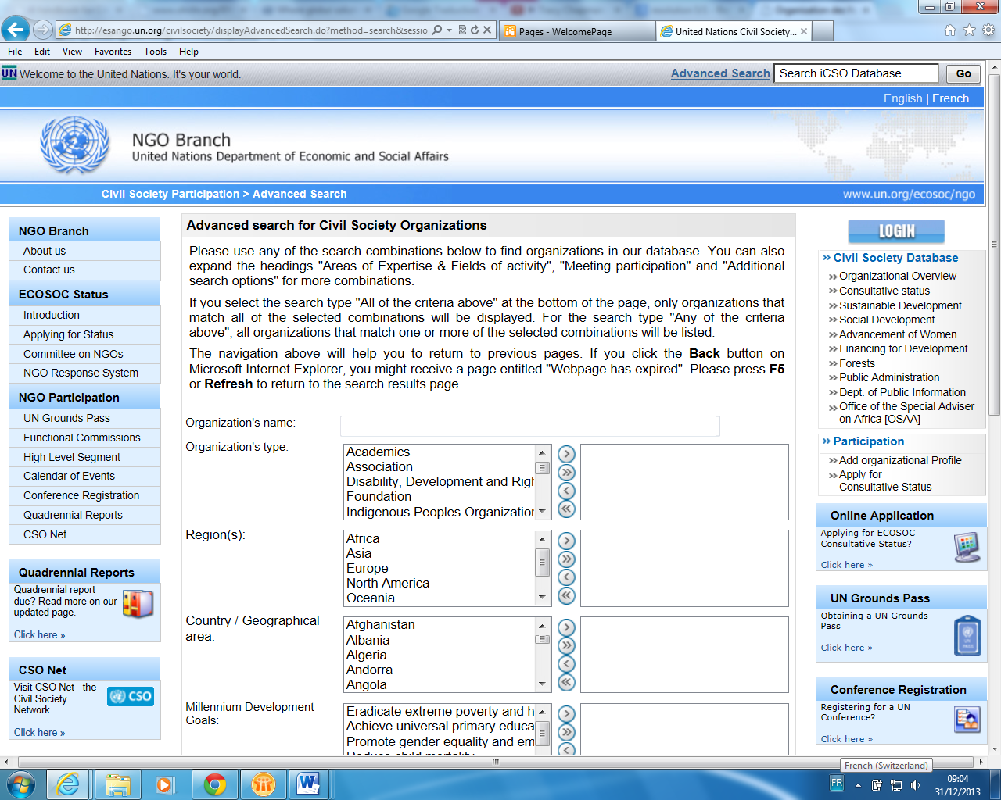
Enter the name of your NGO here
By entering the name of your NGO in the box above, you will be redirected to the page showing the exact name of your NGO as registered in the database or a list of similar names of NGOs.
You can try the search also by criteria such as Organization’s type, Regions, Country…
You will be redirected to the result page and in the list, you will need to click the name of your NGO from the “search results” page (see below), copy the exact name of your NGO and paste it into the HRC registration form.
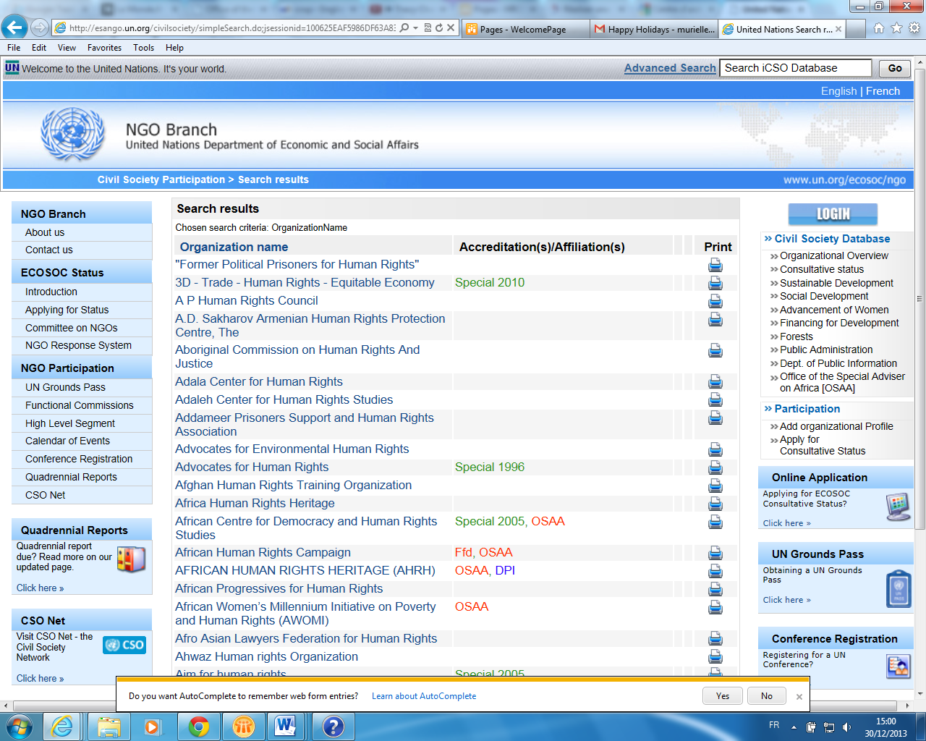

STEP 2: Register your request(s) for debates
After having created a username (#1) and password (#2), you can proceed to register your request(s) to make oral statements:
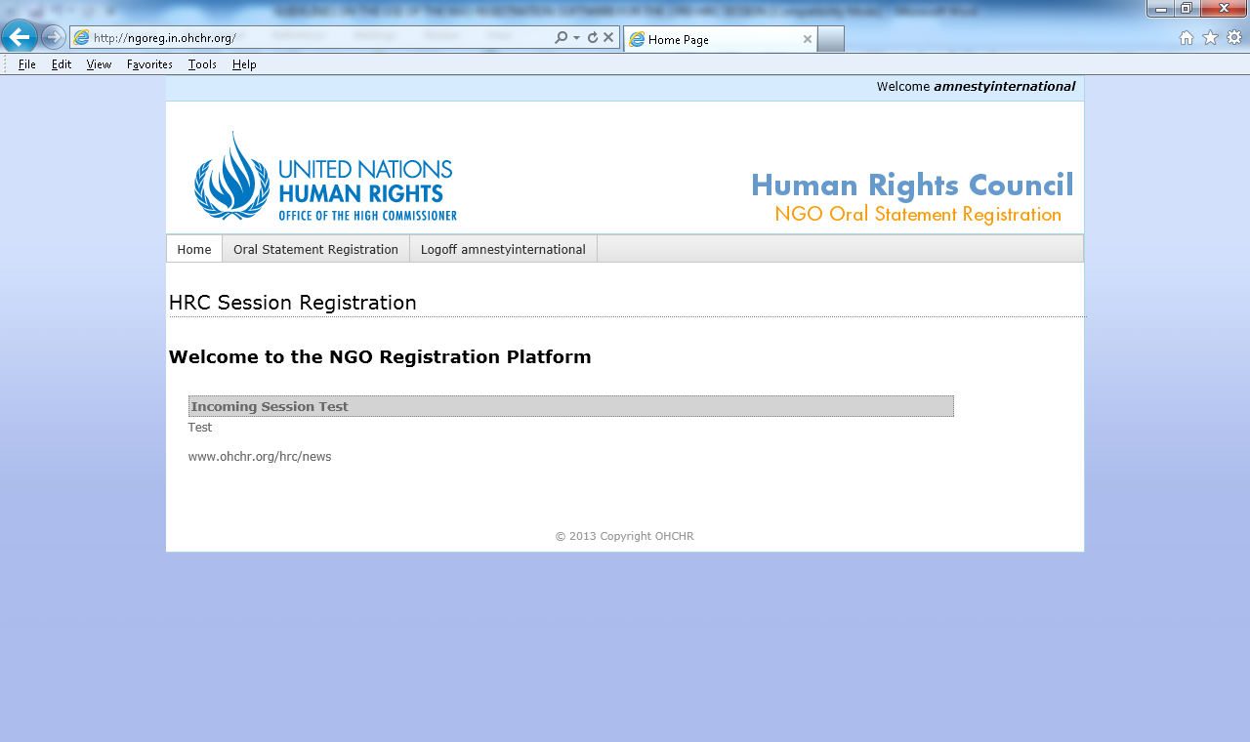
Click “Oral Statement Registration”.

When you click “Oral Statement Registration”, you will be redirected to the page below. Click “Sign up for debates” in order to access the list of debates:
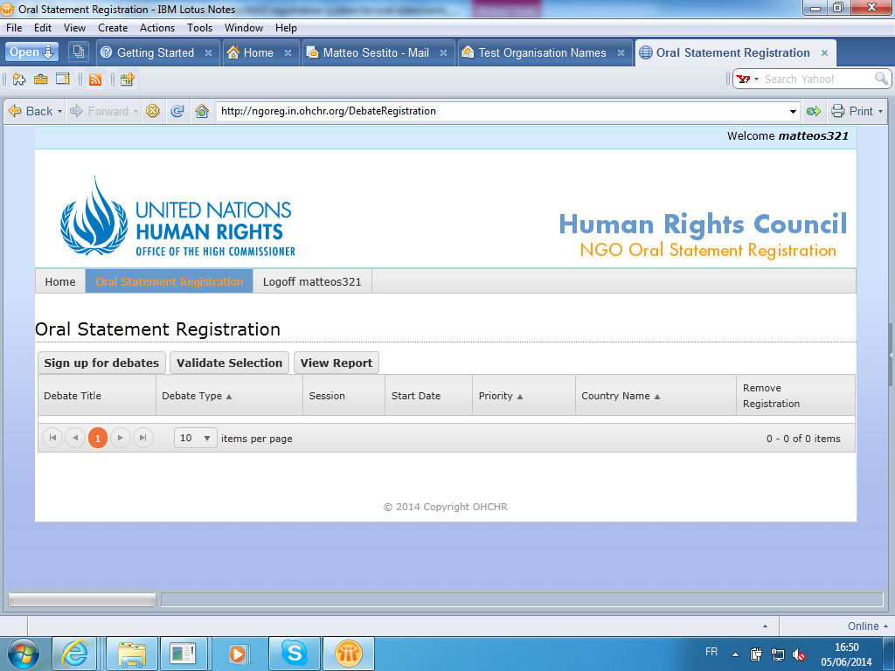
Before signing up for debates, take a look at the draft Programme of Work of the session which is available on the HRC website: http://www.ohchr.org/EN/HRBodies/HRC/RegularSessions/Session26/Pages/26RegularSession.aspx

You will be required to select a specific debate from the list below under “Debate Type”. 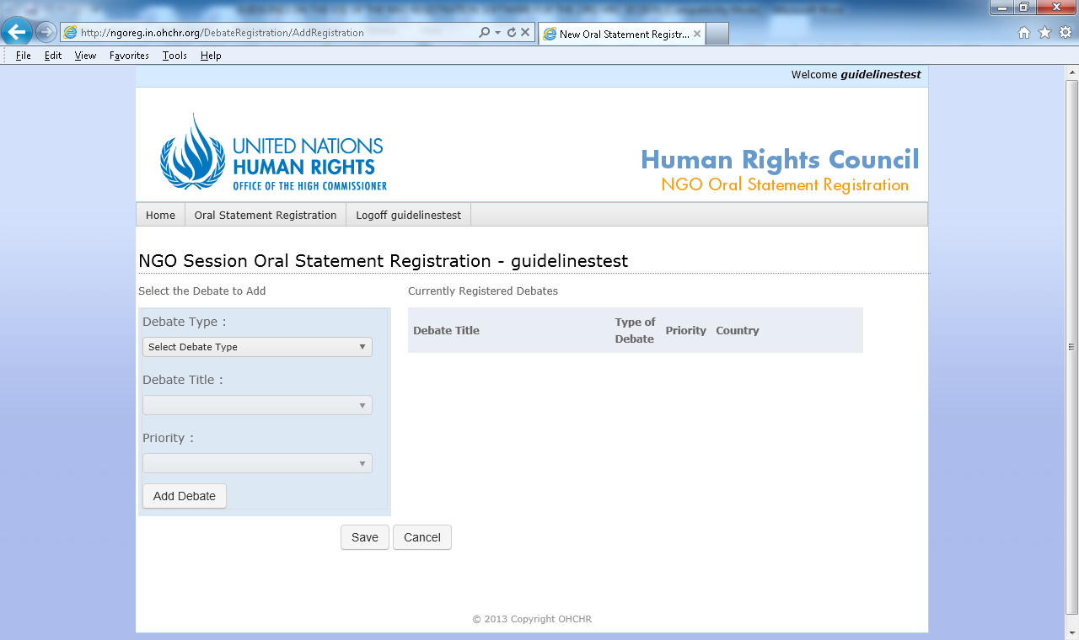
REMINDER: Only NGOs attending in person can make statements during General Debates.
The “Debate Type” section will enable you to choose between “General Debate”, “Interactive dialogue”, “Panel/Annual discussion”, and “UPR”.
The “Debate Title” section will enable you to register for a specific debate.
Select your Priority number, with “1” being first priority. Once you are done, click the “Add Debate” button. The selected debate (e.g. General Debate; Interactive Dialogue; Panel) will appear on the table at the right of the screen (see below). Repeat these steps for every debate for which you want to register.

If you make a mistake, you can click on the “remove” button (see below):
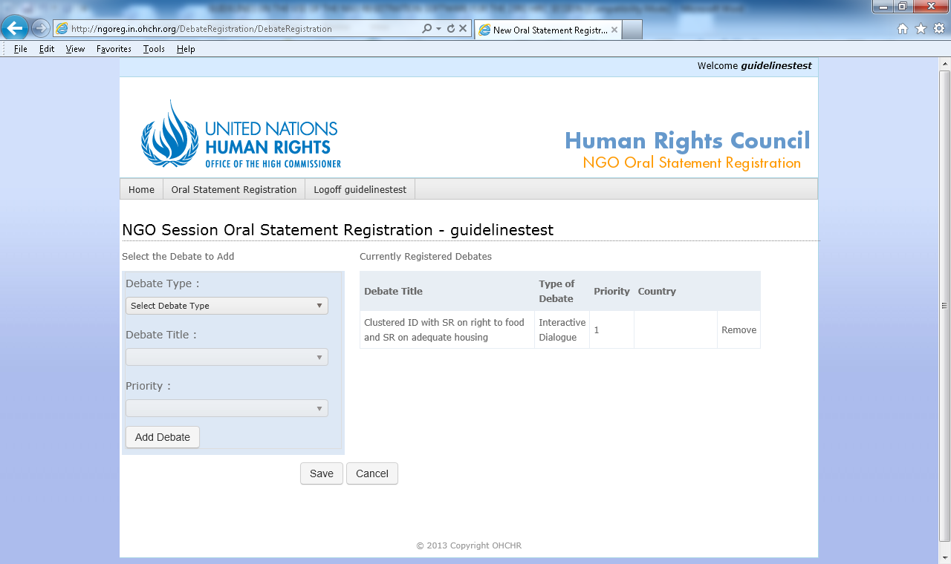
Once your choices are finalized, don’t forget to click on SAVE.

Once finished, click on “continue” to be redirected to the page enabling to upload documents.

STEP 3: Upload documents

On this page, an “Upload Materials” button will appear next to each debate for which you have signed up under the “Oral Statements Registration” tab (see the arrow below):

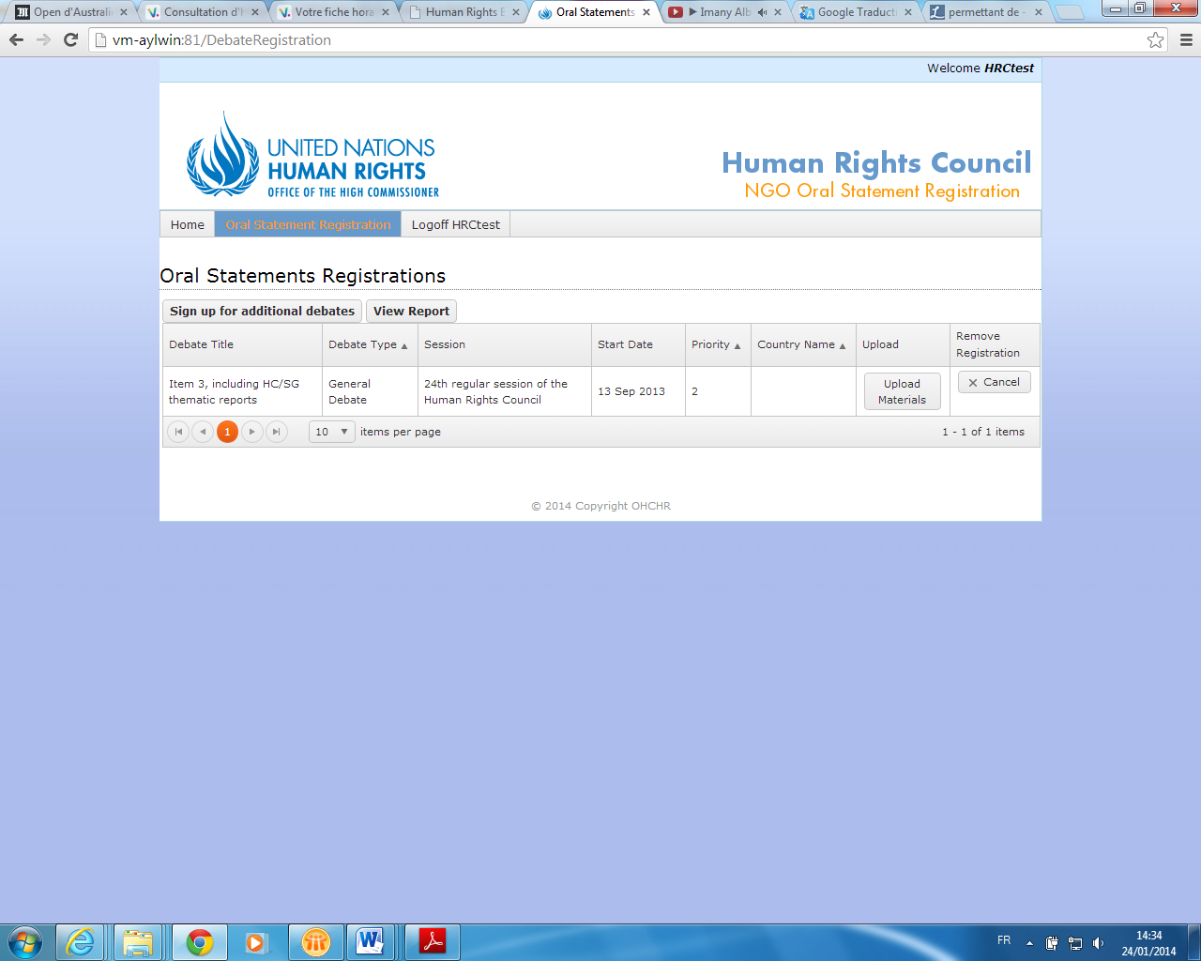

Clicking the “Upload Materials” button will redirect you to this page:

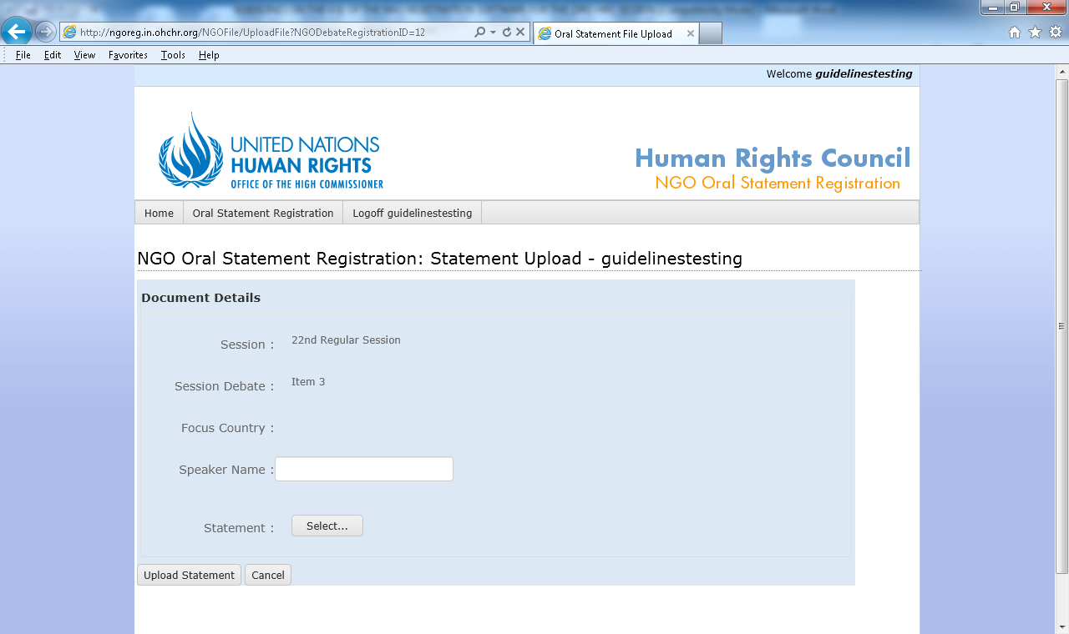
1
2
The speaker’s name must be confirmed in Room XX within 24 hours prior to the relevant debate.
3

Enter the Speaker Name, and upload your statement by clicking the “Select…” button.

Your statement is uploaded successfully when you are redirected to the page below:

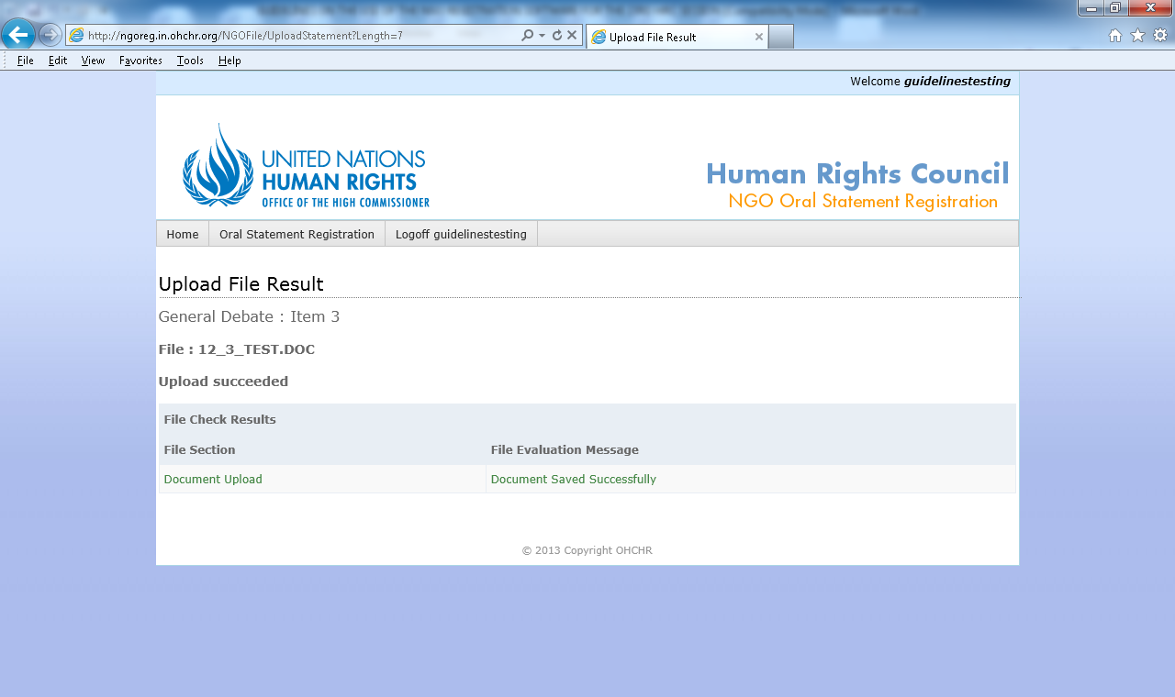

To continue uploading additional materials, click on Oral Statement Registration and repeat previous steps.

STEP 4: LOG OFF

Once you finish using the online system, please logoff by clicking on the “logoff” button below. Otherwise, it will not be possible for other users from your organization to log in with the same username and password.
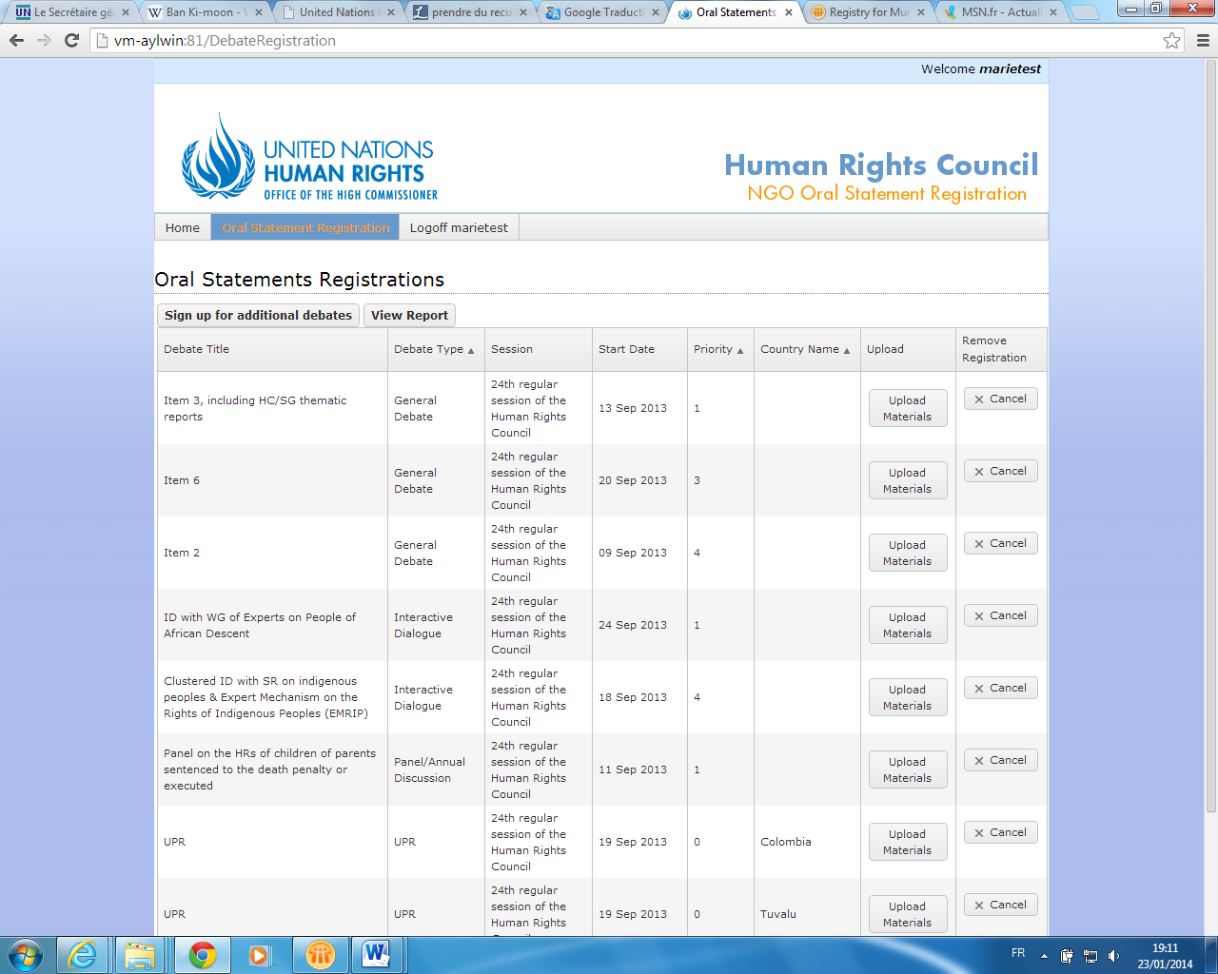

STEP 5: Additional options

- Sign up for additional debates:
There is a possibility to sign up for additional debates. NGOs can register for debates up to 24 hours prior to the relevant debates. In this regard, you will need to click on “Sign up for additional debates” and follow the same instructions suggested in steps 2 & 3.

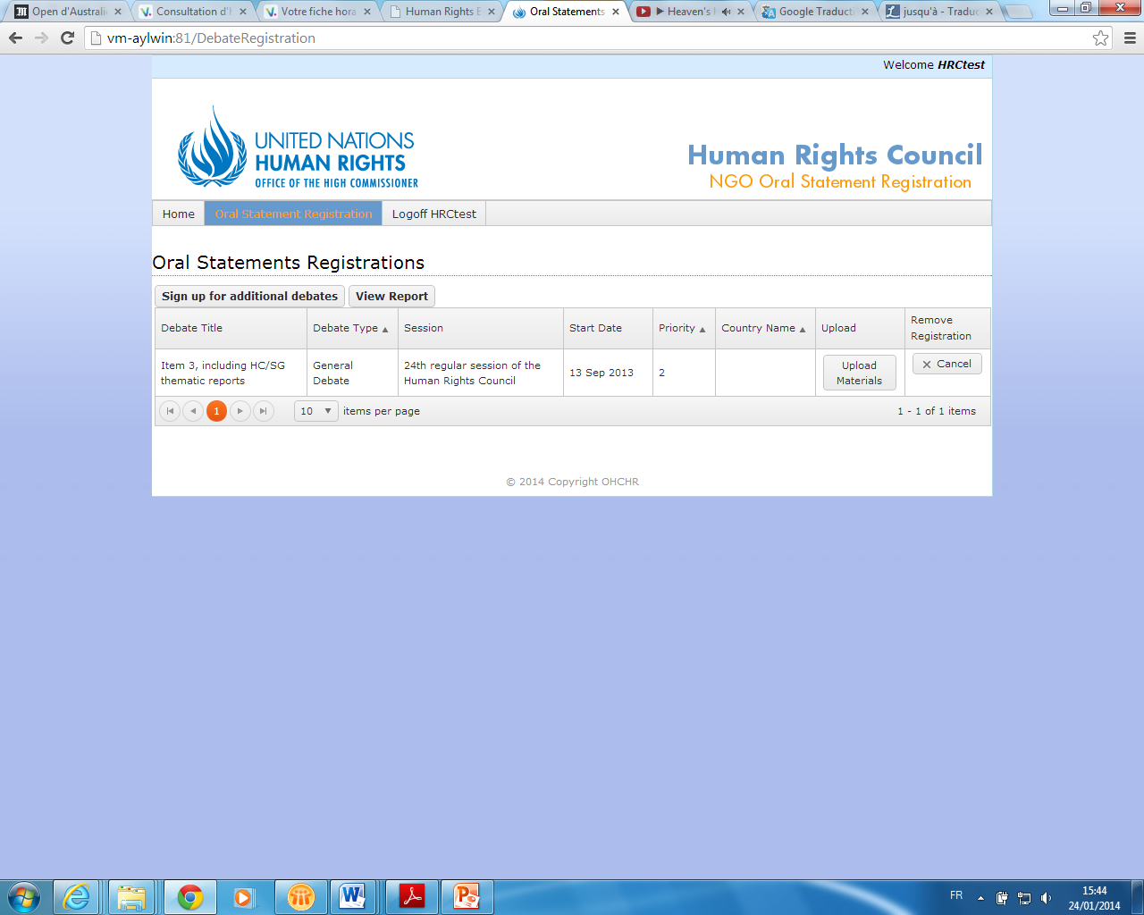
- View report:
The option “view report” will enable you to have an overview of the debates subscribed with some indications: Type, date and priority number as it appears below: 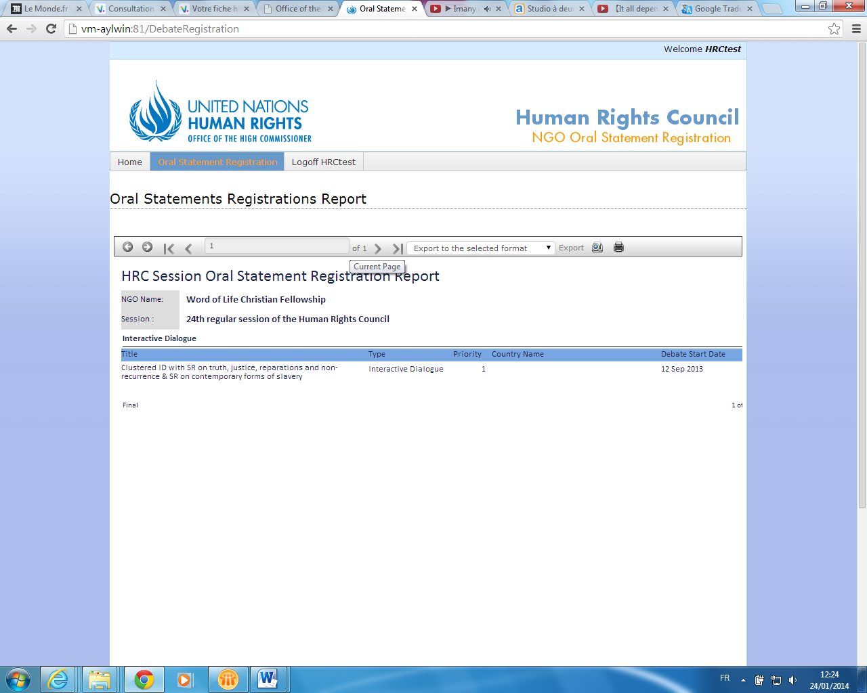
If you click on “export to the selected format” below, you can have your document in different formats such as Excel, PDF, Rich Text Format…then, you can either save it or print it by clicking on the printer button.

- Upload video messages
Please note that this option is available only for NGOs in consultative status with ECOSOC which do not have an office or representative in Geneva, and which do not have individuals accredited to the relevant session of the Council. For more information, please see the guidelines on participating in the Human Rights Council by video message. Video messages may only be submitted for the following types of debate:
1. The General Segment of the Council plenary session held in March;
2. Interactive dialogues with special procedures relating to reports on country missions;
3. Plenary adoption of Universal Periodic Review outcomes; and
4. Panels/annual discussions.

If you have indicated that you will participate by video message, click the “Finalise sign-up” button, an “Upload Materials” button will appear next to each debate for which you have signed up under the “Oral Statements Registrations” tab:
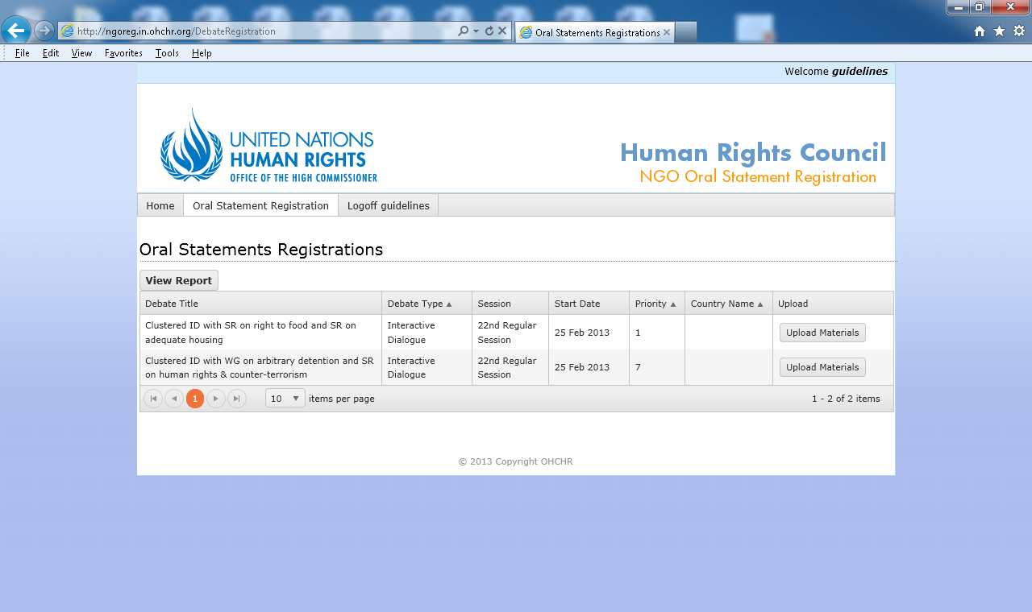
Clicking on “Upload Materials” will redirect you to this page:
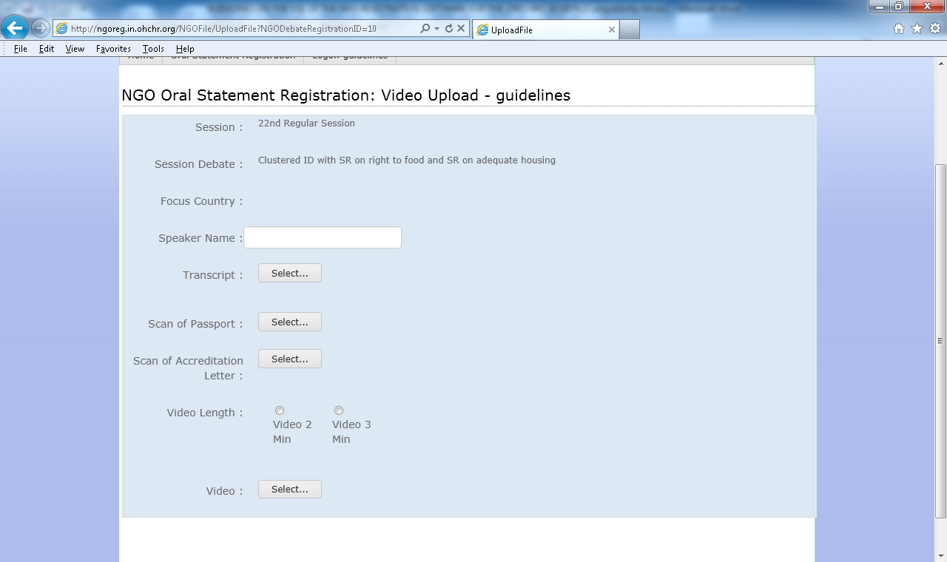
NGOs wishing to participate by videomessage must upload the following materials:
- The video statement itself, which must comply with the Guidelines for NGO video messages, available here: http://www.ohchr.org/EN/HRBodies/HRC/Pages/NgoParticipation.aspx
- Letter submitted with the NGO’s official letterhead and signed by its President, Chief Executive Officer or Main Representative of the United Nations Office at Geneva (if the person is authorized to accredit representatives to the United Nations Office at Geneva);
- Colour copy of the photograph page of a passport or formal identity document of the person who will deliver the statement.
If you get the following error message, your video does not comply with the technical specifications outlined in the Guidelines for NGO video messages, and you must therefore upload a new message which complies with the guidelines.
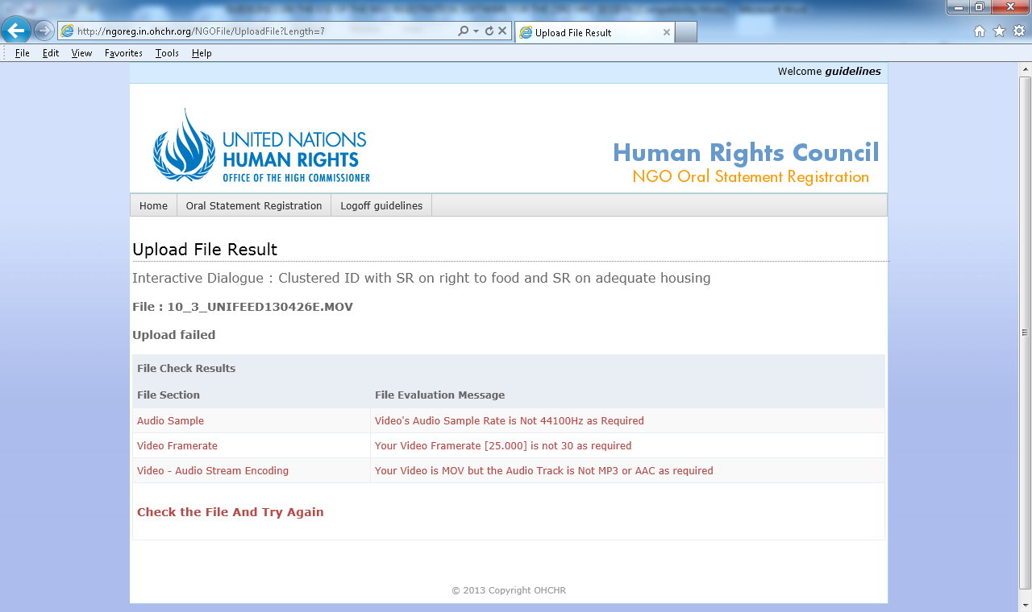
Your video statement has been correctly registrered when you are redirected to this page:
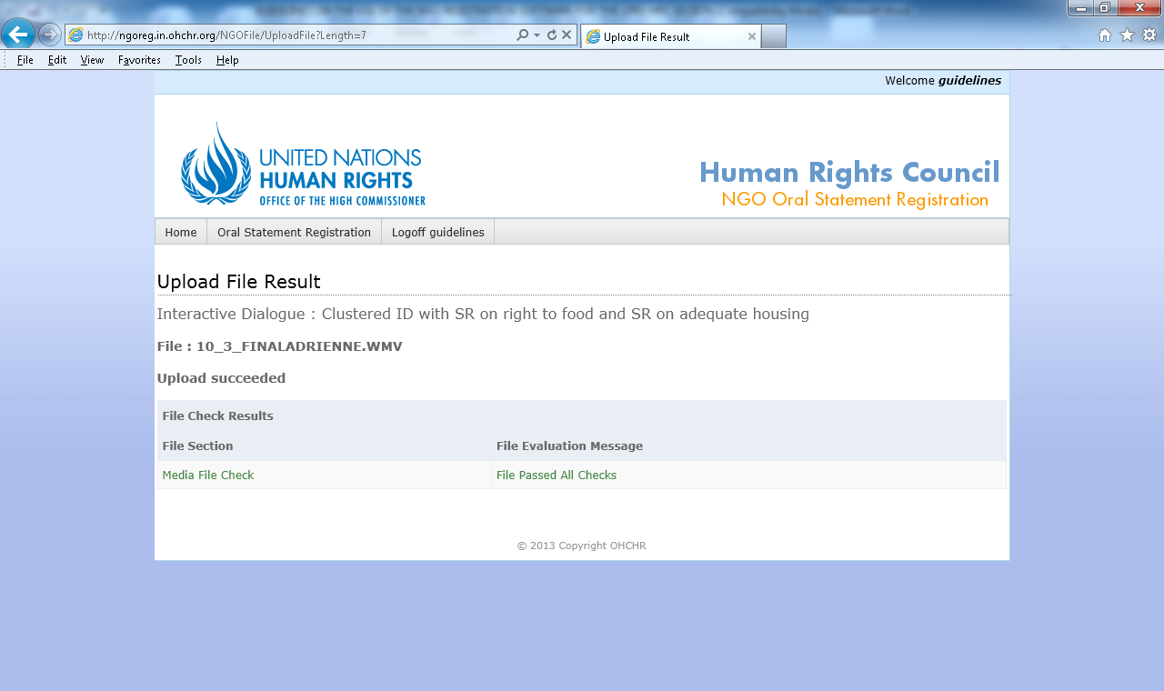

Updates about the on-going session of the Human Rights Council will be posted on the “Home page” of the online registration system during the session, and are also available via the Human Rights Council secretariat’s twitter account and wesbite:
Twitter: @UN_HRC
Website: http://www.ohchr.org/EN/HRBodies/HRC/Pages/HRCIndex.aspx

Available in the six UN languages from http://www2.ohchr.org/english/
The registration to obtain log-in details should be requested only one time. Once you have them, this can be used for the online registration for written and oral statements.
The guidelines are available here: http://www.ohchr.org/EN/HRBodies/HRC/Pages/NgoParticipation.aspx
Refer to the Step 1, the box referring to "attendance type" please see page 2.

