Check against delivery

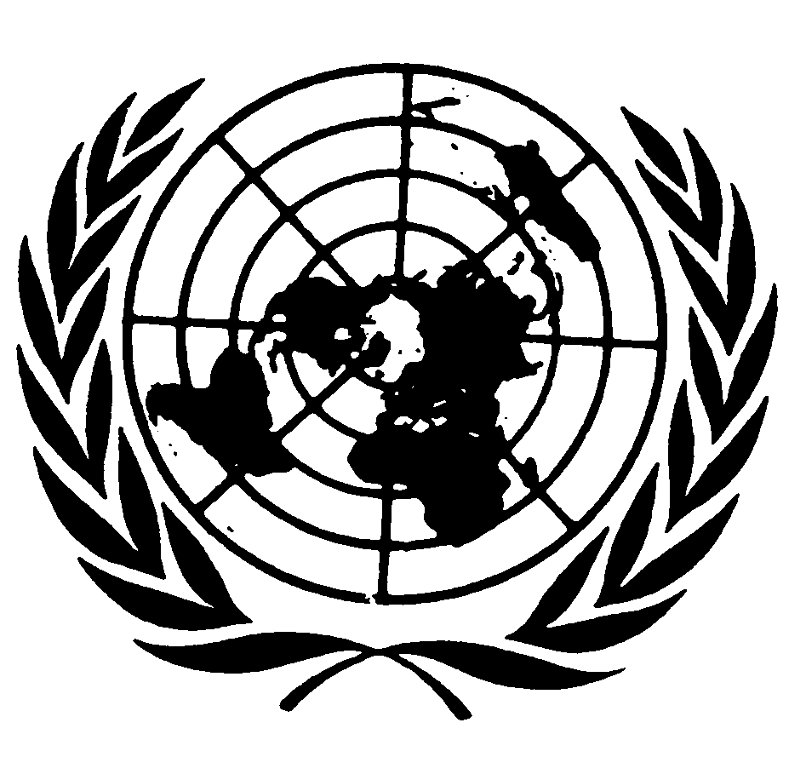

Statement by Ambassador H.E. Sisahasak Phuangketkeow
President of the Human Rights Council

“Commemoration of the 100th session of the Human Rights Committee”

Palais des Nations, Room XIX

29 October 2010, Geneva



Mr. Chairperson,
Mr. Ndyae,
Distinguished Experts,
Ladies and Gentlemen,

It is my honour and privilege to participate in this important commemoration, marking the 100th session of the Human Rights Committee. At the outset, allow me to express my sincere thanks to the Committee for its invitation and to congratulate it for its 100th session.

Mr. Chairperson,

Much will be said and cherished today with regard to the centrality of the International Covenant on Civil and Political Rights, which, together with the International Covenant on Economic, Social and Cultural Rights and Universal Declaration of Human Rights, constitute the backbone of the “International Bill of Human Rights”. The implementation by States parties of the standards set out in these core human rights instruments would nonetheless be hard to assess or to improve, without the impartial, independent and experienced oversight by treaty bodies, such as the Human Rights Committee. Indeed, among the many achievements of this eminent body, we all have to acknowledge the Committee’s invaluable work in monitoring the implementation of the ICCPR and in contributing to standard-setting through its jurisprudence. Moreover, the Committee has immensely contributed to the fulfilment of civil and political rights through its work aiming at engaging in constructive dialogues with States parties and all other stakeholders.

The notion of constructive engagement with States has also been very much at the centre of the Human Rights Council’s work since its establishment. Indeed, one of the main objectives of the transition from the Commission on Human Rights was to find ways to provide more space to cooperation and genuine dialogue. The Council has undoubtedly had some success in this regard. Nonetheless, I believe that there are many experiences to share among all UN human rights mechanisms – not least from the Human Rights Committee – to produce meaningful impact on the ground through constructive engagement with States.

Distinguished experts,

Although there is no formal channel allowing for dialogue and exchange of information between the Council and the Committee, I would like to emphasize that the work of the Committee is in reality largely taken into account by the Council.

First, the work of the Committee has resonated in the Human Rights Council Chamber during the sessions of the Universal Periodic Review. The so-called “UN compilations”, in which treaty bodies’ work and outputs feature prominently, are referred to by many State delegations when formulating recommendations to the State under review. The UPR has therefore provided an effective way to raise awareness about the Committee’s work, disseminate it to a larger audience and give new impetus to the Committee’s recommendations. Furthermore, synergies seem to have emerged ahead or as a consequence of the UPR, with several States ratifying more human rights treaties or submitting reports to treaty bodies.

The normative work undertaken by the Committee has fed into the deliberations of the Council. Specifically, General Comments which provide solid legal analysis civil and political rights, have helped States to shape their positions thereon. This will also be the case for the upcoming General Comment on Article 19, which, I believe, will add significant value and help clarify views concerning the current controversial debate in the Council on the concept of “defamation of religions”.

Last but not least, independent expertise has often been provided by members of the Committee through their participation in various Human Rights Council’s panels, roundtables or side-events, which I believe are good practices that will continue to be enhanced.

Mr. Chairperson,

Taking into account that one of the mandates of the Human Rights Council is to mainstream human rights with the UN system, the synergy between the Council and all UN human rights mechanisms should continue to be enhanced. This will be one of the issues the Council will discuss under the on going review of its work and functioning this year. Our review process will be finalized by late spring next year and feed into the review of status of the Council, to be undertaken by the UNGA in New York. The goal is to assess what we have achieved and where improvements can be made to enhance the effectiveness of the Human Rights Council in promotion and protection of human rights for all.

In concluding, Mr. Chairperson, allow me to wish all members of the Committee full success in the continuation of their work and to reiterate the profound admiration and acknowledgment by the Council of your impartial and authoritative human rights expertise, which session after session contributes tangibly to the improvement of national human rights legislation, policies and programmes, and to the protection of the human rights of so many individuals the world over.
***

